**How to encrypt existing RDS instance and move it to private subnets**

**Taking a snapshot of RDS instance.**

1. Open AWS Console and Navigate to the Amazon RDS Service.

2. On the left side pane, click on "Databases", select database that You want to take snapshot of, click on “Actions” and then on “Take snapshot”.

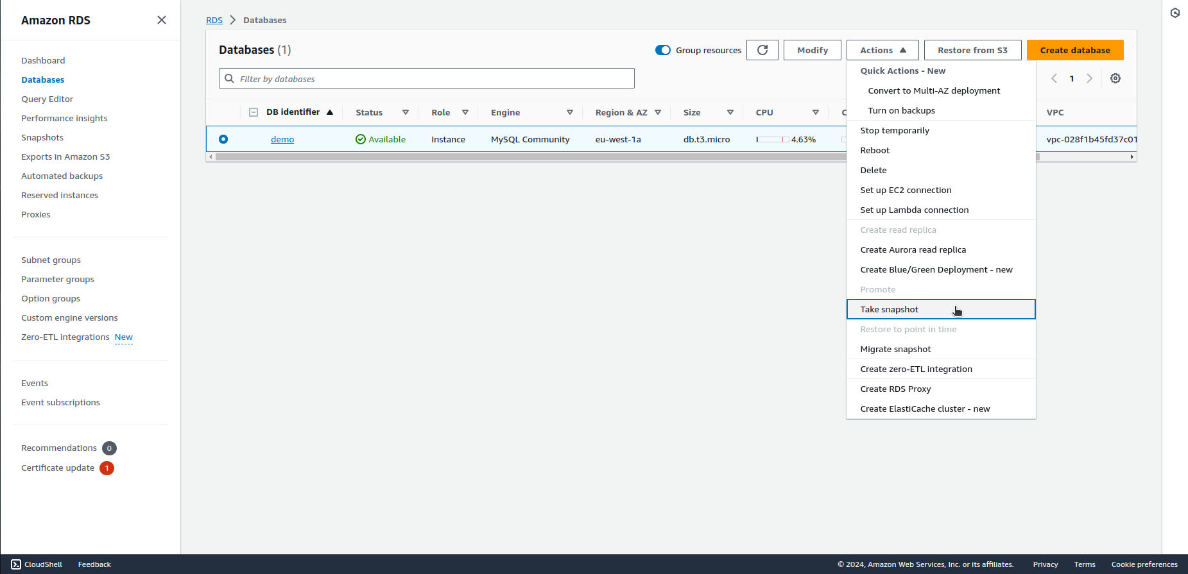

3. Give the snapshot name and click on “Take snapshot”.

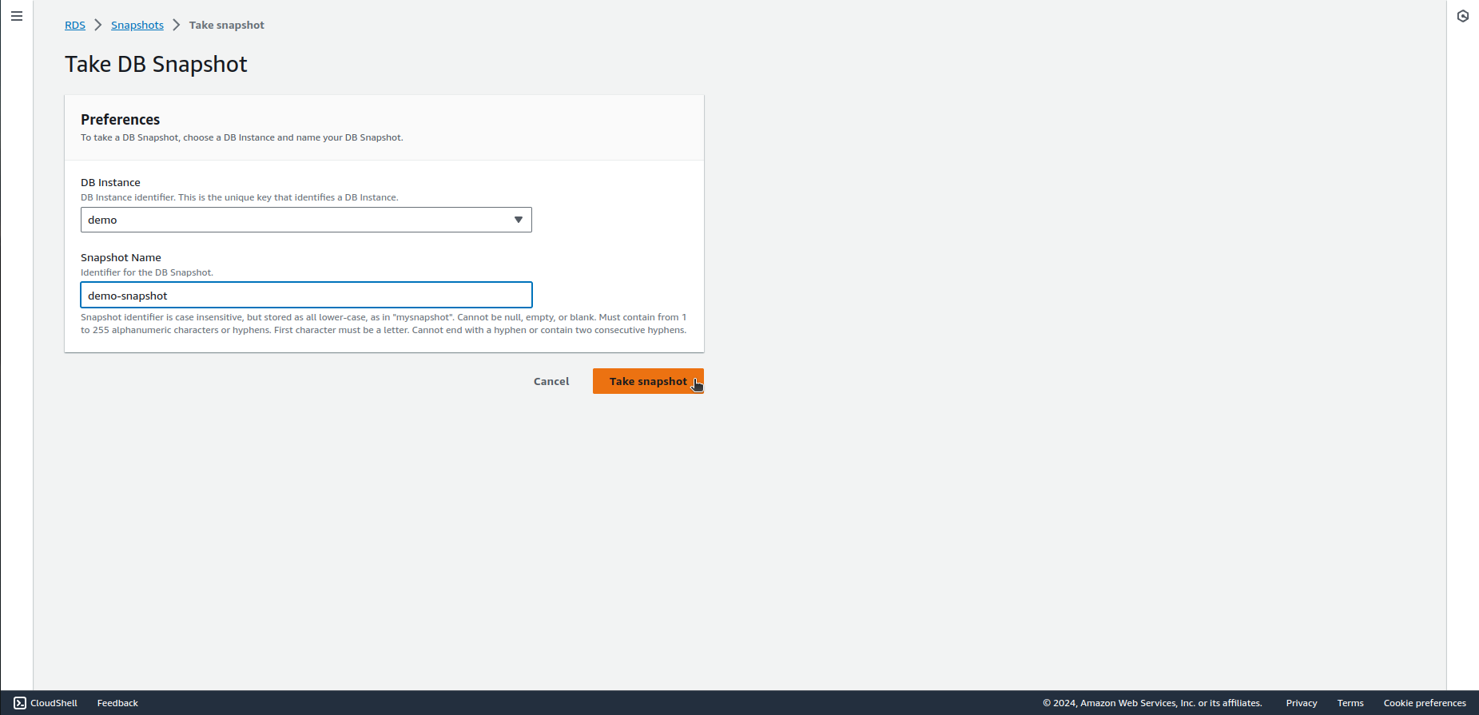

**Encrypting the snapshot**

1. On the left side pane, click on "Snapshots", select the newly created snapshot, click on “Actions” button and select “Copy snapshot”.

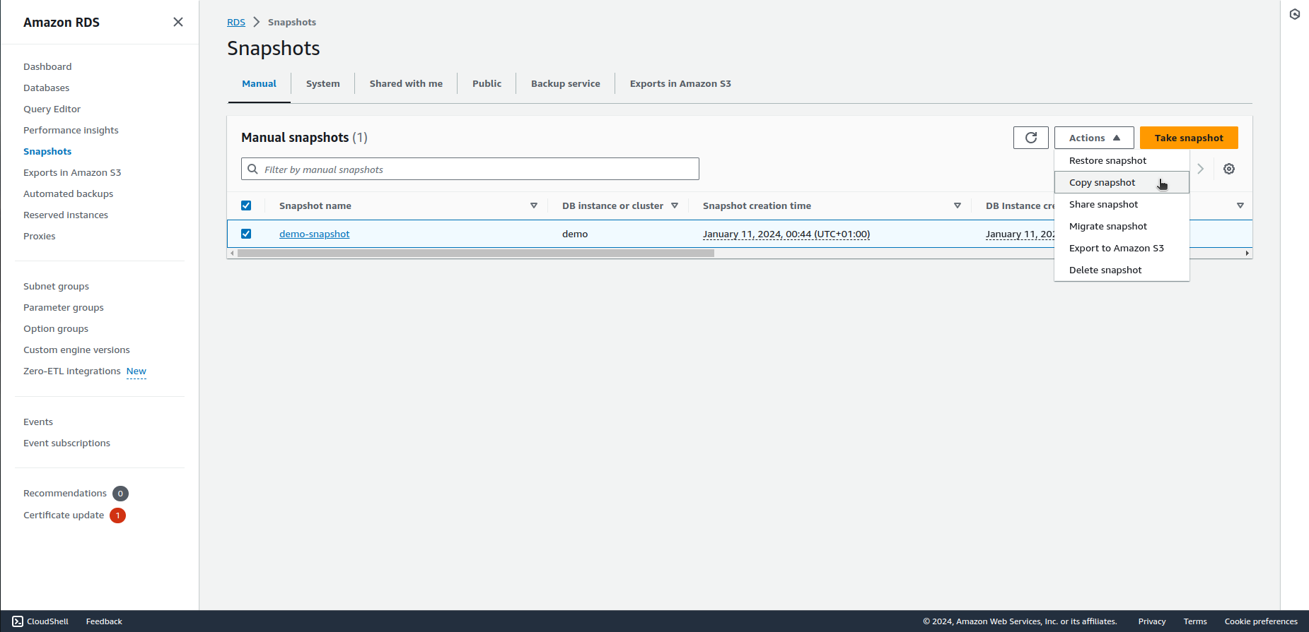

2. Select region, give Your new, encrypted snapshot a name, select the “Enable encryption” checkbox and click on “Copy snapshot”.

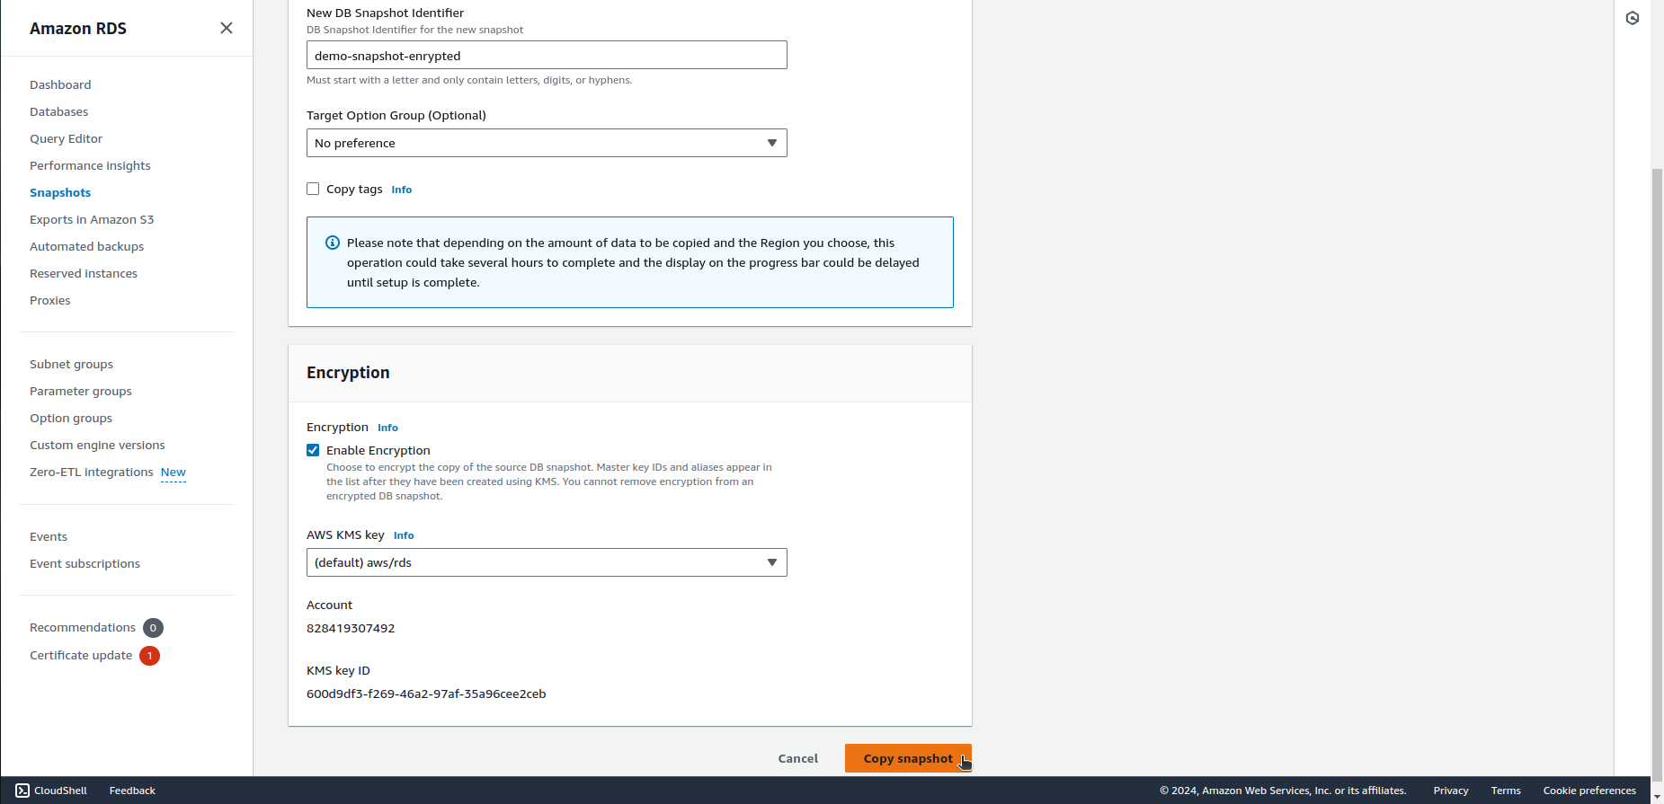

**Restoring encrypted RDS instance from the snapshot**

1. Once again, on the left side pane, click on "Snapshots", select the newly created, encrypted snapshot, click on the "Actions" button at the top of the snapshot list. From the drop-down menu, choose "Restore Snapshot."

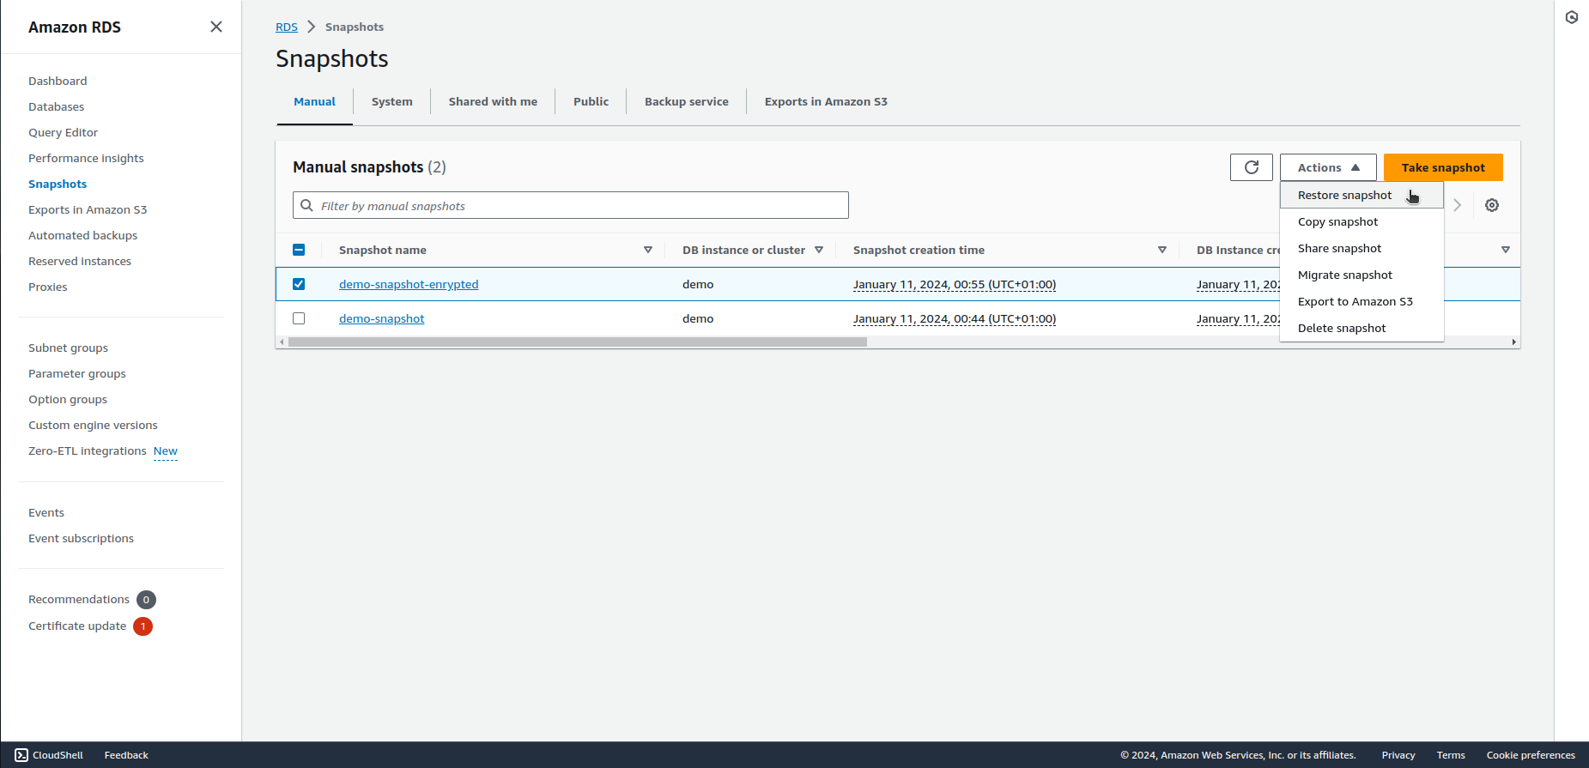

2. Set all the RDS setting as You need or the same, as in the old unencrypted instance. Scroll down to the bottom of the page to review your configurations and click on the "Restore DB instance" button.

**Moving RDS instance to private subnets**

RDS instance subnet group cannot be changed for another subnet group in the same VPC. In order to move the instance to private subnets in the same VPC, You have to follow the restoring process described above. But first You have to create subnet group with private subnets only.

1. On the left side pane, click on "Subnets groups" and then on “Create DB subnet group” in the upper right corner.

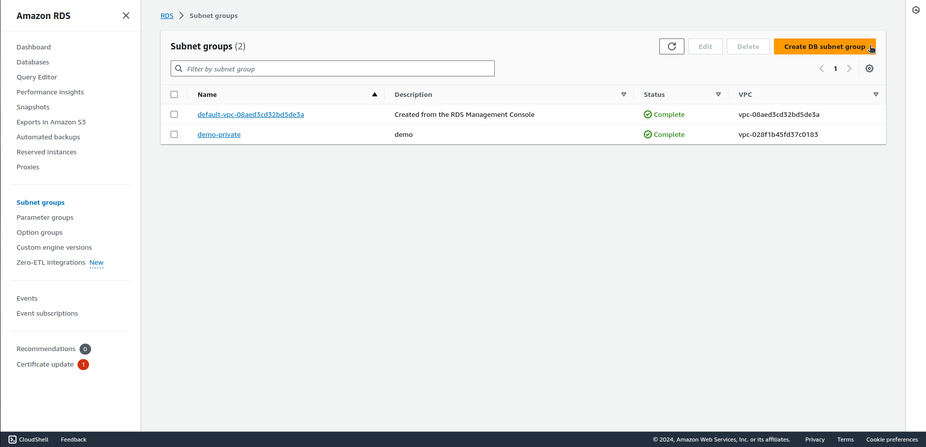

2. Give the group a name, select VPC, availability zones, private subnets and click on “Create” at the bottom of the page.

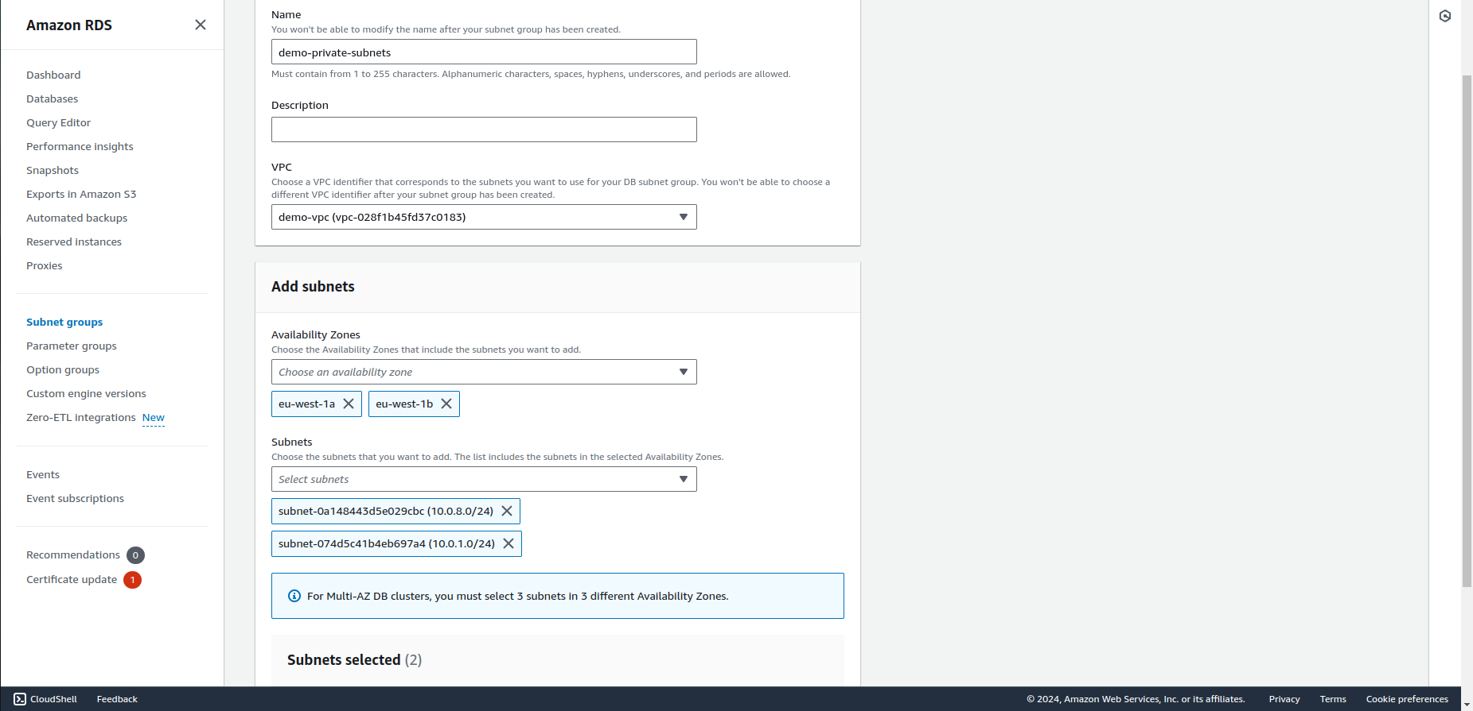

3. When restoring RDS, in “Connectivity” section, choose VPC, newly created subnet group, disable public access and select security groups.

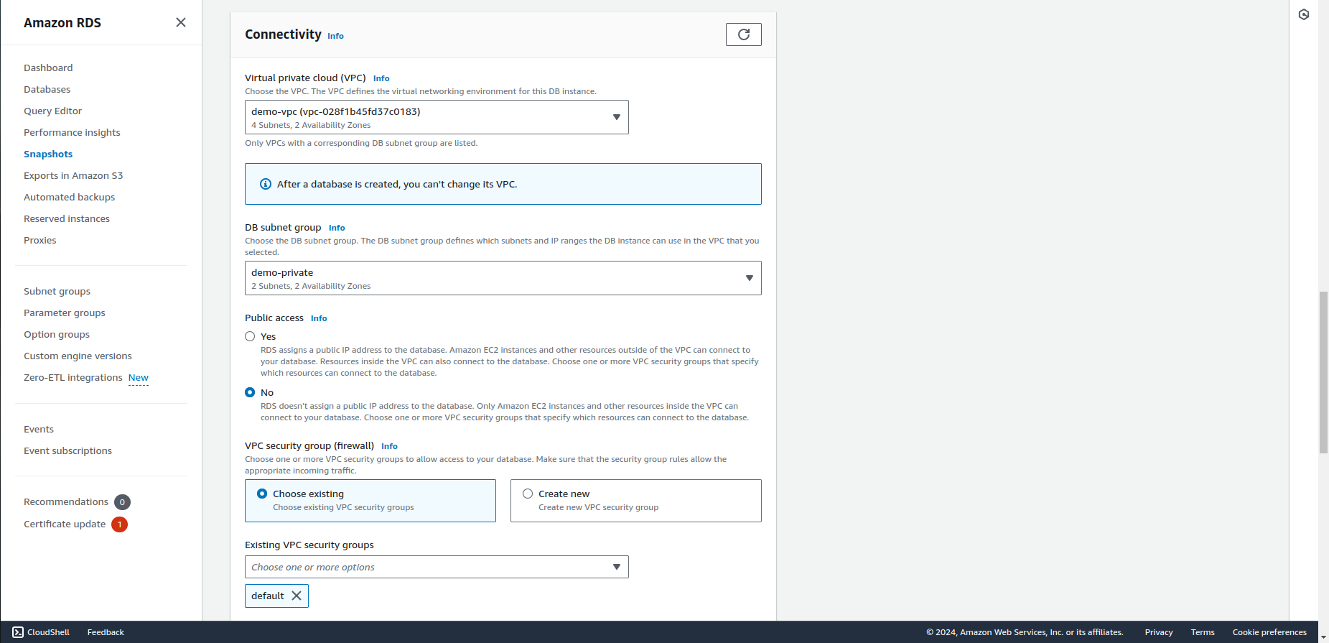

4. Restore the instance.