**Restricting access to an Amazon S3 origin**

1. Open the AWS Management Console and navigate to the CloudFront service.

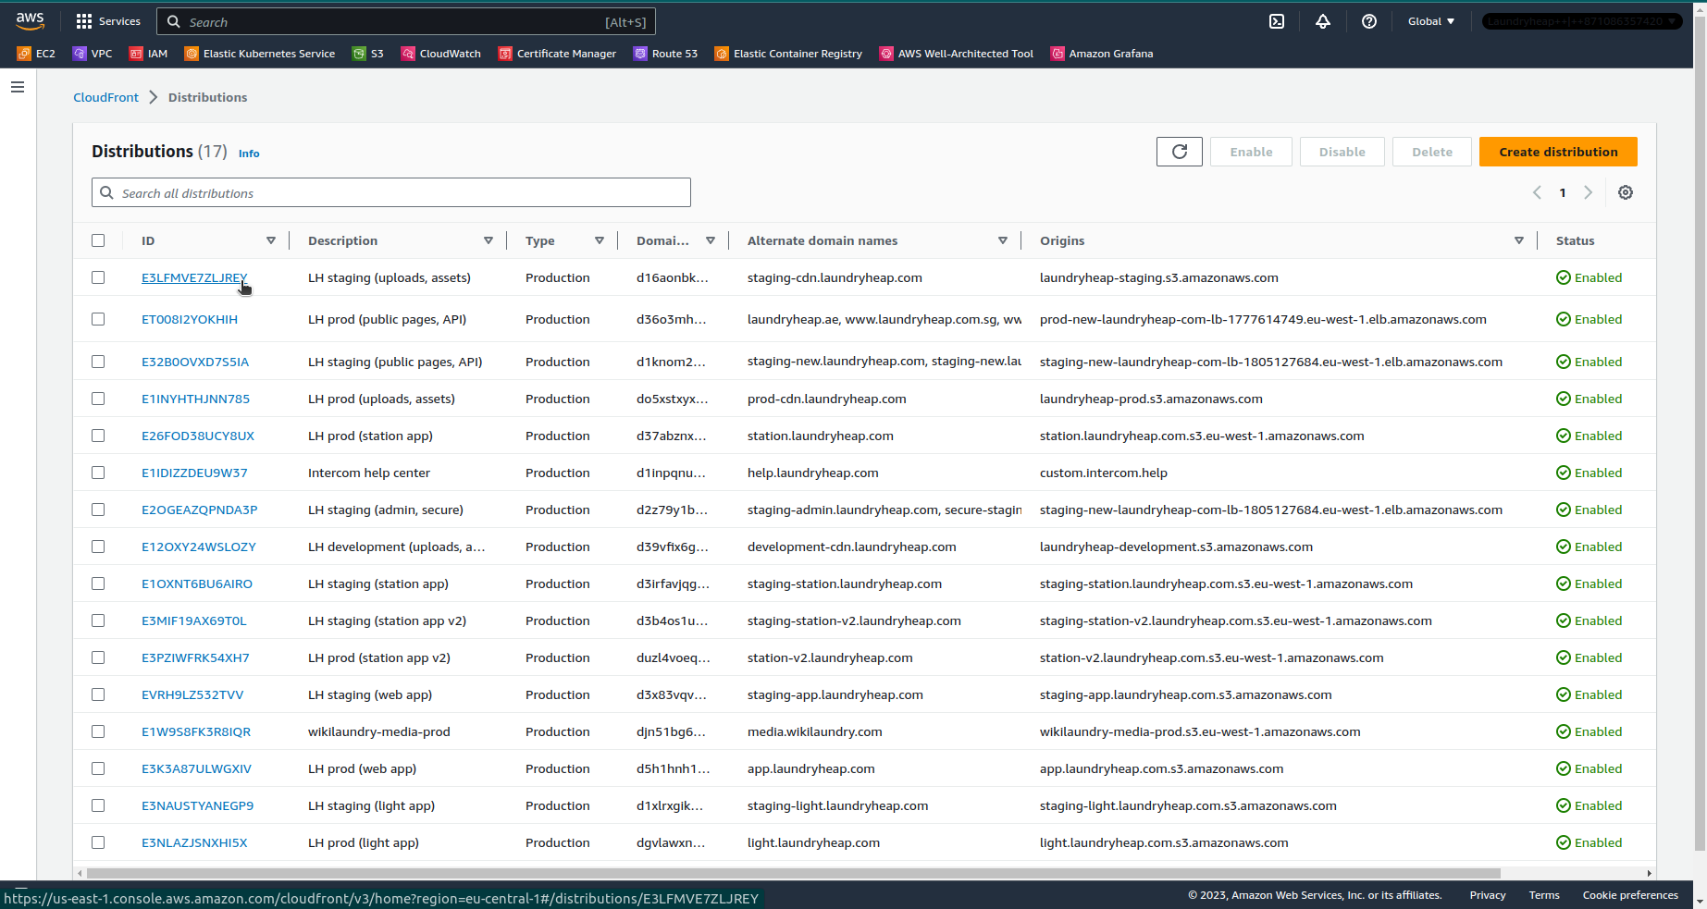2. Select your CloudFront distribution that is using the S3 bucket as an origin.

3. In the "Origins" tab, select the S3 origin associated with your distribution and click on "Edit".

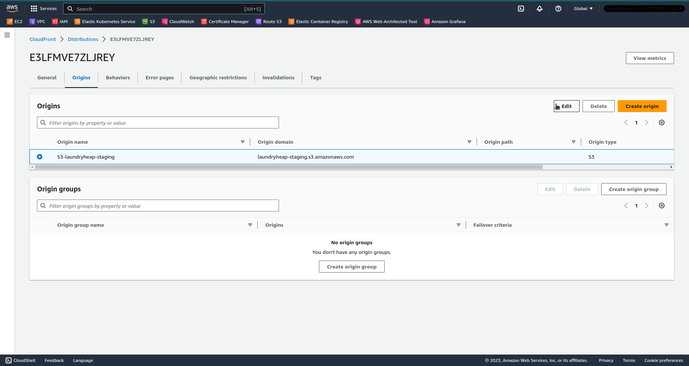

4. In the "Origin access" section, choose "Origin access control settings" and click on "Create control setting".

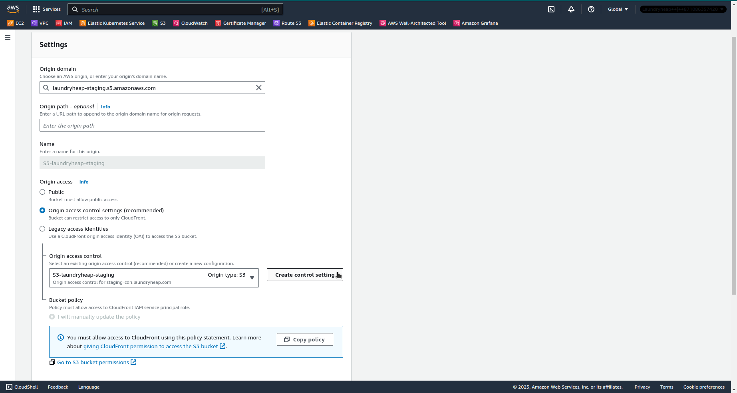

6. In the "Create control setting" window, leave the default name and settings and click on "Create".

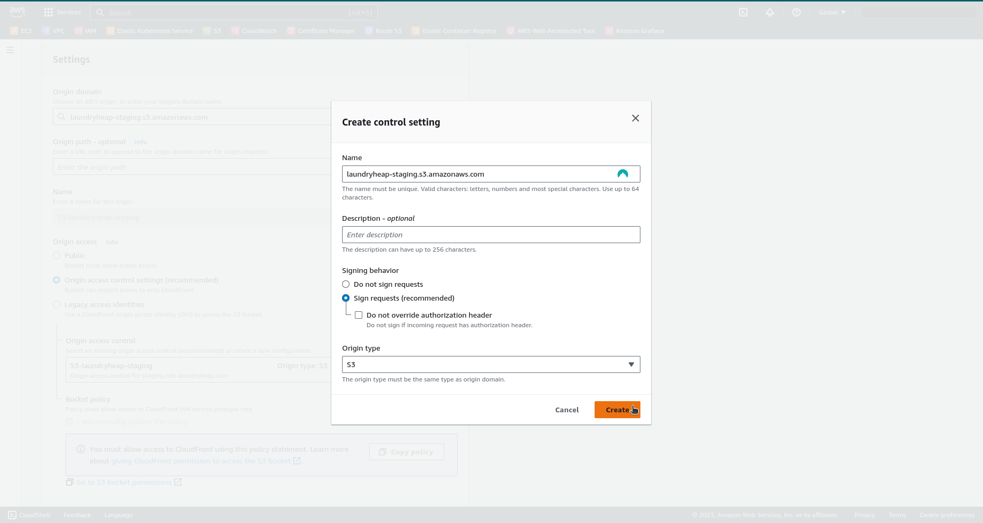

7. Back in the "Edit origin" page, in the "Origin access" section, click on "Copy policy", then on "Go to S3 bucket permissions".

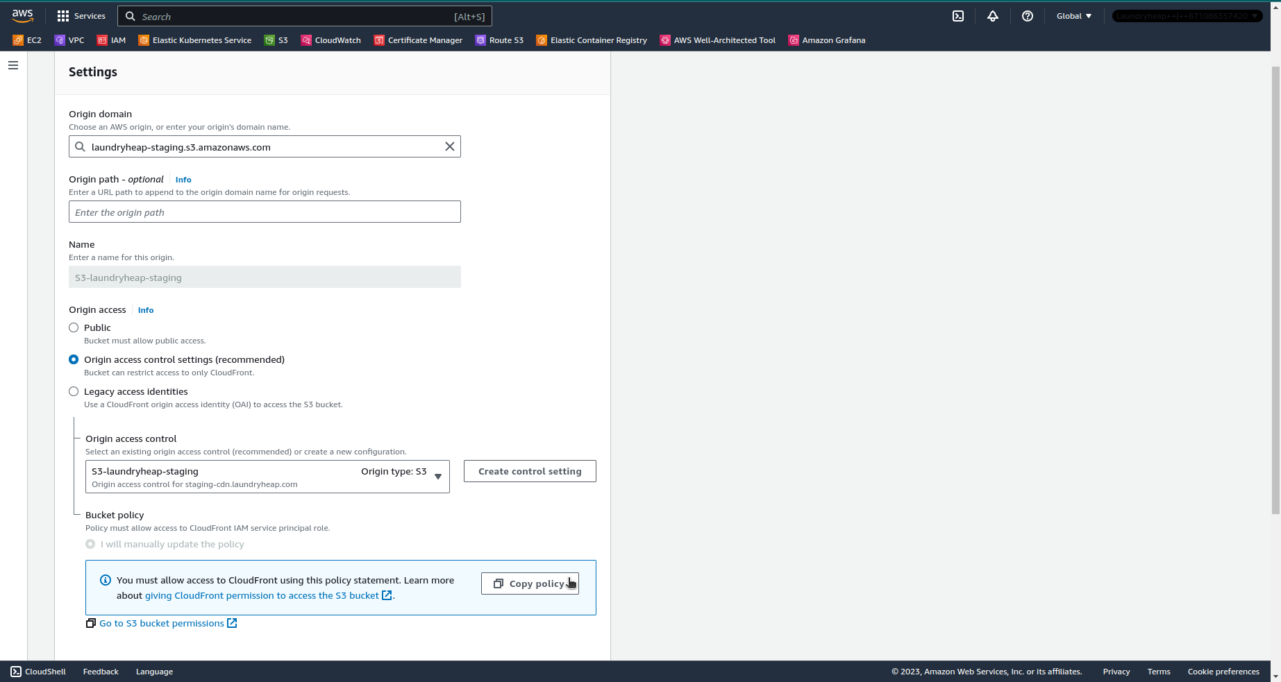

8. In the S3 bucket "Permissions" tab, in the "Block public access" section, click on "Edit", enable the "Block all public access" checkbox, and then click on "Save changes".

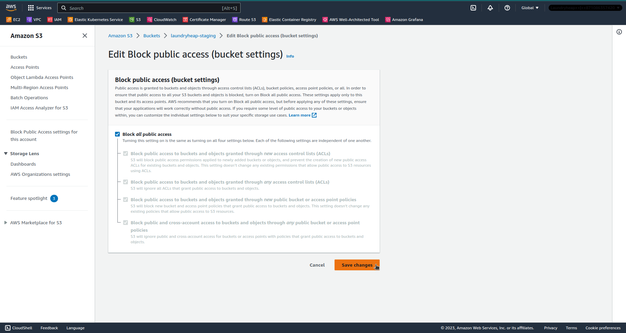

9. In the "Bucket policy" section, click on "Edit" and paste the policy copied from the CloudFront origin settings. Click on "Save changes".

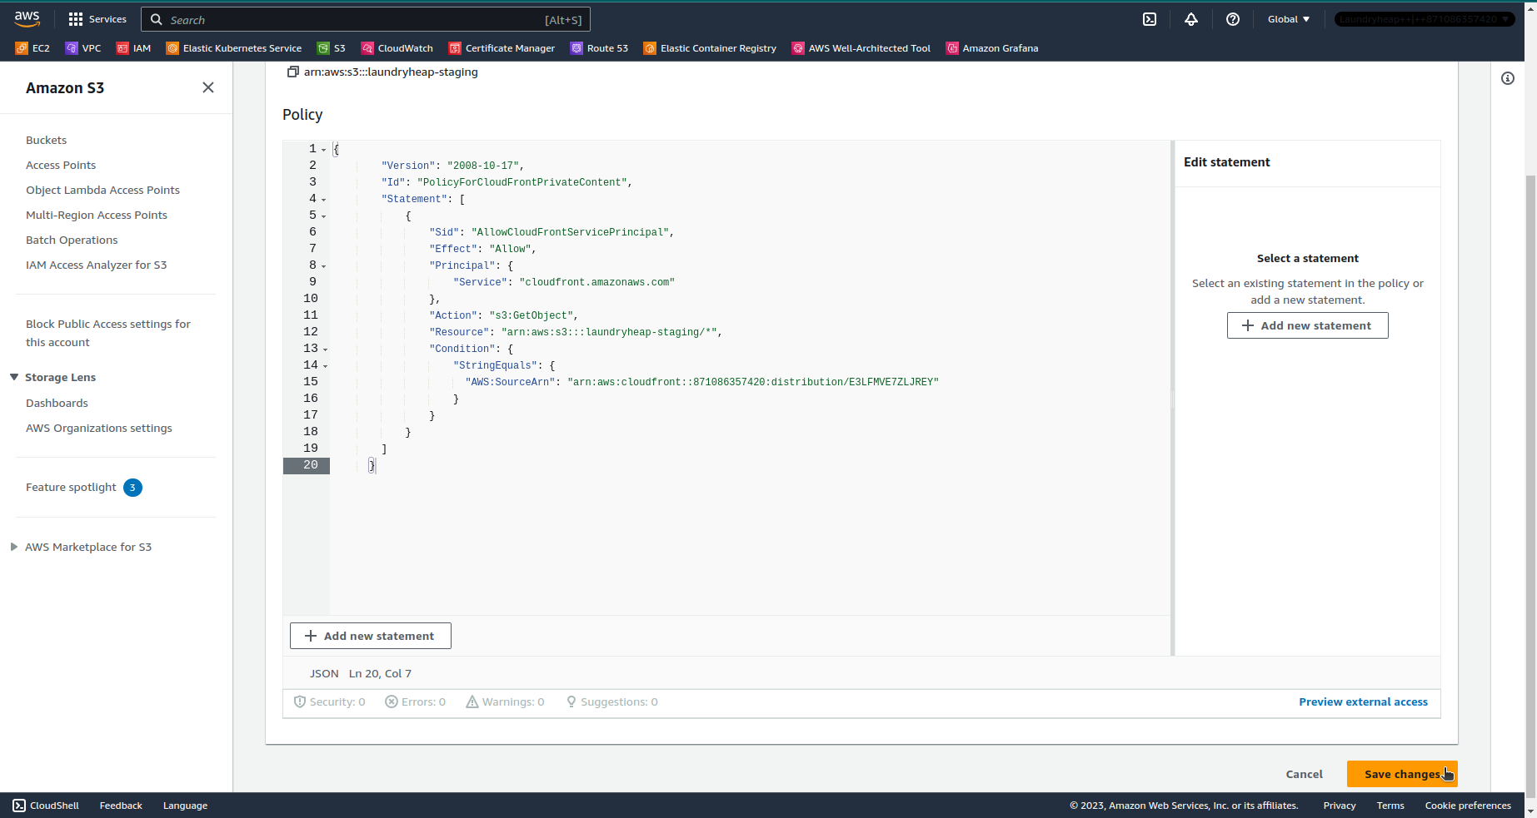

10. Back in the CloudFront origin settings, click on "Save changes".

