**How to add RSS feed to MS Teams and the list of recommended channels**

Here’s the list of the recommeded channels:

* **AWS Security RSS Feed** - <https://aws.amazon.com/blogs/security/feed/>
* **AWS Security Bulletin RSS Feed** - <https://aws.amazon.com/security/security-bulletins/rss/feed/>
* **Generic Security Related RSS Feed** - <https://www.f5.com/labs/rss-feeds/threats.xml>
* **List of other AWS feeds** - https://jiripik.com/2021/09/02/list-of-all-amazon-aws-rss-feeds/

1. Open MS Teams and click on “Apps” toward the bottom of the left-hand sidebar.

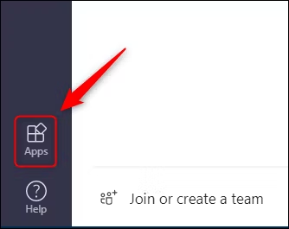

2. Type "RSS" in the search box, then click on the RSS connector that appears in the results.

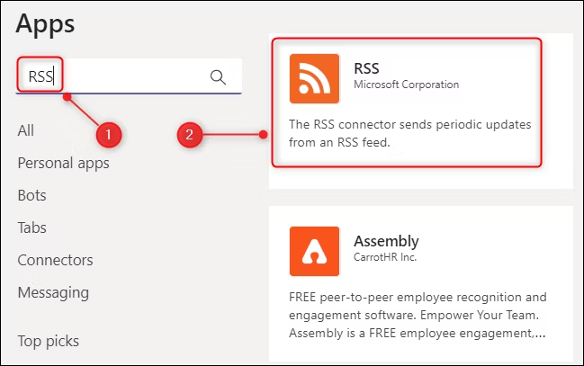

3. Select the "Add to a Team" button.

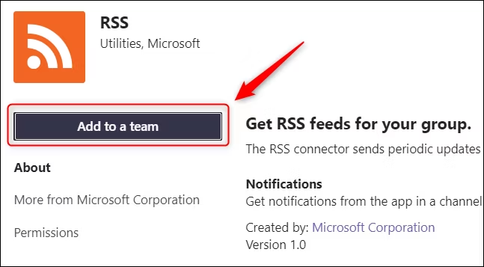

4. Type the name of the channel you want to add the RSS feed to and select it from the list of matching channels.

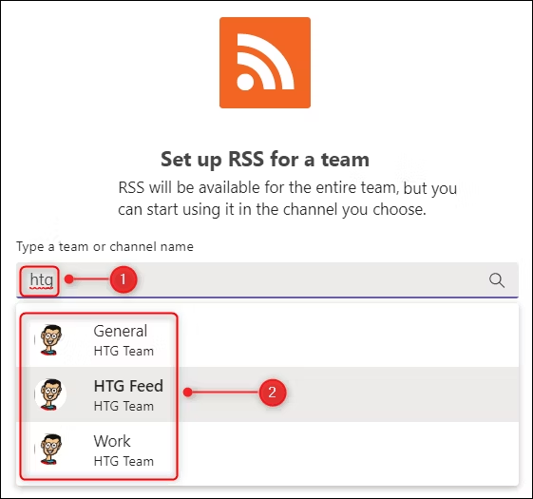.

If you were already in a channel when you clicked "Apps," that channel will be automatically filled in, but you can change to another Microsoft Teams channel if you want.

5. Now click "Set Up a Connector."

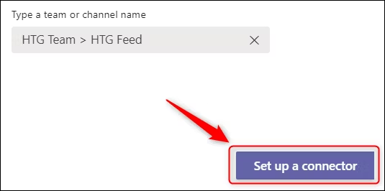

6. Enter a name for your feed, the RSS feed link, the frequency at which you'd like to check the feed, and, finally, select "Save."

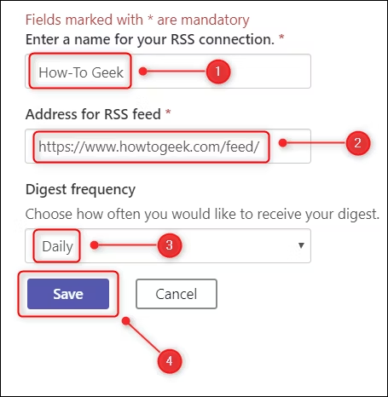

The feed will now be added to the channel.