**S3 Intelligent Tiering**

S3 Intelligent-Tiering is a storage class that is designed to optimize storage costs automatically based on your access patterns. Here are some best practices and recommendations:

1. **Understand Your Data Access Patterns:**

Before implementing S3 Intelligent-Tiering, it's crucial to have a clear understanding of your data access patterns. This includes knowing which objects are frequently accessed, which are rarely accessed, and which might not be accessed at all.

1. **Leverage S3 Lifecycle Policies:**

Use S3 Lifecycle policies in conjunction with Intelligent-Tiering to further optimize storage costs. For example, you can transition objects to other storage classes or delete them based on specific criteria.

1. **Use S3 Storage Class Analysis:**

Enable S3 Storage Class Analysis to monitor and analyze access patterns. This tool provides insights into which objects are being frequently accessed and which can be moved to lower-cost storage tiers. More info [here](https://docs.aws.amazon.com/AmazonS3/latest/userguide/configure-analytics-storage-class.html).

1. **Combine with S3 Object Tagging:**

Tag your objects to provide additional context about their usage. This can be useful for making more informed decisions about which objects should be moved to which storage class.

1. **Consider Long-term Object Storage:**

For objects that are infrequently accessed, consider using S3 Glacier or S3 Glacier Deep Archive. S3 Intelligent-Tiering is optimized for objects that are accessed at least once a month, so for very rarely accessed data, Glacier may be more cost-effective.

1. **Evaluate S3 Standard and S3 Intelligent-Tiering:**

For data with predictable access patterns, consider using S3 Standard for frequently accessed data and S3 Intelligent-Tiering for data with less predictable access patterns.

1. **Monitor and Adjust as Needed:**

Regularly monitor the access patterns and costs associated with your objects. Use the S3 Storage Class Analysis and S3 Inventory features to get insights into your storage usage.

1. **Consider Multi-Region Replication:**

If you have data that requires high availability and disaster recovery, consider using S3 Cross-Region Replication to replicate objects to a different AWS region.

1. **Testing and Validation:**

Consider conducting tests with sample data before implementing S3 Intelligent-Tiering in a production environment. This will help you understand how your specific data behaves in this storage class.

1. **Cost Monitoring and Budgeting:**

Set up AWS Cost Explorer and Budgets to monitor your storage costs. This will help you stay within budget and make adjustments if necessary.

1. **Review Your Configuration Periodically:**

Regularly review your storage configuration and adjust it based on changing access patterns and business requirements.

Remember that the effectiveness of S3 Intelligent-Tiering depends on your specific use case and data access patterns. Regular monitoring and adjustments are key to optimizing costs while maintaining performance and availability.

**Instructions**

1. Log in to the AWS Management Console and navigate to the ***S3 service***.
2. In the S3 dashboard, click on the name of the bucket You want to enable Intelligent-Tiering on.
3. Select ***Properties*** Tab.
4. Under the ***Intelligent-Tiering Archive*** configurations click on ***Create configuration***.

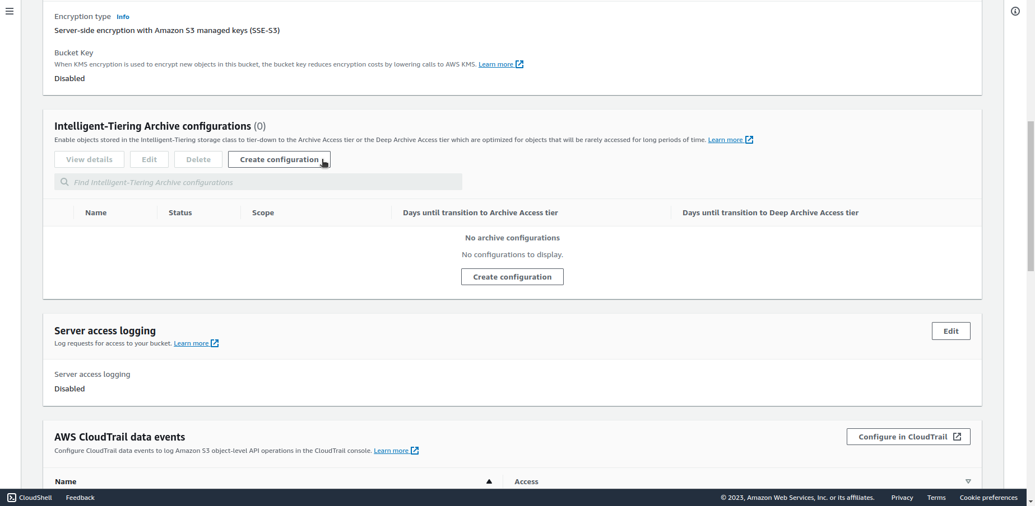

1. Enter a configuration name, ahoose a configuration scope, add prefix 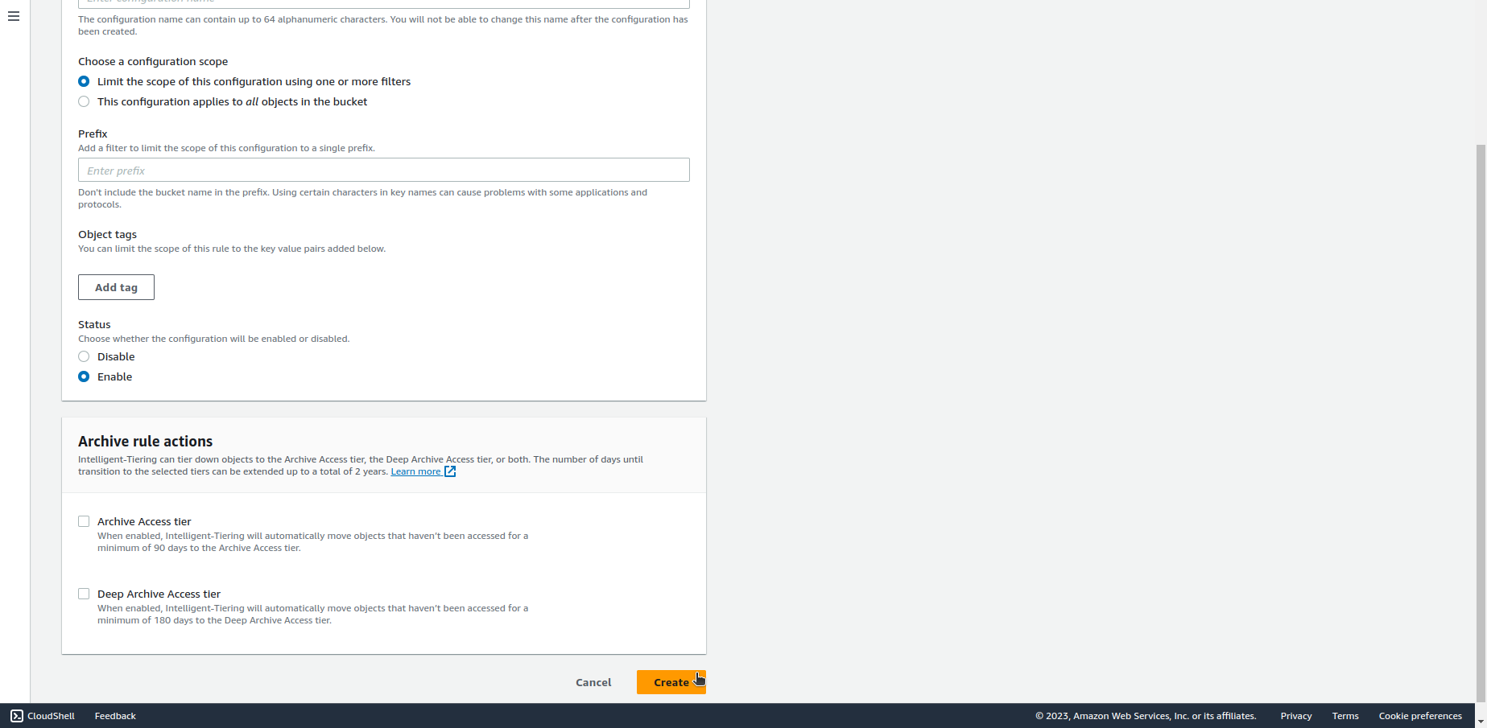(optional), adjust other setting as needed. Click on ***Create*** at the bottom.