**AWS S3 bucket replication**

1. Open the AWS Management Console and navigate to the S3 service.

2. Create a destination S3 bucket to replicate Your source bucket to. Enable bucket versioning and leave the rest of the settings default.

3. Click on the newly created destination bucket, go to the "Management" tab, click on "Actions," and select "Receive replicated objects".

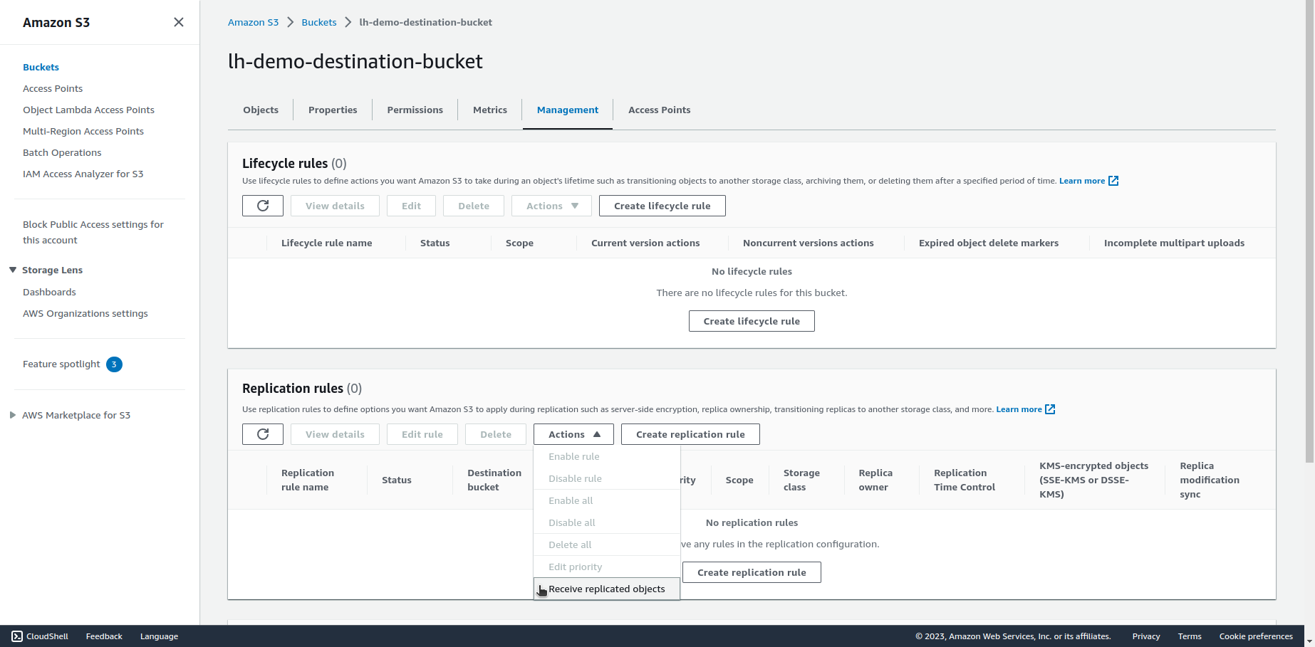

4. Enter your account ID and click on "Generate policies".

5. Next, click on "Apply settings".

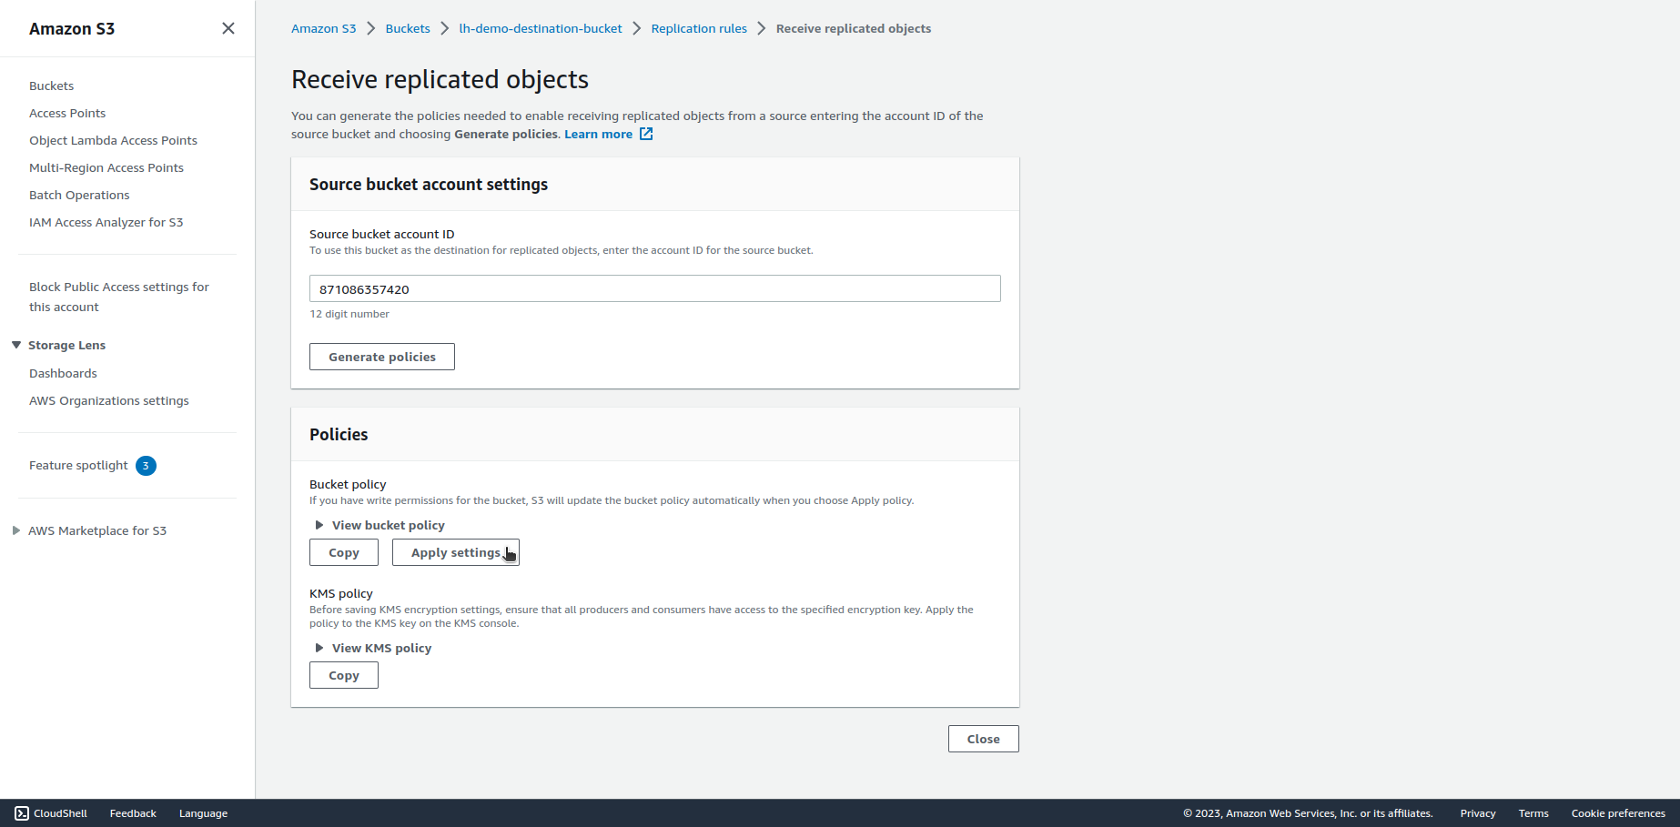

6. Go back to the destination bucket and check if the policy has been applied in the "Permissions" tab.

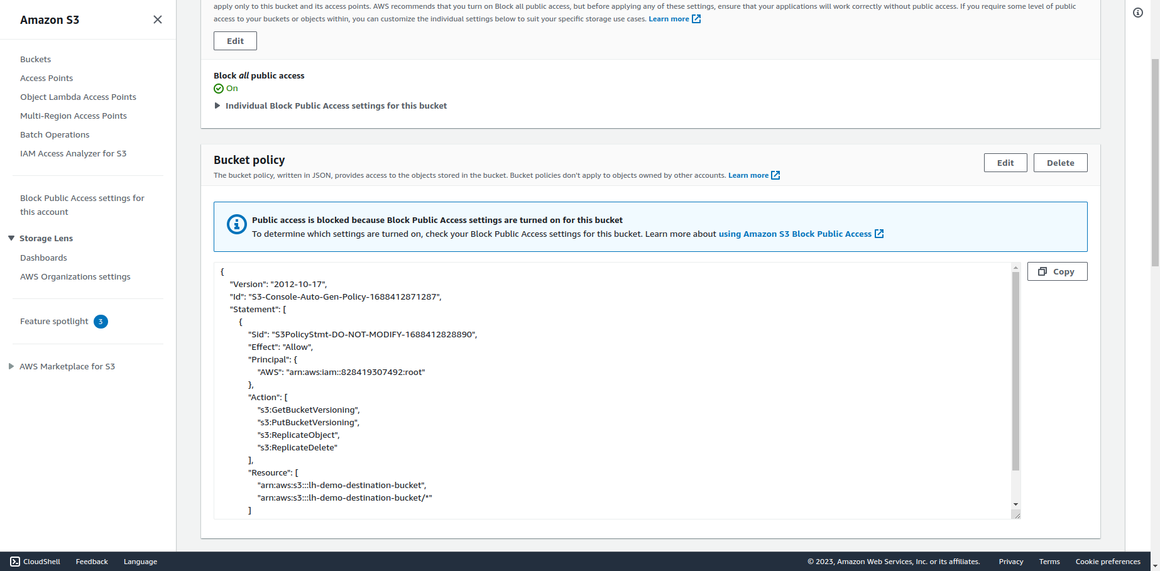

7. Next, navigate to the IAM service, and choose "Policies".

8. Click on "Create policy".

9. Choose JSON editor and copy the following policy:

{

"Version":"2012-10-17",

"Statement":[

{

"Effect":"Allow",

"Action":[

"s3:GetReplicationConfiguration",

"s3:ListBucket"

],

"Resource":[

"arn:aws:s3:::SOURCE-BUCKET"

]

},

{

"Effect":"Allow",

"Action":[

"s3:GetObjectVersionForReplication",

"s3:GetObjectVersionAcl",

"s3:GetObjectVersionTagging"

],

"Resource":[

"arn:aws:s3:::SOURCE-BUCKET/*"

]

},

{

"Effect":"Allow",

"Action":[

"s3:ReplicateObject",

"s3:ReplicateDelete",

"s3:ReplicateTags"

],

"Resource":"arn:aws:s3:::DESTINATION-BUCKET/*"

}

]

}

Replace "SOURCE-BUCKET" with your source bucket name and "DESTINATION-BUCKET" with your destination bucket name, and then click on "Next" in the bottom right corner.

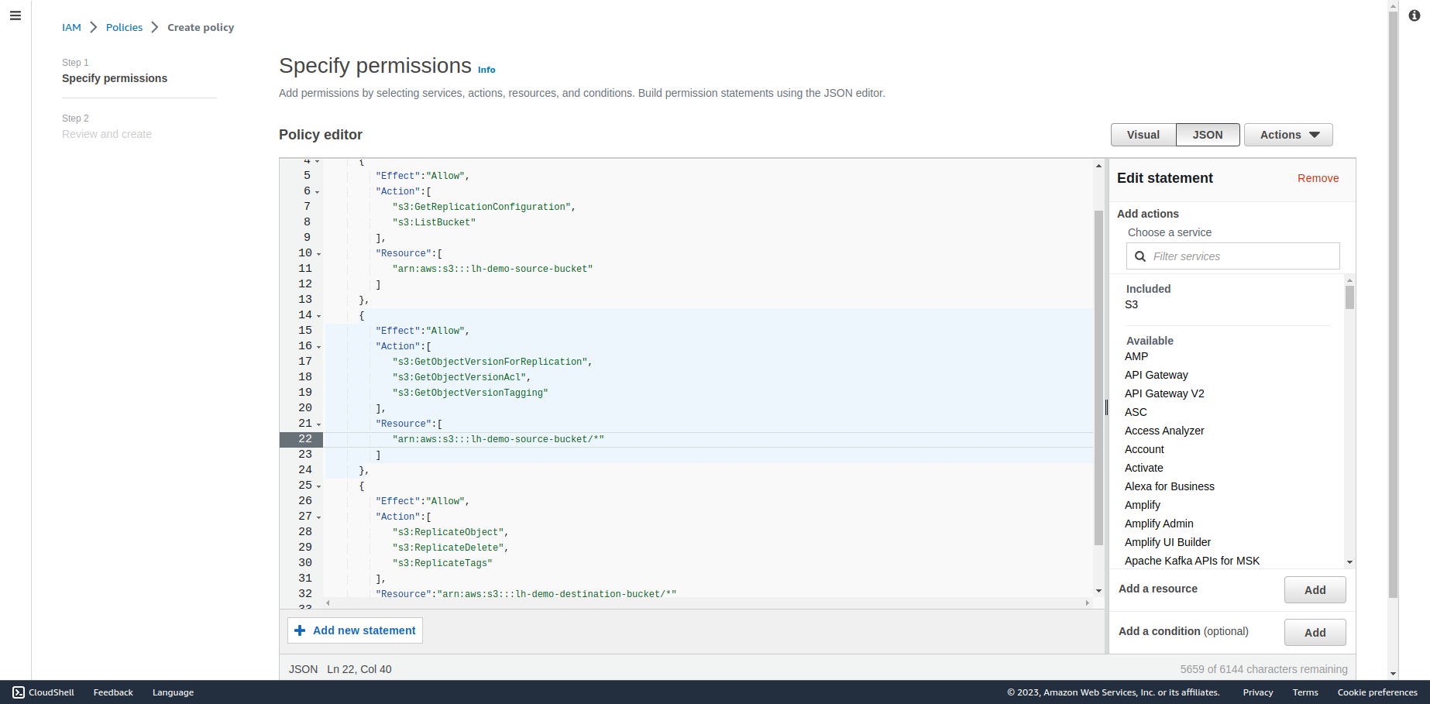

10. Give the IAM policy name and click on "Create policy" in the bottom right corner.

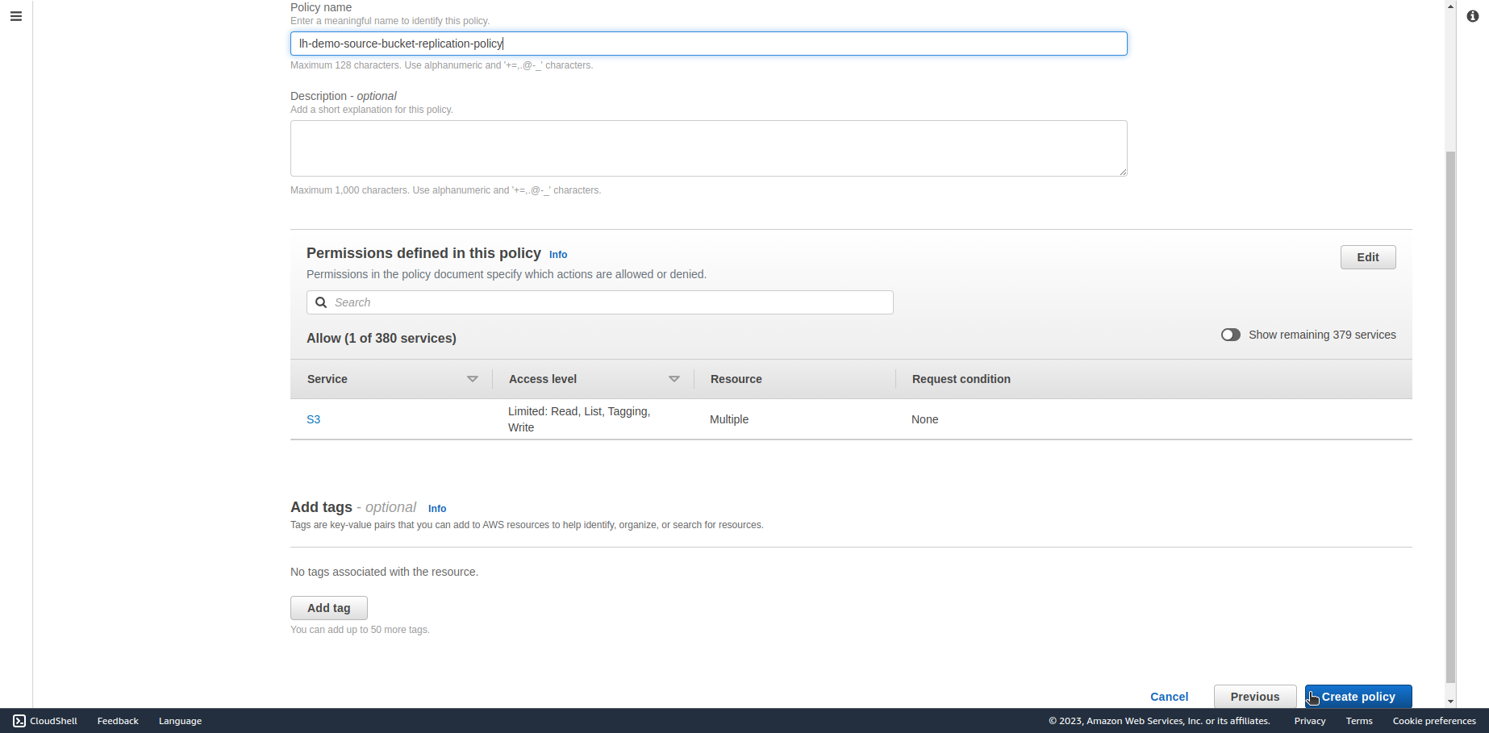

11. Next, go to IAM Roles and click on "Create role".

12. In the "Select trusted entity" section, choose "Custom trust policy" and copy the following policy:

{

"Version": "2012-10-17",

"Statement": [

{

"Effect": "Allow",

"Principal": {

"Service": [

"batchoperations.s3.amazonaws.com",

"s3.amazonaws.com"

]

},

"Action": "sts:AssumeRole"

}

]

}

Then click on "Next" in the bottom right corner.

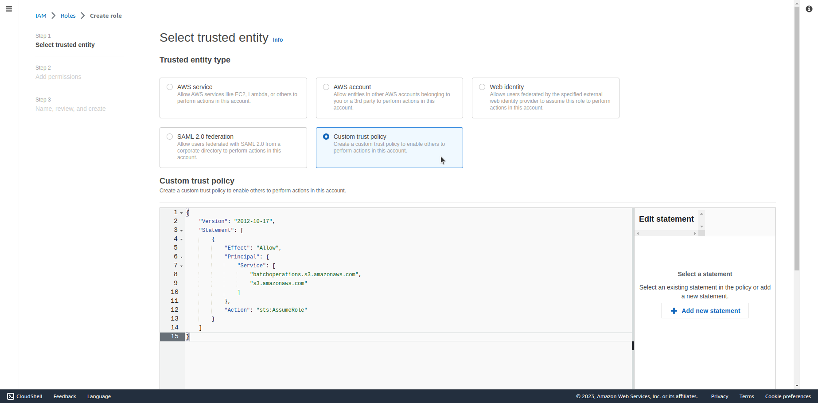

13. Select the newly created policy and click on "Next" in the bottom right corner.

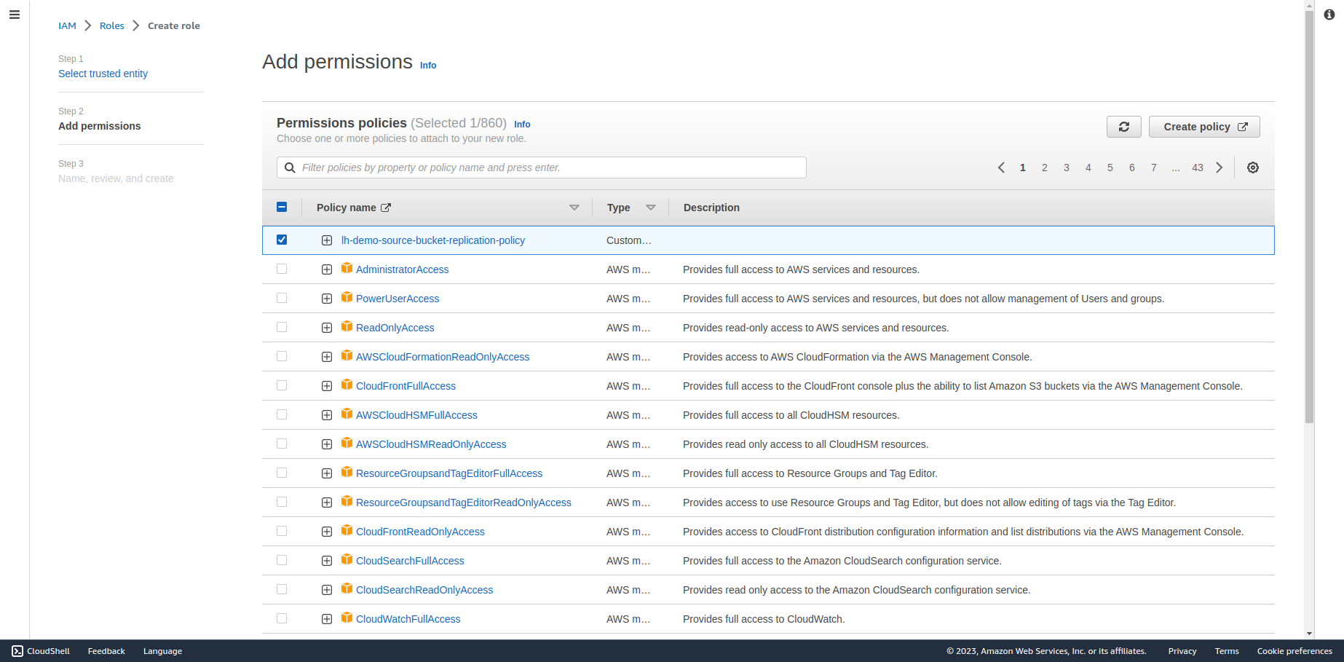

14. Give the IAM role name and click on "Create role" in the bottom right corner.

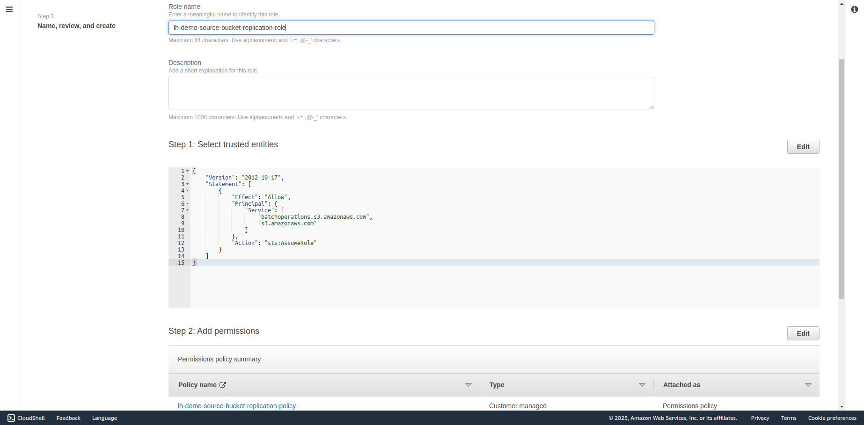

15. Next, go back to the S3 buckets list and click on your source bucket name.

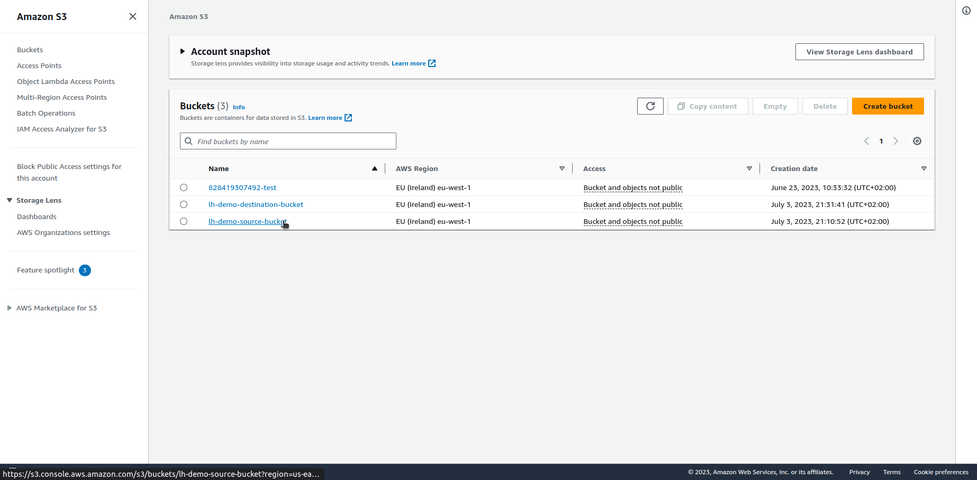

16. In the "Management" tab, in the "Replication rules" section, click on "Create replication rule".

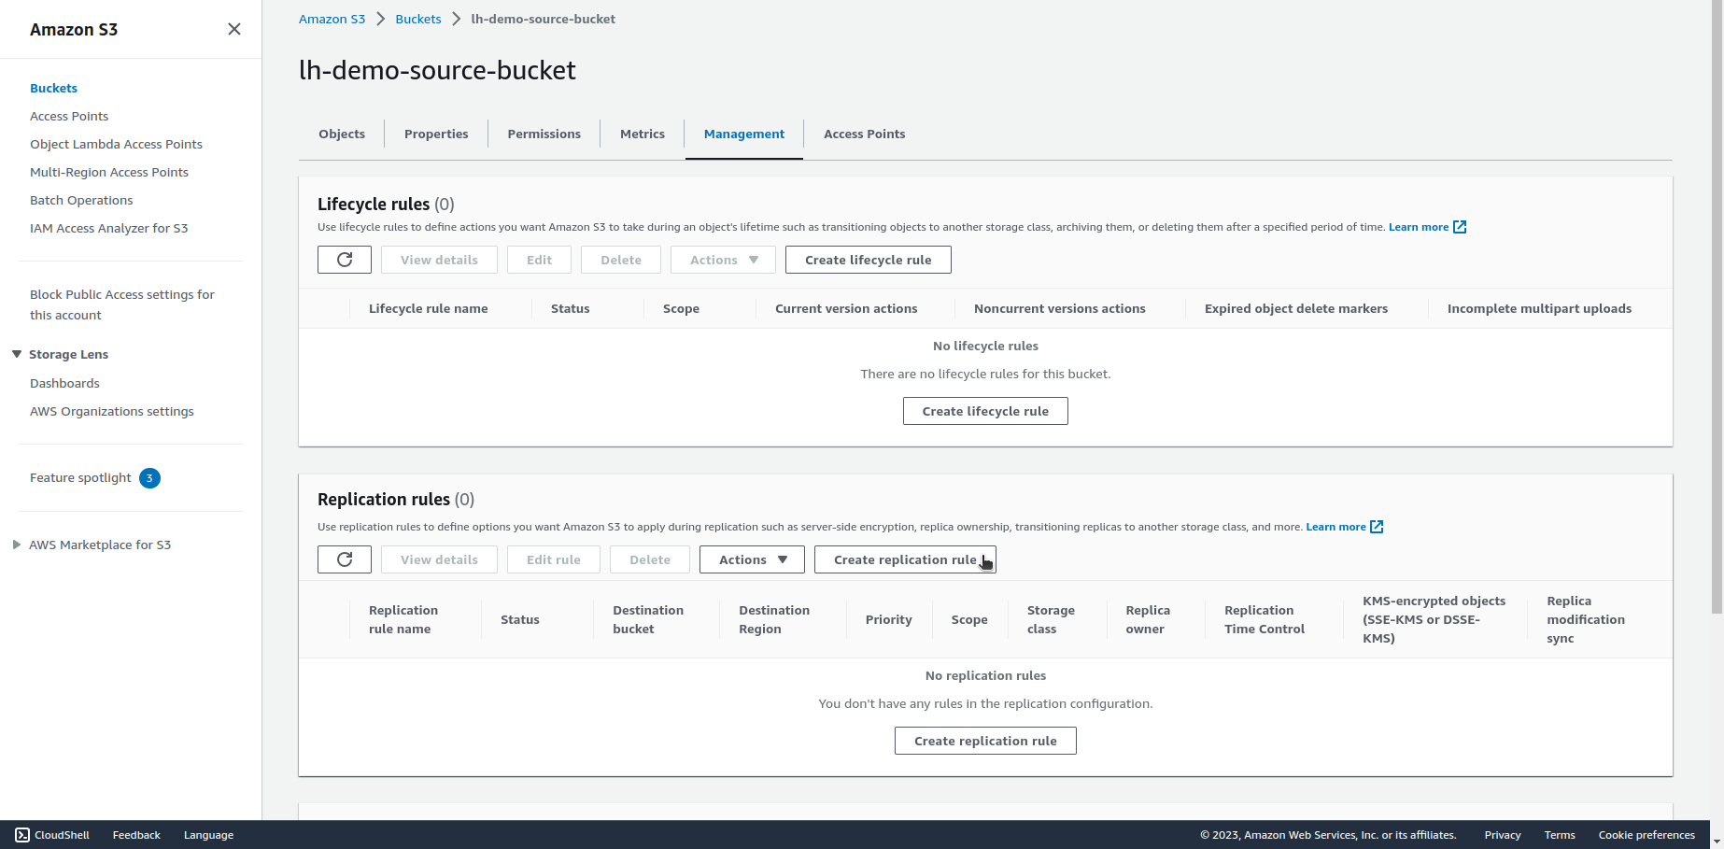

17. Enter the rule ID, enter the specific prefix that you want to replicate in the "Source bucket" section, then choose the destination bucket in the "Destination" section.

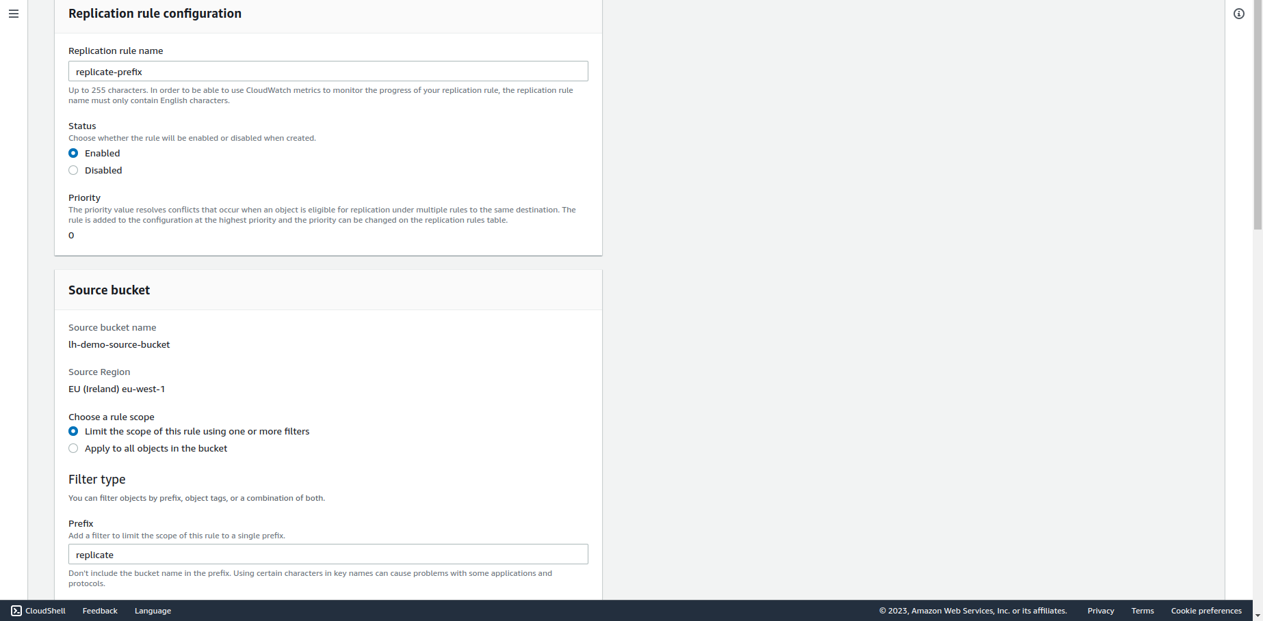

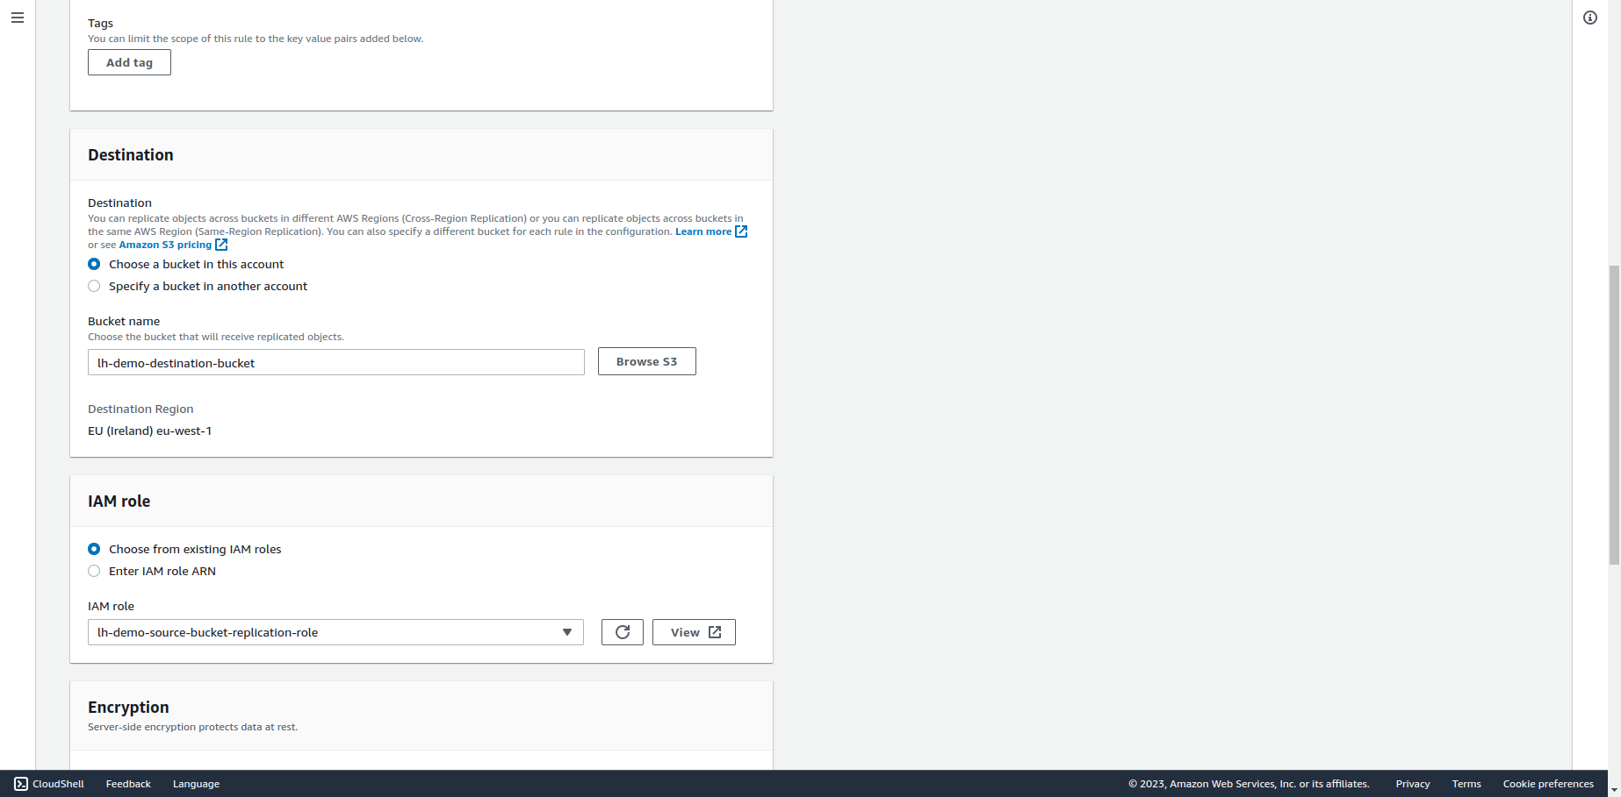

18. In the "IAM role" section, choose the previously created IAM role.

19. Choose additional replication options as per your needs and click on "Save".

20. If You want to replicate existing files select “Yes, replicate existing objects.” in the pop-up window and click on “Submit”.

21. Choose the path in S3 bucket for completion report or disable this option. Leave the rest of the settings default and click on “Save”.

22. Repeat steps 16-21 for every prefix that You want to replicate.