**AWS VPC flow logs**

**Benefits of Using VPC Flow Logs**

1. **Security and Compliance:** VPC flow logs provide detailed visibility into the network traffic within your Virtual Private Cloud (VPC). This enhanced visibility is crucial for security monitoring, compliance auditing, and troubleshooting.
2. **Network Troubleshooting:** Flow logs allow you to analyze and diagnose network connectivity issues. By examining the flow logs, you can identify the source and destination of traffic, as well as the accepted or rejected packets, aiding in the rapid resolution of network-related problems.
3. **Traffic Pattern Analysis:** VPC flow logs help in understanding the traffic patterns within your VPC. This information is valuable for capacity planning, optimizing resource placement, and identifying potential bottlenecks.
4. **Forensic Analysis:** In the event of a security incident, flow logs provide a forensic trail of network activity, enabling security teams to investigate and respond to incidents effectively.
5. **Integration with Security Information and Event Management (SIEM) Systems:** VPC flow logs can be easily integrated with SIEM systems, allowing for centralized log analysis and correlation with other security events across your infrastructure.
6. **Customizable Logging:** You can choose which fields to include in your flow logs, tailoring the level of detail to your specific requirements. This flexibility ensures that you capture the necessary information without overwhelming your logging system.

**Cost Considerations**

While VPC flow logs offer valuable insights, it's important to consider the associated costs. Flow logs incur charges based on the volume of log data generated and stored. The costs depend on factors such as the number of VPCs, subnets, and the volume of traffic. It is recommended to monitor and manage log retention periods to control storage costs effectively.

**How to enable VPC flow logs**

1. Open the [Amazon S3 console](https://console.aws.amazon.com/s3/) and create a new bucket with the default settings.
2. Open the [Amazon VPC console](https://console.aws.amazon.com/vpc/). In the navigation pane, choose **Your VPCs**. Select the checkbox for the VPC.
3. Choose **Actions**, **Create flow log**.

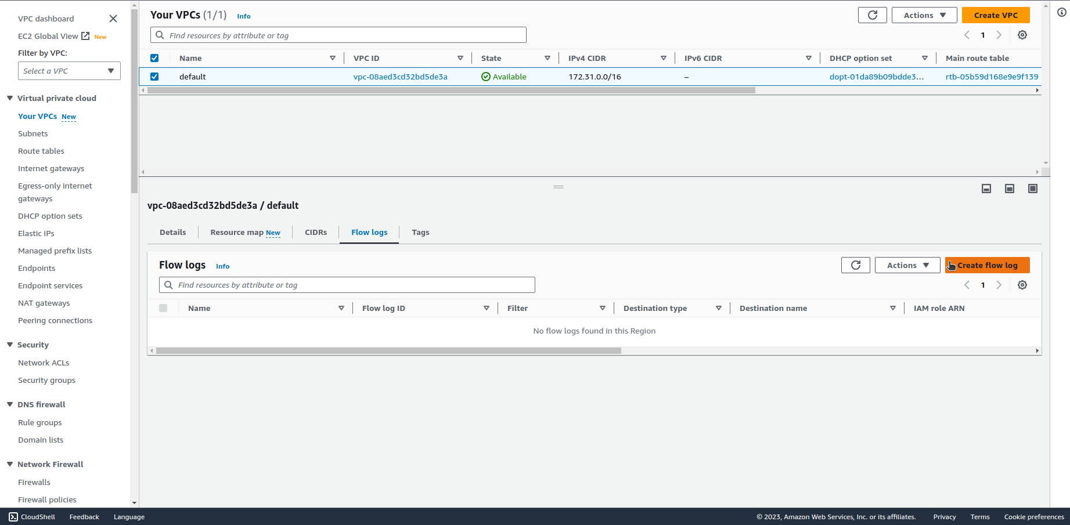

1. For **Filter**, specify the type of IP traffic data to log.

**Accepted** – Log only accepted traffic.

**Rejected** – Log only rejected traffic.

**All** – Log accepted and rejected traffic.

1. For **Maximum aggregation interval**, choose the maximum period of time during which a flow is captured and aggregated into one flow log record.
2. For **Destination**, choose **Send to an S3 bucket**.
3. For **S3 bucket ARN**, specify the Amazon Resource Name (ARN) of the previously created Amazon S3 bucket. You can optionally include a subfolder. For example, to specify a subfolder named my-logs in a bucket named my-bucket, use the following ARN:

*arn:aws:s3:::my-bucket/my-logs/*

The bucket cannot use *AWSLogs* as a subfolder name, as this is a reserved term.

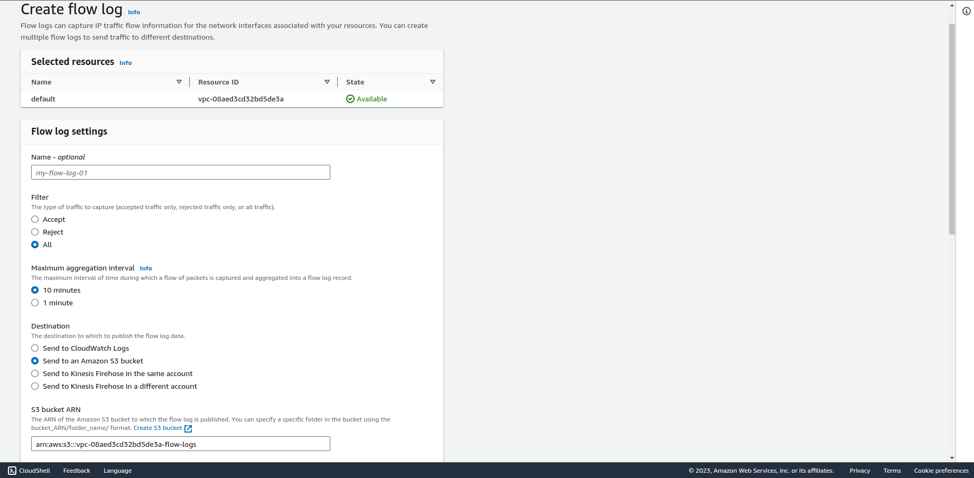

1. If you own the bucket, a resource policy will be automatically created and attached to the bucket.
2. For **Log record format**, specify the format for the flow log record.
3. For **Log file format**, specify the format for the log file.
4. Choose **Create flow log.**

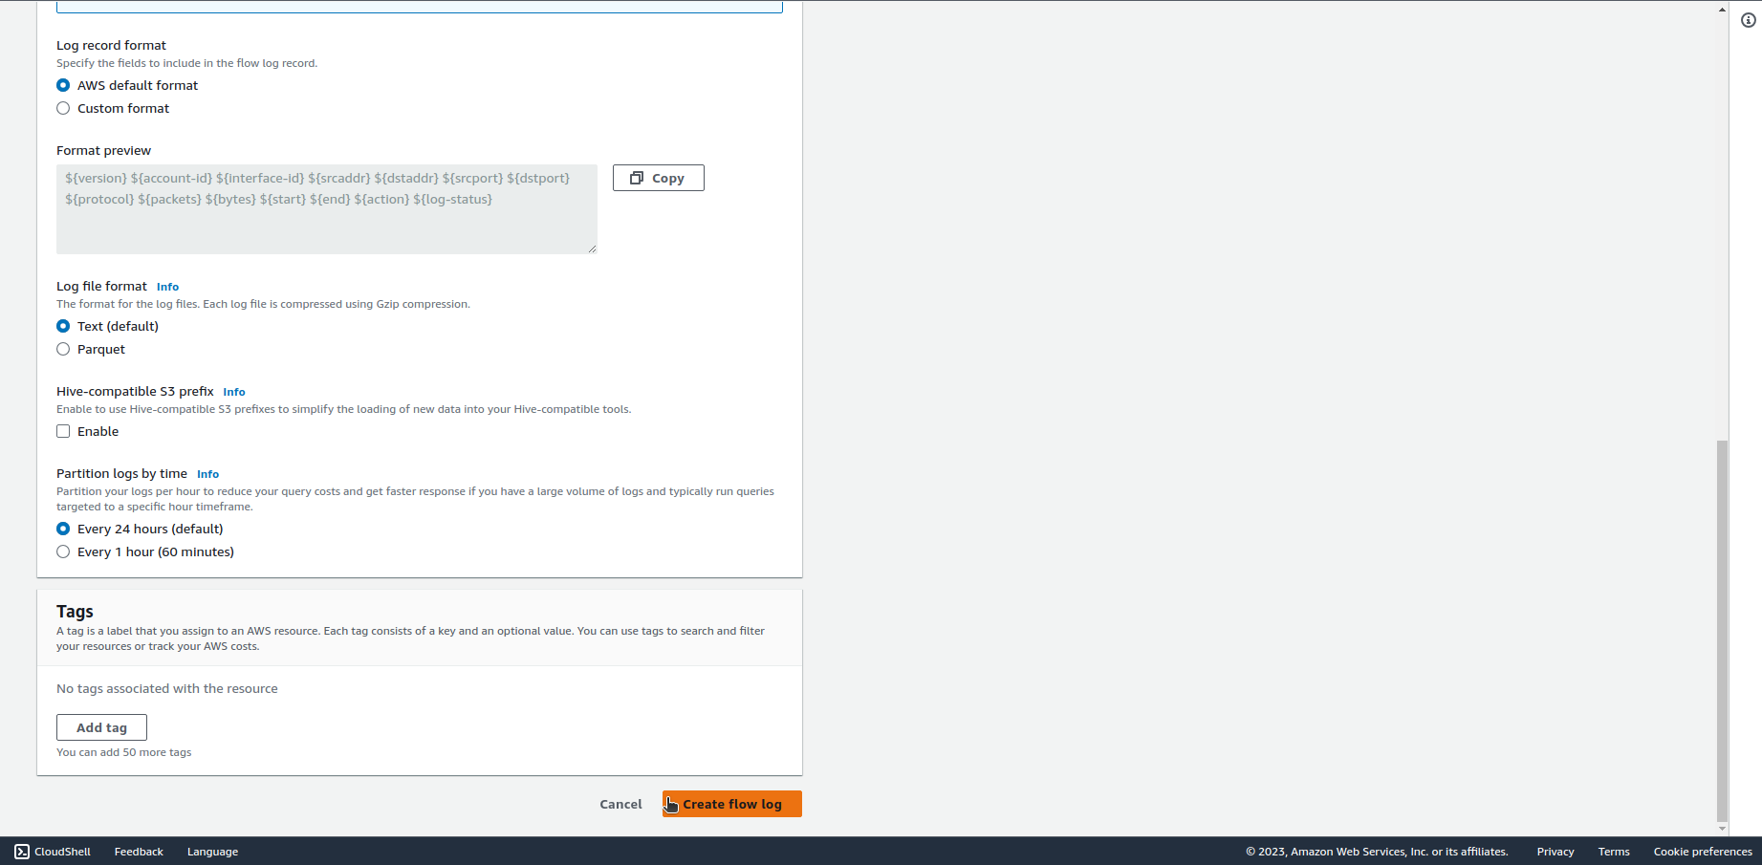

1. You can now check the VPC flow logs in the S3 bucket.

Once enabled, VPC flow logs will start capturing network traffic data and storing it in the specified S3 bucket. You can then analyze and monitor the logs using tools such as Amazon Athena, Amazon QuickSight, or other third-party log analysis solutions. Keep in mind the considerations for log storage costs and adjust the retention period based on your requirements. Regularly review and analyze flow logs to enhance your network security and performance.