Zaap
EC2 Cost analysis

Findings
The analysis is created by the help of AWS Compute Optimizer. Compute Optimizer uses AI and basically analyses AWS CloudWatch metrics available for the last 2 weeks to the instances.
Result that your production instance is optimized, your development instance is under-provisioned.
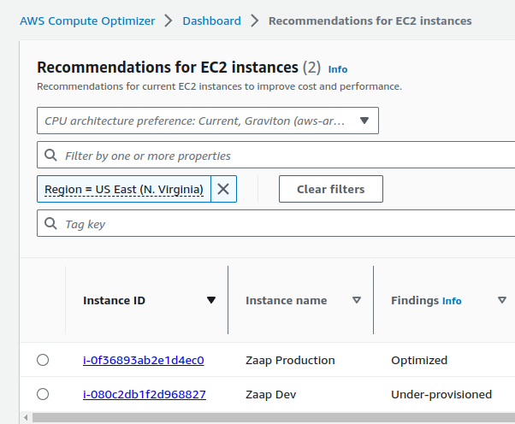
The reason is why your development instance is under-provisioned is related to the EBS volume IOPS and throughput capacity.

Possible optimizations

Production instance:

1. EC2 - Switching to t4g.large from t2.large instance type

- Amazon EC2 T4g instances are powered by Arm-based custom built Amazon Graviton2 processors and deliver up to 40% better price performance over T3 instances for a broad set of burstable general purpose workloads.
- Network bandwidth is up to 5Gbps vs ‘Low to Moderate’ network performance - comparing to the current t2.large solution
- Storage interface is EBS optimized by default
- Saving: $0.0256 per hour /~$18 per month/

2. EC2 - Switching to t3.large from t2.large instance type

- Next generation burstable general-purpose instance type, up to a 30% price performance improvement over T2 instances.
- Network bandwidth is up to 5Gbps vs ‘Low to Moderate’ network performance - comparing to the current t2.large solution
- Powered by the Nitro System, a combination of dedicated hardware and lightweight hypervisor
- Saving: $0.0096 per hour /~$7 per month/

3. EBS - Switching to gp3 storage class from gp2
- Baseline IOPS 3000 vs 300
- IOPS Burst duration: 3000 is always available (gp3) vs 3000 IOPS for 2000 secs (gp2) then go down to baseline and needs 18000 secs to refill balance
- Throughput: 125 Mib/s vs 128 Mib/s
- Saving: $0.02 per Gib (20%) /~$2 per month/

4. Migration considerations:
- EC2:
  - Option 1: a new instance needed and migration of the app, downtime needs to be planned
  - Option 2: It is enough to stop the instance, upscale and start again – quite hassle free
- EBS: Needs to stop and start the application, but if data loss is not acceptable – downtime during snapshot and new volume creation as well

Development instance:

1. EC2 - Switching to t4g.micro from t2.micro instance type

- Amazon EC2 T4g instances are powered by Arm-based custom built Amazon Graviton2 processors and deliver up to 40% better price performance over T3 instances for a broad set of burstable general purpose workloads.
- Network bandwidth is up to 5Gbps vs ‘Low to Moderate’ network performance - comparing to the current t2.micro solution
- Storage interface is EBS optimized by default
- Saving: $0.0032 per hour /~$2 per month/

2. EBS - Switching to gp3 storage class from gp2
- Baseline IOPS 3000 vs 300
- IOPS Burst duration: 3000 is always available (gp3) vs 3000 IOPS for 2000 secs (gp2) then go down to baseline and needs 18000 secs to refill balance
- Throughput: 125 Mib/s vs 128 Mib/s
- Saving: $0.02 per Gib (20%) /less than $1 per month/

3. Migration considerations:
- EC2: a new instance needed and migration of the app, downtime needs to be planned
- EBS: Needs to stop and start the application, but if data loss is not acceptable – downtime during snapshot and new volume creation as well

Amazon Elastic Compute Cloud (EC2) provides several pricing models to choose from, depending on your workload requirements, budget, and use case. Here are the different EC2 pricing models and their estimated cost savings for the customer's instance types:
- Reserved Instances: With Reserved Instances, you make a one-time upfront payment to reserve capacity for a specified term of 1-3 years, and in return, you receive a significant discount on the hourly rate. This pricing model is suitable for workloads that have predictable usage patterns and can commit to a specific capacity for an extended period. Reserved Instances enables you to modify Availability Zone, scope, networking type, and instance size (within the same instance type) of your Reserved Instance
- For the Zaap instance types, the estimated cost per hour is as follows:
t2.large - $ 0.058 (1-year reserved) vs $ 0.0928 (on demand instance price)
t2.large - $ 0.040 (3-year reserved) vs $ 0.0928 (on demand instance price)
t3.large - $ 0.052 (1-year reserved) vs $ 0.0832 (on demand instance price)
t3.large - $ 0.036 (3-year reserved) vs $ 0.0832 (on demand instance price)
t4g.large - $ 0.042 (1-year reserved) vs $ 0.0672 (on demand instance price)
t4g.large - $ 0.029 (3-year reserved) vs $ 0.0672 (on demand instance price)
t2.micro - $ 0.007 (1-year reserved) vs $ 0.0116 (on demand instance price)
t2. micro - $ 0.005 (3-year reserved) vs $ 0.0116 (on demand instance price)
t4g. micro - $ 0.005 (1-year reserved) vs $ 0.0084 (on demand instance price)
t4g. micro - $ 0.004 (3-year reserved) vs $ 0.0084 (on demand instance price)

- Reserved Instances can provide cost savings of up to 72% compared to On-Demand Instances.

Savings Plans: Savings Plans provide a flexible pricing model that offers savings of up to 72% on compute usage in exchange for committing to a specific dollar amount per hour or per month for a 1- or 3-year term. Savings Plans are suitable for workloads that have consistent usage patterns but may have varying compute requirements. EC2 Instance Savings Plans give you the flexibility to change your usage between instances within a family in that Region. For example, you can move from c5.xlarge running Windows to c5.2xlarge running Linux and automatically benefit from the Savings Plans prices.
- For the Zaap instance types, the estimated cost per hour is as follows:
t2.large - $ 0.0575 (1-year reserved) vs $ 0.0928 (on demand instance price)
t2.large - $ 0.0401 (3-year reserved) vs $ 0.0928 (on demand instance price)
t3.large - $ 0.0522 (1-year reserved) vs $ 0.0832 (on demand instance price)
t3.large - $ 0.0359 (3-year reserved) vs $ 0.0832 (on demand instance price)
t4g.large - $ 0.0421 (1-year reserved) vs $ 0.0672 (on demand instance price)
t4g.large - $ 0.029 (3-year reserved) vs $ 0.0672 (on demand instance price)
t2.micro - $ 0.0072 (1-year reserved) vs $ 0.0116 (on demand instance price)
t2. micro - $ 0.005 (3-year reserved) vs $ 0.0116 (on demand instance price)
t4g. micro - $ 0.0053 (1-year reserved) vs $ 0.0084 (on demand instance price)
t4g. micro - $ 0.0036 (3-year reserved) vs $ 0.0084 (on demand instance price)

- Note that Savings Plans do not provide a capacity reservation. You can however reserve capacity with On Demand Capacity Reservations and pay lower prices on them with Savings Plans.
We encourage you to prefer Savings Plans over Reserved Instances as they offer the same savings as RIs, but with additional flexibility.

Conclusion:

Your average monthly cost is around $1,440. You spend about $180 on ec2 service. With a rough estimate let’s say you save 40% of your ec2 price. So you can save around 5% of your overall costs with ec2 optimization.

Cloudvisor cost optimization recommendation

Production instance:
- Optionally switch to t3.large instance
- Optionally switch to gp3 ebs volume
- Customer creates Savings Plans for Ec2 (1 year) – this is the most important step that can save the most cost

Development instance:
- Switch to gp3 volume because it is under-provisioned

