Create Slack App Channel
First, you want to predetermine which Slack app channel to use to receive incoming messages. For example, you can use an existing channel like #random or create a new channel. For this example, I will be using the #my-test-app naming convention. See the image below for reference.
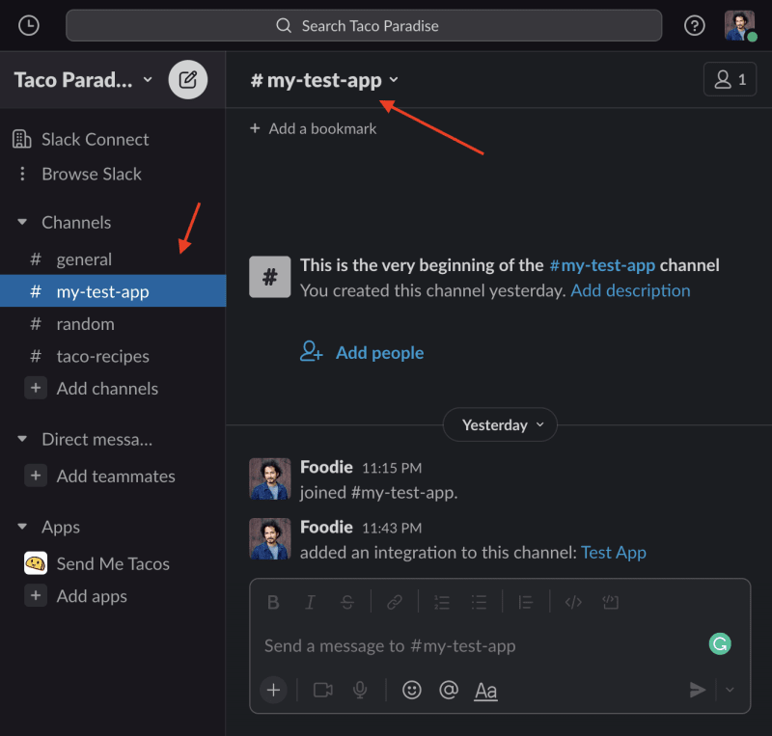

Create a Slack App
To receive messages from external applications, say from your website or a mobile application, you must configure your Slack "API app" settings.
Sign in to your Slack account and navigate the Slack API portal "Your Apps" page. Copy-paste this link to jump there now: https://api.slack.com/apps.
If this is your first time creating a Slack account Your Apps list will be empty. Otherwise, you will see a list of your API apps.
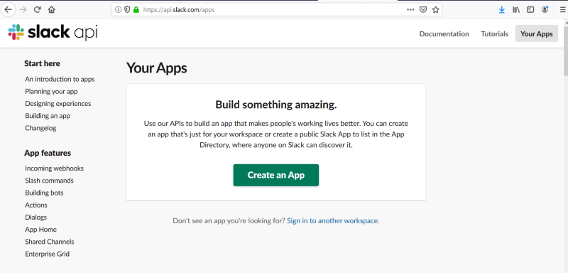
Next, click on the Create New App or Create an App green button to open the "Create an app" modal window.
Select the From scratch option.
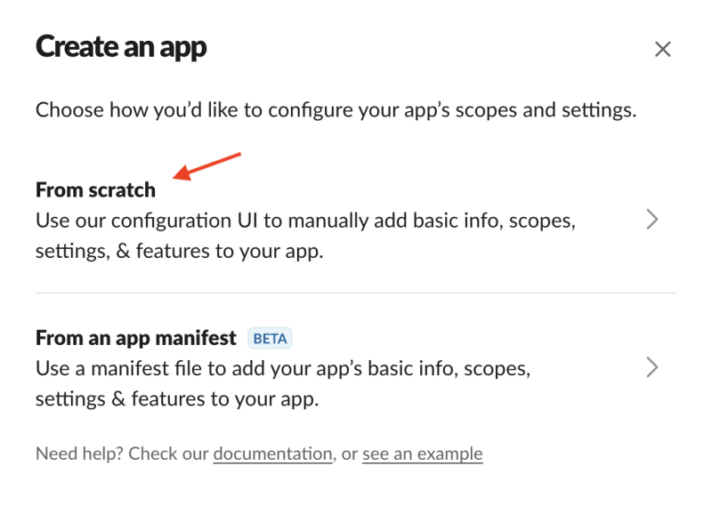
In the App Name, type your app name. I use "Send Me Tacos" for this example, but you can choose anything you like. :)
Next, use the dropdown menu to locate the workspace where you want to send messages. The workspace is the name of the account you created. In this example, I named it "Taco Paradise".
Can you tell I'm thinking about yummy food?
When done, click on Create App. This last step will take you to a new page. See the image for reference.
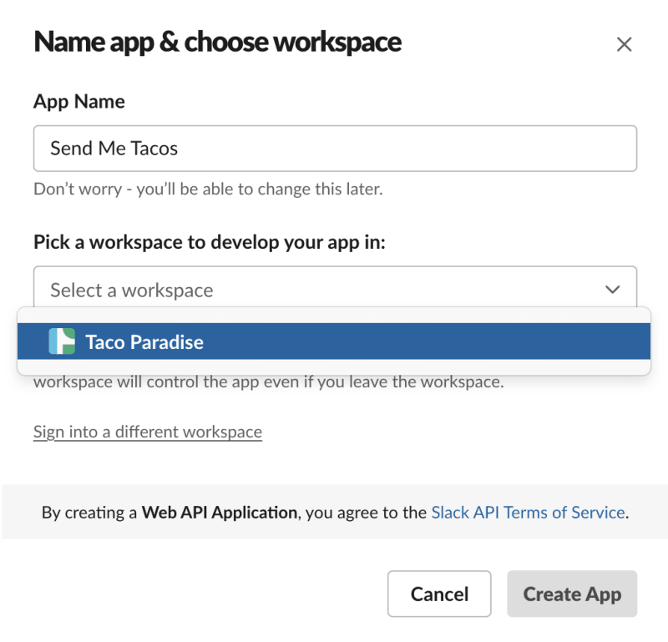
After creating your new app, stay on the same page and scroll down to locate the Incoming Webhooks link on the left menu list. Click on the link to display the webhook configuration page. Notice how next to the words "Activate Incoming Webhooks" is set to off.
Click on that switch to enable it. It should turn green and display the text "On."
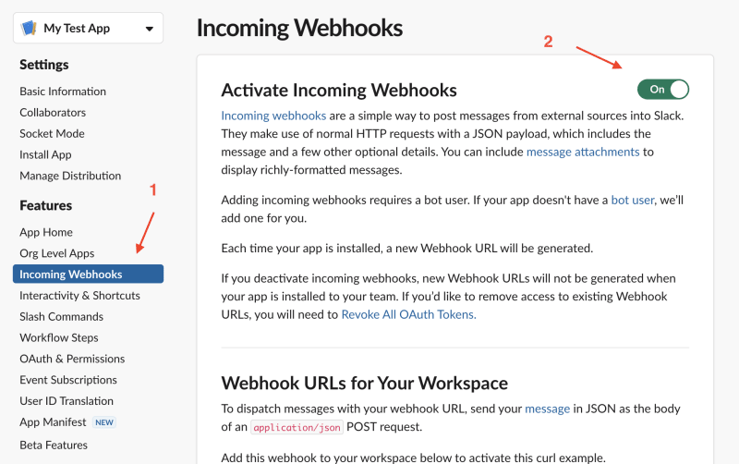
Well done!

Create a Webhook
Finally, click on the Add New Webhook to Workspace button to create a webhook URL. This step opens a new window.
In the new window, notice where it says, "Test App requires a channel to post to as an app" click on the dropdown menu and select the channel you want to send your messages.
Note: We referenced this step at the beginning of the tutorial. In this example, I chose #my-test-app.
You can now take your new webhook URL for a spin. Using your preferred terminal application or API client, Copy-paste YOUR sample curl request into the API client or terminal and execute the command/s.
Note: Replace the webhook URL with yours.
curl -X POST -H 'Content-type: application/json' --data '{"text":"Hello, World!"}' https://hooks.slack.com/services/5CKKM62NX5J/8G8XMGQ3RXM/aadCZ8act32sLJ7dgaC8HLrx
After executing the command, navigate back to the Slack app, web, or mobile and notice the new message; "Hello, World!".
Tada!
SO COOL!!!

