Q-SERIES PORTABLE EV/PHEV CHARGER
Ampere Point Q37 / Q74 / Q11 / Q22 / Q96
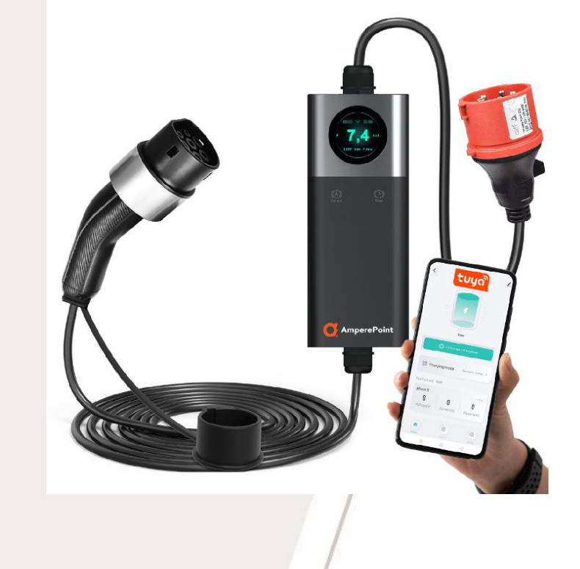
ENGLISH VERSION
User Manual
Read Before Use
- Portable charger for electric and plug-in hybrid vehicles with Type 2 vehicle connector.
- Power, maximum current, cable length, plug or adapter type and accessories depend on the Q-Series version and delivered kit.
- Use only Ampere Point-compatible accessories supplied with, or approved for, the charger.
- Mobile control via Tuya Smart / Smart Life on a 2.4 GHz WiFi network is available only for models equipped with this function.
- Check the vehicle's maximum AC charging power and the electrical installation before selecting the charging current.

Safety Rules
- Do not use extension cords, including electrical extension cords or Type 2 charging cable extensions.
- Do not immerse the charger in water.
- Do not step on, pull, crush or sharply bend the cable.
- Do not drop the charger or place heavy objects on it.
- Do not place the charger near heat sources, inside a closed vehicle, or in sealed spaces while charging.
- Do not use the charger outside its operating temperature range. Follow the rating label and technical specification for the exact model.
- Supply the charger only from a socket suitable for the selected continuous charging current. The socket must be properly grounded.
- The electrical circuit must be protected by a residual current device (RCD type A) and overcurrent protection selected by a qualified electrician.
- Do not repair, modify, disassemble or service the charger yourself. Do not use the charger if it is damaged.
- Do not touch the pins of the charging connector. Contact the distributor if any operating problem occurs.
Q-Series Functions
- Charging-current adjustment and charging scheduling, depending on version.
- WiFi and app control for compatible models: adjust power, schedule charging and check charger status from the mobile app.
- Built-in protection functions: overvoltage, undervoltage, overload, short-circuit, leakage-current, overtemperature, surge and grounding protection.
- IP66 portable design for indoor and outdoor use.Protect the charger from direct rain and standing water.
- Temperature monitoring and automatic retry for temporary charging-process errors, such as communication with the vehicle.
- Some Q PRO kits use interchangeable adapters with temperature monitoring in the plug.
- Advanced functions such as OTA updates, menu languages and smart-home integration depend on charger version and app support.
Kit Contents
- AC EV charger with integrated Type 2 cable.
- User manual.
- Wall holder for the charger.
- Plug/cable holder.
- Adapters, carry bag and other accessories according to version and kit.

EV Charger Components
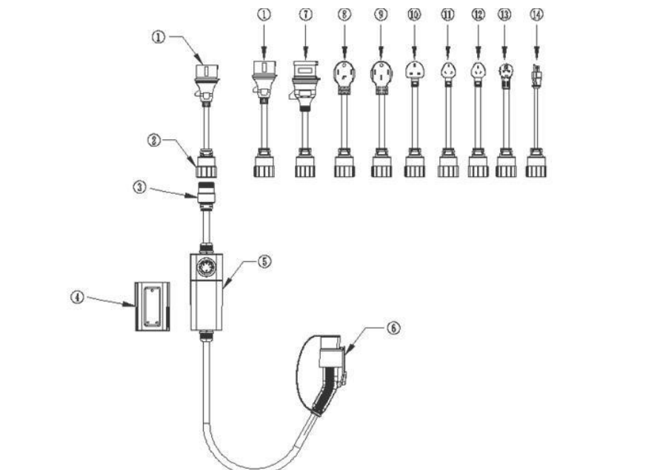
No | Part
1 | AC plug/adapter according to version
2 | Male aviation connector - only for models with interchangeable connectors
3 | Female aviation connector - only for models with interchangeable connectors
4 | Wall holder
5 | EV charger body
6 | Type 2 vehicle connector
7-14 | Additional AC plugs/adapters depending on the kit

Technical Details - Q-Series Family
Parameter | Q37 | Q74 | Q11 | Q22
Phase | 1 phase | 1 phase | 3 phase | 3 phase
Power | 3.7 kW | 7.4 kW | 11 kW | 22 kW
Input voltage | AC 230 V | AC 230 V | AC 400 V | AC 400 V
Output voltage | AC 230 V | AC 230 V | AC 400 V | AC 400 V
Max. current | 16 A | 32 A | 16 A | 32 A
Frequency | 50/60 Hz | 50/60 Hz | 50/60 Hz | 50/60 Hz

Parameter | Value
Power setup | The plug detects temperature and maximum available output power; current can be adjusted according to version.
Efficiency | >=98%
Insulation resistance | >=10 MOhm
Control module power | <=7 W
RCD | Type A 30mA + DC 6 mA according to model documentation and installation requirements.
Operating temperature | -30 °C to +50 °C; follow the product label where it gives a different range.
Storage temperature | -40 °C to +80 °C
Maximum altitude | <2000 m
Screen | LCD depending on version
Communication | WiFi/Bluetooth depending on version
EV plug type | Type 2, IEC 62196-2
Protection class | IP66, IK10
Protection functions | Overvoltage, undervoltage, overload, short-circuit, leakage-current, overtemperature, surge and grounding protection.
Cable length | 5 m / 6 m / 7.5 m depending on version or option
Weight | Depending on version

Starting and Stopping Charging
Installation
- Check that the socket, plug/adapter and installation match the required power of the specific model being used.
- The electrical installation must be properly grounded and protected by the required protective devices.
- Ambient temperature must remain within the allowed operating range; maximum installation altitude is 2000 m.
- Avoid places exposed to water accumulation, strong vibration, explosive materials or flammable materials.
- Install the wall holders so the cable does not lie on the ground, remain under tension or become tangled.
Using the Charger Safely
- Connect the charger only to a correctly functioning electrical installationwith protective earth, phase and neutral conductors correctly wired.
- Set the charging current below the continuous rated current of the socket. For example, when using a 10 A socket, set the charger below 10 A.
- Do not place flammable or hazardous materials near the charger.
- Clean the connector only with a dry cloth and only while the charger is disconnected.
- Do not use the cable if it is damaged, worn, cracked or exposed.
- Do not use the charger during a thunderstorm.
- Do not disconnect the vehicle connector or power plug while charging.
- The vehicle must remain stationary during charging.
How to Start Charging
- Insert the plug firmly into a suitable, compliant and correctly protected power socket.
- Set the current with [Current] and, if needed,set the charging delaywith [Clock/Timer].
- Remove the connector cap and fully insert the Type 2 connector into the vehicle inlet.
- The charger starts charging after the vehicle and charger complete their checks.
How to Stop Charging
- Stop charging from the vehicle or app if required.
- Disconnect the Type 2 connector from the vehicle inlet.
- Close the EV charging port and replace the protective cap on the connector.
- Disconnect the plug from the power socket.
Compatibility
- Compatible with Type 2 vehicles in Europe, subject to the vehicle's maximum accepted AC power.
- A single-phase vehicle uses only one phase even if the charger is a three-phase model.
- Before use, check the vehicle's maximum AC charging power and the available electrical installation.

LCD Screen
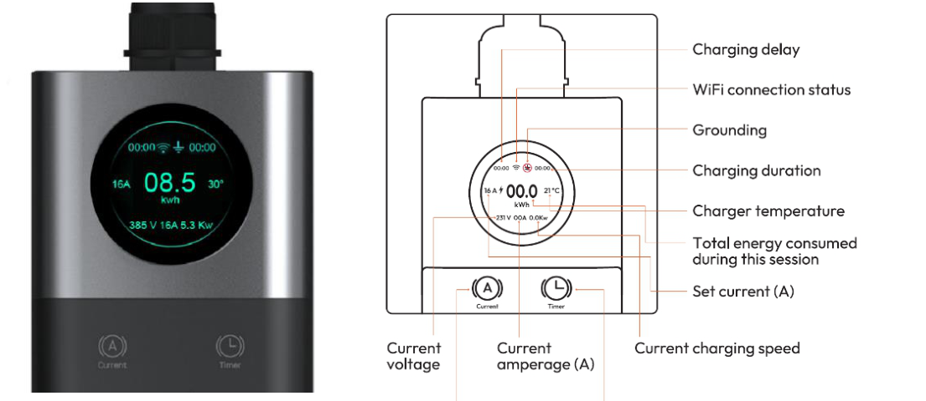
Depending on version, the screen can show WiFi status, charging delay, grounding status, charging duration, charger temperature, energy consumed in the current session, set current, charging speed, voltage and amperage.
Current Setting
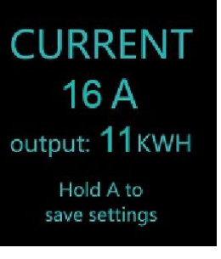 | - With the vehicle connector disconnected, press and hold [Current] for 2 seconds to enter current setting.  - Short press [Current]to increase the value. [Timer] decreases the value.  - Hold [Current] for 2 seconds to confirm.  - If no action is taken for 15 seconds, the screen returns automatically to the main display.
Charging Scheduling
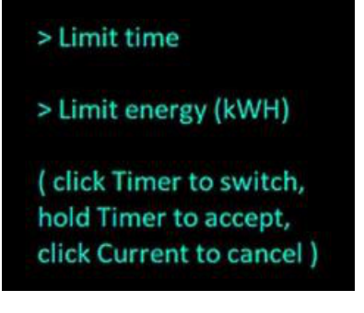 | - Depending on version, scheduling can set a start delay, charging duration or energy limit in kWh.  - These functions are available when the vehicle is not connected to the charger.  - Hold [Timer] to open the menu, follow the screen instructions, then hold [Timer] to confirm.
Charger Options
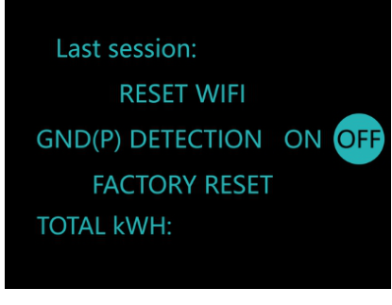 | - Hold [Current] + [Timer] for 10 seconds to open the options menu.  - [Current] changes the option; [Timer] changes the selected value.  - Hold [Timer] for 5 seconds to save.  - Typical options depending on version: RESET WIFI, GND(P) DETECTION, FACTORY RESET, TOTAL kWh.
Changing the Interface Language
- Press and hold both charger buttons simultaneously for 10 secondsto open the configuration menu.
- Keep holding the buttons until the display shows "Language options".
- Short-press the charger button to scroll through available languages: English, Polski, Deutsch, Français, Español.
- When the desired language is displayed, save the selection by pressing and holding the button marked "A".
- After successful saving, the main screen displays a message in the selected language, for example "PODŁĄCZ SAMOCHÓD" for Polish.
WiFi, Tuya and Updates
- For WiFi models, use a 2.4 GHz WiFi network. 5 GHz networks are not supported.
- Enable Bluetooth on the phone during first setup, then add the charger in Tuya Smart or Smart Life.
- Depending on version, the app can set charging schedules, start/stop charging remotely, change charging power, secure the charger and share access.
- For complex schedules, use Tuya automatic actions.
- If an OTA update is offered, keep the charger powered and connected to WiFi until the update is complete.
- Advanced users may integrate some models with Home Assistant using HACS and xtend_tuya; these are unofficial extensions.
App Pairing
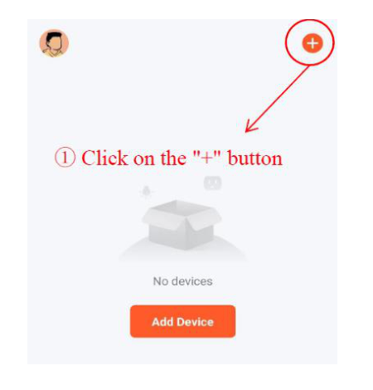 | 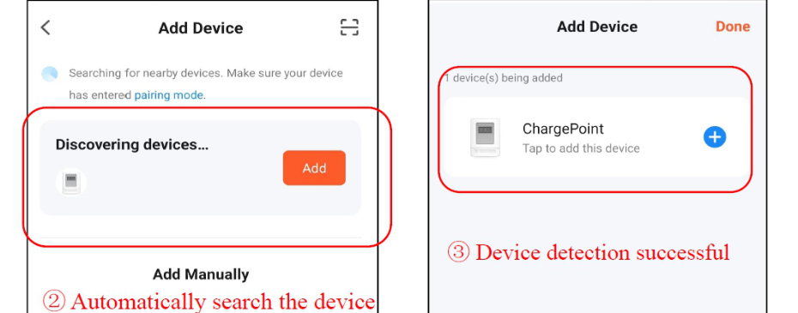
- Install Tuya Smart or Smart Life.
- Open the app and tap the plus sign to add a device.
- If the charger is not detected, open charger options and select "unlink my phone", then search again.
- The app will ask for a device name and WiFi network details.

Troubleshooting
Error | Probable cause | Solution
LED/LCD off | Power not connected | Check the power inlet and power switch.
LED/LCD off | Circuit breaker tripped | Reset the circuit breaker after checking the installation.
LED/LCD off | Device damaged | Contact customer service.
Unable to charge | Connector not fully inserted | Insert the connector fully into the vehicle inlet.
Unable to charge | Grounding issue | Check the installation or the GND(P) DETECTION setting.
Unable to charge | Protection circuit activated | Check the message/status shown on the charger and contact the distributor.
Charging current too low | Vehicle almost fully charged or vehicle limitation | Check the vehicle settings and state of charge.
Persistent fault | Fault detected | Disconnect the charger, check the installation and contact the distributor if the problem returns.

Warranty and Compliance
- The warranty covers the product itself for 24 months from the date of sale unless a different period applies in the country or kit sold.
- The warranty is valid only with proof of purchase.
- Damage caused by non-compliance with the manual, abnormal voltage, water, fire, unusual use or other external factors may be excluded.
Warranty Service: hello@amperepoint.com
Declaration of Conformity
The device complies with applicable directives and standards, including RED 2014/53/EU, IEC 61851-21-2, EN 301489-1/-17, EN 300328, EN 300330 and EN 61000-3-11/-12.
 | Disposal:Do not dispose of this product with unsorted municipal waste.Follow local disposal regulations for electrical and electronic equipment. | 

