
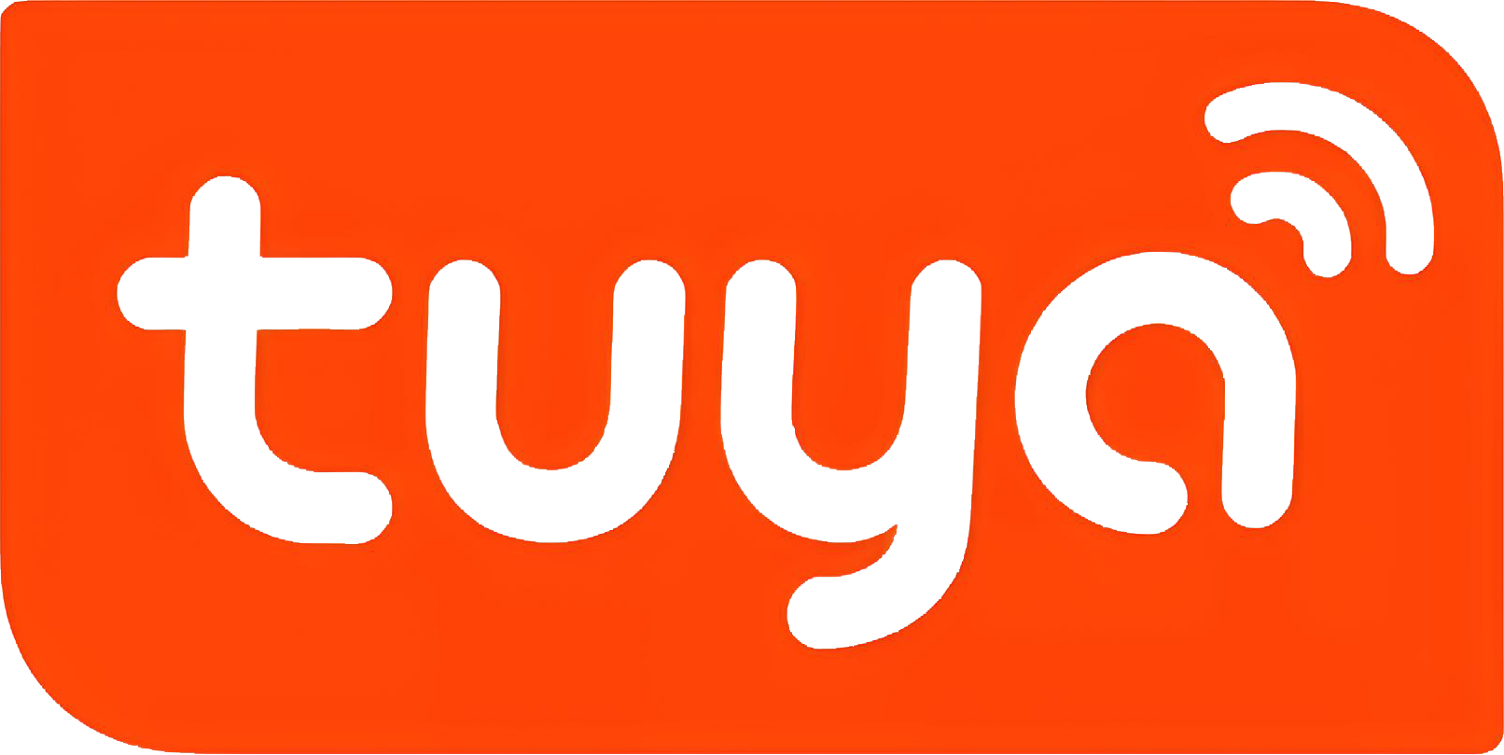
Powered by
SmartApp 2.0
User Manual

- Immediate or Delayed — Charge now, or wait past Peak
- TOU Rate Plan — Your real utility prices in the app
- Smart Schedule — Charge automatically on cheap hours
- Dynamic Rate — Follow live prices where available
- Solar Only — Prefer free solar surplus
- DLB — Protect the home main breaker
- Smart Statistics — Track energy, cost, and savings
- Safety & Health — Self-test and event history
- Charging Approval & NFC — Control who can start charging
- One app — Modes, tariffs, solar/DLB, and statistics together

Charge Smarter, Pay Less.

Ver. 20260916

Start with what you want to do
This guide starts from a charging goal and takes you straight to the App path. Screens and labels may vary slightly by charger model, firmware, account and market.
Your goal | Start here
Charge as soon as possible | Immediate
Wait a few hours, then charge | Delayed
Use the cheapest fixed-tariff hours | Rate Plan → Smart Schedule → Scheduled
Follow a supported dynamic tariff | Rate Plan → Dynamic Rate / Charging mode → Dynamic Schedule
Prefer surplus solar energy | Smart Meter → Solar Only
Avoid overloading the main supply | Smart Meter → Dynamic Load Balancing (DLB)
Check energy, cost and savings | Statistics

GOLDEN RULE
For cost-aware charging, enter your real Rate Plan first. Timeline colors, live estimates and savings depend on it.

Model differences
- Maximum current is limited by the charger, cable or power adapter, supply and vehicle. SmartApp cannot override a hardware safety limit.
- Solar Only, Dynamic Rate, DLB, temperatures and Diagnostics appear only on supported, activated products.

Pair the charger once
Use this when the charger has not yet been added to your Tuya account, or the Wi-Fi network has changed.
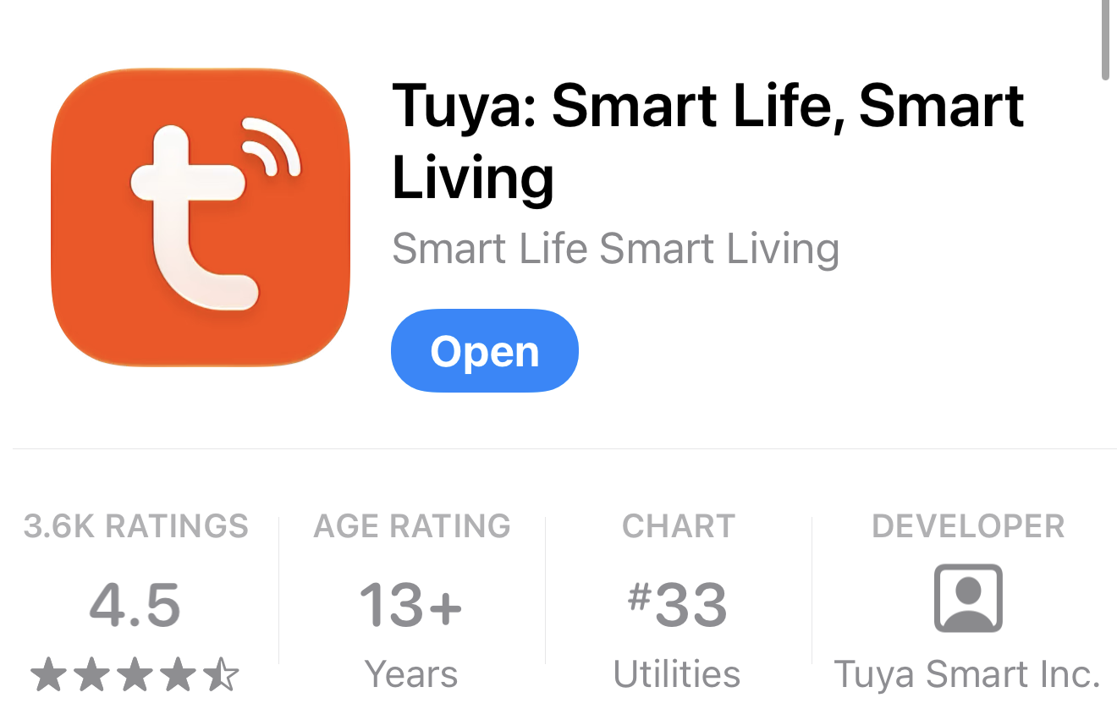  Install Tuya Smart | 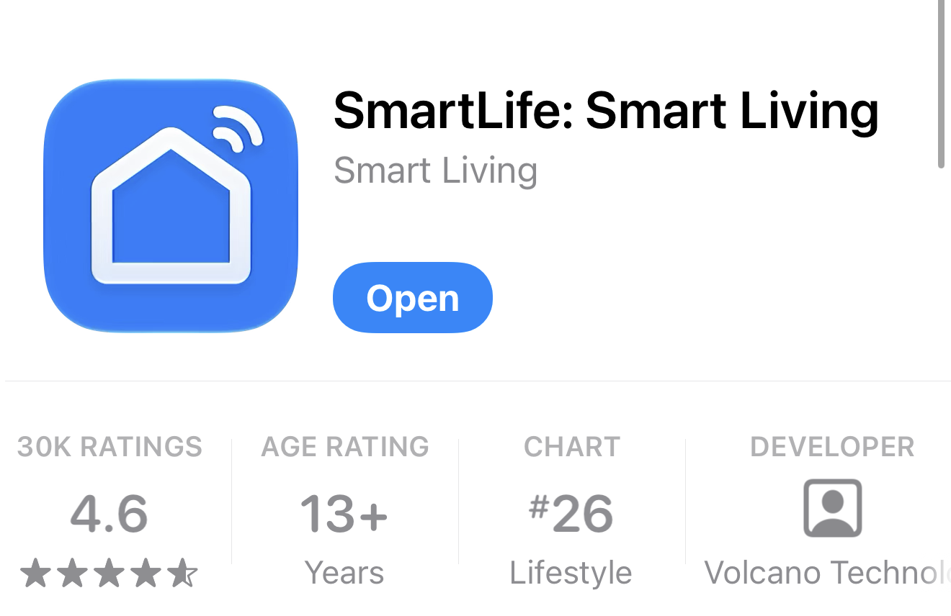  Install Smart Life

- Install Tuya Smart or Smart Life from the official app store and create or sign in to your account.
- Connect the charger to a compatible earthed outlet. Keep the EV connector disconnected and wait for the self-test to finish.
- Hold A key for 8 seconds until the Wi-Fi indicator flashes. This may clear the previous Wi-Fi association.
- Enable Bluetooth on your phone. In Tuya Smart app, tap + → Add Device and select the detected charger.
- Enter the 2.4 GHz Wi-Fi credentials and follow the prompts until the charger appears on Tuya Home.
IF PAIRING FAILS
Confirm that 2.4 GHz is enabled, move closer to the router, keep the EV disconnected and repeat the hardware pairing sequence.

Read Home at a glance
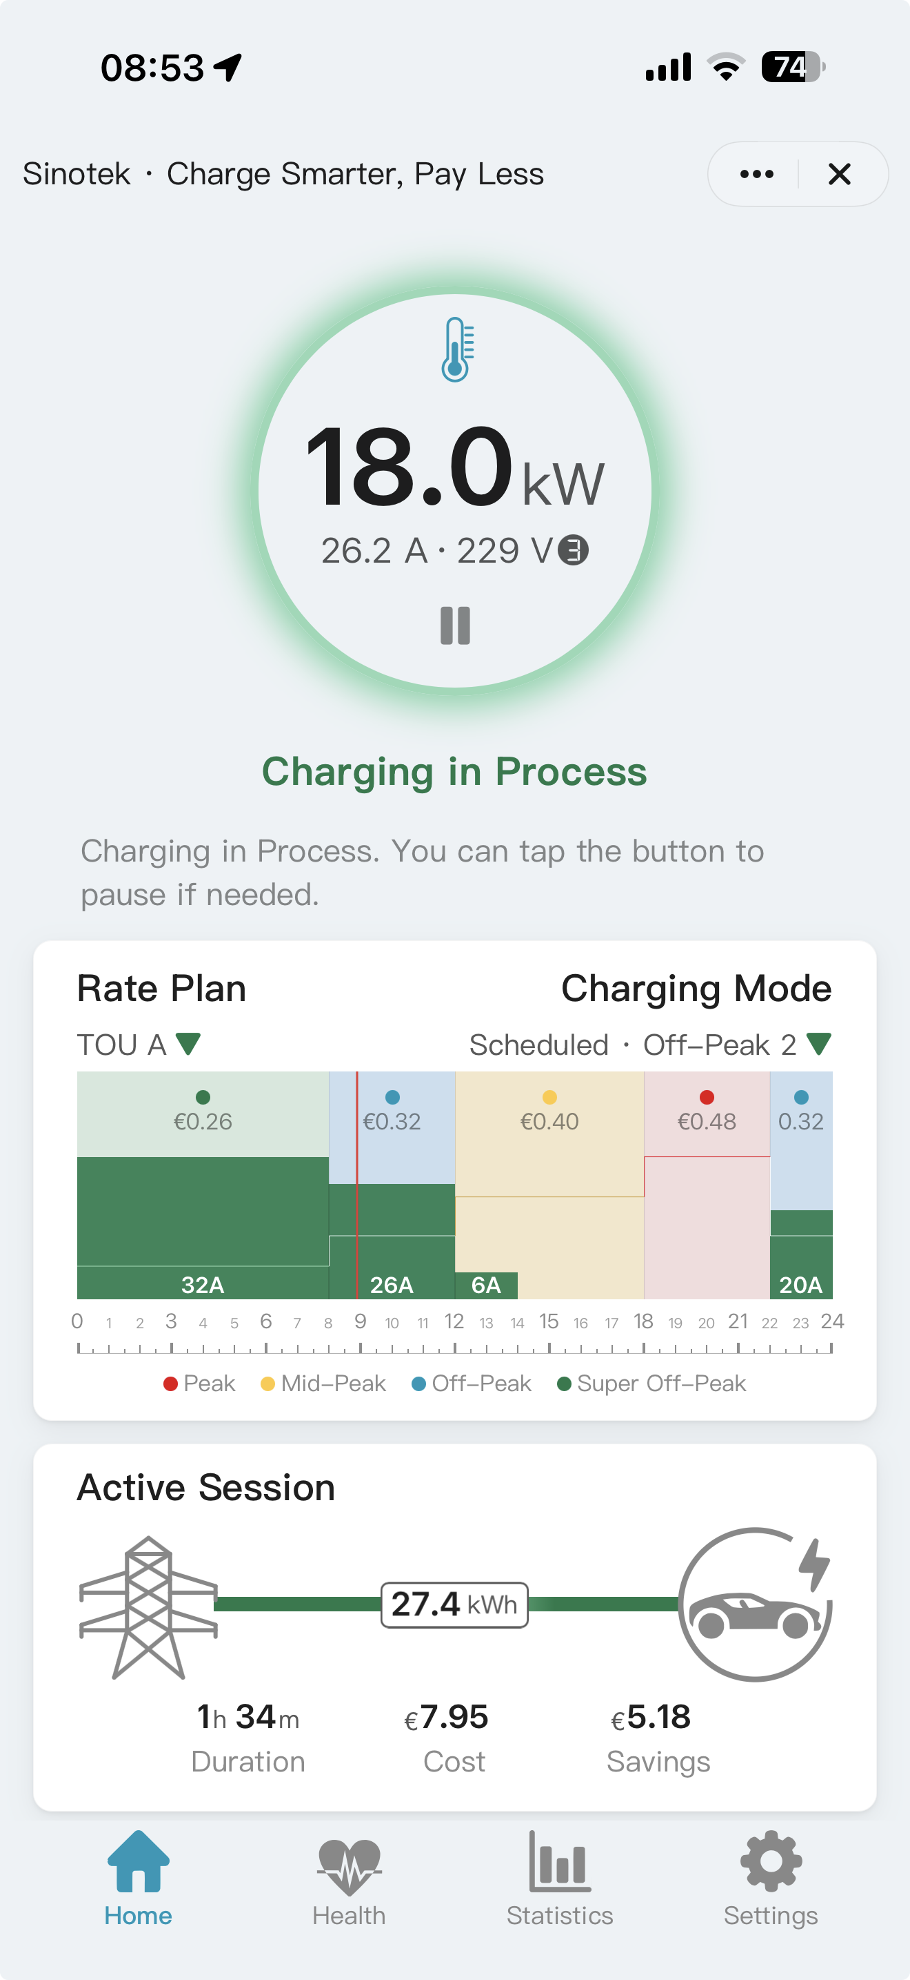
Thermometer
Start/Pause
Charging Mode Selector
Rate Plan Selector
Rate Plan & Curve in Background
Smart Schedule in Foreground
Home answers three questions:

1. What is the charger doing?

2. Which plan and mode are active?

3.How much energy is this session using, and how much is it costing?

cOn Home | What it tells you
Gauge | Status, live power, current and voltage
Background colors | Active Rate Plan periods
Foreground bars | Scheduled, delayed or Solar Only window
Thermometer | Plug, control-box and EV-connector temperatures, where supported
Active Session | Energy, duration, estimated cost and savings

Charge now or after a short wait

Immediate — power as soon as the EV is ready
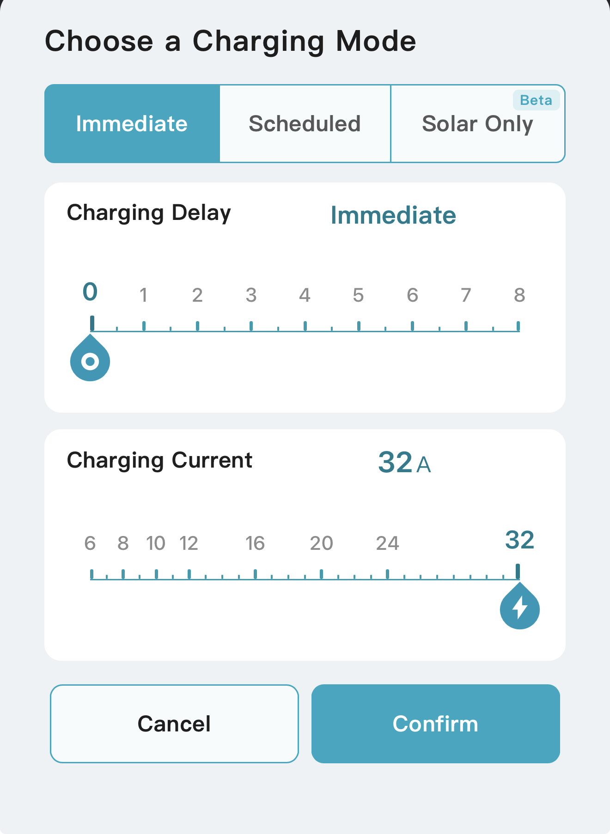
Use this when you need energy before leaving and price optimization is not the priority today.
- Connect the charger to your EV.
- Home → Charging Mode → Immediate.
- Set Delay to 0 and choose a permitted charging current.
- Tap Confirm.

Delayed — simple countdown
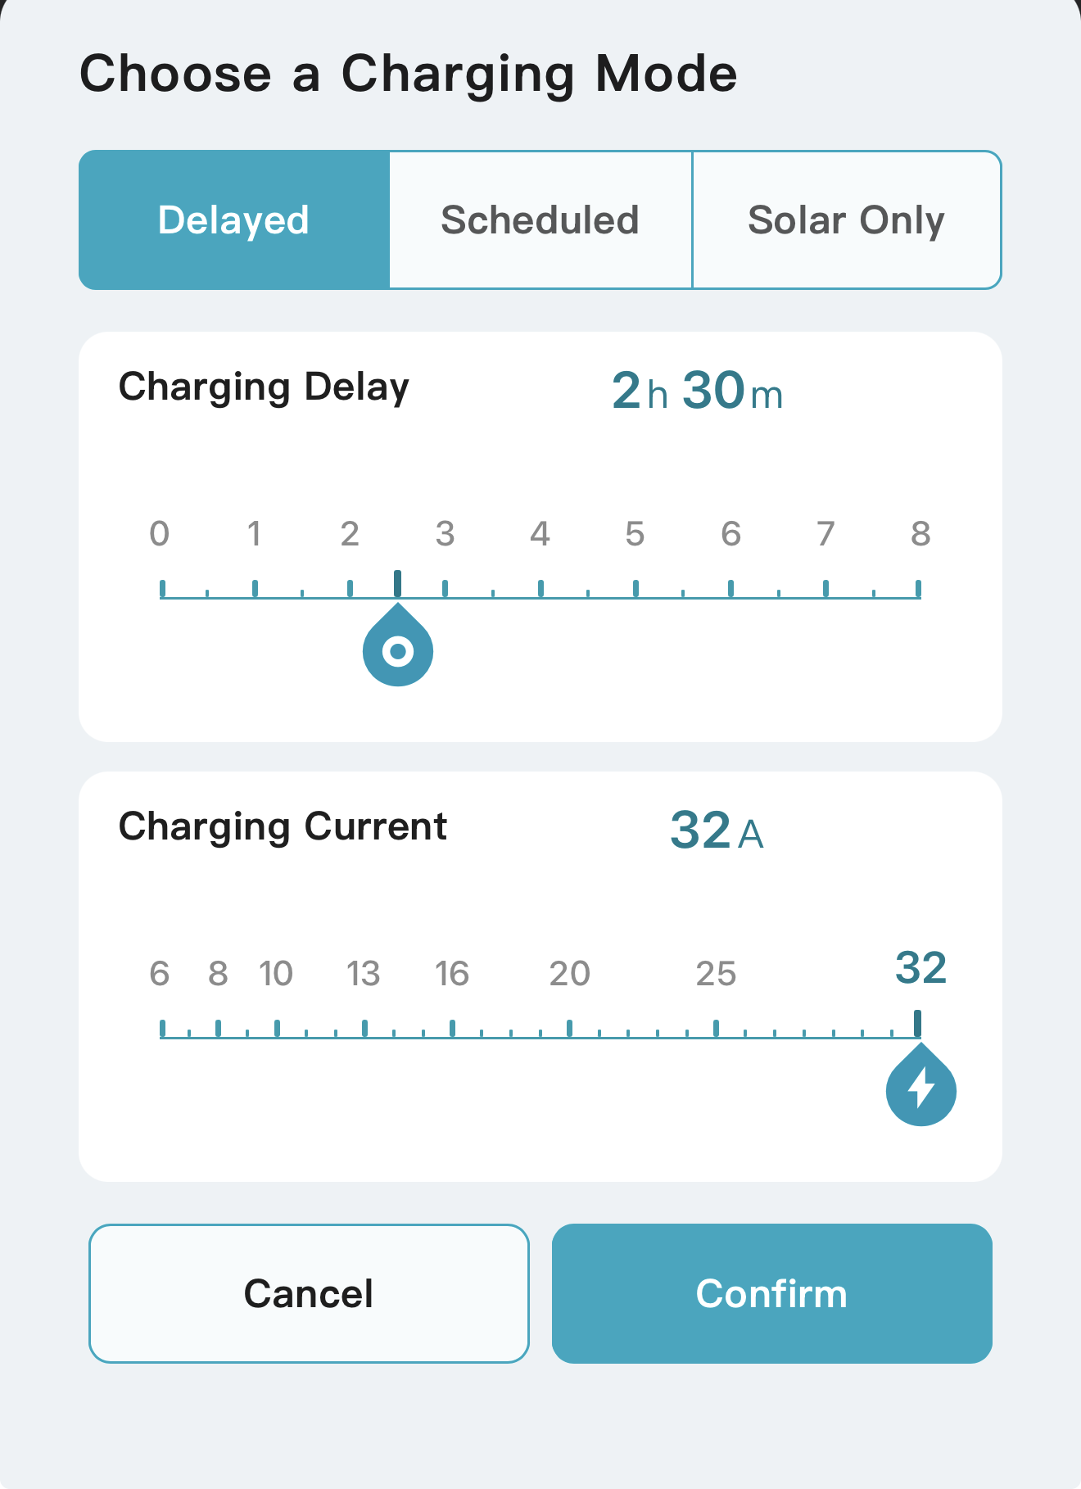
Use this when the expensive period ends soon and you do not need a repeating weekly schedule.
- Connect the charger to your EV.
- Home → Charging Mode → Immediate, set the delay > 0 to enter Delayed mode.
- Choose the countdown and charging current.
- Tap Confirm. Charging begins when the countdown ends.

A DELAY IS NOT A CLOCK TIME
In the LCD screen of the charger, 02:30:00 means start after 2 hours 30 minutes—not start at 02:30.

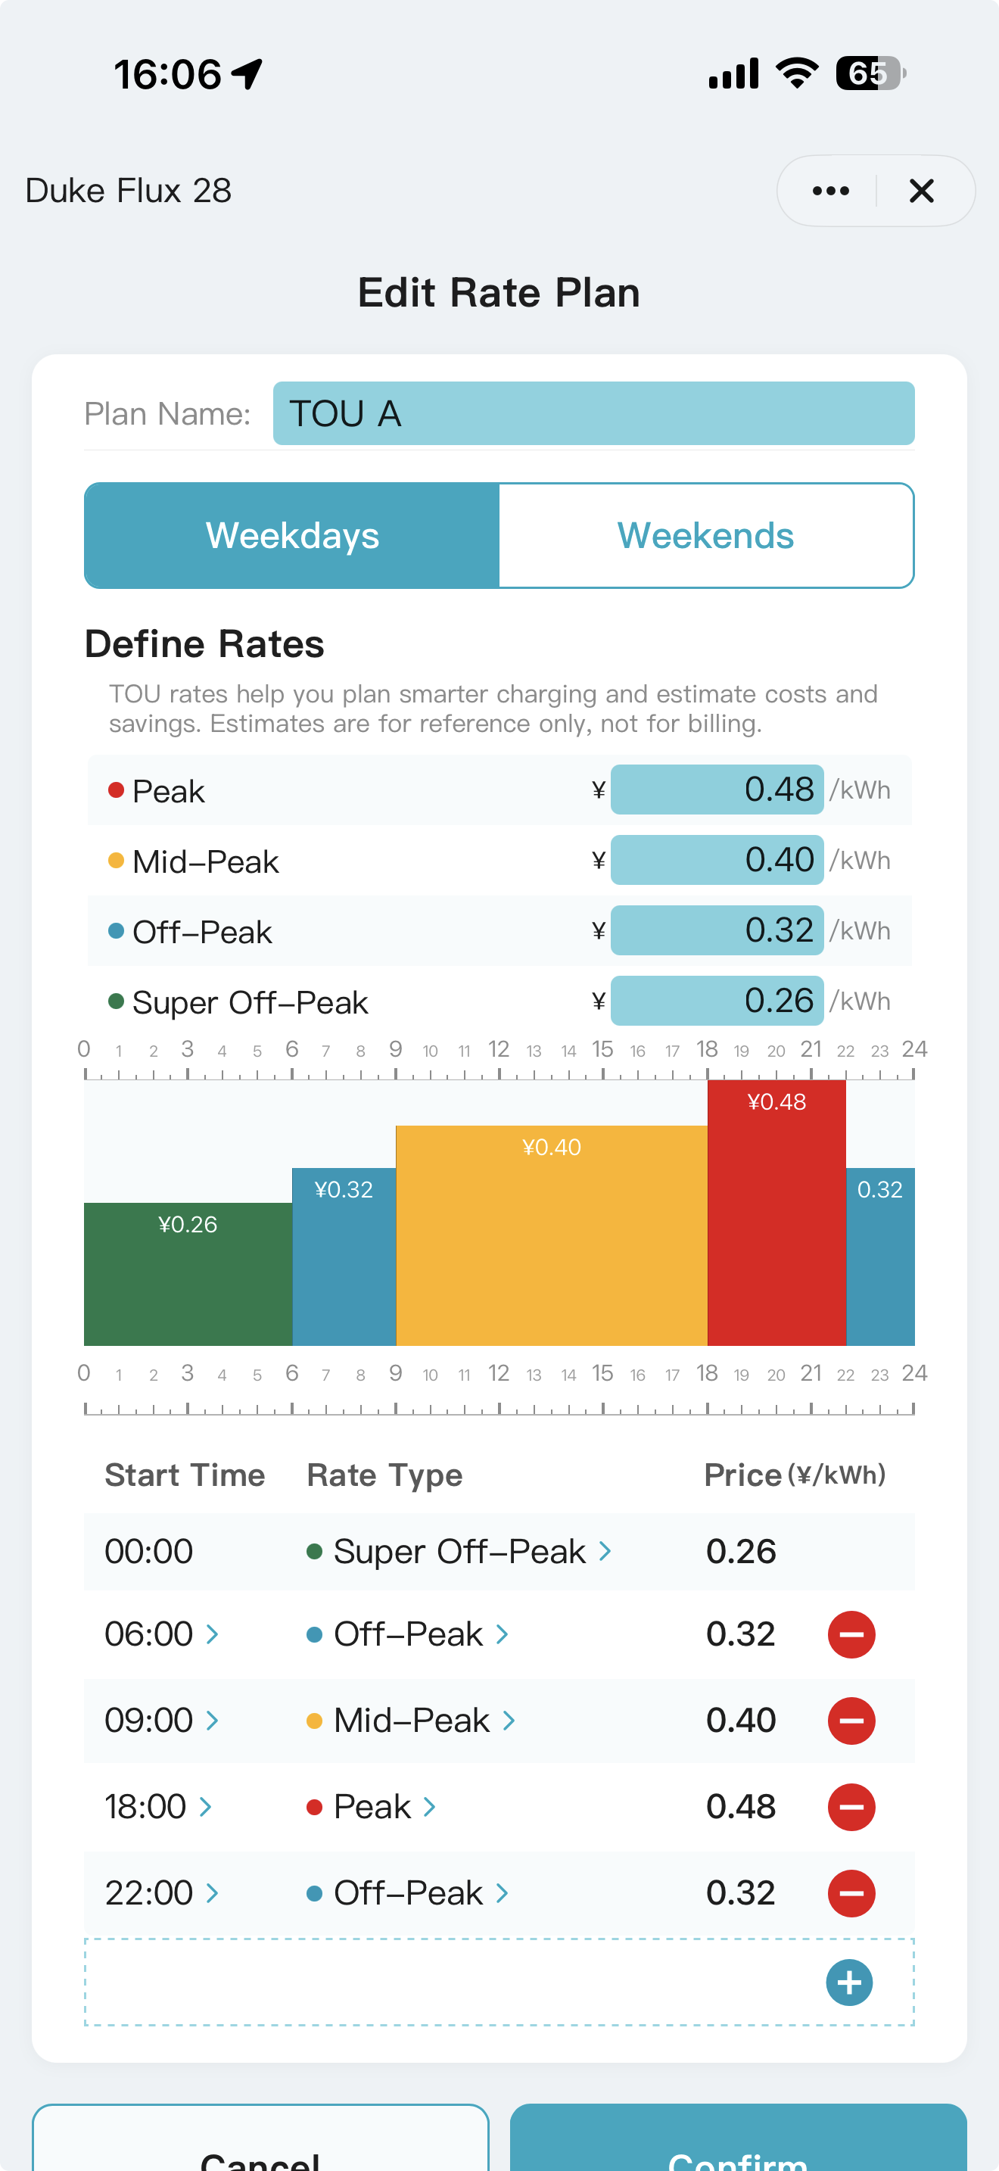

Set your Rate Plan first
Edit plan name
Edit prices
Tap to change rate type
Tap to define start time
Hold & drag to adjust time
Tap to change rate type
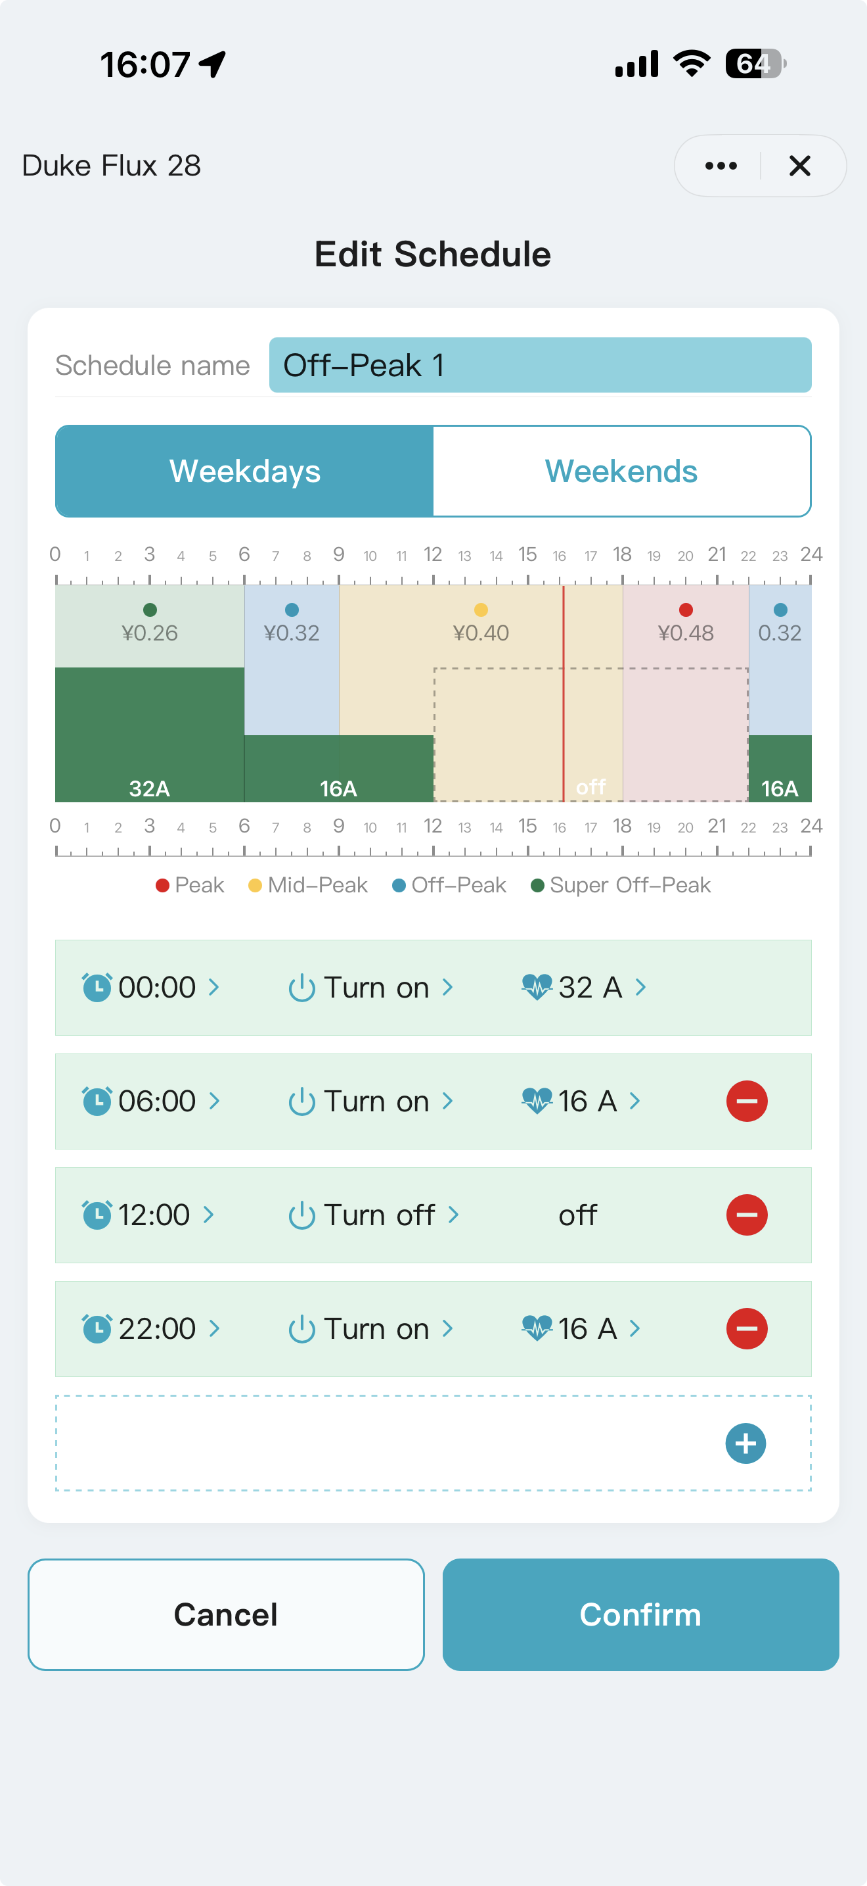

Turn on/off
Delete
Add
Edit name
Save & exit
Define both weekdays & weekends
Set current
Hold & drag to adjust current

Use this when you have a Time-of-Use (TOU) tariff contract and want accurate timeline colors, cost estimates and savings.
- Settings → Rate Plan. Select a profile and open its editor.
- Rename it if useful. Enter the real price for each tariff tier used by your utility.
- Hold and drag a boundary left or right to adjust the time. To change the rate type, hold the period’s top edge and drag up or down. Alternatively, tap › in the table to set the start time and rate type.
- Tap blue + to add a row or red – to remove one if necessary.
- Configure both Weekdays and Weekends.
- Review the 24-hour timeline and tap Confirm.
- Back on the plan list, select the rate plan you want active and confirm again.
ESTIMATE ONLY
Use the Rate Plan to create Smart Schedules and save on charging. Cost estimates are for reference only and cannot be used for billing.

Build a Smart Schedule inside the cheap hours
Use this when you want the charger to wait every evening and run automatically during Off-Peak or Super Off-Peak hours.
- Settings → Smart Schedule. Select a schedule profile to edit. Your active Rate Plan appears in the background for reference.
- Tap the blue + to add a row or the red − to remove one.
- Select a start time within a lower-rate period, choose Turn ON, and set a suitable charging current. Repeat to add more charging events or current changes.
- Select an end time and choose Turn OFF.
- Drag a timeline boundary left or right to fine-tune the event time. Also, you can drag the top edge to adjust the charging current.
- Configure both Weekdays and Weekends.
- Tap Confirm to save the schedule.
USE ONE SCHEDULER
Use SmartApp Scheduled mode or the vehicle's own scheduler—not both. If both are active, charging can occur only when their time windows overlap.

Use the schedule every day
- Home → Charging Mode → Scheduled.
- Select the circle for the saved schedule, then tap Confirm.
- When you arrive home, connect the EV and leave the charger powered.
- The charger waits and starts automatically in the selected low-price window.

Before walking away
- The Rate Plan matches the utility tariff for both weekdays and weekends.
- The intended Rate Plan and Smart Schedule are selected.
- Scheduled mode is active and the EV's own scheduler is off.
- The EV is connected and the charger remains powered.

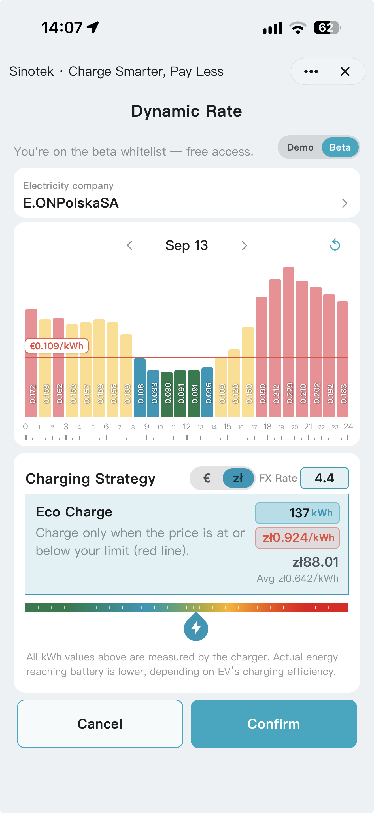
Follow a supported Dynamic Rate
Use this when your electricity contract uses live or day-ahead prices and Dynamic Rate is available for your market and account.
Note: This feature is under Beta test now, and only available to invited users currently.
- Connect the charger to your EV.
- Open Rate Plan and select Dynamic. This is a paid subscription feature, and currently is available to selected beta testers.
- Follow the on-screen instructions to enter your country, city, and postal code. Select your electricity provider and Dynamic Market, then tap Save to load the latest rates onto this screen.
- Set your charging strategy by dragging the red price threshold, then tap Confirm.

IMPORTANT
The data is integrated by Tuya’s Conow Labs from third-party sources. Check the rates and currency regularly, enter correct exchange rate to ensure accuracy.
Dynamic Rates and Eco Charge provide estimates to help you choose the cheapest charging times. For actual charges, refer to your electricity provider’s bill.

Charge from solar surplus (Smart Meter needed)
Use this when you have rooftop PV and want to charge with surplus solar power instead of following a fixed schedule.
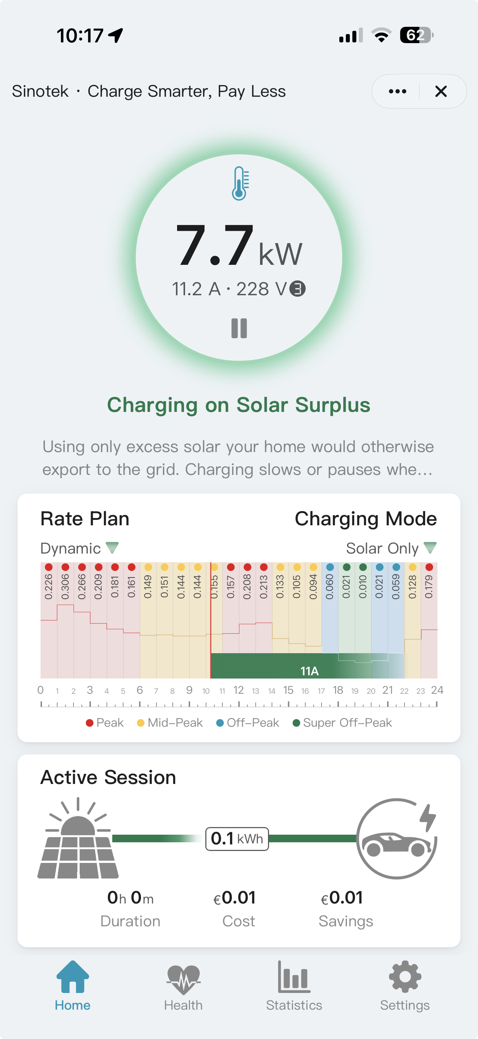
- Install a specified Smart Meter on the home's main incoming supply—NOT just the solar circuit.
- Add the Smart Meter to your Tuya account and check that it is online and reporting correctly.
- Settings → General → Smart Meter. Bind the Smart Meter with the charger.
- Home → Charging Mode → Solar Only. Check that the meter is working correctly, then tap Confirm.
- Plug the connector into your EV. Charging starts automatically once enough surplus solar power is available.
- If the surplus falls below the minimum required for three-phase charging (6 A per phase), the charger automatically switches to single-phase charging, using a higher current to make the most of the available solar power.
- Solar Only charging stops automatically if insufficient solar surplus causes the system to draw 3 A or more from the grid for over 30 minutes, or if the Smart Meter remains offline for 10 minutes.

Protect the main breaker with DLB (Smart Meter needed)
Use this when EV charging plus household loads could together exceed your home’s supply limit.
- Install a compatible Smart Meter on your home’s main incoming supply, then go to Settings → General → Smart Meter to link it to your charger.
- Go to Settings → Dynamic Load Balancing (DLB) and enter your main breaker’s current rating. The system automatically applies a safety margin.
- For multiple chargers, assign one Master and up to two Slaves. Set the main breaker’s current rating on the Master; the Slaves automatically share this setting.
- Tap Confirm.
- Each charger automatically adjusts its charging current as household demand changes, helping prevent overloads while making the most of the available capacity.
ELECTRICAL INSTALLATION STILL MATTERS
DLB manages available site current. It does not replace correct wiring, breaker sizing or required protective devices.

Share access and approve charging
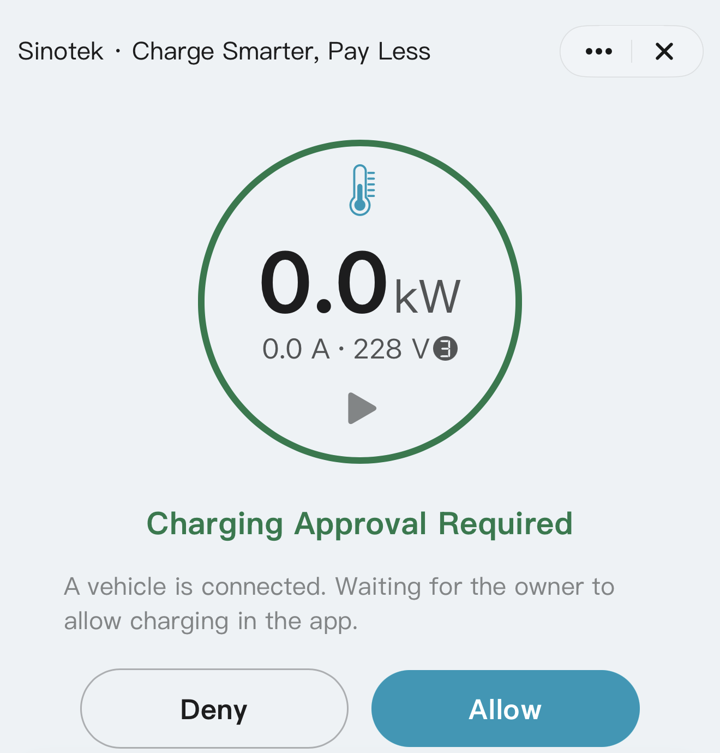
Use this when family members or other permitted users need App access, or you want to approve each charging request.
- Use the Tuya device-sharing controls to invite the intended account. The original account remains the host for most settings.
- To require authorization, open Settings → Charging Approval and turn it on.
- When a vehicle requests charging, respond Allow or Deny in the host App.
- On charger models with NFC support, an NFC card can also be used to authorize charging.
- Under Settings, press and hold the Charging Approval card for 3 seconds to open the NFC card management page, where you can add or remove cards.
CHARGING ACCESS & BILLING
Approval controls who may use the charger. Electricity is billed to the premises supplying the charger; it is not assigned to the user's app account.

Check Health, temperatures and Diagnostics

Health
Review the latest power-on self-test report and safety-event history.

Thermal Protection and Diagnostics
Tap the thermometer on Home for monitored temperatures. Diagnostics in Settings may show phase voltage/current, CP voltage, ground information, temperatures and upload status. These readings are for observation and support—not for bypassing protection or user repair.
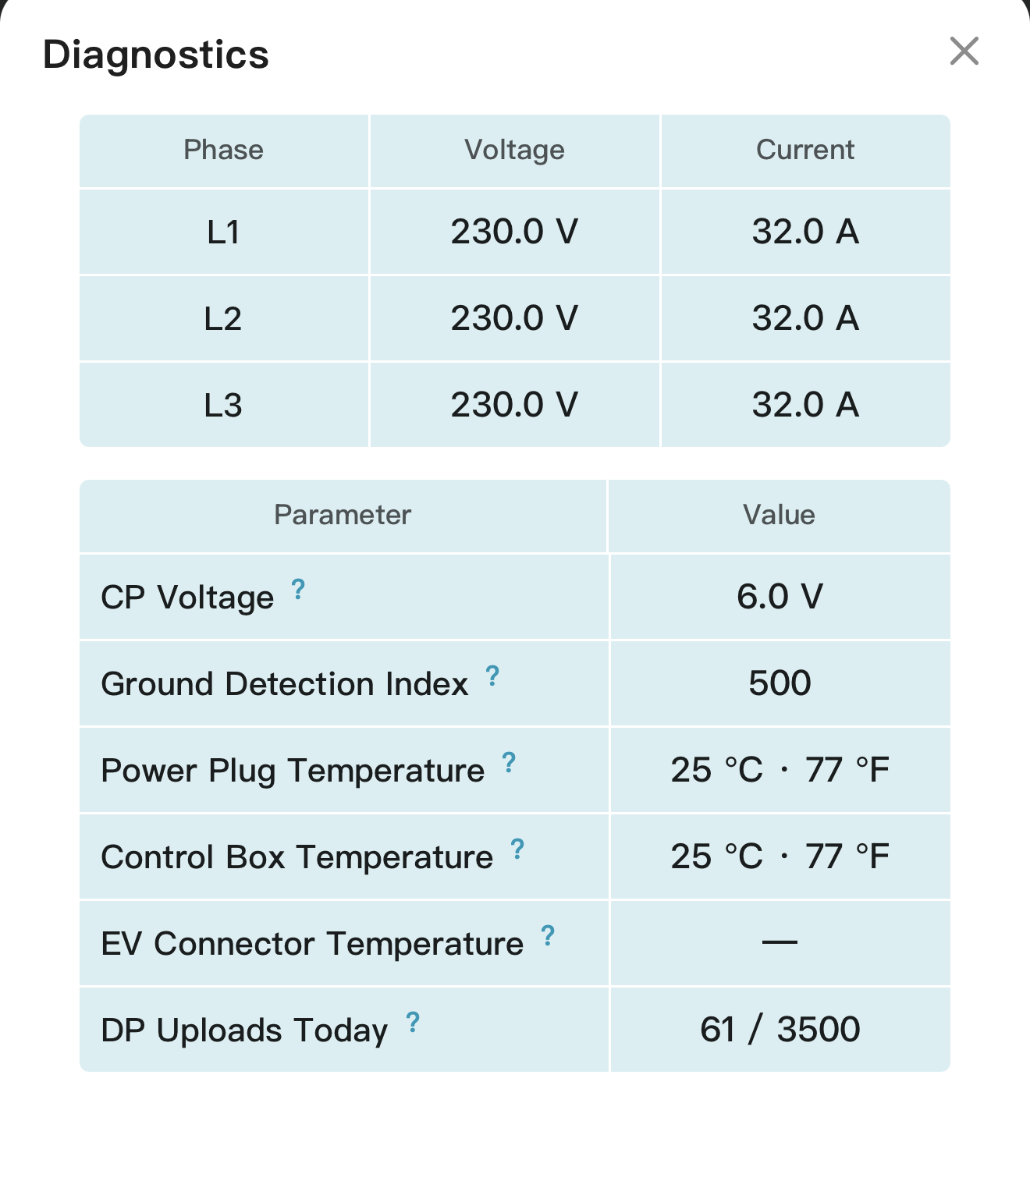
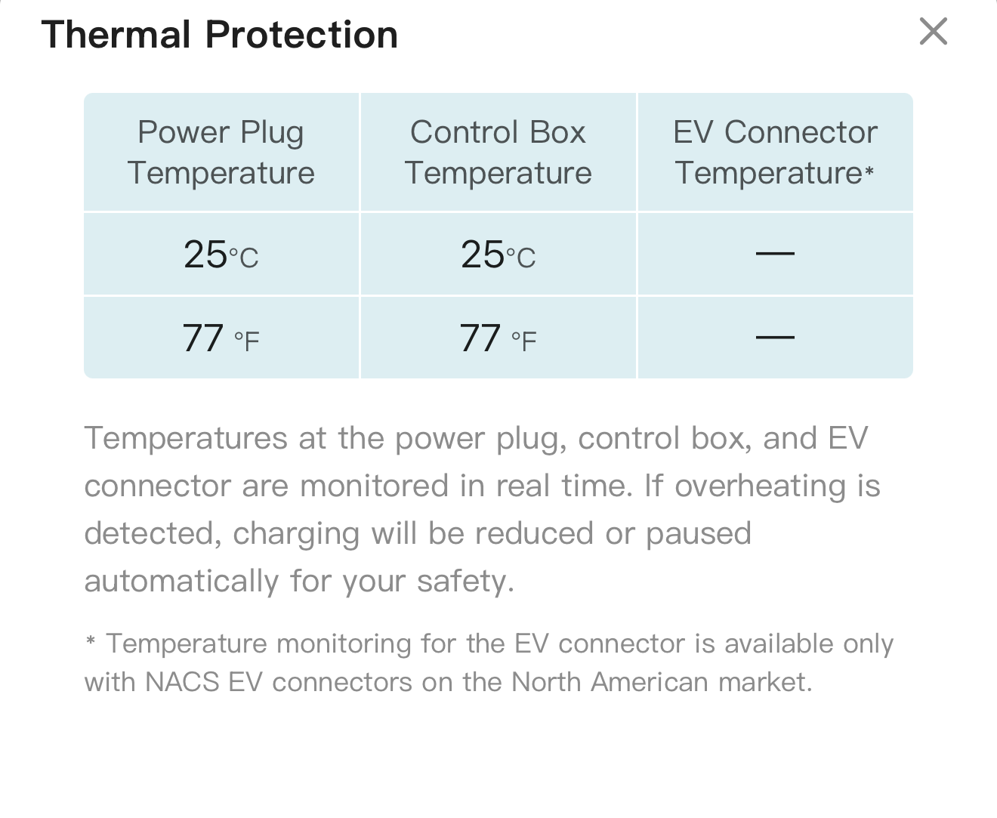
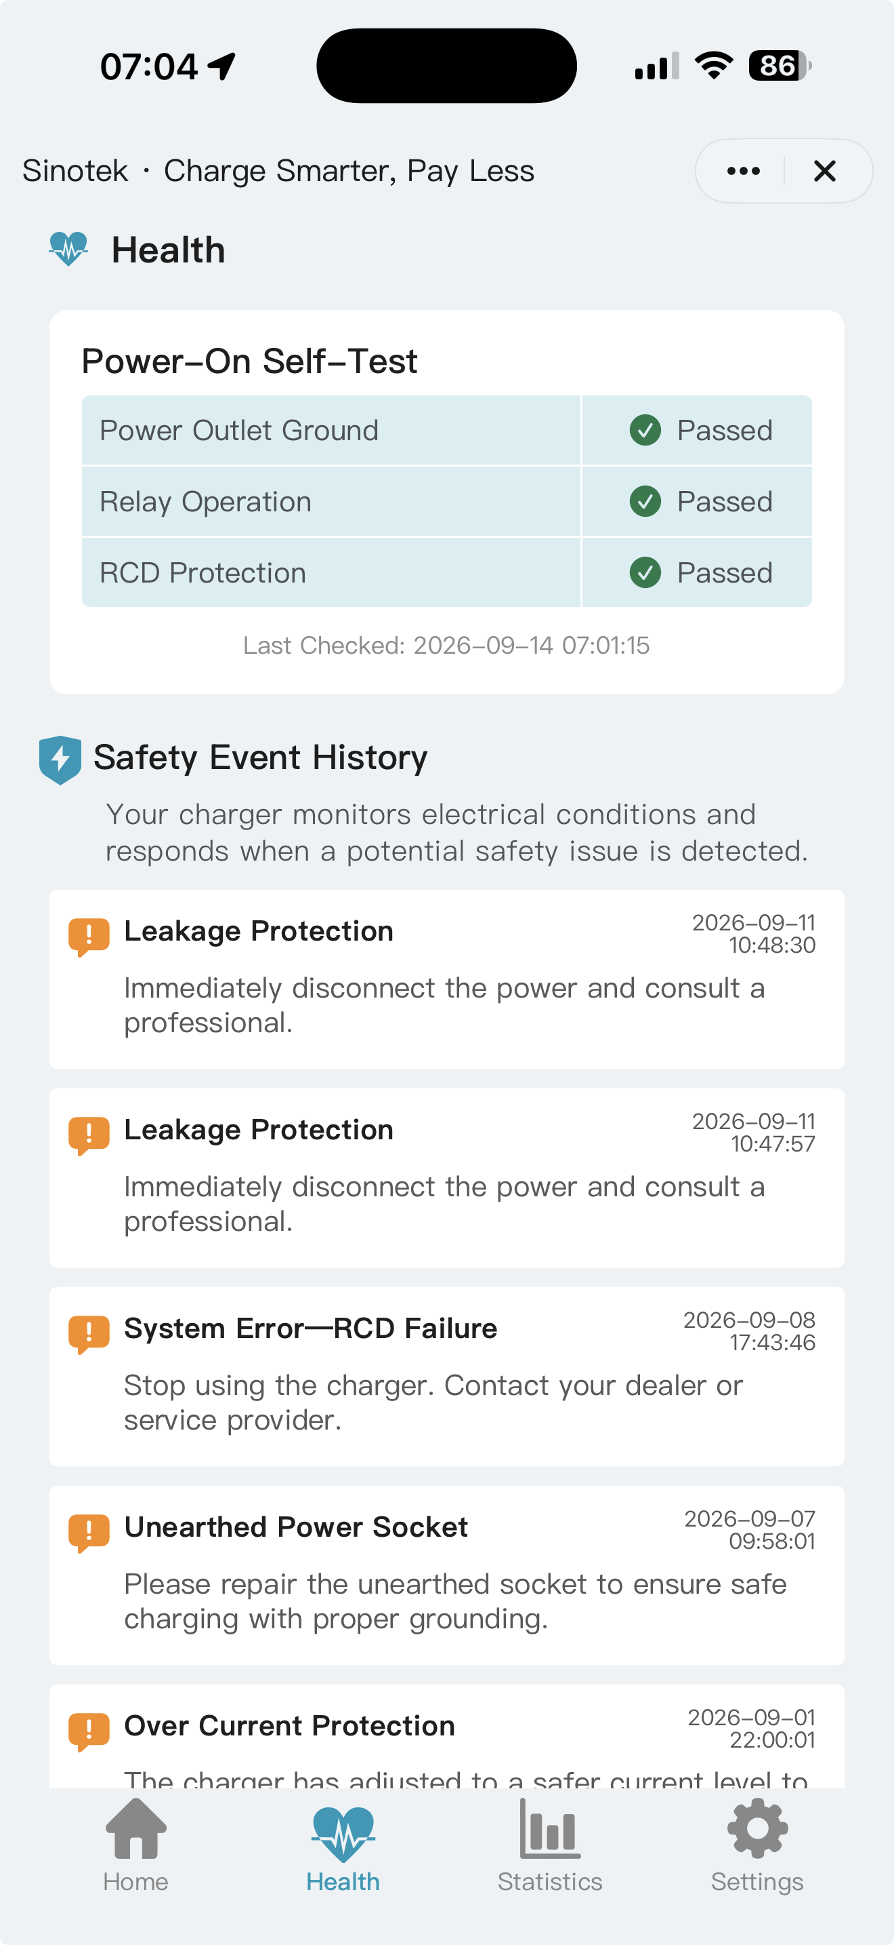
SAFETY FIRST
If a protection warning repeats, stop charging and follow the charger hardware manual. Do not repeatedly reconnect to force charging.

Finish a session and keep its record
Use this when you want the completed session to appear promptly in Statistics.
- When ready to leave, unlock the vehicle inlet and physically remove the EV connector while the charger is still powered.
- Wait for the charger to return to standby and complete the cloud upload. The charging record will then appear in Statistics.
- Only then remove supply power if you need to unplug the charger.
DO NOT UNPLUG THE SUPPLY FIRST
Physical EV-connector removal triggers the upload while Wi-Fi and supply power are still available.

Review Statistics
- Switch between Monthly and Yearly views.
- Swipe a chart or summary card left/right to browse periods; tap a bar to open it.
- Use List or Chart for session detail and export CSV where available.
- Update the Rate Plan after a tariff change. Earlier records may not recalculate.
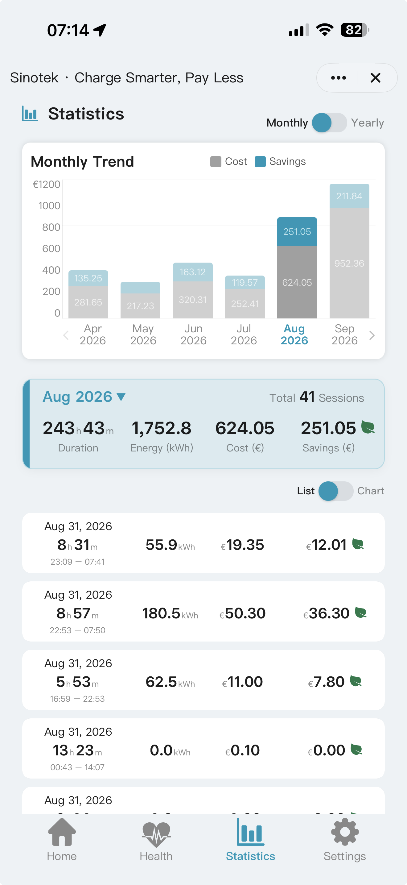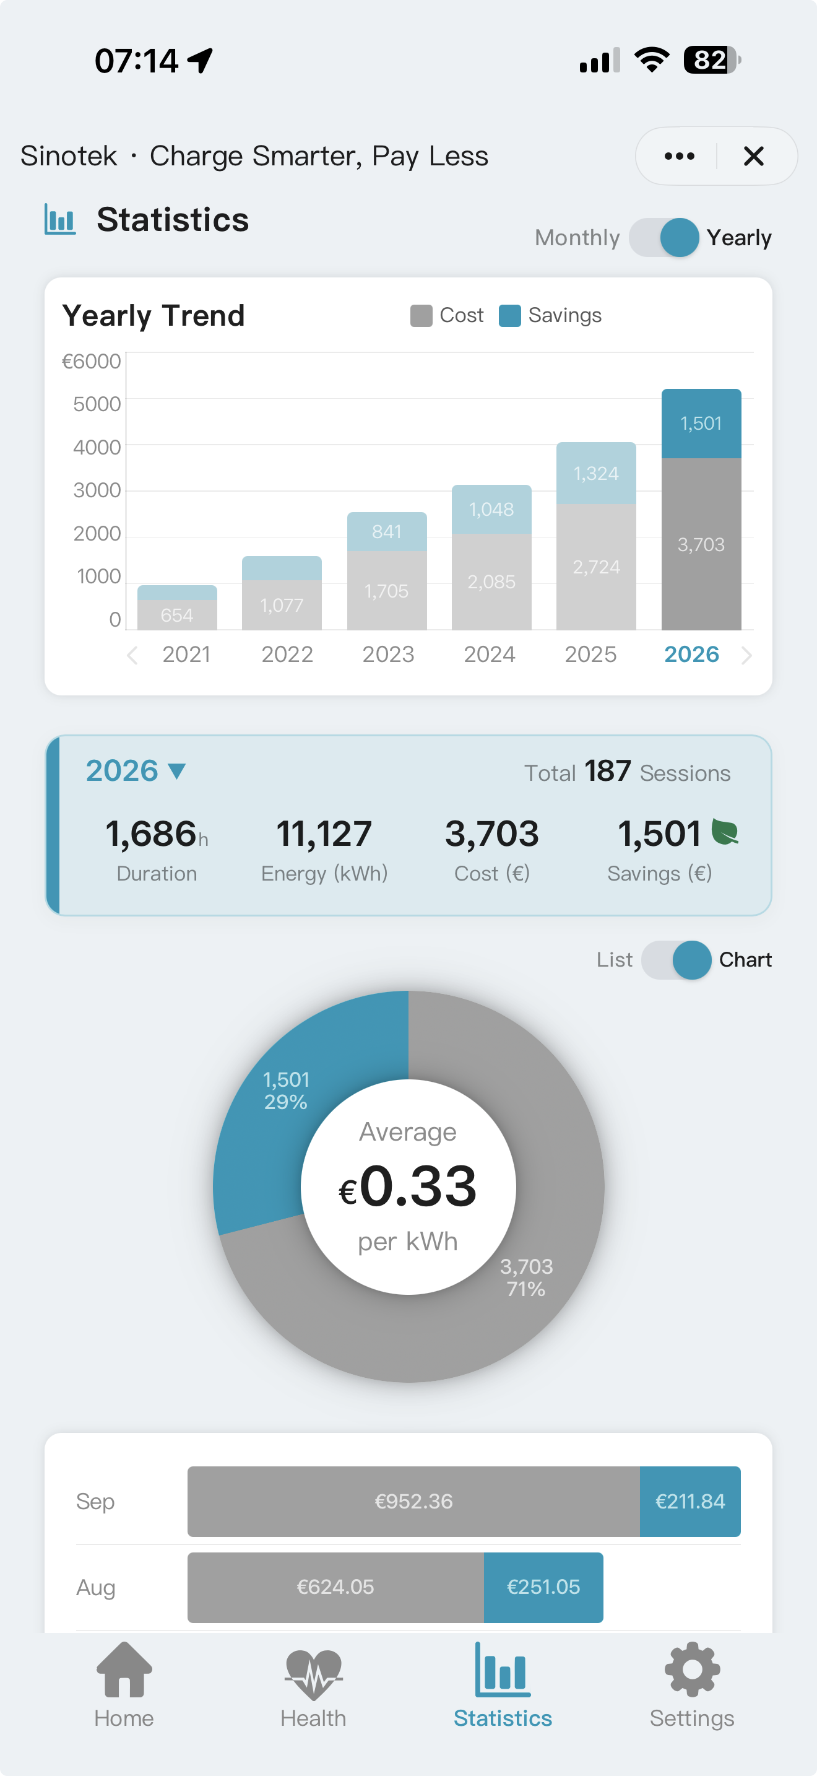
All kWh values are measured by the charger. Actual energy reaching the battery is lower, depending on the EV's charging efficiency.

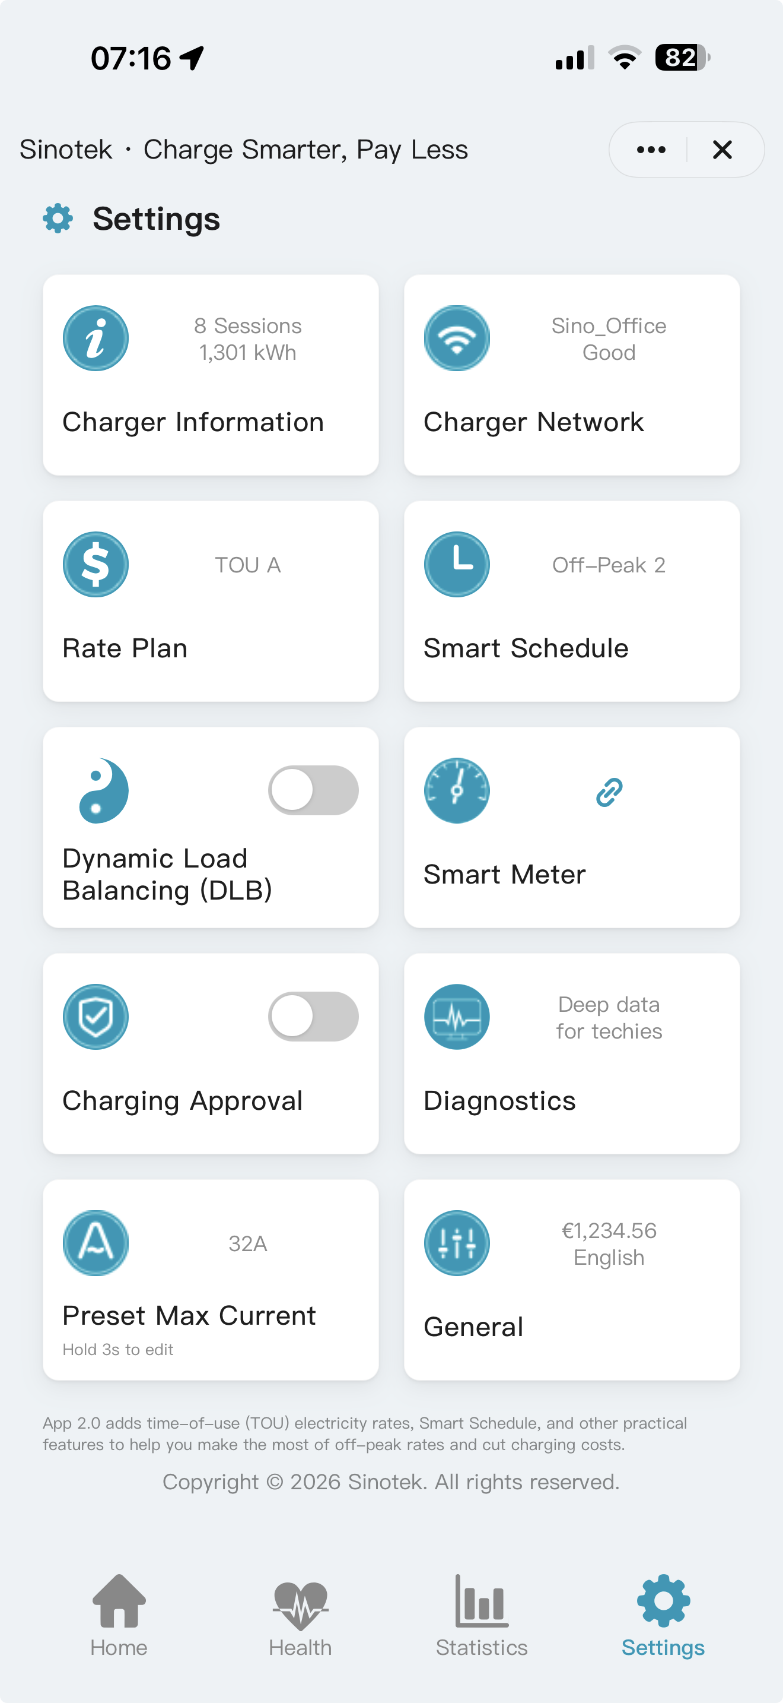
Settings at a glance
DEVICE & CONNECTION
Charger Information — device & session summary
Charger Network — Wi-Fi status and network
CHARGING & COST
Rate Plan — tariff prices and time periods
Smart Schedule — automatic ON/OFF periods
SOLAR & LOAD MANAGEMENT
Smart Meter - Required for Solar Only and DLB
Dynamic Load Balancing — protect the site supply
ACCESS & SAFETY
Charging Approval — allow charging / manage NFC
Preset Max Current — cap charger current
APP PREFERENCES - General Settings
Language, Theme, Currency, Number Format
Icon & Name, Reboot and Factory Reset
IMPORTANT
Dynamic Rate currencies vary by country. If you choose a local currency other than EUR, check the rates and currency carefully and enter an exchange rate if needed for accurate conversion.
If you don’t use Dynamic Rate, feel free to choose your local currency.

If something does not work
What you see | Check first
Pairing fails | 2.4 GHz enabled; Bluetooth on; EV disconnected; charger in pairing mode; move closer to router
Cost or savings looks wrong | Currency; Rate Plan prices/hours; active plan; tariff-change date
Schedule misses cheap hours | Schedule vs Rate Plan; correct schedule selected; vehicle scheduler off
Charging will not start | Hardware status; vehicle lock; mode; delay/schedule; Charging Approval
Solar Only cannot enable | Primary meter bound correctly and online; sufficient surplus
DLB is unavailable | Host account; supported meter; feature activation; Master/Slave role
Dynamic Rate is unavailable | Market/account access; supported data source; correct tariff contract
Session is missing | Physically unplug EV connector while charger remains powered and online
App is offline | Router, signal strength and Charger Network settings

Prepare for support
- Charger model and serial number in Charger Information of Settings.
- App and firmware version
- Mode, Rate Plan or schedule in use
- Screenshot of the message and Diagnostics, if available
- Time of the event and whether it repeats

Daily quick reference
I need… | Do this
Power now | Home → Charging Mode → Immediate → Current → Confirm
A short countdown | Home → Charging Mode → Immediate → set Delay > 0 and Current → Confirm
Cheap overnight charging | Select Rate Plan → select Smart Schedule → Scheduled → connect EV
Live-price charging | Dynamic Rate → fine-tune strategy → Confirm
Solar surplus | Primary Smart Meter online → Solar Only → Confirm
Main-breaker protection | Primary Smart Meter → DLB → main-breaker current → Confirm
A complete session record | Remove EV connector while powered → wait for data upload → unplug supply

New-user checklist
- Rate Plan contains real local TOU prices and both Weekday/Weekend periods.
- The correct Rate Plan profile is selected on Home.
- Smart Schedule ON events fall inside the intended low-price periods.
- For overnight charging, Scheduled mode and the intended Smart Schedule are active.
- Health shows passed self-test results after first installation.
- After several charging sessions, verify that the cost figures in Statistics are consistent with the tariff you entered.

For electrical connection, approved adapters, fault messages, safe disconnection, cleaning and service, follow the hardware manual supplied with the charger.

