Smart Thermometer

Dominik Starzyk, Dawid Ilba

Wydział Informatyki Elektroniki i Telekomunikacji

Akademia Górniczo-Hutnicza

Kraków 2019

***Table Of Contents***

1. *Introduction 3*
2. *Components 3*
3. *Specification of customer requierements 4*
4. *Functionality 4*
5. *Timetable 4*
6. ***Introduction***

Our idea is to create a wireless smart home thermometer based on relative humidity and temperature sensor DHT22 and wifi module ESP8266. Module and sensor will be powered by batteries. All will be controlled by Raspberry Pi 3B with preinstalled “Domoticz” application and connected with smartphone. It is a free software to configure and monitoring, home automatic systems. Simple and extensive GUI that can help to create and use our project.

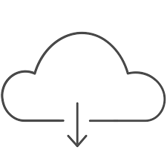

**Internet**



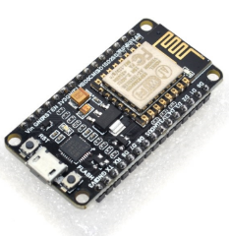

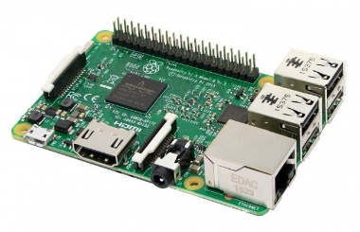

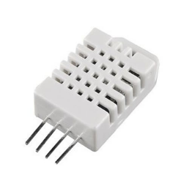

1. ***Components***

* Raspberry Pi 3B
* Domoticz (app to controll sensors)]
* DHT22 sensor
* ESP8266 WiFi module
* Batteries

1. ***Specification of customer requierements***

We were thinking about our project and determinated the minimum assumptions that must be met for the user to be satisfied. Thermometer must be wireless and will be used indoors, therefore the temperature measurement range is from $0℃ to 40℃$ with minimum accuracy of ${}_{-}^{+}{1℃}$. Humidity sensor must have minimum accuracy of ${}_{-}^{+}{3\%}$. Data must be refreshed every 10minutes. Moreover the installation must be safe and economical (maximum power consumption is 30W).

1. ***Functionality***

* Wireless temperature meter with an accuracy of ${}_{-}^{+}{0,5℃}$ in range from $-40℃ to 80℃$
* Wireless humidity sensor with an accuracy of ${}_{-}^{+}{2\%}$
* Data is refreshed every 2 seconds, to which the customer has access from the application
* Low power consumption ( maximum power consumption of Raspberry is 12,5 Watts)
* Safety of the installation
* The installation can be easily expanded with additional sensors and switches

1. ***Timetable***

* Collect main components
* Installing and configuring Domoticz on Raspberry
* Programming WiFi module
* Trying to run wifi modul and check proper work (for example with app like remote XY)
* Connecting DHT22 and ESP8266
* Check work and solve error or all kinds of inaccuracies
* Unplanned fixes
* Presentation