https://www.youtube.com/watch?v=G2G20cmrxAE

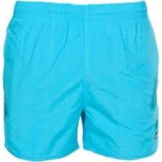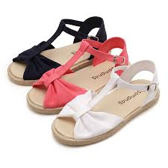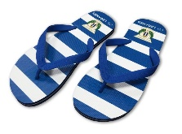1.Clasifica: chaqueta, chancletas, banador, playeras ,traje, camiseta de tirantes, bikini, sandalias

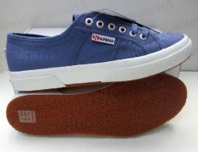

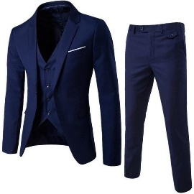______________ _________________ ______________ ______________

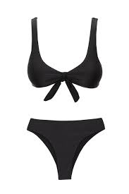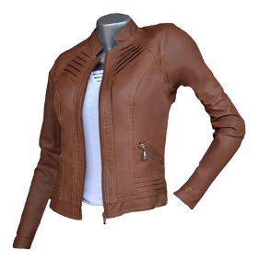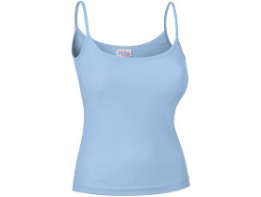

_______________ ___________ _____________ _______________

2- Que llevan en la maleta Eva, su padre o los dos? Escribe solo 13 respuestas

|  |  |  |  |
| --- | --- | --- | --- |
|  | EVA | PADRE DE EVA | LOS DOS |
| 1-Un sombrero |  |  |  |
| 2-Un vestido largo |  |  |  |
| 3-Una camisa a rayas |  |  |  |
| 4-Unos vaqueros |  |  |  |
| 5-Unas Gafas de sol |  |  |  |
| 6-Vestido corto azul |  |  |  |
| 7-Unos pantalones cortos amarillos |  |  |  |
| 8-Unos zapatos |  |  |  |
| 9-Unas playeras |  |  |  |
| 10-Una chaqueta |  |  |  |
| 11-Una toalla |  |  |  |
| 12-Un bañador |  |  |  |
| 13-Un jersey |  |  |  |
| 14-Chanclas |  |  |  |
| 15-Un traje gris |  |  |  |
| 16-Unas sandalias |  |  |  |