Hybrid Quantum-Inspired Profilometry: A Benchmark on Measured Rough Surfaces
Dawid Kucharski
Division of Metrology and Measurement Systems, Institute of Mechanical Technology, Faculty of Mechanical Engineering, Poznan University of Technology, 60-965 Poznan, Poland
Email: dawid.kucharski@put.poznan.pl
Abstract
Quantum and quantum-inspired interferometric concepts are often proposed as routes to improved optical sensing, but their practical value for rough-surface profilometry remains unclear. Optical profilometry is widely used for surface-topography evaluation and on-line metrology [1]. Classical phase-shifting interferometry (PSI) remains a high-precision baseline, but practical deployment is limited by environmental sensitivity, phase-step errors, and photon-statistical constraints [2,3]. Coincidence-based and entanglement-inspired interferometric ideas have been proposed as possible routes towards improved sensing [4,5], yet metrology-facing comparisons on realistic rough surfaces under matched count budgets remain scarce.
This contribution presents the current state of a simulation-first benchmarking study comparing classical four-step PSI, direct coincidence-inspired reconstruction, and a hybrid coarse-to-fine strategy. The benchmark combines controlled synthetic sweeps with real focus-variation (FV) microscopy topographies exported as .sur files, which serve as common reference surfaces for all simulated measurement channels. Performance is assessed using detrended height RMSE, areal roughness errors (Sa, Sq, Sz), per-surface winner counts, and representative spatial-frequency fidelity.
The current results do not support a universal quantum advantage. Classical PSI remains the most reliable baseline for fine-texture recovery and lowest pointwise height error. Direct quantum-like reconstruction is only selectively useful, mainly for smoother finishing-style surfaces and chiefly for envelope-dominated descriptors such as Sq and Sz. The strongest nonclassical result is the hybrid strategy, in which coincidence-like information provides a coarse absolute-height prior while the final fine texture is preserved by the classical short-wavelength branch. In the measured-surface benchmark, the hybrid method gives the lowest median |Delta Sa| (197.0 nm), whereas the direct quantum-like branch gives the lowest median |Delta Sq| and |Delta Sz| (418.6 nm and 9498.0 nm). At the present project stage, the main conclusion is architectural: coincidence-based sensing appears most promising as an auxiliary ambiguity-resolving channel within a hybrid profilometer, rather than as a universal replacement for classical PSI. Ongoing work focuses on a more realistic coincidence model, stronger non-ideality analysis, and experimental validation.
Current Project Goals
- Replace the present phenomenological coincidence proxy with a more realistic fourth-order transfer model.
- Extend the robustness study to stronger non-idealities, including drift, phase-step error, and background or accidental coincidences.
- Translate the benchmark into an experimentally testable hybrid instrument concept.
Selected Figures
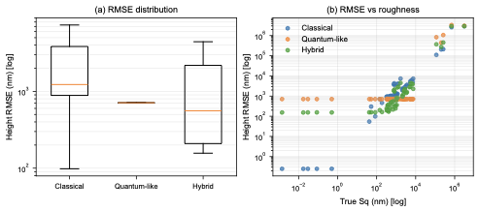
Measured-surface benchmark summary across all FV samples. Classical PSI and the hybrid branch remain the most texture-faithful estimators overall, whereas the direct quantum-like branch is only selectively competitive on smoother surfaces.
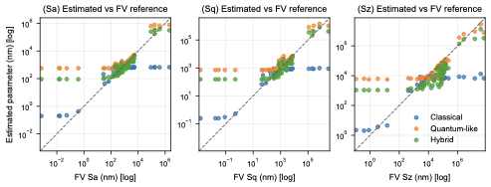
Comparison of reconstructed roughness parameters against the FV reference values. The hybrid branch is strongest for Sa, whereas the direct quantum-like branch is selectively favourable for Sq and Sz.
References
- Vorburger TV, Teague EC. Optical techniques for on-line measurement of surface topography. Precision Engineering. 1981;3:61-83.
- McDonnell EM, Deck LL. Solutions for environmentally robust interferometric optical testing. Proceedings of SPIE. 2020;11487.
- Okamoto R, Tahara T. Precision limit for simultaneous phase and transmittance estimation with phase-shifting interferometry. Physical Review A. 2021;104:033521.
- Richards RK. Quantum-entangled photon interferometry. Proceedings of SPIE. 2004;5531:17-23.
- Rarity JG, Burnett J, Tapster PR, Paschotta R. High-visibility two-photon interference in a single-mode-fibre interferometer. EPL. 1993;22:95-100.

