Hybrid Quantum-Inspired Profilometry: A Benchmark on Measured Rough Surfaces
Dawid Kucharski
Division of Metrology and Measurement Systems, Institute of Mechanical Technology, Faculty of Mechanical Engineering, Poznan University of Technology, 60-965 Poznan, Poland
Email: dawid.kucharski@put.poznan.pl
Abstract
We present a metrology-oriented benchmark comparing classical four-step phase-shifting interferometry (PSI), direct coincidence-inspired reconstruction, and a hybrid coarse-to-fine strategy for rough-surface profilometry under matched count budgets. The study combines controlled synthetic sweeps with real focus-variation (FV) microscopy topographies exported as .sur files and used as common reference surfaces for all simulated measurement channels. Performance is assessed using detrended height RMSE, areal roughness errors in Sa, Sq, and Sz, per-surface winner counts, and representative spatial-frequency fidelity. The current results do not support a universal quantum advantage. Classical PSI remains the most reliable baseline for fine-texture recovery and lowest pointwise height error, whereas direct quantum-like reconstruction is only selectively useful for smoother finishing-style surfaces and chiefly for envelope-dominated descriptors. The strongest nonclassical outcome is the hybrid strategy, in which coincidence-like information provides a coarse absolute-height prior while the final fine texture is preserved by the classical short-wavelength branch. In the measured-surface benchmark, the hybrid method gives the lowest median absolute error in Sa (197.0 nm), whereas the direct quantum-like branch gives the lowest median absolute errors in Sq and Sz (418.6 nm and 9498.0 nm). These results suggest that coincidence-based sensing is presently most promising as an auxiliary ambiguity-resolving channel within a hybrid profilometer rather than as a universal replacement for classical PSI.
1. Background and Aim
Optical profilometry remains an important route for surface-topography evaluation in precision manufacturing and functional-surface metrology [1]. Classical PSI is a strong baseline for high-precision surface measurement, but its practical performance can be limited by environmental sensitivity, phase-step error, and photon-statistical constraints [2,3]. In parallel, coincidence-based and entanglement-inspired interferometric schemes have been proposed as possible routes towards improved sensing [4,5]. What remains insufficiently explored is whether such schemes improve practically relevant rough-surface metrology endpoints under fair comparison conditions.
The aim of the present work is therefore not to claim a generic quantum advantage, but to determine when a coincidence-inspired channel should replace a classical PSI branch, when it should support that branch, and when it should be avoided. The benchmark is designed to extract a regime-dependent architectural recommendation rather than a single winner.
2. Benchmark Formulation
The study uses a common-surface framework. Real measured surfaces acquired by FV microscopy are exported as Mountains/DigitalSurf .sur files and treated as reference topographies. The same measured surfaces are then used to generate simulated classical photon-counting PSI frames and simulated coincidence-like measurements, allowing direct comparison of reconstruction pipelines on identical input topography.
Three reconstruction strategies are evaluated: classical four-step PSI, direct quantum-like reconstruction, and a hybrid coarse-to-fine method. In the hybrid branch, the coincidence-inspired channel provides only coarse or ambiguity-resolving height information, while the final fine texture is carried by the short-wavelength classical PSI branch. The coincidence channel is treated here as a phenomenological architecture proxy rather than a complete laboratory-grade fourth-order transfer model, so the present conclusions should be interpreted as benchmark-guided architectural evidence rather than as final experimental proof.
3. Current Results
Figure 1 summarises the measured-surface height benchmark across the FV dataset. Classical PSI and the hybrid branch remain the most texture-faithful estimators overall, whereas the direct quantum-like branch is only selectively competitive on smoother measured surfaces. Figure 2 shows the corresponding roughness-parameter comparison. The hybrid method is strongest for Sa, while the direct quantum-like branch is selectively favourable for Sq and Sz, which are more sensitive to envelope-scale excursions than to pointwise fine-texture fidelity.
This split is the central current result. The data do not support a universal quantum advantage. Instead, they support a regime-dependent conclusion. If the target is the lowest detrended height RMSE or the most faithful recovery of fine texture, classical PSI remains the default method. If coarse ambiguity handling is needed without sacrificing short-wavelength detail, the hybrid strategy is the stronger nonclassical option. A direct quantum-like branch is defensible only selectively, mainly in smoother finishing-style regimes and chiefly when Sq or Sz matters more than the absolute lowest pointwise height error.
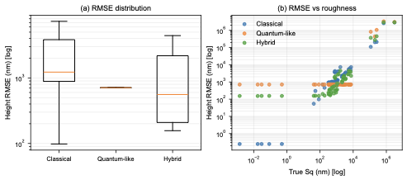
Figure 1. Measured-surface benchmark summary across all FV samples. Classical PSI and the hybrid branch remain the most texture-faithful estimators overall, whereas the direct quantum-like branch is only selectively competitive on smoother surfaces.
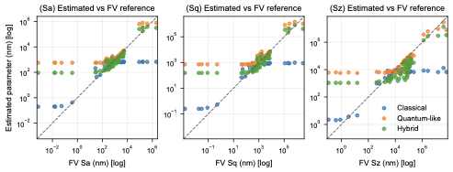
Figure 2. Comparison of reconstructed roughness parameters against the FV reference values. The hybrid branch is strongest for Sa, whereas the direct quantum-like branch is selectively favourable for Sq and Sz.
4. Conclusions
At the current stage of the project, the strongest conclusion is architectural. Coincidence-based sensing appears most promising as an auxiliary ambiguity-resolving channel within a hybrid profilometer rather than as a universal replacement for classical PSI. Ongoing work is focused on a more realistic coincidence model, stronger treatment of non-idealities, and experimental validation of the hybrid concept.
References
- Vorburger TV, Teague EC. Optical techniques for on-line measurement of surface topography. Precision Engineering. 1981;3:61-83.
- McDonnell EM, Deck LL. Solutions for environmentally robust interferometric optical testing. Proceedings of SPIE. 2020;11487.
- Okamoto R, Tahara T. Precision limit for simultaneous phase and transmittance estimation with phase-shifting interferometry. Physical Review A. 2021;104:033521.
- Richards RK. Quantum-entangled photon interferometry. Proceedings of SPIE. 2004;5531:17-23.
- Rarity JG, Burnett J, Tapster PR, Paschotta R. High-visibility two-photon interference in a single-mode-fibre interferometer. EPL. 1993;22:95-100.

