
CAREER DEVELOPMENT AND SUCCESSION PLANNING DEPARTMENT
IS GRADUATE TRAINEE PROGRAM
Investigate Data quality management and Develop a Predictive model for early warning for Loan Status Using machine learning, Explainable Artificial intelligence, and Deploy Model in case of CBE

BY
Dawit Shibabaw Bogale

Addis Ababa, Ethiopia August 2024



Table of content
Table of Contents
Table of content ii
List Table iv
List Figure v
Abstract vii
CHPATER ONE 1
INTRODUCTION 1
1.1. Background of the Study 1
1.2. Statement of the Problem 2
1.3. General objective 3
1.3.1. Specific objective 4
1.4. Scope of the study 4
1.5. Significance of study 4
CHAPTER TWO 5
Literature Review 5
2.1. Credit 5
2.2. Machine learning, deep learning and Explainable Artificial intelligence 5
2.3. Related work 5
CHAPTER THREE 7
Research Methodology 7
I. Data preprocessing and Explanatory data analytics (EDA) 7
3.1. Data preprocessing (Data quality issues) 7
3.1.1. Data cleansing 7
3.1.2. Data understanding 7
3.1.3. Handling Missing Values 7
A. Categorical features 8
B. Numerical features 8
3.1.4. Data Redundancy(duplication) 9
3.1.5. Data inconsistency (inaccurate/not updated) 9
3.1.6. Data inconsistency 9
3.1.7. Data transformation 9
3.1.8. Outlier detection and removal (numerical features only) 9
II. Explanatory data analytics (EDA) 10
A. Categorical feature analysis 11
B. Numeric feature analysis 20
3.2. Feature selection 23
3.2.1. Experiment# Wrapper methods 23
3.3. Model Development and Model Architecture 24
CHAPTER FOUR 26
Result and Discussion 26
Model development and model Explanability using Explainable Artificial intelligence 26
4.1. Hyperparameter tuning 26
4.2. Result and discussion 27
# Random forest 27
#Extreme Gradient Boost (XGBoost) 28
#lightBoost 28
#CatBoost 28
#Long Short Term Memory (LSTM) 29
#Multi-Layer Perceptron (MLP) neural network (MLPNN) 29
Model Explanation using Explainable AI such as: 29
4.3. Explanatory data analytics (EDA) and Model Deployment 31
# (EDA) Deploy 31
#Model Deploy 35
CHAPTER FIVE 37
Conclusion and recommendation 37
Conclusion 37
Recommendation 38
Reference 39

List Table
Table 1: the feature selection within the different feature 24
Table 2:- Algorithm Parameters 27
Table 3: overall result algorithms 29

List Figure
Figure 1: missing value by graph 8
Figure 2: after filling value accordingly 9
Figure 3: data redundancy if any or duplication 9
Figure 4: outlier detection using different plotting methods 10
Figure 5: outlier removal using IQR 10
Figure 6: outlier removal using Z-score 10
Figure 7: loan distribution across the country 11
Figure 8: loan status across the Ethiopia Region 12
Figure 9: loan status vs Region by parentage 12
Figure 10: districtname vs loan_status 12
figure 11: cbe_region vs loan_status 13
Figure 12: branchname vs loan_status by a line graph 13
Figure 13: branchname vs loan_status by percentage 13
figure 14: tenure vs loan_status 14
figure 15: term vs loan_status 14
figure 16: loan_type vs loan_status 15
figure 17: ltype vs loan_status 15
figure 18: loan_description vs loan_status 15
figure 19: loan_product vs loan_status 16
figure 20: dao_name vs loan_status by line graph 16
Figure 21: dao_name vs loan_status by percentage 16
figure 22: risk_grade vs loan_status 17
Figure 23: economic_sector vs loan_status 17
figure 24: industry vs loan_status by a line graph 17
Figure 25: industry vs loan_status by percentage 17
figure 26: ownership vs loan_status 18
figure 27: sector vs loan_status by a line graph 18
Figure 28: sector vs loan_status by bar percentage 18
figure 29: term_of_payment vs loan_status by line graph 19
Figure 30: figure 31: term_of_payment vs loan_status by percentage 19
figure 32: product_owner vs loan_status by line graph 19
Figure 33: product_owner vs loan_status by percentage 19
figure 34: collateral vs loan_status by the line graph 20
Figure 35: figure 36: collatteral vs loan_status by parentage 20
Figure 37: Loan_status vs quarter by bar graph 20
Figure 38: Loan_status vs quarter by line graph 20
Figure 39: Trends loan_status over all Dataset 21
Figure 40: loan_staus between 2014 -2024 since T24 by line graph 21
Figure 41: loan_staus between 2014 -2024 since T24 by percentage graph 21
Figure 42: Loan status over the months from 2014 -2024 22
Figure 43: loan status month since (2014-2024) by parentage 22
Figure 44: weekly loan status from 2014- 2024 22
Figure 45: daily loan status from 2014- 2024 22
Figure 46: model Architecture 25
Figure 47: random forest result 28
Figure 48: # XGBoost result 28
Figure 49: Light boost result 28
Figure 50: CatBoost Result 28
Figure 51: The Result of LSTM 29
Figure 52: The result of MLPNN 29
Figure 53: Explainable AI using SHAP and LIME 30
Figure 54: GUI for EDA 32
Figure 55: EDA dynamic tool single year, which is yearly 32
Figure 56:EDA dynamic tool for monthly 33
Figure 57: EDA dynamic tool for Weekly 33
Figure 58: EDA dynamic tool for daily 34
Figure 59: Quarterly Report, the same procedure for Quarter 3, and Quarter 4 35
Figure 60: GUI which is used to accept new data from users and make decisions 36
Figure 61: Model displays the prediction result with its probability for each class 36

Abstract
The Commercial Bank of Ethiopia is a giant commercial bank in Ethiopia. It was established in 1942 as the State Bank of Ethiopia. Over the last few years, CBE has undergone several reforms that include new technology deployment and modernization of its operations. These reforms aim to enhance the efficiency and competitiveness of CBE, thereby helping it play a bigger role in Ethiopia's economy. Currently, it has more than 1,900 branches across Ethiopia. The probability of being creditworthy of the borrowers can be characterized by the willingness and ability of the borrowers. These factors might have significant impacts on the repayment performance of the respective borrowers
As the researcher’s knowledge, related works show some limitations/gaps attempt to predict loan default and deploy model and EDA. In this study, hence, we develop the predictive model and prototype for loan default and dynamic data analytics. Data was collected from the Commercial Bank of Ethiopia credit data from 1980 to 2060 G.C. The data were pre-processed to get quality data that are suitable for a machine-learning or deep learning algorithm to develop a model that predicts loan default. For constructing the proposed model, six experiments were conducted with a training and testing dataset split ratio of 80/20 using Random forest, Extreme gradient boosting, cat boost, light boost, long short-term memory, and Multi-layer preceptor neural network algorithms. The overall accuracy of random forest, gradient boosting, and cat boost with 30 features. The extreme gradient boost algorithm is selected as the best algorithm due to the result of both objective evaluation-based metrics. After we trained the model and maintained the data quality we deployed the model and EDA on the Streamlit Python framework for real-world scenarios.
Keywords: loan default, early warning signal, loan Status, Explanatory data analytics (EDA) deploy, Streamlit. Model deployment

CHPATER ONE

INTRODUCTION

Background of the Study
The Commercial Bank of Ethiopia is a giant commercial bank in Ethiopia. It was established in 1942 as the State Bank of Ethiopia. Since then, it has provided essential banking services to businesses and individuals, and it also plays a role in the government's economic development policies (HUNDE, 2023). Over the last few years, CBE has undergone several reforms that include new technology deployment and modernization of its operations. These reforms aim to enhance the efficiency and competitiveness of CBE, thereby helping it play a bigger role in Ethiopia's economy. Currently, it has more than 1,900 branches across Ethiopia (HUNDE, 2023).
One of the most significant products from financial institutions is the loan. Every institution is attempting to devise successful business plans in order to get more clients to submit loan applications. However, after their applications are granted, some consumers are unable to repay the loan (Chang Han et al., 2019). One of the most significant offerings from financial institutions is the loan. Every institution is attempting to devise successful business plans in order to get more clients to apply for loans. Nevertheless, some clients find that even once their application is accepted, they are unable to repay the loan. Because of this, many financial institutions consider a number of factors before accepting a loan. It might be challenging to predict whether a particular borrower will pay off the loan in full or will cause it to be charged off. Less loans are accepted when a lender is overly stringent, which reduces the amount of interest that may be collected (Liang et al., 2019).
The Loan Prediction System (LPS) is an advanced financial tool that utilizes machine learning and data analytics to assess the creditworthiness of early warning signal for loan status. early warning signals of loan status using AI involves identifying potential signs that a borrower may default on a loan or face financial difficulties. AI can help in this process by analyzing large amounts of data to identify patterns and indicators that may not be obvious through traditional analysis(Rathore et al., 2023).

Statement of the Problem
The willingness and capacity of the borrowers can be used to determine their likelihood of being creditworthy (Adinew, 2019). These elements may have a major effect on how well the individual borrowers do when making their repayments. Furthermore, the presence of additional internal and external variables that may impact borrowers' attitudes toward repayment can have a substantial impact on the overall payback recovery rate of lending institutions (Adinew, 2019). Banking institutions' primary duty is to lend money to its clients. Banks sought to meet community credit demands while generating revenue as their main goal when allocating cash (GERBA, 2019). One of the most crucial roles for the use of cash, according to the banking sector, is lending. The main source of income for banks is from loans and advances, which are the most profitable of all their assets. Since banks are businesses, their goal when offering loans and advances is to maximize profits (GERBA, 2019).
In the context of asymmetric knowledge, banks offer loans and advances, which inevitably entails some degree of risk. It is therefore unlikely to actually have 100% of the collection of loans and advances due to both controllable and uncontrollable circumstances. Since there are additional circumstances that are both inside and beyond of one's control, as well as the uncertainty surrounding future economic situations, loan defaults are unavoidable. Finding ways to reduce this risk's rate is the primary problem. How can we lower the percentage of non-performing loans by figuring out what causes them, or improve the asset quality of financial institutions? Crisis in banking is intimately linked to non-performing loans(Asgedom et al., 2015). The amount of non-performing loans is a major factor in the start and development of banking and financial crises, according to several experts. In both industrialized and developing nations, bank failures and financial crises are frequently linked to non-performing loans (NPLs) if they are not adequately managed and maintained at a fair standard. Since a significant quantity of non-performing loans (NPLs) in the banking system directly leads to bank collapse, the problem of NPLs has drawn attention from all over the world in the last several decades(Asgedom et al., 2015). Historically, a significant build-up of non-performing loans has been linked to the occurrence of banking crises. These loans can make up a substantial portion of the total assets of bankrupt banks and financial institutions, particularly during a time of systemic crises(GERBA, 2019)(Bededa, 2021).
To this end, different research was conducted on predicting loan default and its related risk factors all over the world. Most research is done on loan default prediction using machine learning and deep learning algorithms across the world, while research conducted in another country couldn’t be adopted directly because they trained different datasets, data types, and data structures. For example, Chang Han et al.(Chang Han et al., 2019), A. G. HUNDE et al.(Adinew, 2019) and M. B. Bededa et al. (Bededa, 2021), However, these researches were conducted using descriptive statistical analysis methods on the statistical package for social science (SPSS) methods by applying binary and multivariate logistic regression techniques.. These studies did not develop a predictive model, did not design an artifact, In such situations, new technologies like machine learning, and deep learning algorithms may help to discover hidden patterns, identify a set of risk factors proactively, and generate rules that may facilitate policy formulation toward reducing loan default risk levels (Abaidullah et al., 2014). Hence, the lack of previous research that used descriptive statistical analysis methods to study loan default in Ethiopia motivates this study to investigate the potential application of big data analytics and some Deep learning algorithms to identify risk factors, predict early warning signal loan status default risk, and design artifacts in the case of Ethiopia and generate rules that help to develop evidence-based policies and interventions towards loan default risks in Ethiopia. This study, therefore, aims to develop a model that predicts early warning signals for loan status using neural networks and some homogeneous ensemble machine learning algorithms.
To this end, this study attempts to explore and answer the following research questions:
- What is the underlying structure and evolution of loan status on its in Ethiopia over time?
- Which machine learning methods are most effective works for loan status?
- To what extent models are correctly classify the loan status?

General objective
To Investigate Data quality issues and Develop a Predictive model for early warning signals for Loan Status Using machine learning, Explainable Artificial intelligence, and Deploy Model

Specific objective
To achieve the general objective stated above, the following specific objectives were accomplished throughout the study: These specific objectives are:
- To explore the different explanatory data analytics techniques to manage data quality issues.
- To investigate how the model works /classifies using the Explainable AI
- To develop a classification model for credit repayment status.
- To identify the model which performs better, for deployment
- To calculate the probability of each target class of the loan status.
- To deploy the model for domain expert usage.

Scope of the study
The mainly focus on developing early warning for loan status starting from credit dispersed up to collection and design dynamic Explanatory data analytics to words loan status. The model works customer starting from loan dispersed up to collection of loan, to know the customers properties and bank profitability by early/ proactively loan status before date repayment using Artificial intelligence.

Significance of study
The findings of this research would be used to predict loan repayment status and the result would help different stakeholders to prevent and tackle loan default risks. For credit follow up: -these model helps to know the borrower’s behavior before the repayment date and follow up based on the repayment, in addition to date held on T-24. Policymakers and credit analyst can make use of the model to develop new guidelines and policies and/or modify the existing risk grade and collateral value to improve the achievement of healthiness of credit and reduce loan default. The results may also serve the programmers and researchers as baseline data for reference and initiate further researches to be conducted in the future. And also, dynamic Explanatory data analytics to know the healthy credit and to know loan status using different features dimensionality.

CHAPTER TWO

Literature Review

Credit
Credit is established when a person borrows money and agrees to pay it back. The money can be obtained through a bank or other institution, as well as through friends and family (Black, 2017). There is usually a set agreement outlining a repayment schedule and setting the amount the individual will be charged for using the money (interest and fees)(Can & Both, 2021). In most lending situations the borrower pays back more than was borrowed (Black, 2017).

Machine learning, deep learning and Explainable Artificial intelligence
Machine learning: is all about creating algorithms that allow the computer to learn. Learning is the process of identifying statistical regularities or other data patterns, and machine learning algorithms are designed to mimic a human's approach to learning a task (Nasteski, 2017).
Deep learning: is a class of machine learning which performs much better on unstructured data. Deep learning techniques are outperforming current machine learning techniques (Mathew et al., 2021). It enables computational models to learn features progressively from data at multiple levels (Mathew et al., 2021).
Explainable Artificial Intelligence (XAI): Deep learning (DL) and machine learning (ML) are major branches of Artificial Intelligence. The ‘black box’ nature of DL and ML makes their inner workings difficult to understand and interpret (Barredo Arrieta et al., 2020). The deployment of explainable artificial intelligence (XAI) can help explain why and how the output of DL and ML models are generated. As a result, an understanding of the functioning, behavior, and outputs of models can be garnered, reducing bias and error and improving confidence in decision-making (Love et al., n.d.).

Related work
According to G. Arutjothi et al.(Arutjothi & Senthamarai, 2018) conducted research on Prediction of Loan Status in Commercial Bank using Machine Learning Classifier, researchers used the total datasets 924 records and total 74 feature having 73 independent feature. The research used K-NN algorithms with accuracy different percentage of training and testing datasets.
According to E. E. Hussein,et al.(Hussein et al., 2023), conducted research on the Machine Learning Algorithms for Predicting the Loan Status, the total dataset researcher used the commercial banks data 614 dataset and researcher also used experimental science, researcher also obtained 75%, 74% accuracy of using Logistic regression and Support vector machine respectively.
E. Enas,et al. (Enas et al., 2024), conducted research on the, Improving Loan Status Prediction Accuracy with Generative Adversarial Networks: Addressing Data Scarcity and Bias, the total datasets of researcher used in these research was We identified the obstacles of insufficient data, bias, and imbalanced classes and have illustrated how generating datasets using GAN data augmentation can tackle such issues. Through the use of ActGAN to generate synthetic loan data points, we managed to improve the accuracy of several machine learning models to a great extent. Support Vector Machines (SVM) and bagged tree model ensemble were the best performers, the accuracy rates (both train and test) have been above 93%.
According H. Singh Sandhu et al.(Singh Sandhu et al., 2023), conducted research on the, Loan Prediction System Using Machine Learning, To create a logistic classification model that predicts loan status, over 600 sample data were collected and evaluated. The algorithm can obtain a maximum accuracy of about 82 percent and regression models are used to obtain such precision.
Accordingly A. Jafar Hamid, et al. (Jafar Hamid & Ahmed, 2016)Developing prediction model of loan Risk in banks using data mining. Researcher employed the following algorithms Naïve Bayes Classifier, Neural Network Classifier, decision Tree Classifier. three algorithms - j48, bayesNet and naiveBayes algorithms was used to build a predictive model that can be used to predict and classify the applications of loans that introduced by the customers to good or bad loan by investigate customer behaviors and previous pay back credit.
And also G. J. Sitepu, et al. (Sitepu & Nugraha, 2022) also conducted researcher on, A Backpropagation Artificial Neural Network Approach for Loan Status Prediction, researcher used the total dataset 983 observation and did the experiment shows the best performance metrics from the first model are 94.37% accuracy, 78.57% sensitivity, 98.25% specificity, 91.67% precision, and 84.62% F1 score using Backpropagation Artificial neural networks.

CHAPTER THREE

Research Methodology
Research design is a strategic framework for action that acts as a link between research questions and the execution, or implementation, of the research strategy. Design science research design method includes six steps: problem identification and motivation, the definition of the objectives for a solution, design and development, demonstration, evaluation, and communication (Ponti, 2018). In this study, we used the design science research method.

I. Data preprocessing and Explanatory data analytics (EDA)

Data preprocessing (Data quality issues)

3.1.1. Data cleansing

3.1.2. Data understanding
In the data understanding phase, we have to understand the types of features, and their values and also identify which features are continuous and which features are discrete/categorical valued. Also, knowing about basic statistics. The dataset in credit was around 29309 datasets while we selected 73293 datasets randomly from the beginning, middle, and end of the record.

3.1.3. Handling Missing Values
The researcher will use the Imputation method. In this approach, missing values are filled in with estimated values. Common imputation techniques include mean imputation, median imputation, mode imputation, or regression imputation. Mean imputation replaces missing values with the mean of the available values for that feature, while median imputation uses the median, and mode imputation uses the most frequent value.
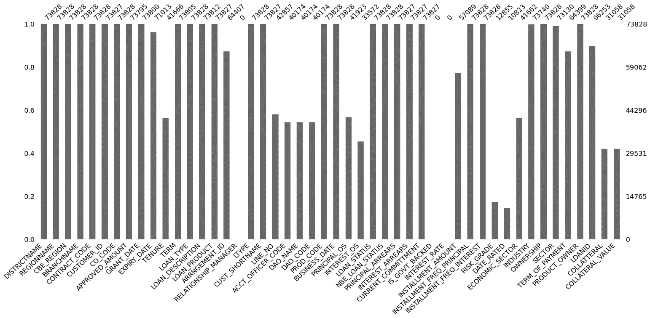
Figure 1: missing value by graph
There are 100% missed features in the above graph such as Relashishop_managger, Is_Gov’t_backed, and interest rate, so there is no means way to fill these missed values so we delete these columns.

Categorical features
Fills missing values using the specified method:
- Mode: Fills with the most frequent value in the column.
- Bfill: Backward fills missing values
- Ffill: Forward fills missing values
- Constant: Fills with a constant value (e.g., 0).
- Interpolate: the method used to estimate unknown values that fall between known values in a sequence or dataset.

Numerical features

Fills missing values using the specified method:
- mean: Fills with the mean of the column.
- median: Fills with the median of the column.
- mode: Fills with the most frequent value in the column.
- ffill: Forward fills missing values.
- bfill: Backward fills missing values.
- constant: Fills with a constant value (e.g., 0).
- K-Nearest Neighbors: Uses K-Nearest Neighbors imputation to fill in missing values. The number of neighbors can be specified with n_neighbors.
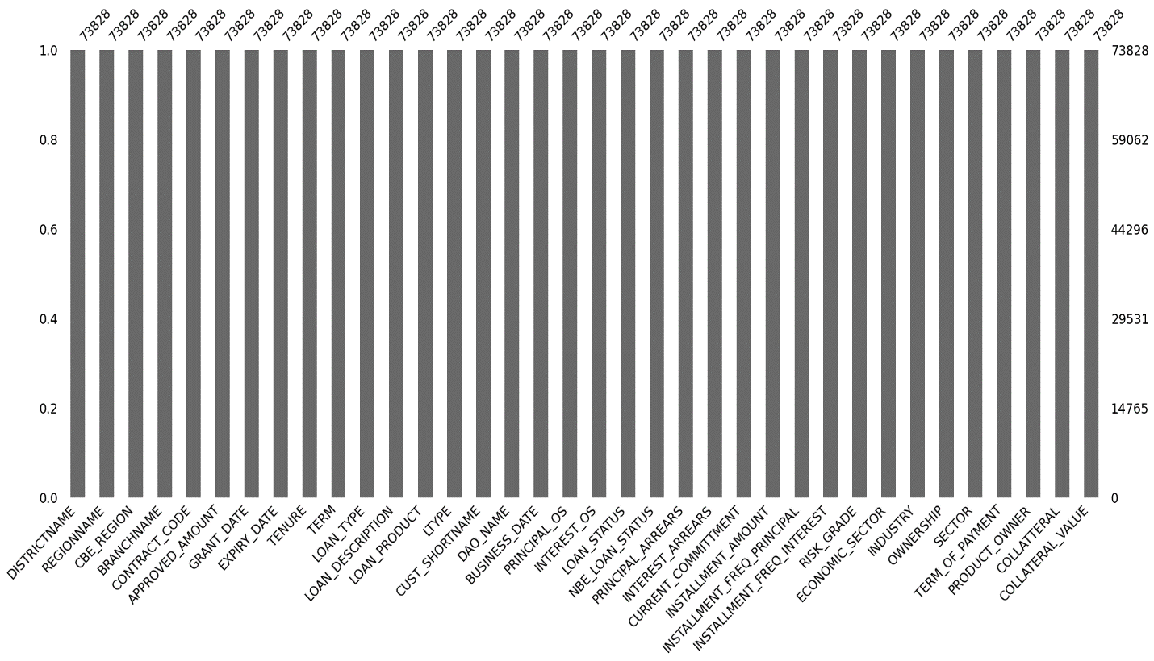
Figure 2: after filling value accordingly

3.1.4. Data Redundancy(duplication)
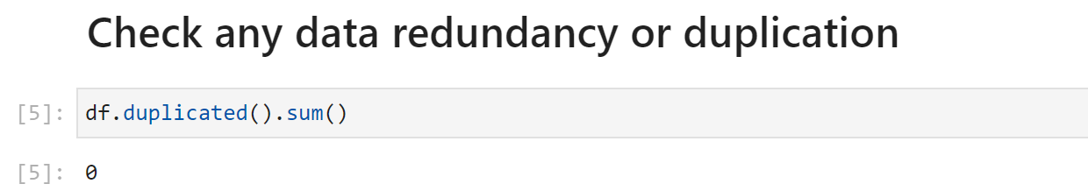
Figure 3: data redundancy if any or duplication

3.1.5. Data inconsistency (inaccurate/not updated)
PRODUCT_OWNER and DISTRICTNAME

- CONSUMER WEST ADDIS
- CONSUMER NORTH ADDIS
- CONSUMER EAST ADDIS
- CENTRAL ADDIS CONSUMER
- CONSUMER SOUTH ADDIS
- Resident Housing Loan
- RESIDENT HOUSING LOAN
- International Banking

  - **All of PRODUCT_OWNER and DISTRICTNAME is under Head office **

3.1.6. Data inconsistency
- DEBRE BIRHAN and DEBRE BREHAN but two the PRODUCT_OWNER spelling error, correct on is DEBRE BREHAN

3.1.7. Data transformation
Above data inconsistency and inaccurate or not updated data must be transformed into accurate and consistent ones by the recommendation of the domain expert accordingly. Above inconsistent and inaccurate transformed by Binning method as domain expert’s recommendation

3.1.8. Outlier detection and removal (numerical features only)
Visualizes outliers using three types of plots:
- Box Plot: Helps to visualize the distribution of the data and identify outliers.
- Histogram: This shows the frequency distribution of the data and can indicate the presence of outliers.
- Scatter Plot: Used to visualize the relationship between two numeric columns. If there's only one numeric column, it skips this plot.
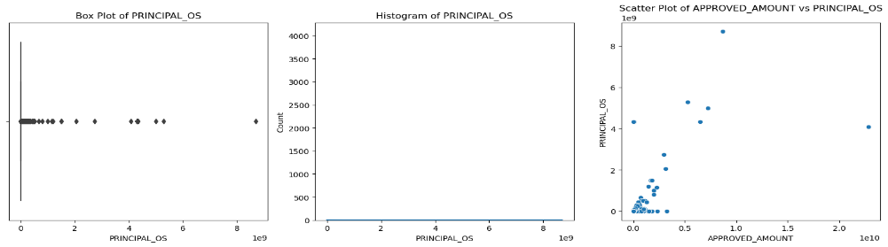
Figure 4: outlier detection using different plotting methods
Detects and remove outliers using the specified method:
- 'z_score': Uses the Z-score method to detect outliers. A Z-score above the threshold (default 3) is considered an outlier.
- 'Inter quartel range': Uses the Interquartile Range (IQR) method to detect outliers. Values outside 1.5 times the IQR below the first quartile (Q1) or above the third quartile (Q3) are considered outliers
Inter quartile range (IQR) Outlier detections Z-score

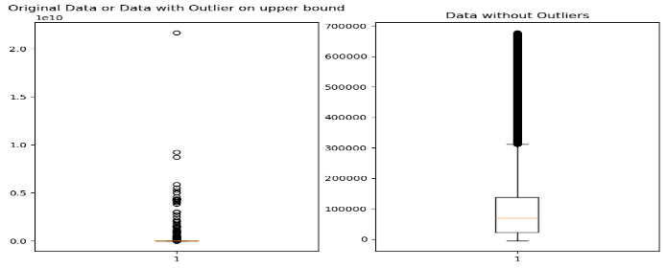
Figure 5: outlier removal using IQR
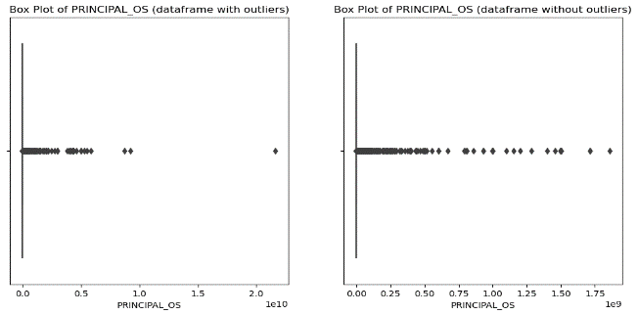
Figure 6: outlier removal using Z-score

II. Explanatory data analytics (EDA)
We classified the dataset into two data frames to extract patterns from a dataset that we used in our experiments since we have both categorical features and numeric features in order to easily extract patterns from both datasets.

Categorical feature analysis

show distribution credit across the country on the map
- from the Region name we extract the latitude and longitude.
- From geospatial data we extract shapes.
- we view the distribution of credit in the country.
- identify which region is mostly taking credit and why?
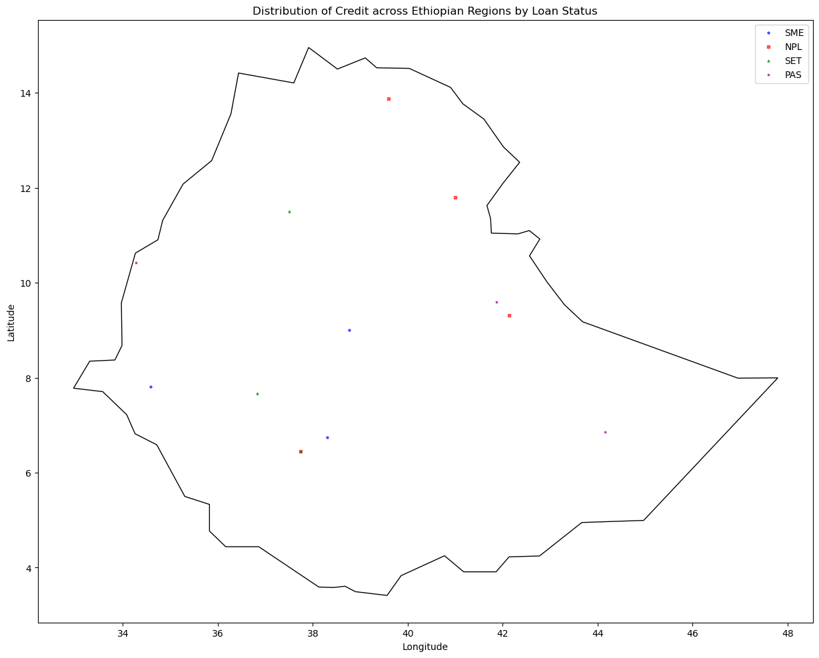
Figure 7: loan distribution across the country
REGIONNAME vs LOAN_STATUS
- Addis Ababa SET and PAS highly
- next to AA Oromia
- next to Oromia Amhara is highly PAS and SET loan
- NPL is higher in Tigray region

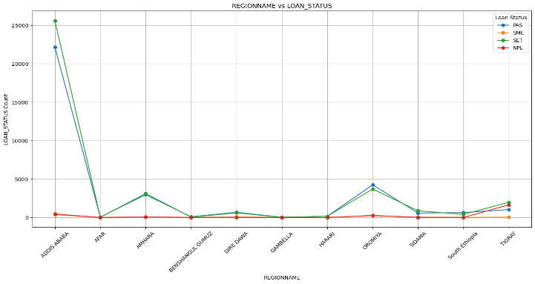
Figure 8: loan status across the Ethiopia Region
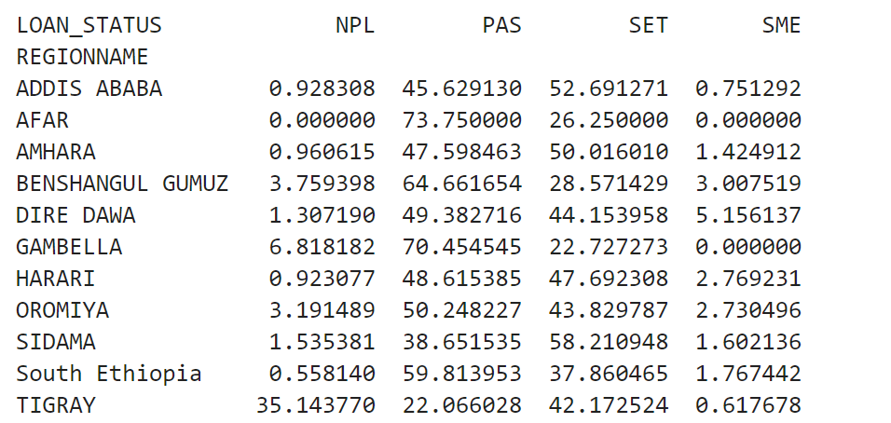
Figure 9: loan status vs Region by parentage

DISTRICTNAME vs LOAN_STATUS
- List of Districts which is highly SET and PAS loans
- consumer east Addis
- central Addis consumer
- List of Districts which is highly SET and PAS loans
- wolitya sodo
- yeka
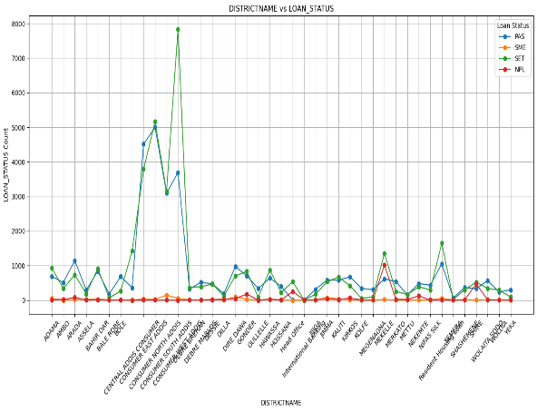
Figure 10: districtname vs loan_status
CBE_REGION vs LOAN_STATUS
- relatively central region highly in terms SET and Pass
- in North east region there, the high number of loans which NPL
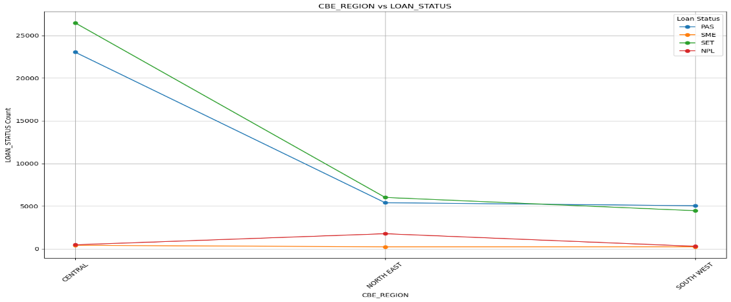
figure 11: cbe_region vs loan_status
BRANCHNAME vs LOAN_STATUS

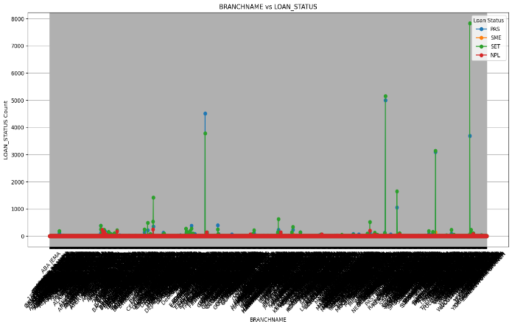

Figure 12: branchname vs loan_status by a line graph
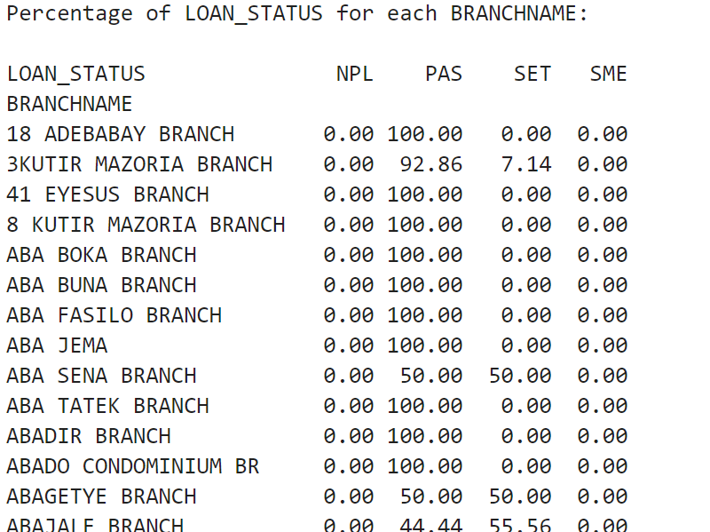

Figure 13: branchname vs loan_status by percentage

on the above, it's difficult to identify which branches are well-collected loans as well, since we have a number of branches that way in the axis is blared so we use another method such as parentage some branches screen shoots.
TENURE VS LOAN_STATUS
- long Term highly SET
- relatively Pass them from long, Medium, and Short term decreasing
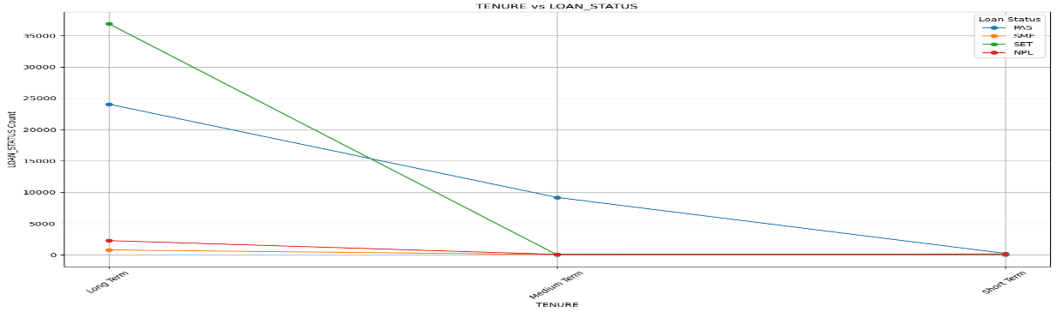
figure 14: tenure vs loan_status
TERM vs LOAN_STATUS
- most long-term loan SET
- most long-term loan PAS
- short term loan also PAS
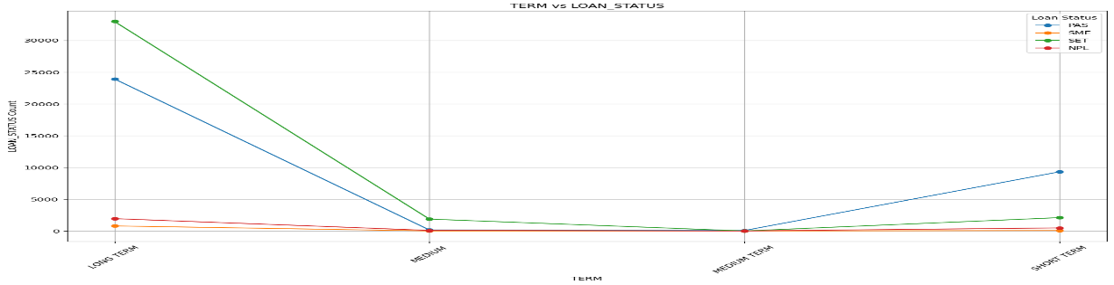
figure 15: term vs loan_status

LOAN_TYPE vs LOAN_STATUS
- TL loan_type highly SET and also PAS
- IFB, GB, ML, and AL type of loans remain the same in all Loan Status
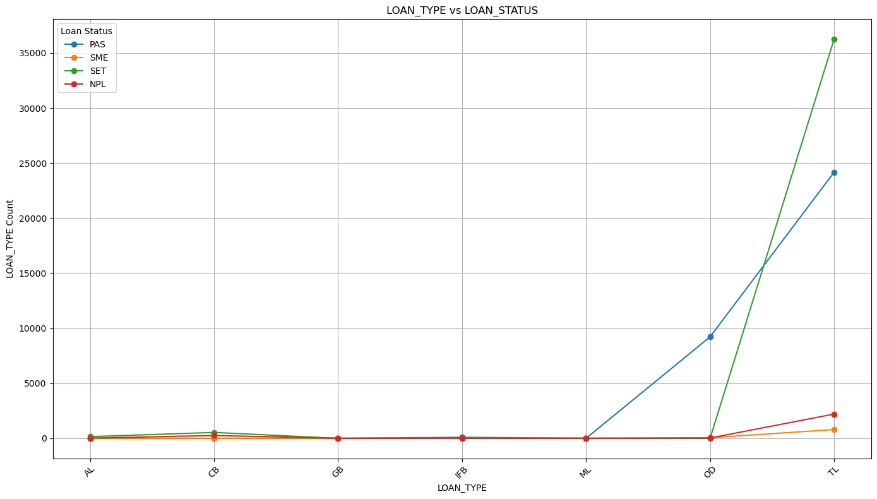
figure 16: loan_type vs loan_status
LTYPE vs LOAN_STATUS
- AA LTYPE is highly SET and PAS
- OD also PAS well
- while LA and LD remain the same in the whole Aspects (LOAN_STATUS)
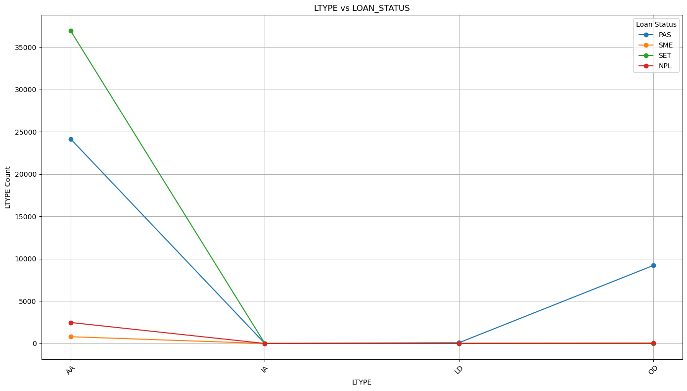
figure 17: ltype vs loan_status
LOAN_DESCRIPTION vs LOAN_STATUS
- Most agricultural investment products Loan are SET and also PAS
- Special Staff loans are SET
- Staff personal Loan
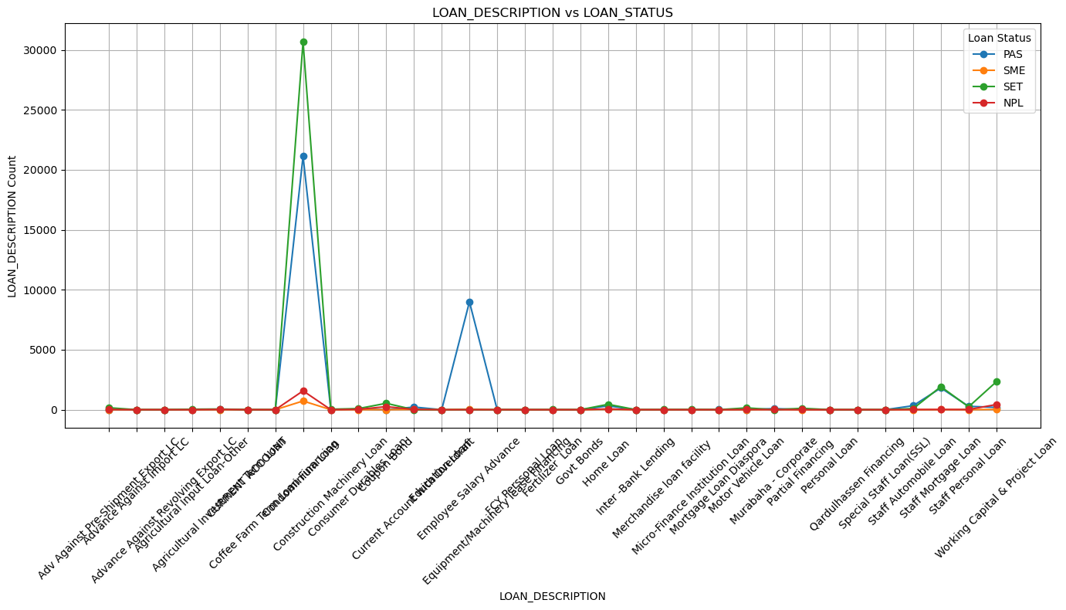
figure 18: loan_description vs loan_status

LOAN_PRODUCT vs LOAN_STATUS
- coffee term fin loan products are highly SET
- condo. 1 BED loan products are highly SET
- NREV.preseve highly PAS
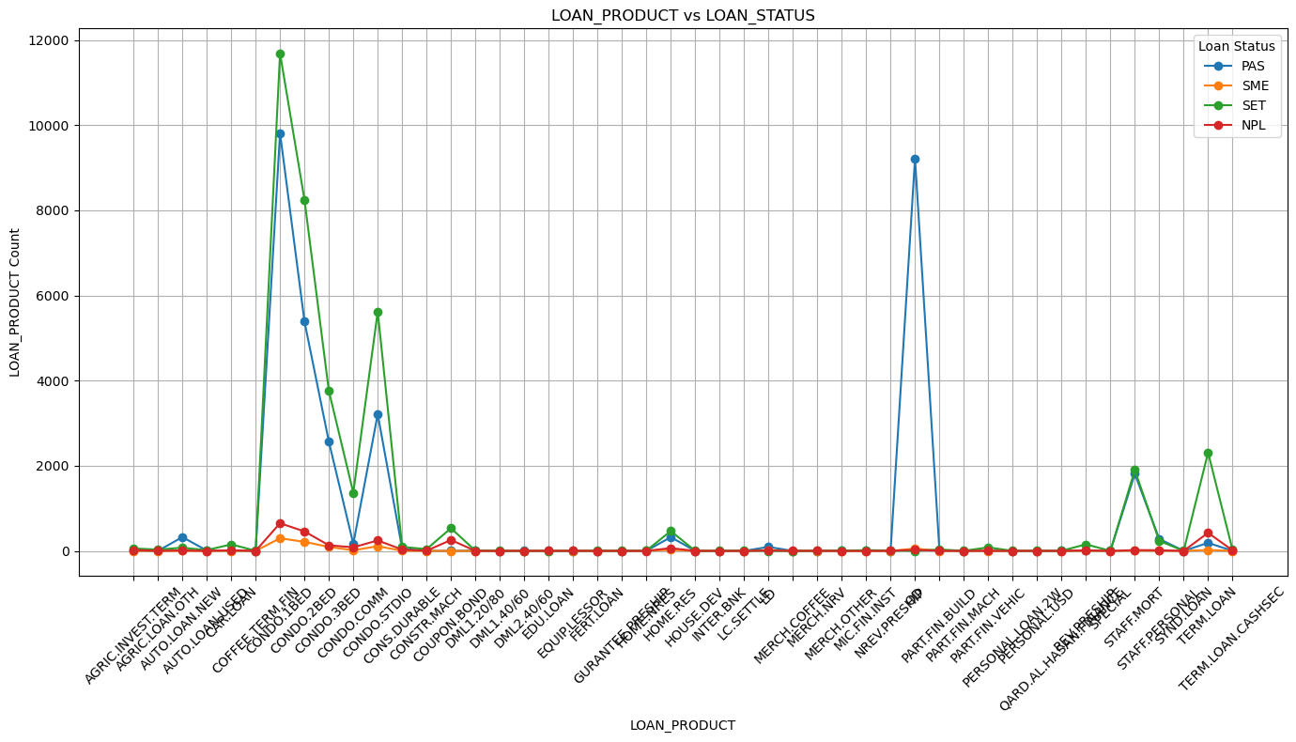
figure 19: loan_product vs loan_status
DAO_NAME vs LOAN_STATUS

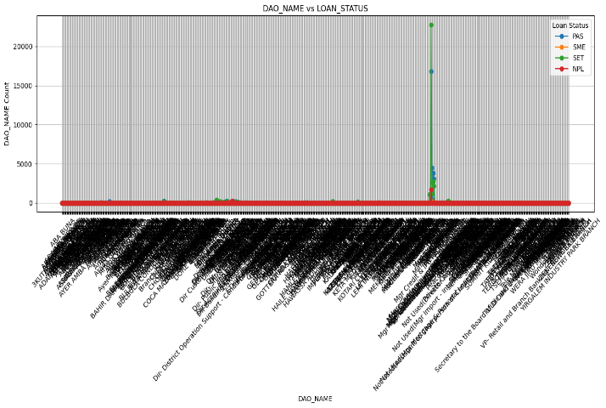
figure 20: dao_name vs loan_status by line graph
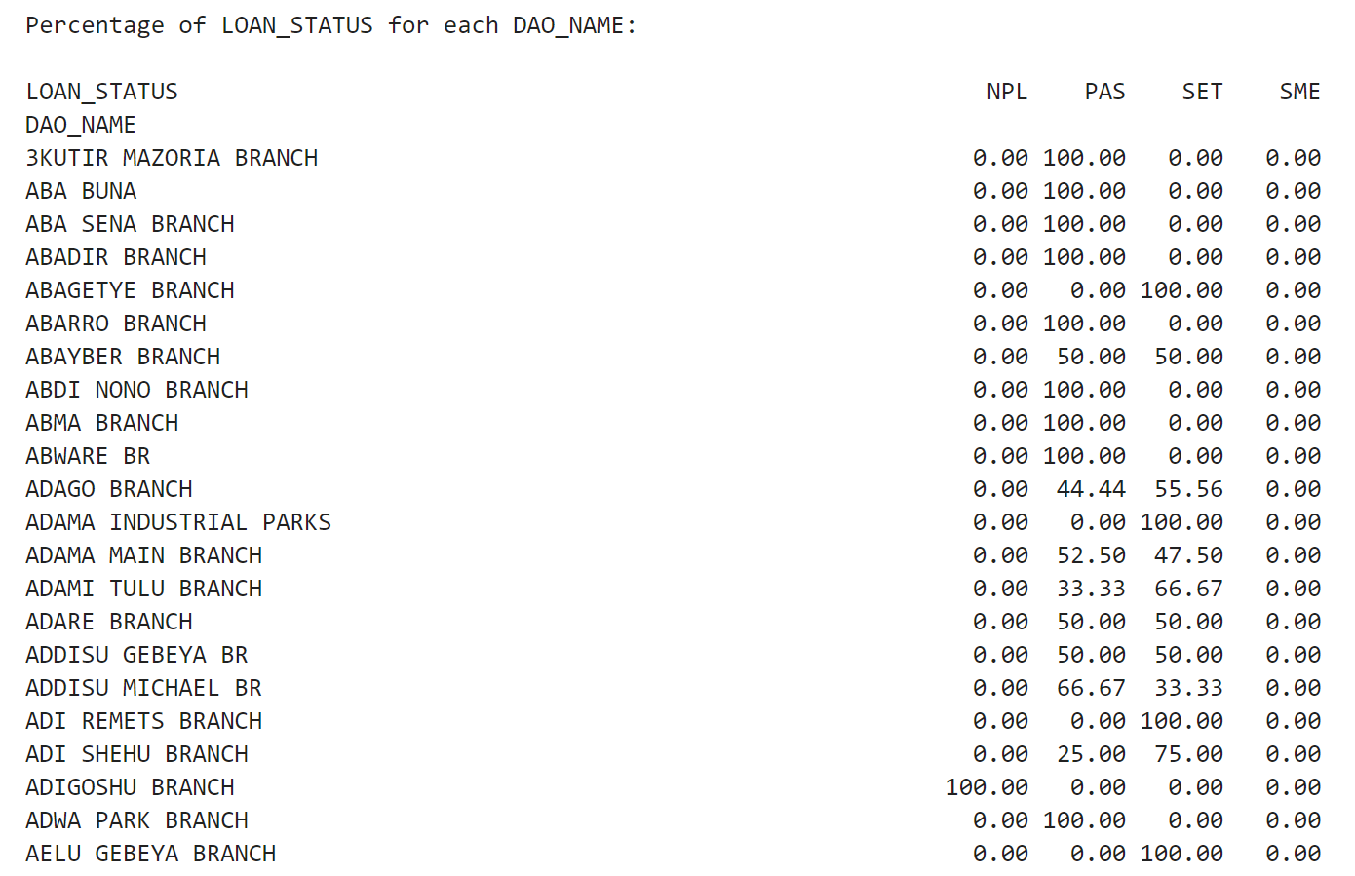

Figure 21: dao_name vs loan_status by percentage

Since the above line graph did not show any clarity issue we used another alternative on the issues that way we used the percentage
RISK_GRADE vs LOAN_STATUS
- RG3 Highly SET Loan
- RG3 Highly PAS Loan
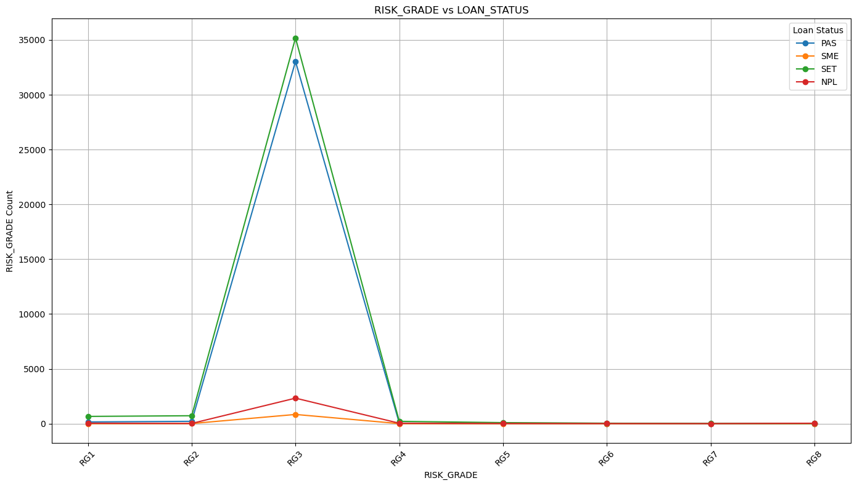
figure 22: risk_grade vs loan_status
ECONOMIC_SECTOR vs LOAN_STATUS
- Building and constriction have SET and PAS max
- consumer and staff loans have SET and PAS max
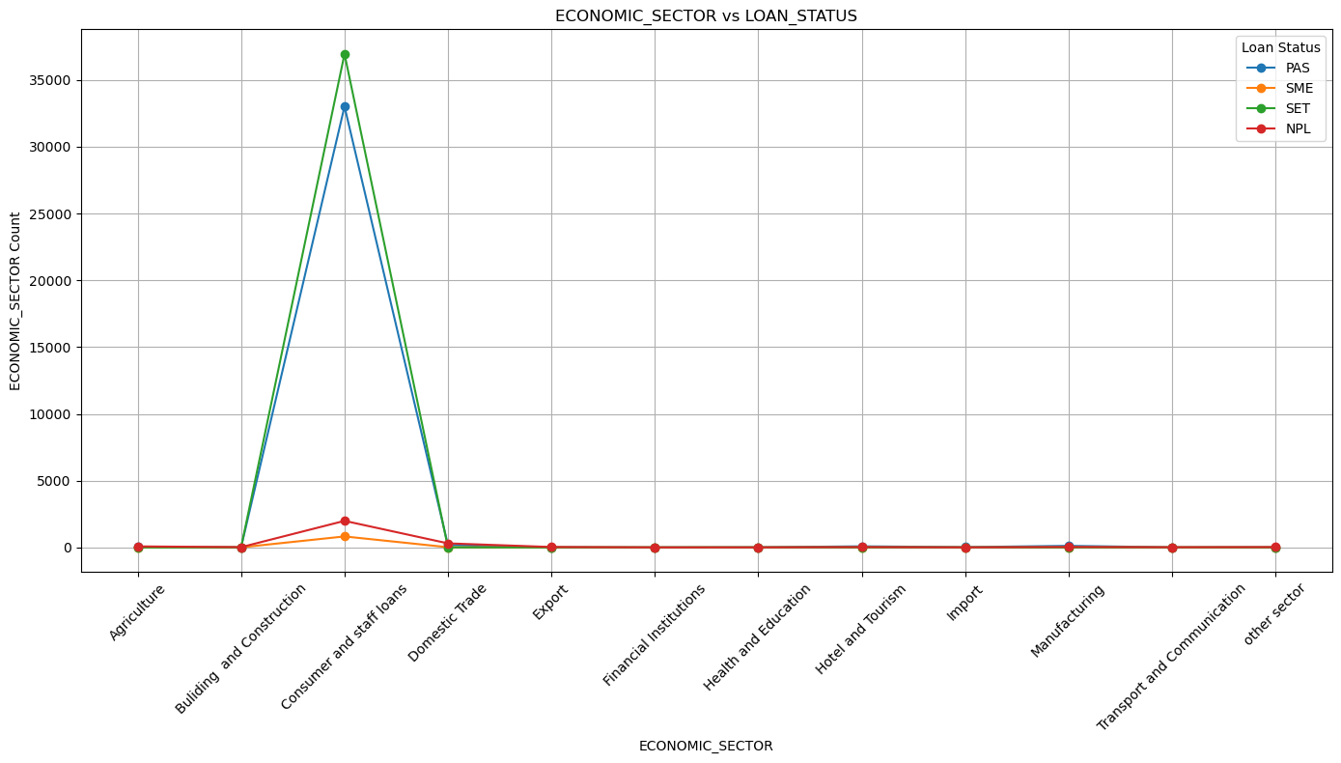

Figure 23: economic_sector vs loan_status

INDUSTRY vs LOAN_STATUS

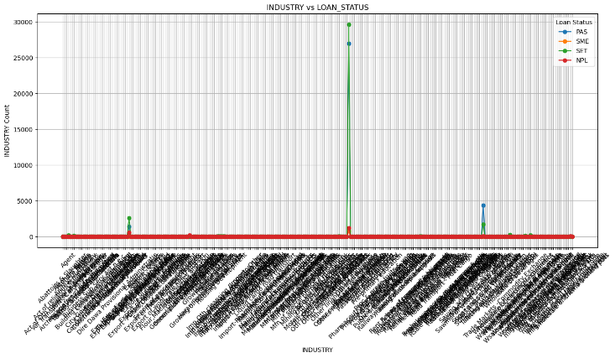
figure 24: industry vs loan_status by a line graph
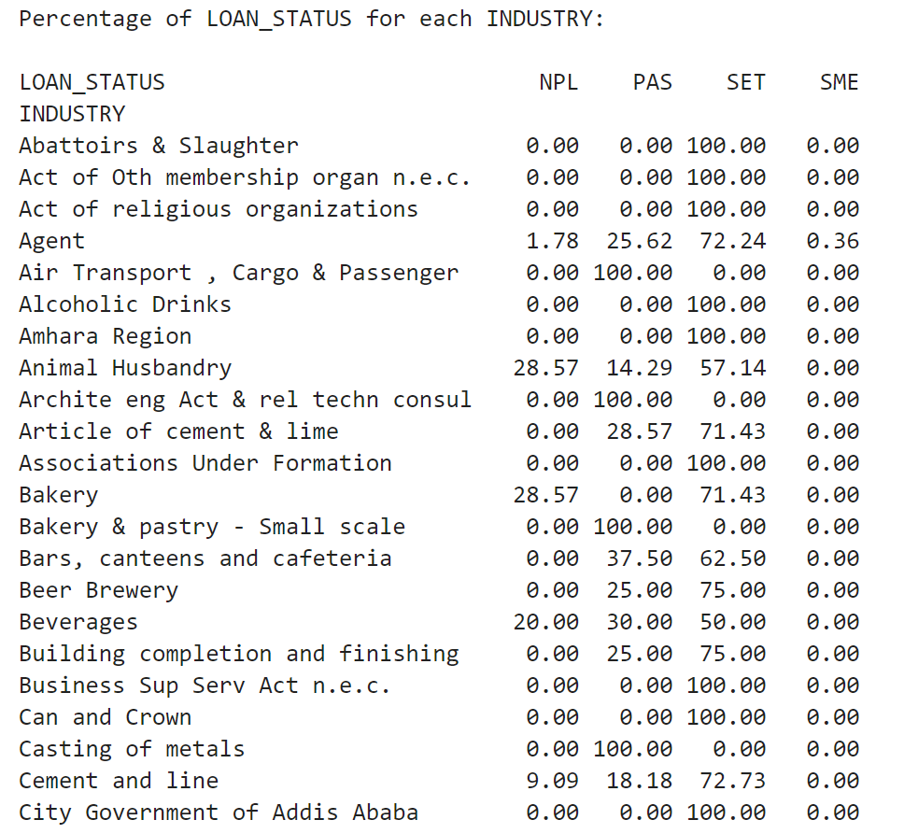
Figure 25: industry vs loan_status by percentage

in these graphs, we can show zoom-in and zoom-out options in the Python editing environment while in order to present we have seen these percentage
OWNERSHIP vs LOAN_STATUS
- private owners have highly PAS and SET loan
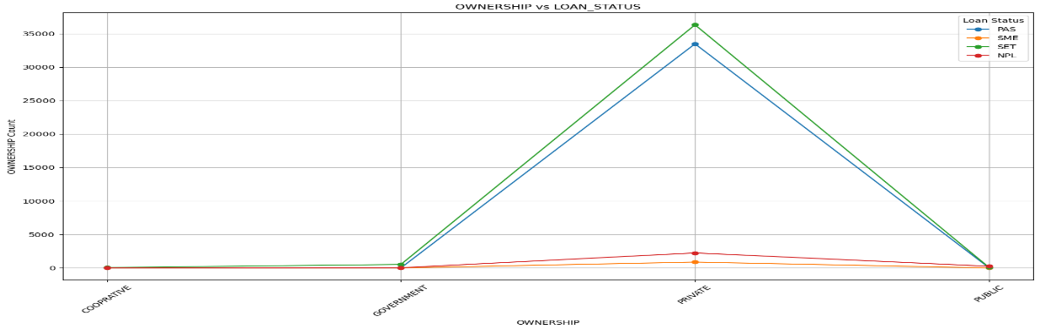
figure 26: ownership vs loan_status
SECTOR vs LOAN_STATUS
- individual sectors have highly SET Loan

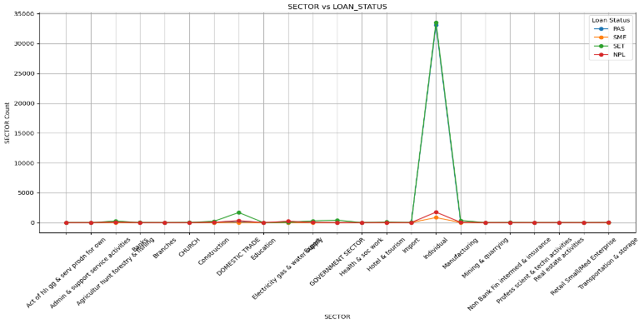
figure 27: sector vs loan_status by a line graph
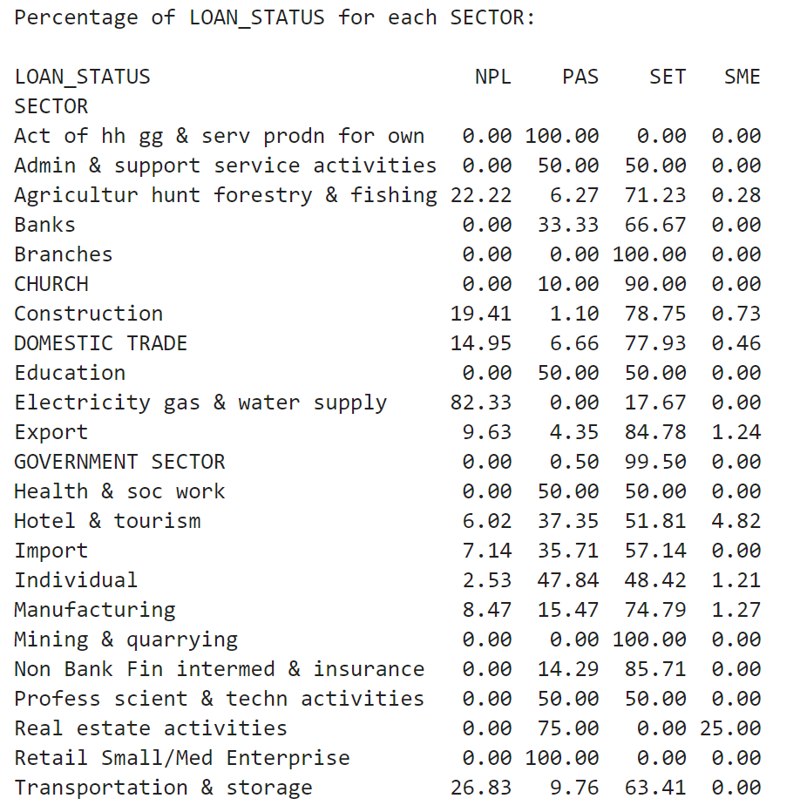
Figure 28: sector vs loan_status by bar percentage

100% PAS Sectors
- Act of hh gg & serv prodn for own
- Retail Small/Med Enterprise
80% NPL Sectors
- Electricity gas & water supply
100% SET Sectors
- Branches
- Mining & quarrying
25 % SME Sectors
- Real estate activities

TERM_OF_PAYMENT vs LOAN_STATUS
- Monthly paid customers are highly PAS and SET Loan

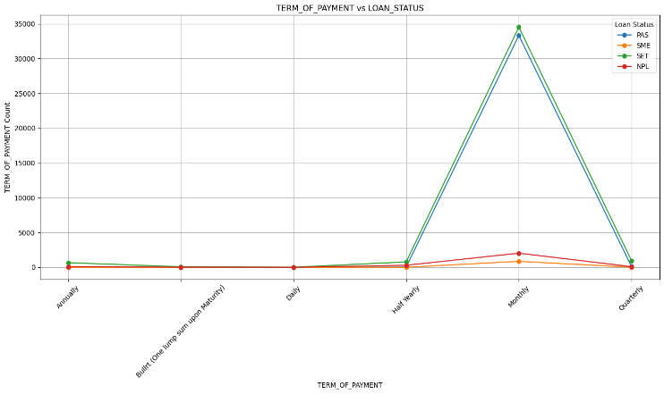
figure 29: term_of_payment vs loan_status by line graph
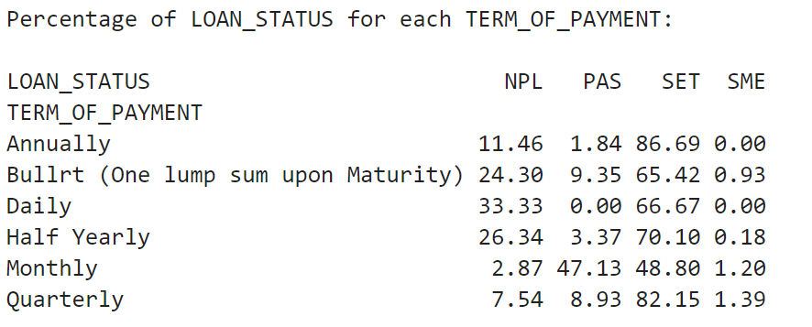

Figure 30: figure 31: term_of_payment vs loan_status by percentage

PRODUCT_OWNER vs LOAN_STATUS
- consumer North Addis has max Loan SET
- central Addis Consumer next to Consumer North Addis SET loan
- central Addis Consumer PAS highly loan

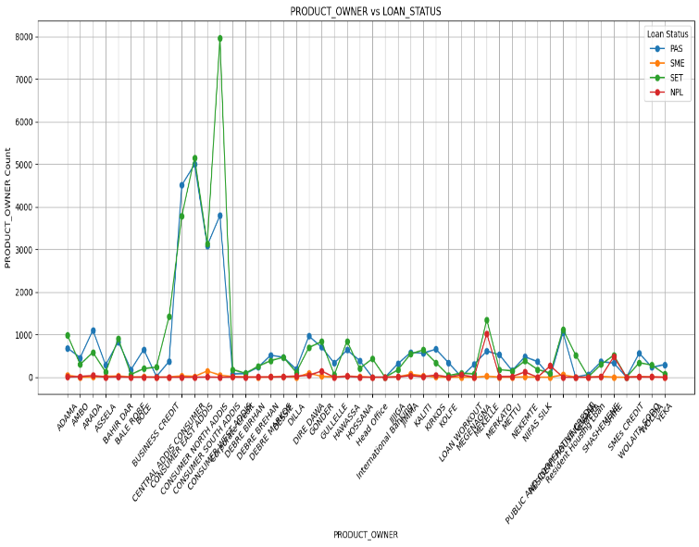
figure 32: product_owner vs loan_status by line graph
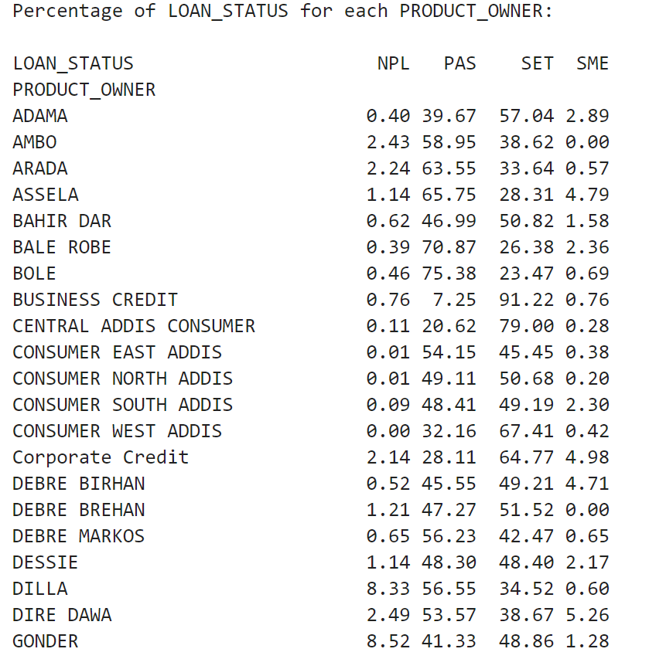

Figure 33: product_owner vs loan_status by percentage

COLLATERAL vs LOAN_STATUS

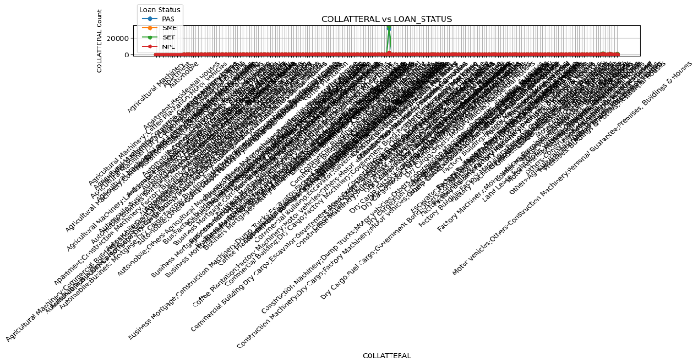
figure 34: collateral vs loan_status by the line graph
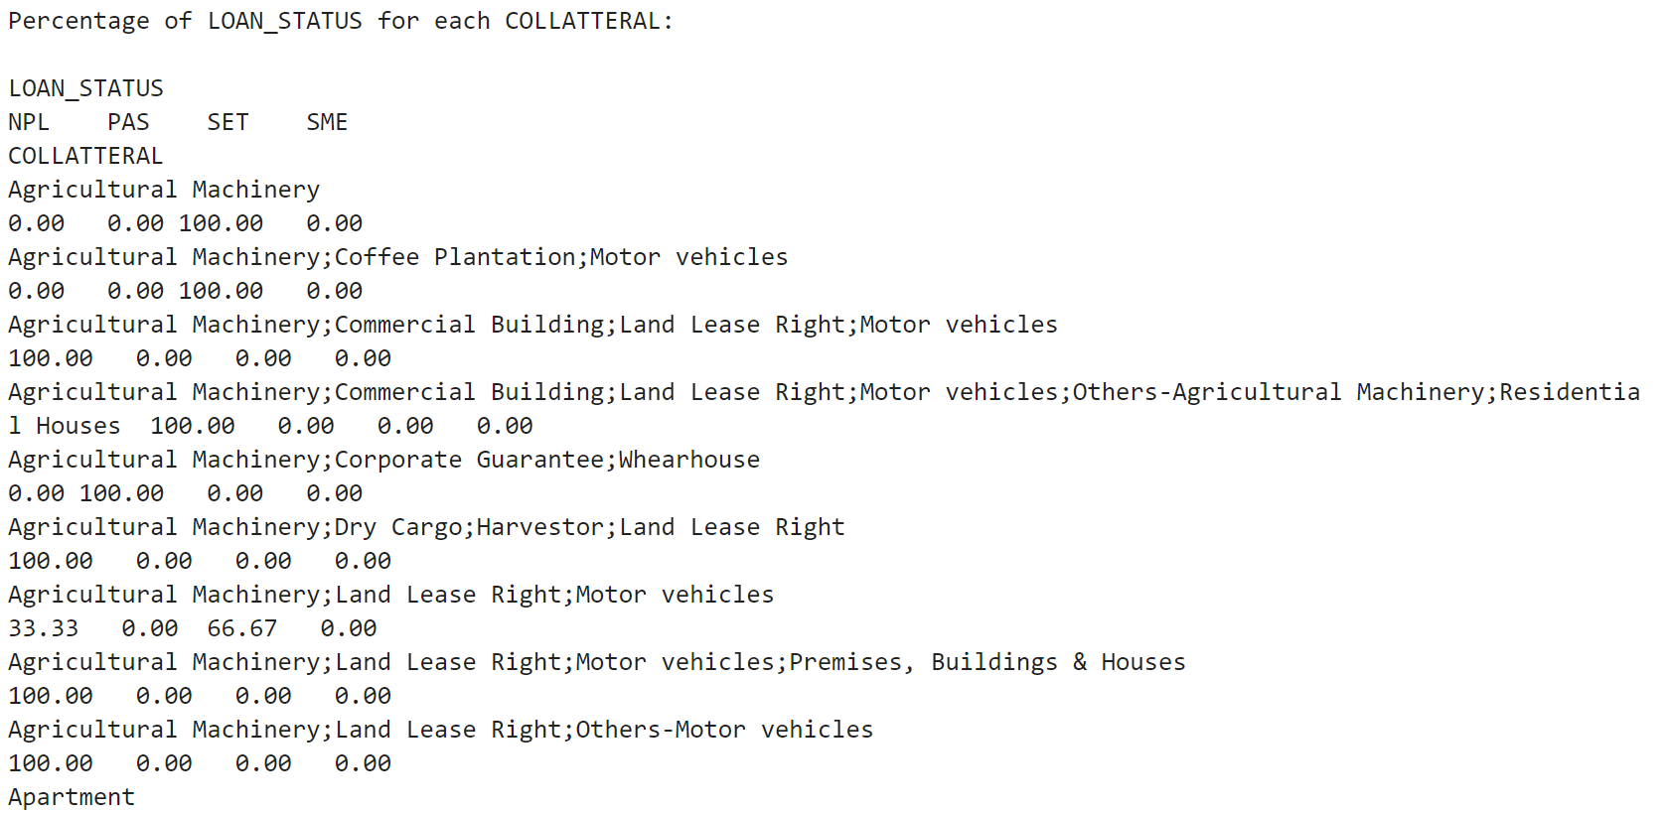
Figure 35: figure 36: collatteral vs loan_status by parentage

but it is difficult to identify which collateral is mostly correlated with more loan status, so we have another option by percentage.

Numeric feature analysis
Trends of Loan_status Reference Expire_Date with four quarter by bar graph series
- we extracted quarters from the Expire_Date of the credit according then
- finally, we can see the effects of each quarter accordingly

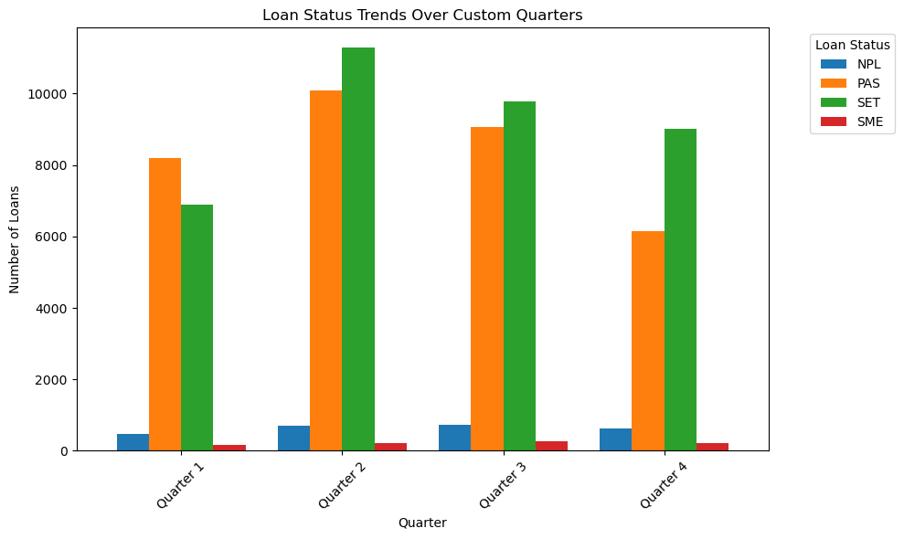
Figure 37: Loan_status vs quarter by bar graph

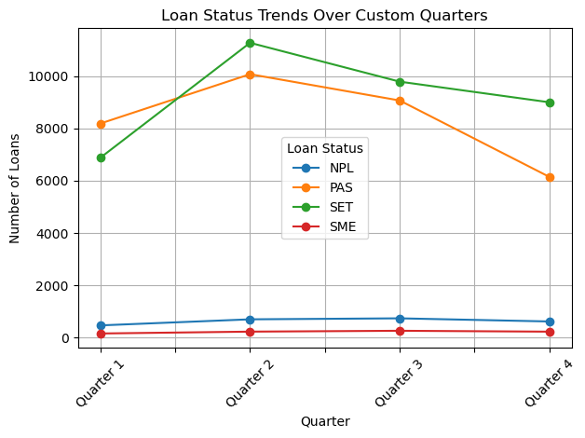
Figure 38: Loan_status vs quarter by line graph

- Most loan SET on the second quarter
- Most credit are PAS on the also second quarter

Trends loan_status over all Dataset which is used in experiment
- starting from data collect in CBE
- goes up to the future expire date of the loan
- refence is expire date
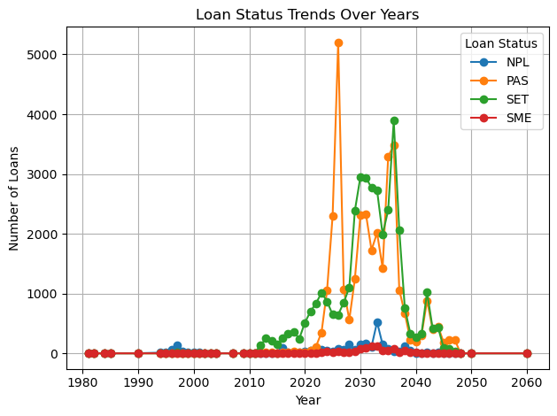
Figure 39: Trends loan_status over all Dataset
Trends of loan_staus between 2014 -2024 since T24 started in CBE
- since T24 started up to know
- when seen the changes even in data management
- maximum loan SET since 2023
- maximum loan pass since 2024
- NPL remains constant while increase

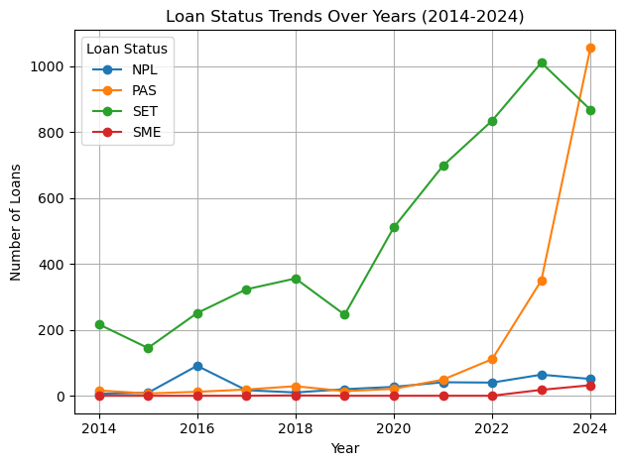
Figure 40: loan_staus between 2014 -2024 since T24 by line graph
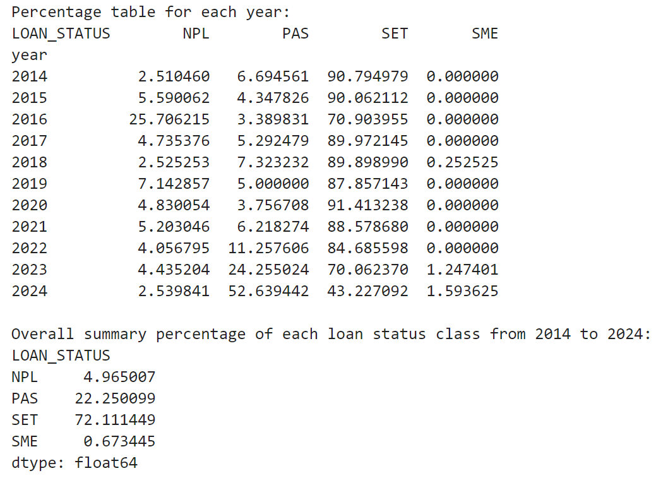
Figure 41: loan_staus between 2014 -2024 since T24 by percentage graph

Extracting month from Expire_date and trend of over months of loan status(2014-2014)
- which month was more loans expiring date=Dec
- which month loans are collected more March and Dec

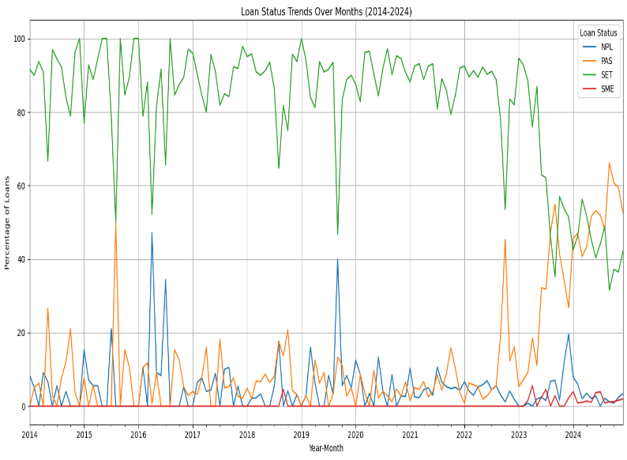
Figure 42: Loan status over the months from 2014 -2024

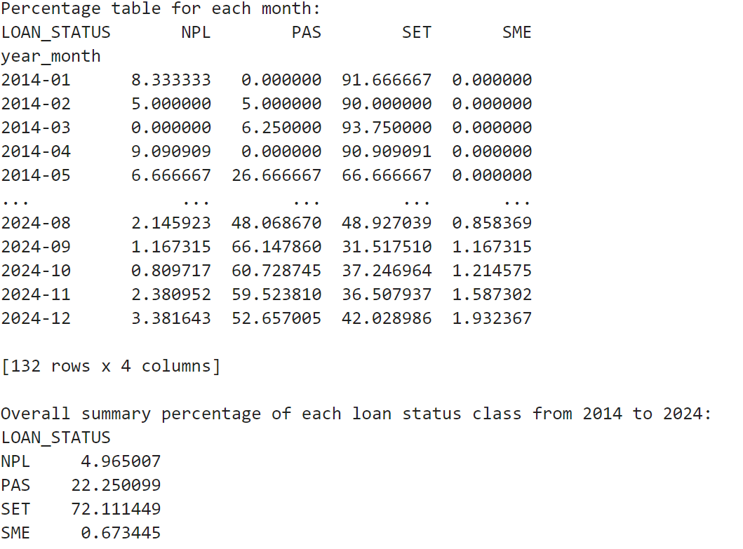
Figure 43: loan status month since (2014-2024) by parentage
Extracting Week and days from Expire_date and trends of loan status (2014-2014)
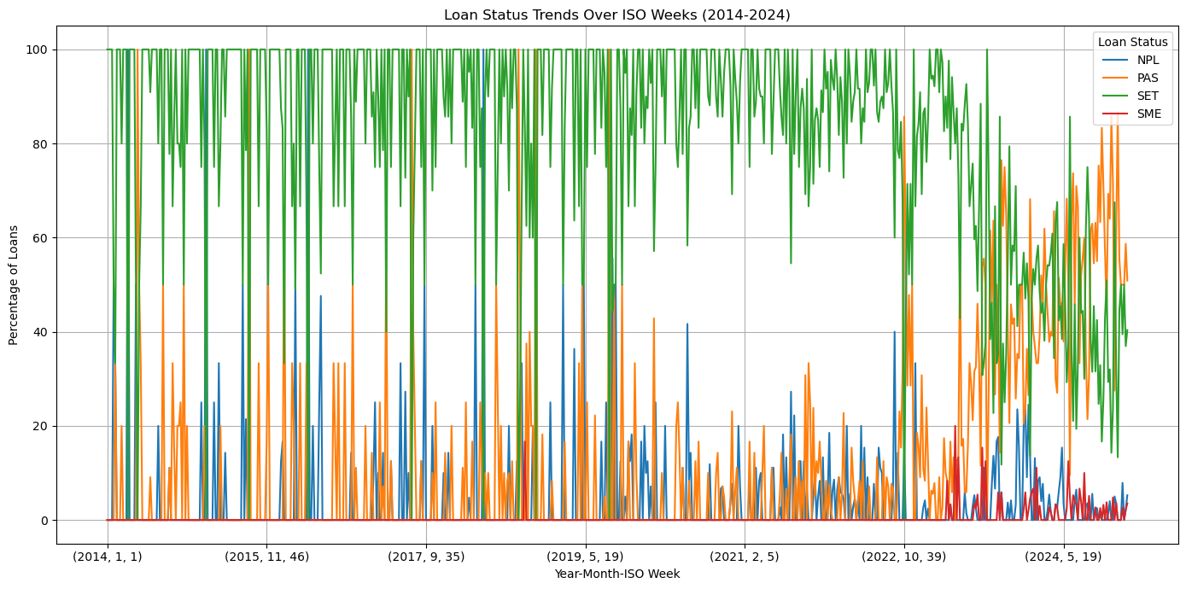
Figure 44: weekly loan status from 2014- 2024
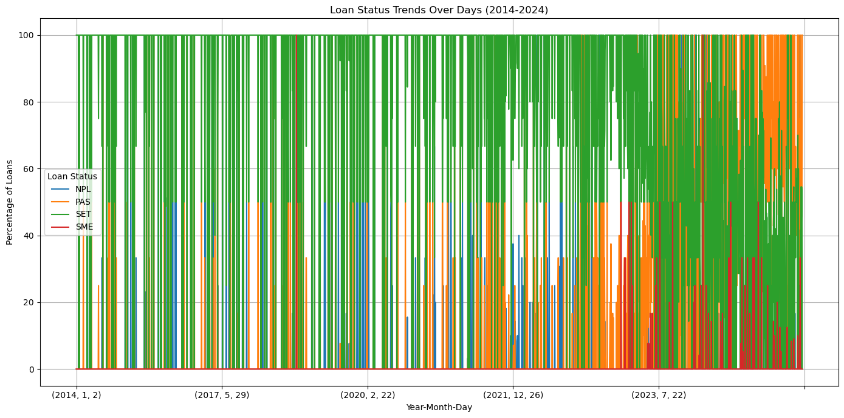
Figure 45: daily loan status from 2014- 2024

3.2. Feature selection
When working with a dataset that comprises a large number of features, the relevance of feature selection becomes clear (Li et al., 2017). The baseline fitness improvement (BFI) measures the number of values gained by applying feature selection (Keromytis, 2011). The BFI measure may be used to evaluate feature selection methods across datasets by evaluating the change in classifier performance as a result of feature selection, compared to the baseline when all features are included (Keromytis, 2011).

3.2.1. Experiment# Wrapper methods
Wrapper methods work by evaluating a subset of features using a machine learning algorithm that employs a search strategy to look through the space of possible feature subsets, evaluating each subset based on the quality of the performance of a given algorithm (Wah et al., 2018). Searching methods of wrapper feature selection techniques are: -
Sequential Forward Feature Selection (SFFS): This method starts with no feature and adds one at a time. So, here we used random forest classifiers with forward sequential feature selection methods. To select relevant features using wrapper methods, which is a sequential greedy search strategy, we import “pandas” libraries such as “SequentialFeatureSelector” and “RandomForestClassifier”.
For “SequentialFeatureSelector”, we configure sets of parameters such as (
k_features=13, forward=” True”, scoring=” accuracy”, cross-validation cv=10 ) and also set the relevant tuning parameters for RandomForestClassifier using “GridSearchCV” such as max_depth=10,max_leaf_node=50, criterion=” entropy,n-estimators=200. See the results of the experiment table below (Table 1 (SFFS))
Sequential Backward Feature Selection (SBFS): This method starts with all features present and removes one feature at a time. So, here we used random forest classifiers with backward sequential feature selection methods. To select relevant features using wrapper methods, which is a sequential greedy search strategy, we import “pandas” libraries such as “SequentialFeatureSelector” and “RandomForestClassifier”.
For “SequentialFeatureSelector”, we configure sets of parameters such as (
k_features=13, forward=“False”, scoring=” accuracy”, cross-validation cv=10) and also set the relevant tuning parameters for RandomForestClassifier using “GridSearchCV” such as max_depth=10, max_leaf_node=50, criterion=” entropy,n-estimators=200. See the results of the experiment table below (Table 1 (SBFS)).
Number of Feature | SFFS |  | SBFS
The whole feature (30) |  | Accuracy  0. 95 |  | Accuracy  0.97
Having the 10 selected feature | Selected features by SFFS | Accuracy | Selected features by SBFS | Accuracy
 | REGIONNAME', 'CBE_REGION', 'BRANCHNAME',  'APPROVED_AMOUNT', 'TENURE', 'TERM', 'LOAN_TYPE', 'LOAN_DESCRIPTION',  'LOAN_PRODUCT', 'LTYPE', 'CUST_SHORTNAME', 'DAO_NAME', 'PRINCIPAL_OS',  'INTEREST_OS', | 0.87 | REGIONNAME', 'CBE_REGION', 'BRANCHNAME',  'APPROVED_AMOUNT', 'TENURE', 'TERM', 'LOAN_TYPE', 'LOAN_DESCRIPTION',  'LOAN_PRODUCT', 'LTYPE', 'CUST_SHORTNAME', 'DAO_NAME', 'PRINCIPAL_OS',  'INTEREST_OS', | 0.93
Having the 14 selected feature | Selected features by SFFS | Accuracy | Selected features by SBFS | Accuracy
 | DISTRICTNAME', 'REGIONNAME', 'CBE_REGION', 'BRANCHNAME',  'APPROVED_AMOUNT', 'TENURE', 'TERM', 'LOAN_TYPE', 'LOAN_DESCRIPTION',  'LOAN_PRODUCT', 'LTYPE', 'CUST_SHORTNAME', 'DAO_NAME', 'PRINCIPAL_OS',  'INTEREST_OS', 'PRINCIPAL_ARREARS', 'INTEREST_ARREARS',  'CURRENT_COMMITTMENT', 'INSTALLMENT_AMOUNT',  'INSTALLMENT_FREQ_PRINCIPAL', | 0.90 | DISTRICTNAME', 'REGIONNAME', 'CBE_REGION', 'BRANCHNAME',  'APPROVED_AMOUNT', 'TENURE', 'TERM', 'LOAN_TYPE', 'LOAN_DESCRIPTION',  'LOAN_PRODUCT', 'LTYPE', 'CUST_SHORTNAME', 'DAO_NAME', 'PRINCIPAL_OS',  'INTEREST_OS', 'PRINCIPAL_ARREARS', 'INTEREST_ARREARS',  'CURRENT_COMMITTMENT', 'INSTALLMENT_AMOUNT',  'INSTALLMENT_FREQ_PRINCIPAL', | 0.92

Table 1: the feature selection within the different feature

3.3. Model Development and Model Architecture
To conduct this study, we will use a neural network and some ensemble machine learning algorithms. The reason that the researcher used ensemble deep learning algorithms is that they are stronger and more accurate than the other individual algorithms (Kramer, 2013).
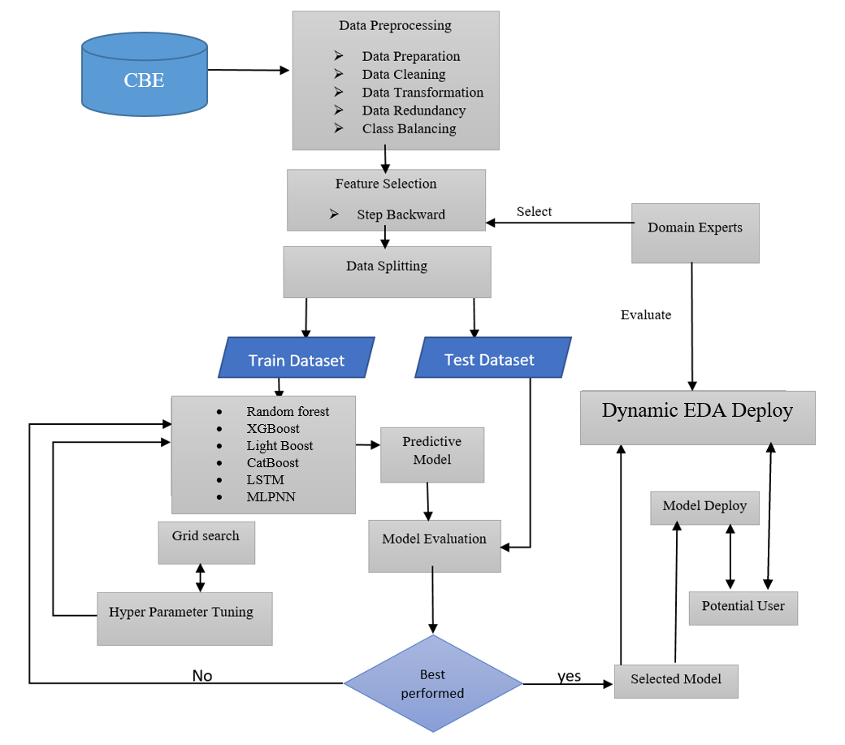
Figure 46: model Architecture

CHAPTER FOUR

Result and Discussion

Model development and model Explanability using Explainable Artificial intelligence

4.1. Hyperparameter tuning
Before implementing experiments, a tuning parameter for each classification algorithm is decided using GrideseachCV by putting a dictionary set. In this study, we split the dataset into a train and test, 80 and 20 respectively. The tuning parameters for random forest are identified by grid search cross-validation for all experiments. Then, the tuning parameters for “GradientboostingClassifier”, Random forest, XGBoost, Light Boost, LSTM, MLPNN, and Cat boost are described in Table 2 given below. Again, in these experiments, the evaluation metrics are similar for all algorithms. These evaluation metrics are confusion matrix, accuracy, ROC, precision, Fl-score, and recall.
No | Algorithm | Parameters
 | Extreme Gradient Boost () | - criterion='entropy'  - max_depth= 15  - max_Depth= max_Depth  - bootstrap=True  - N_estimators=warn,  - N_jobs=none  - random state=42
 | Random Forest | - criterion='entropy'  - max_features='sqrt'  - min_samples_split=3  - n_estimators=200  - random_state=42  - max_depth=20  - max_leaf_nodes=400  - n_jobs=-1
 | Cat Boost | - loss_function='Logloss'  - verbose = False  - eval_metric='AUC'  - iterations=500  - thread_count = None  - random_state=SEED
 | lightBoost | - random_state=42  - base_score=None,  - booster=None,  - callbacks=None,  - colsample_bylevel=None,  - early_stopping_rounds=None,  - enable_categorical=False,  - eval_metric=None,  - gamma=None,
 | LSTM (Long short-term memory) | - optimizer='adam',  - loss='sparse_categorical_crossentropy'  - epochs=20,  - batch_size=32
 | Multi-Layer Perceptron (MLP) neural network (MLPNN) | - activation='relu',  - activation='softmax'  - optimizer='adam',  - loss='sparse_categorical_crossentropy'  - epochs=20,  - batch_size=32,

Table 2:- Algorithm Parameters

4.2. Result and discussion

# Random forest

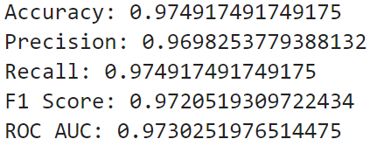
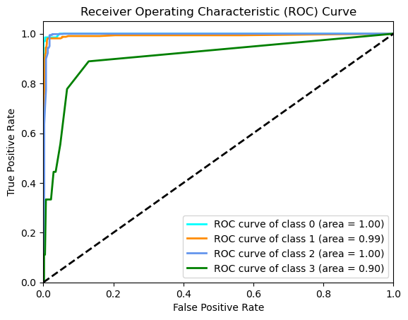

Figure 47: random forest result

#Extreme Gradient Boost (XGBoost)

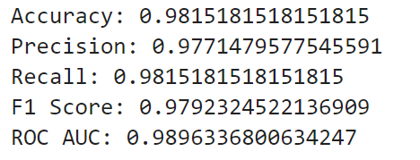
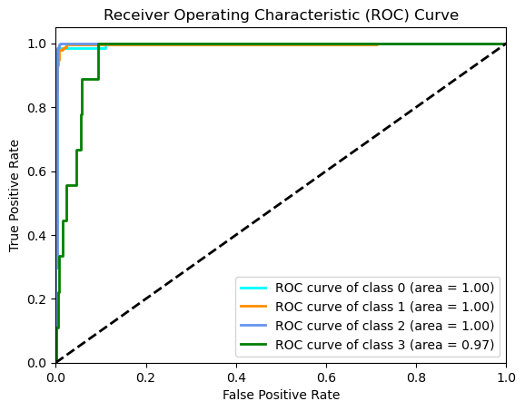

Figure 48: # XGBoost result

#lightBoost

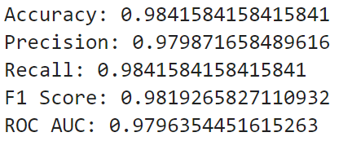
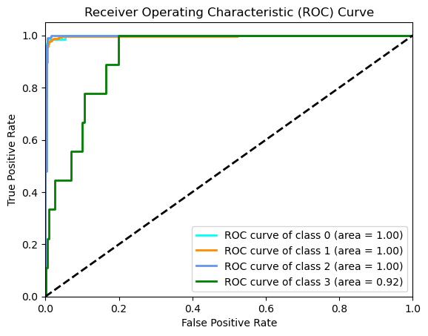

Figure 49: Light boost result

#CatBoost

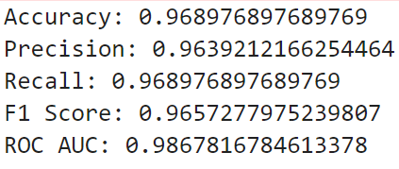
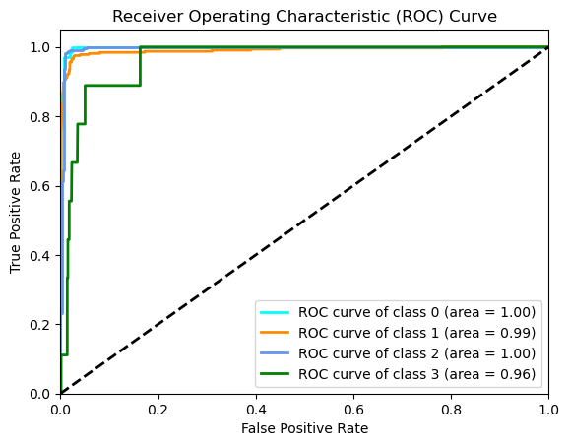

Figure 50: CatBoost Result

#Long Short Term Memory (LSTM)
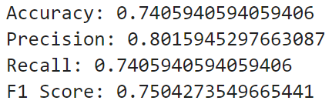
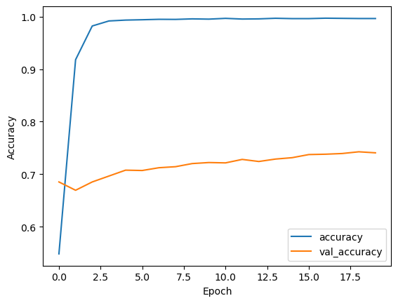

Figure 51: The Result of LSTM

#Multi-Layer Perceptron (MLP) neural network (MLPNN)

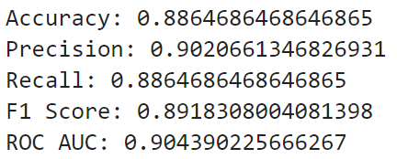
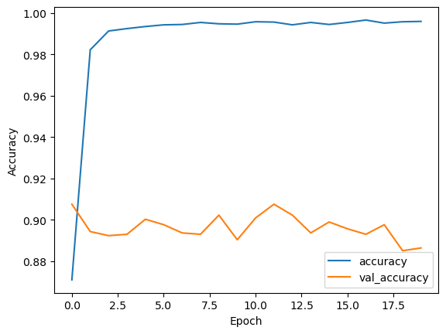

Figure 52: The result of MLPNN
Generally, the results of all algorithms are been shown below table
No | Algorithms | Accuracy | Recall | Precision | F1_score | ROC AUC
 | Random forest | 0.974 | 0.974 | 0.969 | 0.972 | 0.973
 | XGBoost | 0.987 | 0.981 | 0.977 | 0.979 | 0.989
 | Light Boost | 0.984 | 0.984 | 0.979 | 0.981 | 0.979
 | CatBoost | 0.968 | 0.968 | 0.963 | 0.965 | 0.986
 | LSTM | 0.740 | 0.740 | 0.801 | 0.750 | --
 | MLPNN | 0.886 | 0.886 | 0.902 | 0.891 | 0.904
Table 3: overall result algorithms

Model Explanation using Explainable AI such as:
- SHAP (Shapley Additive explanations) and
- LIME (Local Interpretable Model-agnostic Explanations)
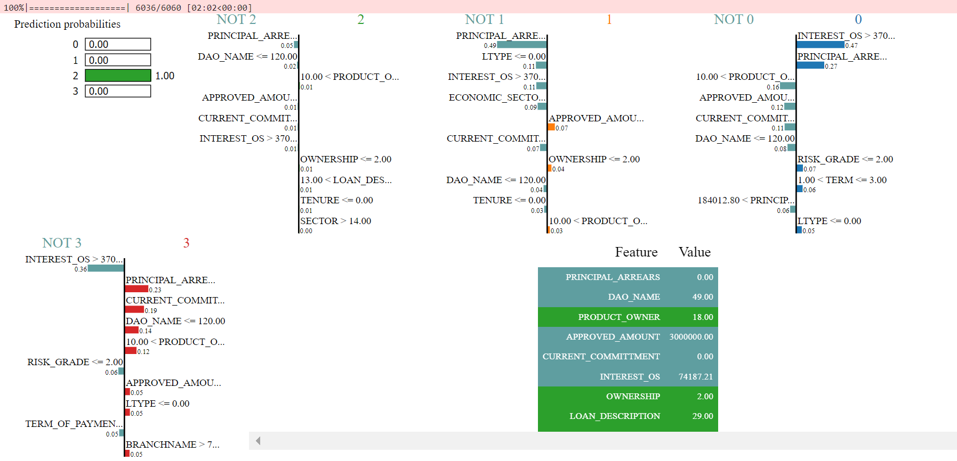
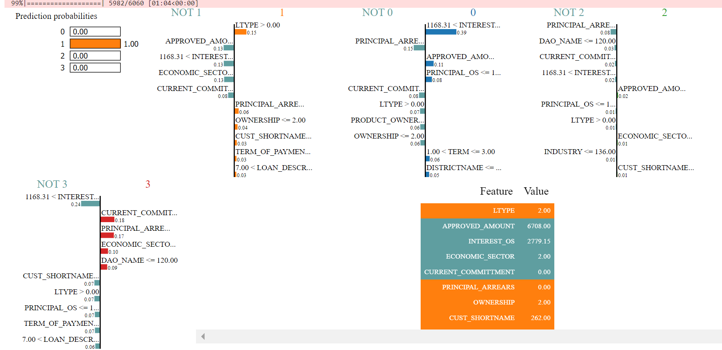
Figure 53: Explainable AI using SHAP and LIME

4.3. Explanatory data analytics (EDA) and Model Deployment
Deployment is a way of designing a framework to be applied in public-policy settings as an external partner or internal analytic team trying to use deep learning methods in a production environment [28]. A web framework is a set of frameworks and modules that allow web application developers to create apps without having to worry about low-level concerns like protocol and thread handling [29]. Django is a free and open-source web application framework written in Python. It is used for rapid web development and clean, pragmatic design [30]. To deploy a final model on Streamlit framework development techniques to design the artifacts for deploying purposes. We deploy the model to the Streamlit framework which is a support Python library for both back-end and front-end development, which supports real-world scenarios or real-world applications of the model. We deploy these models having the selected 30 features with the best-performing model, which is XGBoost. We also deploy EDA dynamic for easy usage of EDA dynamic tool for domain experts as well as concerned bodies for seeking report writing.

# (EDA) Deploy
In the application
What You Can Do:
- Feature Distribution: Examine feature distributions on both aggregated and by specific loan year.
- Bivariate Analysis: Examine feature Selected feature with Loan_status aggregated year
- Correlation Analysis: Understand feature correlations for any CBE year.
- Generate report: generate report yearly, monthly, weekly, daily for selected features with loan_status
- Generate Quarterly Report: Generate report Quarterly with specific year and feature.
- In single year report and Quarterly report model show total loan_status for selected granurilty and quarter
Dive into the rich data of CBE from 2014 to 2024, interact, and uncover valuable insights!

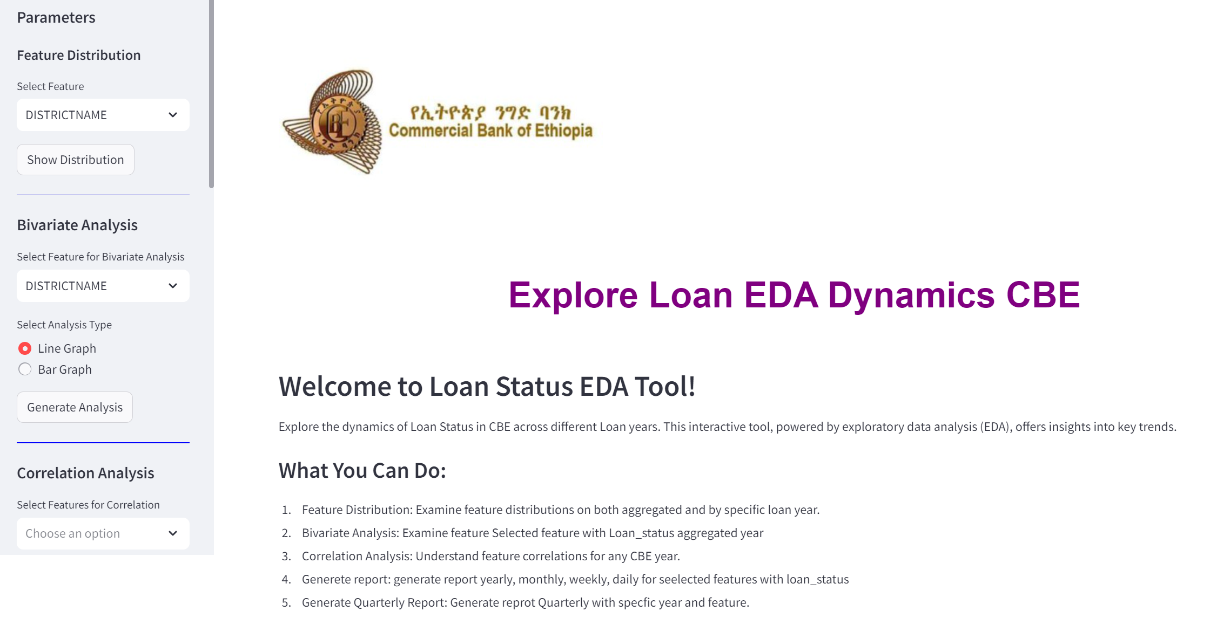
Figure 54: GUI for EDA

#Single year report
#Yearly
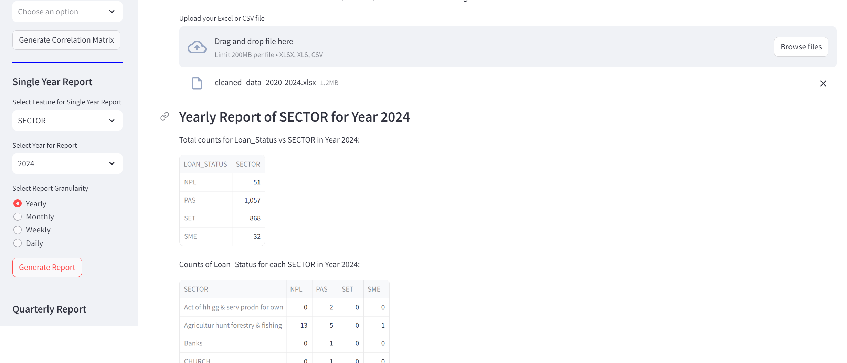
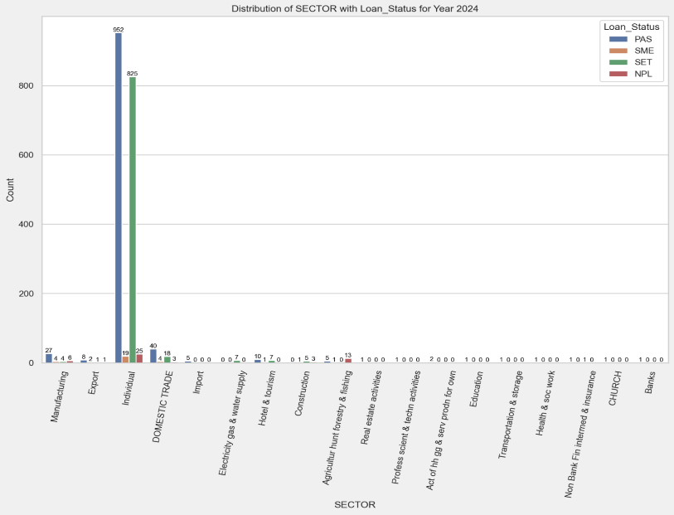

Figure 55: EDA dynamic tool single year, for yearly

#Monthly
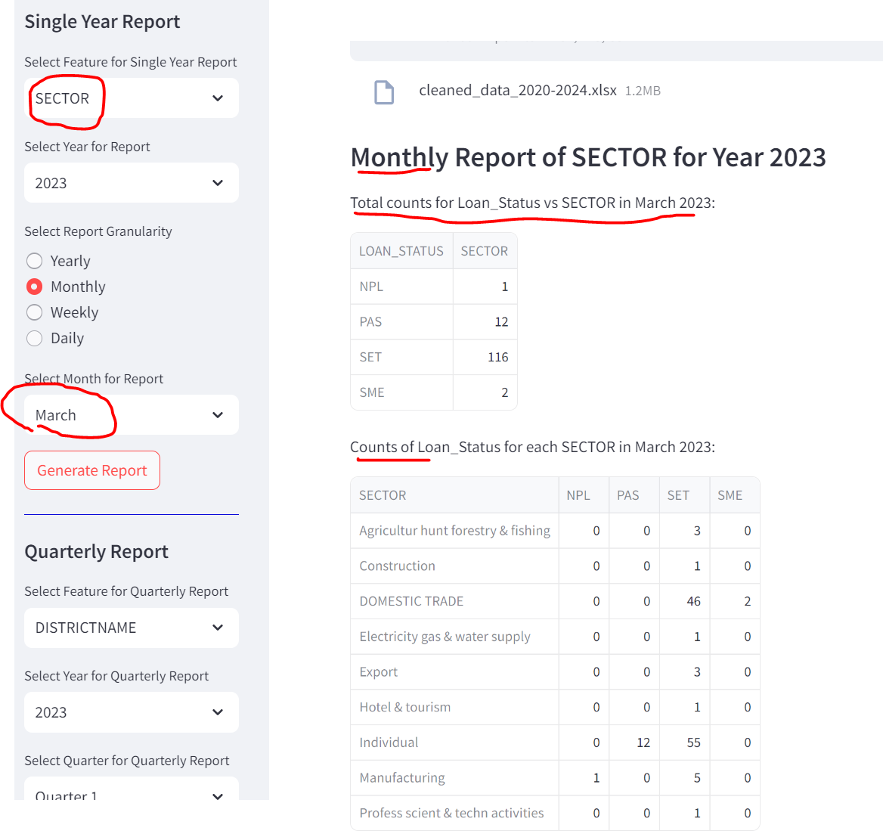
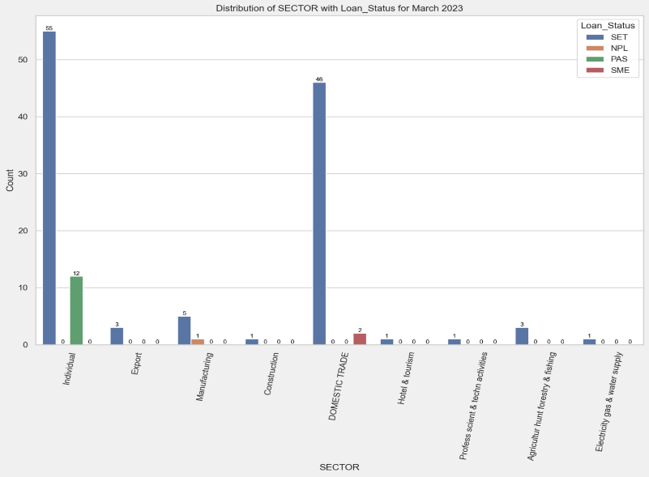

Figure 56:EDA dynamic tool for monthly
#Weekly

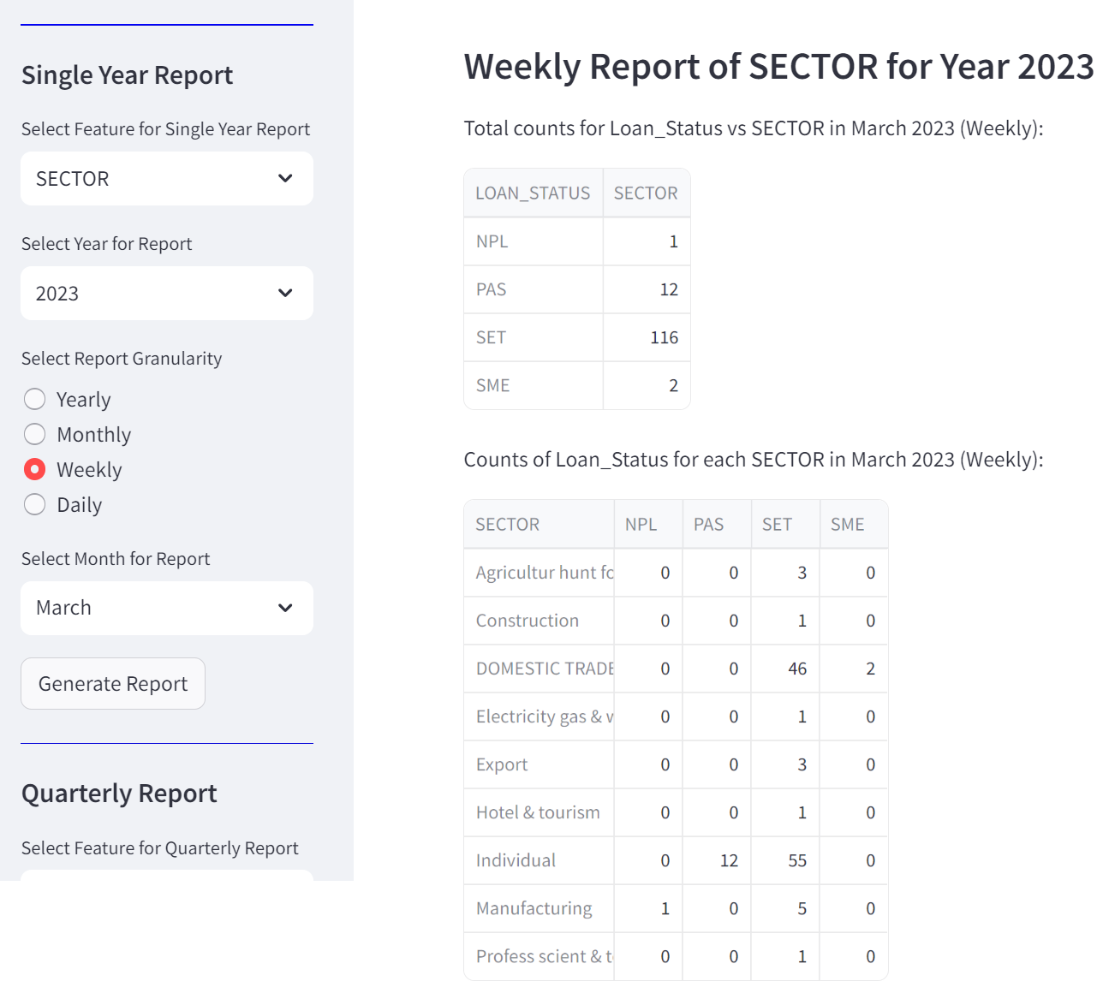
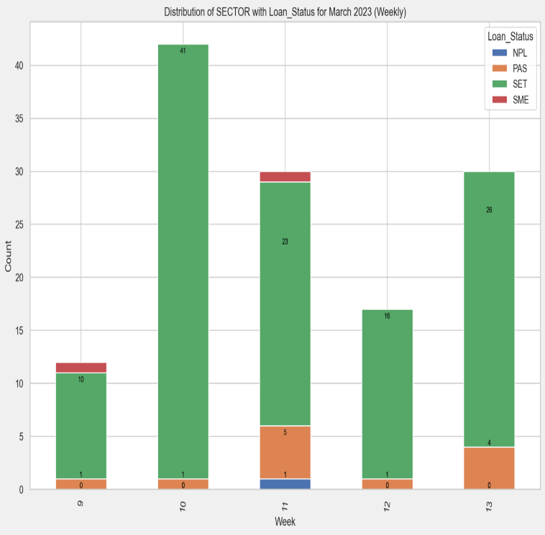

Figure 57: EDA dynamic tool for Weekly

#Daily

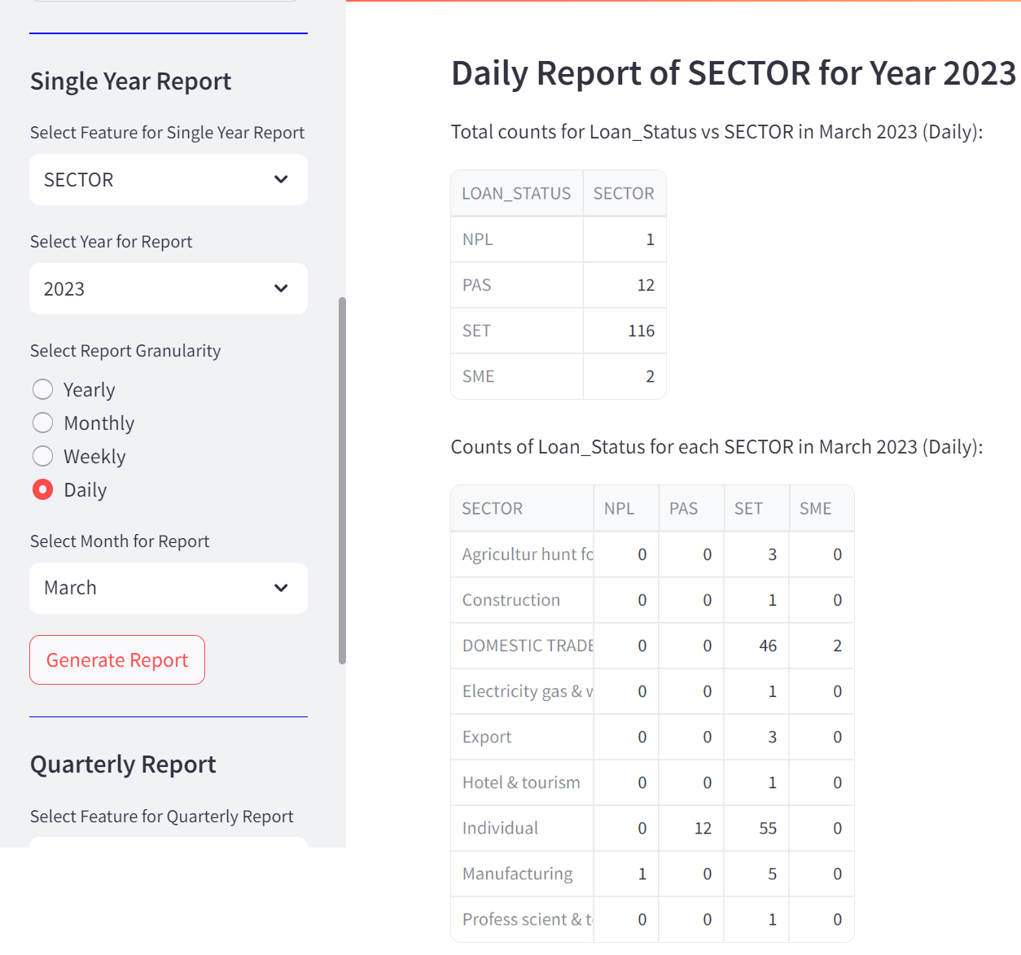
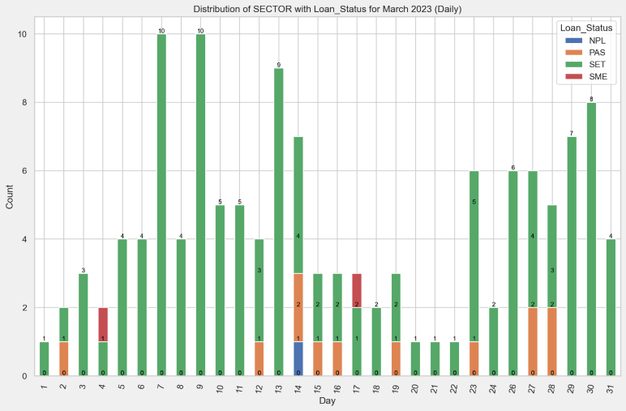

Figure 58: EDA dynamic tool for daily

#Quarterly
#Quarter 1
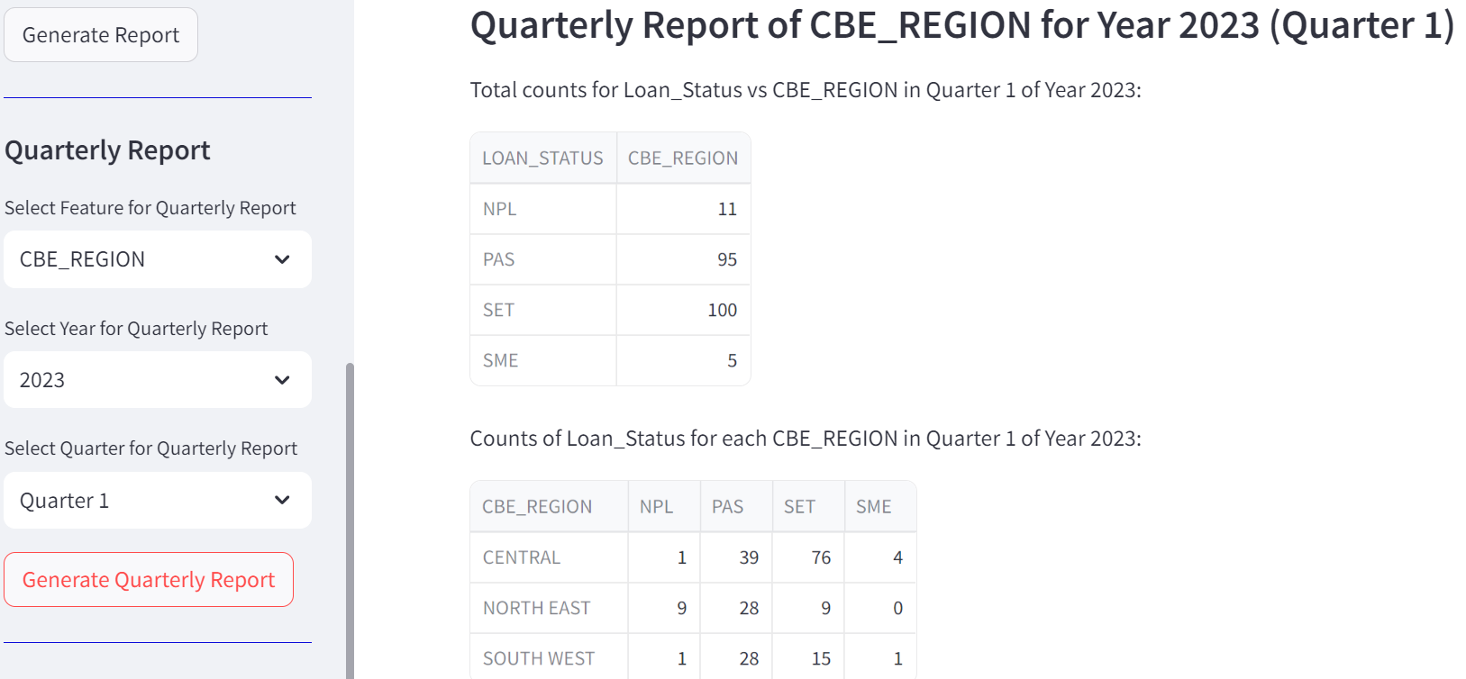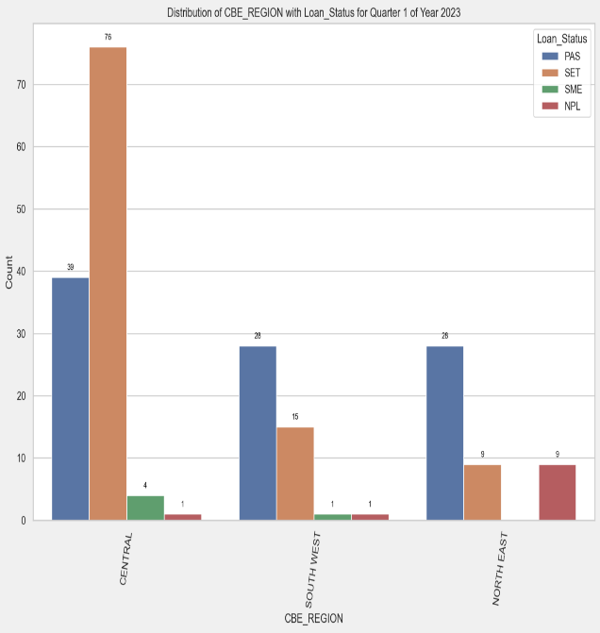

#Quarter2
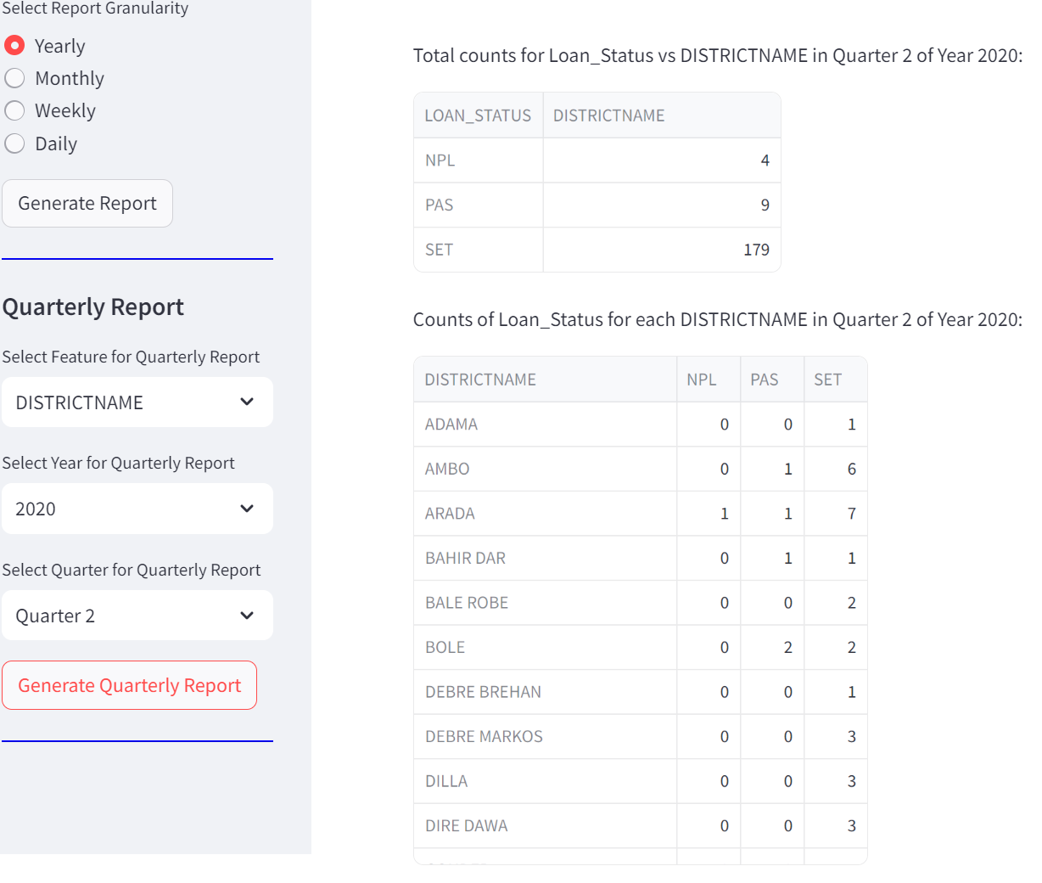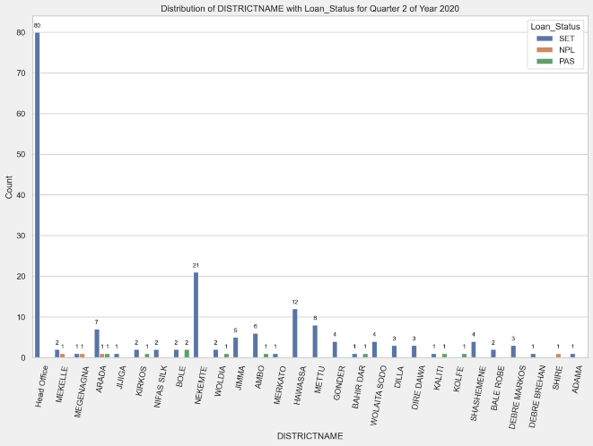
Figure 59: Quarterly Report, the same procedure for Quarter 3, and Quarter 4

#Model Deploy
First, we made the following activities to design a Graphical user interface for real real-world scenarios Front and back ends were developed by Python, and the necessary libraries such as Streamlit, panda, Geopanda, pickle, joblib, Gradio and Dash
The necessary activity is as follows:
- Save best performed model in our case XGBoost
- Save label encoder for categorical feature, using label encoder
- Save Min-max scaler for limit min max value for the numerical feature
Then we loan in to interface all saved the design and group features into three (bank_information, Credit_information, and collateral)
In the application
What You Can Do:
- Know the customers' properties proactively which helps decide loan default risks.
- Credit follow-up and creditworthiness.
- Credit scoring (probability prediction) using Explainable AI to limit the Risk grade.
- Based on the credit scoring (probability of prediction), each class may update/limit the collateral.
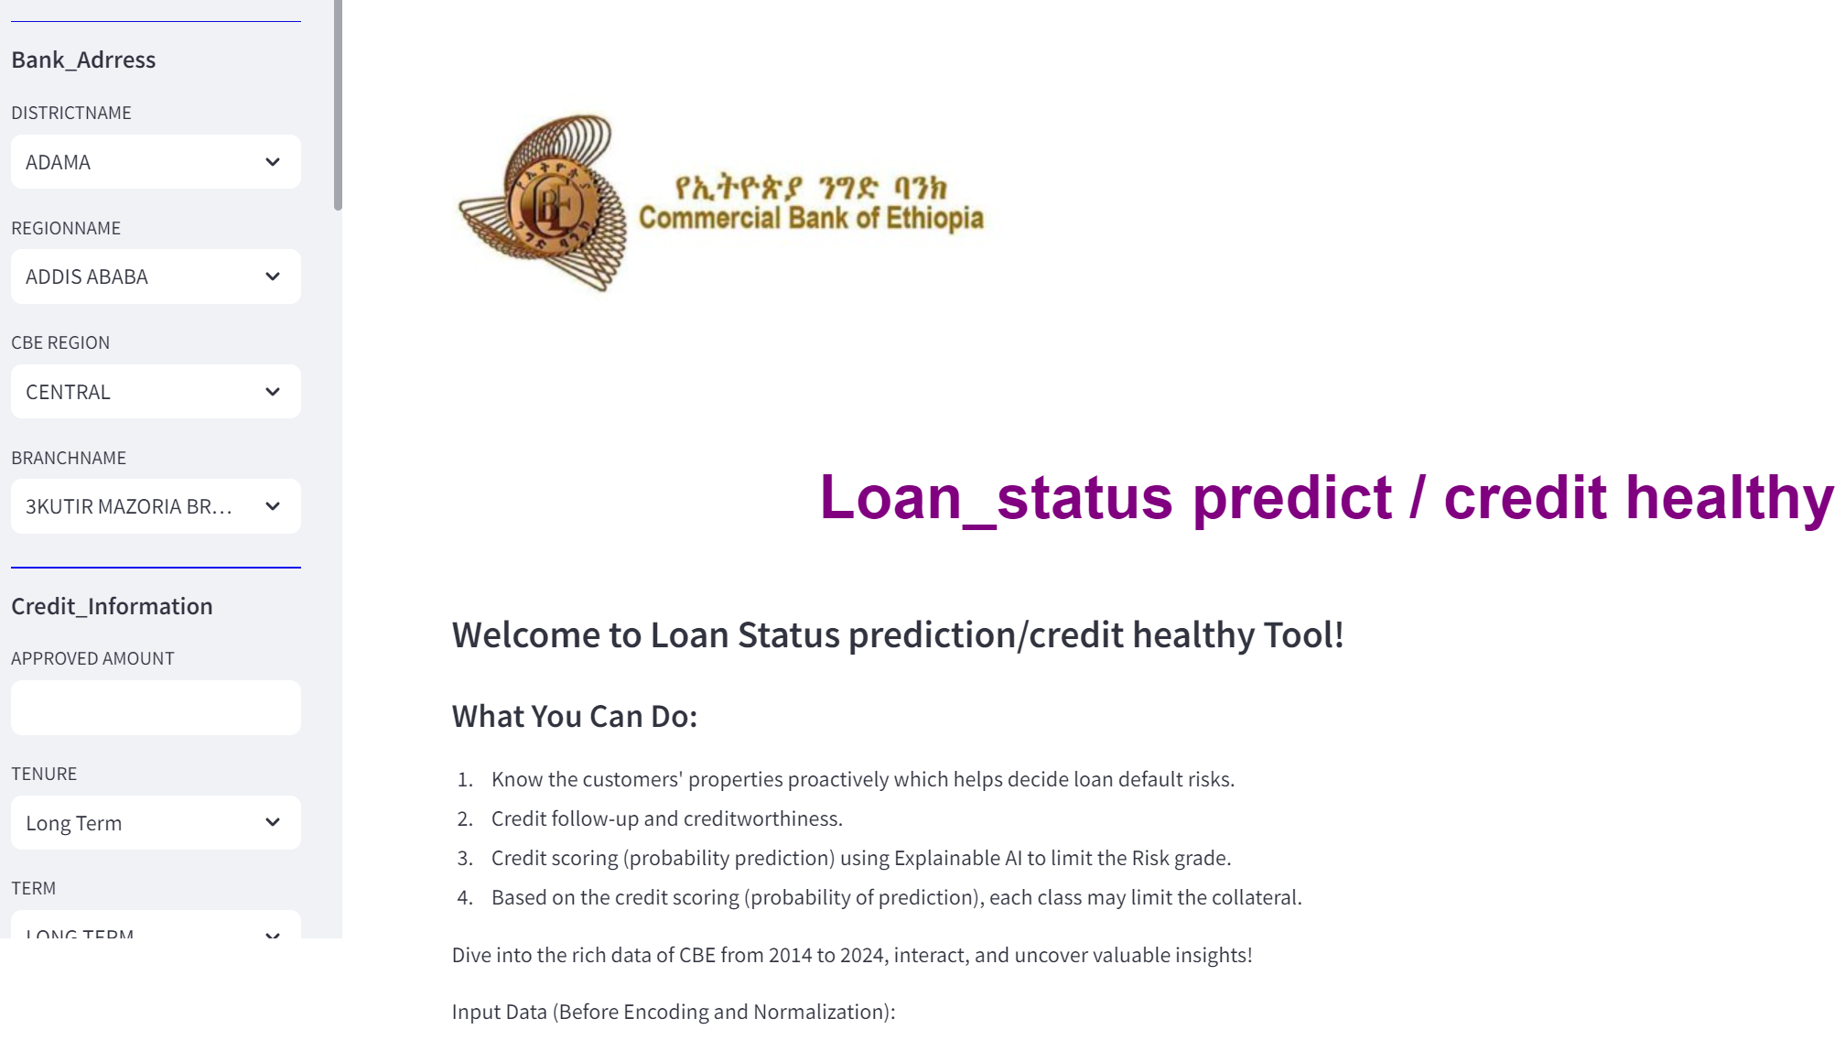
Figure 60: GUI which is used to accept new data from users and make decisions
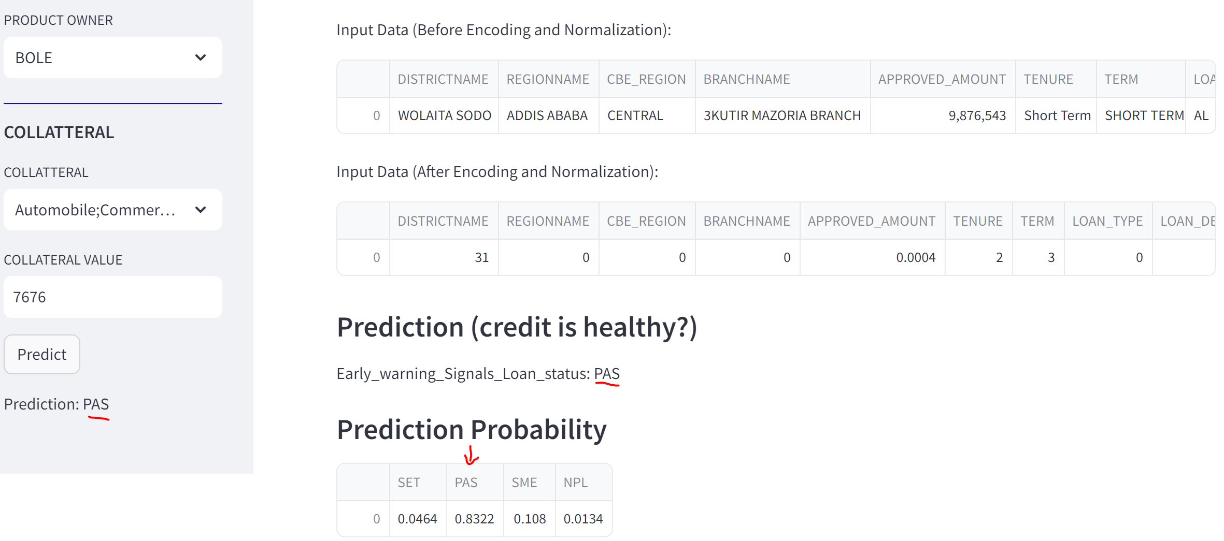

Figure 61: Model displays the prediction result with its probability for each class

CHAPTER FIVE

Conclusion and recommendation

Conclusion
This paper deals with the prediction of loan default in CBE. The 30 attributes present the best attributes are taken for prediction. Prediction is done using the machine learning and deep learning technique, XGBoost. In this classification problem, XGBoost classifies the output into four classes SET, PAS, SME, and NPL. The main objective of this study was to predict customers with a higher accuracy. Here we obtain an accuracy of about 0.9849 Percent. Among the models that developed with different feature selections, the best performed was having features all with XGBoost algorithms. Having the best-performed model, we deploy it on the Streamlit framework, for easy usage of real-world scenarios and we also deploy EDA for dynamic data analytics tool and model deployment.
Generally, in this study: first, we have done descriptive statistics to show the trend over time in commercial Bank of Ethiopia. Second, we identified the most appropriate homogeneous ensemble machine learning and deep learning algorithm to build a prediction model for loan default in the case of the Commercial Bank of Ethiopia. Third, we have extracted important rules using risk factors that enable policymakers to formulate policies and decisions related to loan defaults. Fourth, we have designed an interactive user interface or artifacts by using the both back and front ends by Python for both EDA and model deployment on, the Streamlit framework for the best-performing Extreme gradient boost algorithm. So, the responsible body could follow up on the early warning signal for loan status using such determinant risk factors for improvement of the loan default risk. Similarly, the policymakers will formulate policy using important rules that are extracted and designed artifacts in this study.

Recommendation
At the end of this conclusion, the researcher recommended that other researchers:
- In this study, we strongly recommend that all datasets of credit have real systems or real applications.
- Like that of generative AI apply fin-tuning which uses each test data added to the trained model to enhance model performance.
- Provide service dockization or kubernets which provides a modular system for software as a service or software as a platform and makes application modulization.
- On top of a predictive model which is the proactive treatment of Loans, develop a loan Recommender system that applies a new branch banking model

Reference
Abaidullah, A. M., Ahmed, N., & Ali, E. (2014). Identifying Hidden Patterns in Students’ Feedback through Cluster Analysis. International Journal of Computer Theory and Engineering, 7(1), 16–20. https://doi.org/10.7763/ijcte.2015.v7.923
Adinew, W. (2019). Determinants of successful loan repayment performance in foreign owned investments in Ethiopia: the case of development bank of Ethiopia and commercial bank of Ethiopia. Research.
Arutjothi, G., & Senthamarai, C. (2018). Prediction of loan status in commercial bank using machine learning classifier. Proceedings of the International Conference on Intelligent Sustainable Systems, ICISS 2017, Iciss, 416–419. https://doi.org/10.1109/ISS1.2017.8389442
Asgedom, A., Desta, T., Poverty, G. B.-J. of, and, I., & 2015, undefined. (2015). Factors affecting group loan repayment performance: A case of dedebit credit and saving institution (DECSI), Mekelle, Ethiopia. Core.Ac.Uk, 10, 22–44. https://core.ac.uk/download/pdf/234695191.pdf
Barredo Arrieta, A., Díaz-Rodríguez, N., Del Ser, J., Bennetot, A., Tabik, S., Barbado, A., Garcia, S., Gil-Lopez, S., Molina, D., Benjamins, R., Chatila, R., & Herrera, F. (2020). Explainable Artificial Intelligence (XAI): Concepts, taxonomies, opportunities and challenges toward responsible AI. Information Fusion, 58, 82–115. https://doi.org/10.1016/j.inffus.2019.12.012
Bededa, M. B. (2021). Determinants of Pri vate Commercial Banks ’ Lending i n Ethiopia COLLEGE OF BUSINESS AND ECONOMICS DEPARTMENT OF BANKING AND FINANCE Determinants of Pri vate Commercial Banks ’ Lending i n Ethiopia COLLEGE OF BUSINESS AND ECONOMICS.
Black, H. (2017). 2017_Understanding_Credit_Book. https://iog.wayne.edu/outreach/2017_understanding_credit_book.pdf
Can, C., & Both, B. (2021). Credit Can Be Both Good and Bad. December, 1–2.
Chang Han, Sinica, A. P., Science, A. L., Stedmon, C. A., Markager, S., Bro, R., Fellman, J. B., Petrone, K. C., Grierson, P. F., D’Orazio, V., Traversa, A., Senesi, N., Lapierre, J. F., Frenette, J. J., Catalá, T. S., Mladenov, N., Echevarría, F., Reche, I., Science, E., … Qianheng, G. (2019). Loan Repayment Prediction Using Machine Learning Algorithms. Estuarine, Coastal and Shelf Science, 2020(1), 473–484.
Enas, E., Dinar, A. M., .. M. A., & AL-Attar, B. AL. (2024). Improving Loan Status Prediction Accuracy with Generative Adversarial Networks: Addressing Data Scarcity and Bias. Enas A. Raheem*1, Ahmed M. Dinar1, Mazin Abed Mohammed 2, Bourair AL-Attar3, 13(1), 225–233. https://doi.org/10.54216/jisiot.130116
GERBA, N. S. (2019). Factors Affecting Loan Repayment Performances : a Case Study in Factors Affecting Loan Repayment Performances : a Case Study in Development Bank of Ethiopia , College of Business & Economics. September.
HUNDE, A. G. (2023). COMMERCIAL BANK OF ETHIOPIA CAREER DEVELOPMENT AND SUCCESSION PLANNING DEPARTMENT IS GRADUATE TRAINEE PROGRAM ATM CASH MANAGEMENT OPTIMIZATION : IN THE CASE OF COMMERCIAL BANK OF ETHIOPIA By. September.
Hussein, E. E., Jat Baloch, M. Y., Nigar, A., Abualkhair, H. F., Aldawood, F. K., & Tageldin, E. (2023). Machine Learning Algorithms for Predicting the Water Quality Index. Water (Switzerland), 15(20), 3677–3685. https://doi.org/10.3390/w15203540
Jafar Hamid, A., & Ahmed, T. M. (2016). Developing Prediction Model of Loan Risk in Banks Using Data Mining. Machine Learning and Applications: An International Journal, 3(1), 1–9. https://doi.org/10.5121/mlaij.2016.3101
Keromytis, A. D. (2011). Comparative Analysis. SpringerBriefs in Computer Science, 1, 57–60. https://doi.org/10.1007/978-1-4419-9866-8_5
Kramer, O. (2013). Ensemble Learning. May, 25–32. https://doi.org/10.1007/978-3-642-38652-7_3
Li, J., Cheng, K., Wang, S., Morstatter, F., Trevino, R. P., Tang, J., & Liu, H. (2017). Feature selection: A data perspective. ACM Computing Surveys, 50(6). https://doi.org/10.1145/3136625
Liang, Y., Jin, X., & Wang, Z. (2019). Loanliness: Predicting Loan Repayment Ability by Using Machine Learning Methods. https://github.com/Yiyun-Liang/loanliness
Love, P. E. D., Fang, W., Matthews, J., Porter, S., Luo, H., & Ding, L. (n.d.). Explainable Artificial Intelligence ( XAI ): Precepts , Methods , and Opportunities for Research in Construction Explainable Artificial Intelligence ( XAI ): Precepts , Methods , and Opportunities for Research in Construction. 1–58.
Mathew, A., Amudha, P., & Sivakumari, S. (2021). Deep learning techniques: an overview. Advances in Intelligent Systems and Computing, 1141(August 2020), 599–608. https://doi.org/10.1007/978-981-15-3383-9_54
Nasteski, V. (2017). An overview of the supervised machine learning methods. Horizons.B, 4(December), 51–62. https://doi.org/10.20544/horizons.b.04.1.17.p05
Ponti, M. (2018). Introduction SCC5933 – Research Methodology in Computer Science What is research ?
Rathore, A., Sharma, S., Sharma, S., & Nigam, N. (2023). Loan Prediction System. International Research Journal of Modernization in Engineering Technology and Science, 08, 92–96. https://doi.org/10.56726/irjmets43769
Singh Sandhu, H., Sharma, V., & Jassi, V. (2023). Loan Approval Prediction Using Machine Learning. Emerging Trends In Engineering And Management, May, 1–6. https://doi.org/10.56155/978-81-955020-3-5-01
Sitepu, G. J., & Nugraha, E. S. (2022). A Backpropagation Artificial Neural Network Approach for Loan Status Prediction. Jurnal Teknik Informatika, 15(2), 147–158. https://doi.org/10.15408/jti.v15i2.27006
Wah, Y. B., Ibrahim, N., & Hamid, H. A. (2018). Feature selection methods : Case of filter and wrapper approaches for maximising classification accuracy SCIENCE & TECHNOLOGY Feature Selection Methods : Case of Filter and Wrapper Approaches for Maximising Classification Accuracy. January.

