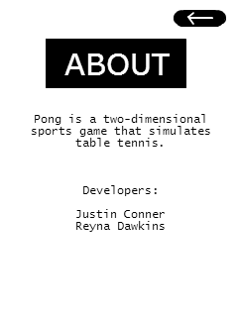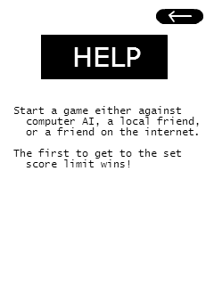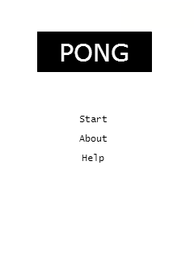

Figure 1

Figure 2

Figure 3

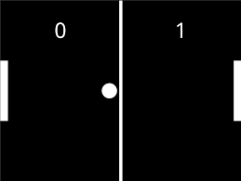

Figure 4

Figure 1 represents the title/starting screen for the app. Pressing the button ‘About’ on the title screen takes you to the ‘About’ screen, as seen in figure 3 and pressing the button ‘Help’ takes you to the ‘Help’ screen as seen in figure 2. On both the ‘About’ and ‘Help’ screen, there is a ‘back’ button that takes the user back to the title screen upon press. Text fields are used in both screens to project each screen’s purpose. The button ‘Start’, upon press, takes you into a ‘Pong’ game instance as seen in figure 4. The user will be able to play a fully functional if desired by manually dragging either of the pong paddles.