**Professor Xin Chen, Biometrics, Fall 2015**

**Assignment: Biometrics Systems Design and Evaluation**

1. Plot imposter and genuine distributions and corresponding ROC curve according to the case below.

A,B,C,D,E five subjects’ iris match scores are listed in the table. 0.0 = complete agreement; 0.5 = random agreement; 1.0 = complete difference

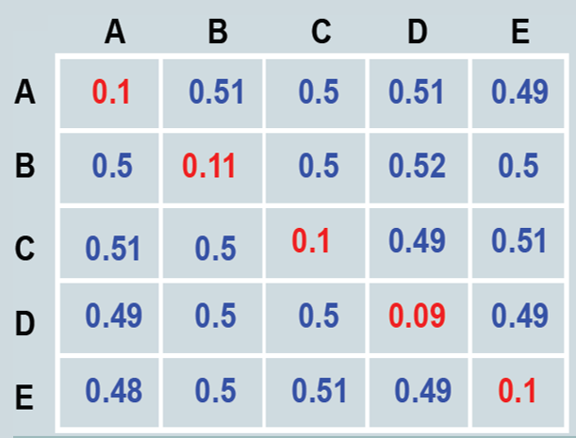

1. Draw ROC curve of a “perfect” biometrics system. “Perfect” means that the system can achieve 100% TMR and 0% FNMR.
2. Can we (NOT) estimate recognition error rates from verification error rates? Assuming (1) The identification system returns all the identities whose match score is above the threshold (2) The same threshold is used for both verification and identification scenarios.

If your answer is yes, how to derive FNR from FRR and FPR from FAR? If you answered no, please explain why? Which is challenging, verification or recognition, why?

Team member: Weihan Chu(wcm350)

Rui Liao

1.According to the form, we draw the diagram below

(We have adjusted the interval of the x-coordinate to make it clearer)

To draw the ROC curve, we need to caculate first.

(1) When threshold=0, TM=0, FNM=5, FM=0, TNM=1+5+8+5+1=20,TMR=0, FMR=0

(2) When threshold=0.09, TM=1, FNM=4, FM=0, TNM=1+5+8+5+1=20,TMR=1/5=0.2, FMR=0

(3) When threshold=1,TM=4,FNM=1,FM=0,TNM=20 TMR=0.8, FMR=0

(4) When threshold=0.11,TM=5,FNM=0,FM=0,TNM=20 TMR=1, FMR=0

(5) When threshold=0.48,TM=5,FNM=0,FM=1,TNM=19,TMR=1, FMR=0.05

(6) When threshold=0.49,TM=5,FNM=0,FM=6,TNM=14,TMR=1, FMR=0.3

(7) When threshold=0.5, TM=5,FNM=0,FM=14,,TNM=6,TMR=1,

FMR=0.7

(8)When threshold=0.51,TM=5,FNM=0,FM=19,TNM=1,TMR=1,

FMR=0.95

(9)When threshold=0.52,TM=5,FNM=0,FM=20,TNM=0TMR=1,

FMR=1

Then we can get the ROC Curve below

2. When the system can achieve 100% TMR and 0% FNMR.

TM=1,FNMR=0,FMR=[0,1]

We can also get another form of the ROC curve

3. We cannot estimate recognition error rates from verification error rates. Because if somebody A is on the list of identification system, and the system misunderstands A as another member B on the list to raises a match score above the threshold, this accident will be considered as a True match, but indeed it is a false one. So these kinds of accidents will decrease the FNR in the identification system, which means FNR<FRR. In the meanwhile, if somebody C is not in the list, but the identification system has to compare he or she with all members in the list, it will enhance the FPR, which means FPR>FAR.