**How to get started with Team-Based Learning**

**Objectives:**

* Define team-based learning
* Describe at least three benefits of team-based learning compared to lectures
* Describe how to prepare for team-based learning in a classroom setting
* Identify best practices for successful implementation of team-based learning

**Why do TBL?**

* TBL is a form of **active learning**, which has been shown to help students learn better than lectures (Modell & Michael, 1993; Prince, 2004). Active learning refers to a broad range of teaching strategies which engage students as active participants in their learning during class time with their instructor (University of Minnesota, 2019). TBL falls closer to the middle with regards to complexity along with other types of grouping strategies.

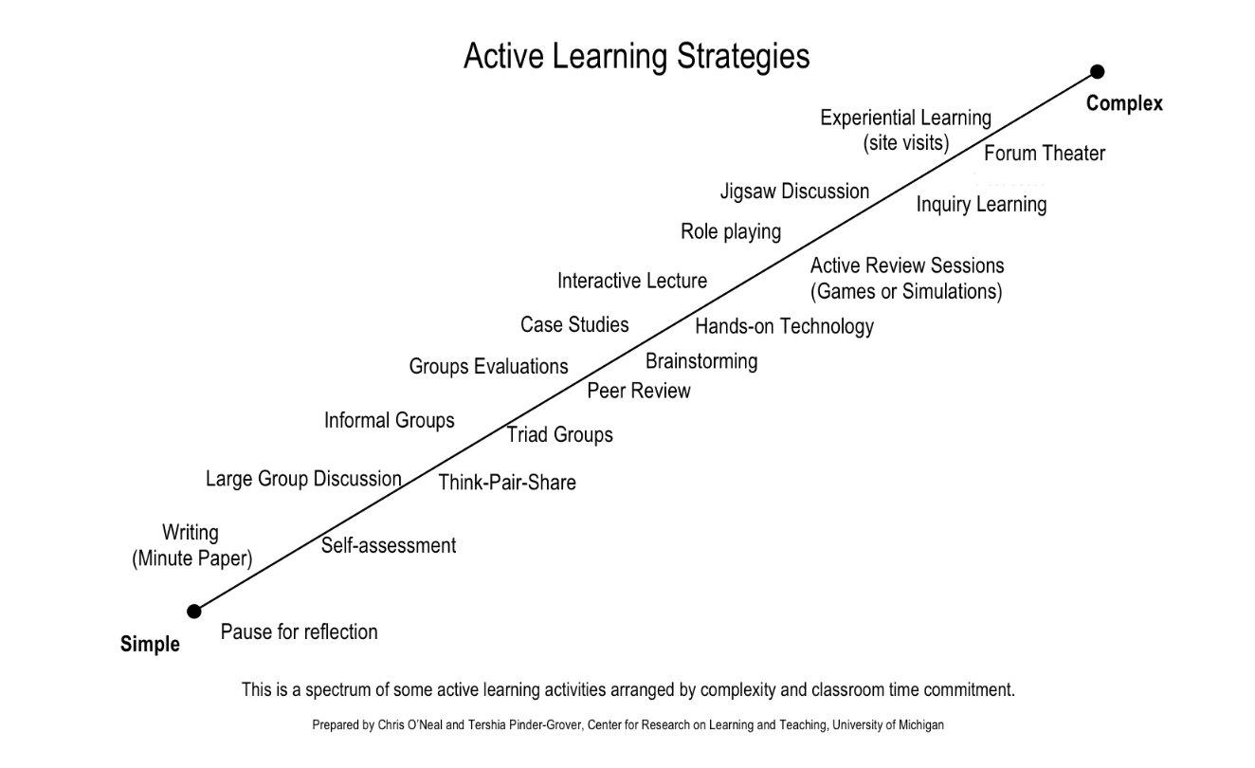

* 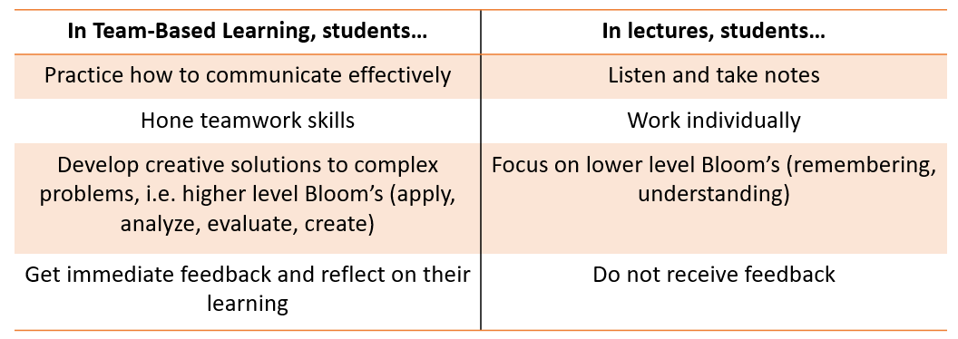Not only do students learn more in TBL, but they also practice additional skills that they would not otherwise practice during a lecture.

Case studies:

* Levine and colleagues incorporated team-based learning into a psychiatry clerkship curriculum, replacing half of the lectures with TBL activities including readiness assurance tests and application exercises (2004). Following implementation of team-based learning, students performed significantly better on the National Board of Medical Examiners psychiatry subject test.  They also scored higher on attitudes about working in teams and reported the team learning activities to be more effective learning strategies.
* Koles and colleagues compared medical students’ test performance on questions that assessed concepts learned by TBL methods or by other methods (2010). Students exhibited higher mean scores on questions that assessed knowledge of content learned via TBL than on questions assessing content learned using other methods. Importantly, students within the lowest quartile showed the greatest gains: average  improvement of 7.9% for students in the lowest quartile as compared to average improvement of 5.5% for all students.
* Zgheib and colleagues investigated the impact of team-based learning for second year medical students in a pharmacology course (2010). They found that team-based learning approaches were more effective than traditional lecture-based pedagogy for improving student learning of difficult concepts but were not more effective for easier concepts.

**What is TBL?**

* + Team-Based Learning (TBL) originated in 1979 with Larry Michaelsen at the University of Oklahoma. When Larry's class size tripled from 40 to 120 students, he saw a need for a more effective teaching strategy than straight lecture that engaged students in effective problem solving and gave them a reason to prepare before class.
  + TBL is a structured form of small-group learning that emphasizes student preparation out of class and application of knowledge in class. Students essentially learn the material that would be covered in a lecture on their own before class, and then spend class time working on complex problems in diverse teams of 5-7 students.
  + Role of the teacher vs. role of the learner in TBL:
    - Teacher: more of a facilitator
      * With TBL, the teacher establishes the learning objectives and chooses the problems on which the students will focus, but then acts as a guide while teams work toward their solution to the problem.
    - Learner: more of a problem-solver
      * In TBL, students take more responsibility for their learning, focusing on applying new knowledge through the problem-solving process and later reflecting on their progress.

Video example: <https://www.youtube.com/watch?v=57rpN4sYnZU>

**How do I do TBL?**

* Four principles:

1) Groups must be properly formed and managed

* + Minimize barriers to group cohesiveness (I.e. make sure groups are mixed/diverse)
  + Assigned teams should be 5-7 members and heterogenous as possible, permanent for semester

2) Students must be made accountable for their individual and group work

* + Readiness Assurance Process
  + Peer assessments
  + Group exercise forces students to create a "product"

3) Group assignments must be designed to promote both learning and team development

4) Students must have frequent and timely performance feedback, which they can get from their individual and group readiness test scores, reviewing answers, and self/peer evaluations.

* Process:
  + Student pre-work before class
    - Assign heterogeneous student teams based on Principle #1.
    - Backwards Design (Wiggins & McTighe, 1998) is often used to design TBL courses.
      * First, identify the learning goals students should achieve by the end of the TBL and construct the assessment items that align with those goals. (These items will likely be on the next exam, not necessarily employed in the TBL)
      * Next, identify activities that the students will do to “learn how to use” (i.e. apply) the course content.
      * Then, identify the necessary background knowledge or most important concepts the student must have to begin problem solving.
      * Lastly, select readings and construct questions or a reading guide to help student acquire this background knowledge. The questions or guide should prepare students to be successful on the Individual and Group Readiness Assurance Tests.
  + In class: the IRAT/GRAT
    - Orient students to TBL by briefly explaining the rationale for this method. The more students understand why this teaching strategy is worthwhile, the more invested they will be.
    - Students start with an Individual Readiness Assurance Test, or IRAT (typically 5-10 questions, 15 min. or less time limit). The tests are typically multiple-choice, and as the name implies, students take them on silently their own.
    - Students then complete the Group Readiness Assurance Test, or GRAT (both the individual and the group scores contribute to the students' grades). Sometimes the GRAT is the same as the IRAT, but it doesn't have to be the same.
      * Most practitioners of TBL use an IF-AT (Immediate Feedback Assessment Technique) card for the team test, which is a scratch-and-win-type testing card. The team discusses a question, decides an answer, and scratches off the coating over their choice to see if it is correct. If the answer is not correct, they return to question and discussion. They do not leave each question until they know the correct answer. This type of card is also available digitally in Leo, so students can take the GRAT on their computers (just one person per team can submit the answers).
  + After the IRAT/GRAT
    - After the students complete the group test, encourage teams to appeal questions that they got incorrect. The appeals process encourages students to review the material, evaluate their understanding, and defend the choice they made.
    - To conclude the Readiness Assurance Process, give a mini-lecture that focuses on concepts with which students struggled the most.
    - This work serves as preparation for the in-class application activities that complete the session.
  + The Application Activities
    - These application activities require the teams to make a specific choice about a significant problem.
    - A careful choice of problems can help reveal common student misconceptions, and the constant interaction and debate among team members allows learners to compare their current understandings with those of other team members and to construct new understandings.
    - Importantly, all teams work on the same problem and report their decisions simultaneously. This structure requires teams to articulate their thinking, and gives teams an opportunity to evaluate their own reasoning when confronted with different decisions that other teams may make.
  + Peer Evaluations
    - Peer evaluation is an important part of team-based learning; it is essential for keeping students accountable to their teammates.
    - If the class is relatively small, peer evaluation can be carried out manually by having each student complete independently an appraisal form to evaluate the contribution of other team members relative to themselves. The instructor then compiles the information, and sends each student the anonymous comments and ratings from their team members.
    - For larger classes, it is faster and much easier to use Leo or software such as iPeer, CATME, or SparkPlus that have been developed specifically for this purpose. The software is set up to allow students to evaluate firstly themselves, then their team members according to a range of criteria. These criteria can be derived from the literature, or from the educator’s own research. When students have completed their evaluations, they can view the anonymized results that can include ratings on the criteria, and text comments.
  + Summary

For a 100-minute class period (approximately two 50-minute lecture blocks combined), below is a suggested TBL timeline:

15 min: Brief rationale, IRAT

15 min: GRAT

20 min: Question appeal and mini-lecture

(10-min Break)

25 min: Application activity

15 min: Groups share out answers, closure by instructor

10 min: Peer evaluations

Times may be adjusted based on the length of the IRAT/GRAT and appeal period.

References:

Iowa State CELT. [isucelt]. (2015, August 3). *What is Team-Based Learning?* [Video file]. Retrieved from <https://www.youtube.com/watch?v=kN8mebiIWFc>

Koles, P. G., Stolfi, A., Borges, N. J., Nelson, S., & Paremelee, D. X. (2010). The impact of team-based learning on medical students’ academic performance. *Academic Medicine, 85,* 1739-1745.

Levine, R.E., O’Boyle, M., Haidet, P., Lynn, D. J., Stone, M. M., Wolf, D. V., & Paniagua, F. A. (2004). Transforming a clinical clerkship with team learning. *Teaching and Learning in Medicine, 16,* 270-275.

Modell, H. I. & Michael, J. A. (1993). [Promoting active learning in the life science classroom: Defining the issues.](https://nyaspubs.onlinelibrary.wiley.com/doi/abs/10.1111/j.1749-6632.1993.tb19770.x) *Annals of the New York Academy of Sciences, 701*(1), 1-7.

Prince, M. (2004). [Does active learning work? A review of the research.](https://onlinelibrary.wiley.com/doi/abs/10.1002/j.2168-9830.2004.tb00809.x) *The research journal for engineering education, 93*(3), 223-231.

Team-Based Learning Collaborative. (2019). [History](http://www.teambasedlearning.org/history/).

University of Minnesota. (2019). [Active Learning](https://cei.umn.edu/active-learning).

Vanderbilt University. (2019). [Team-based learning](https://cft.vanderbilt.edu/guides-sub-pages/team-based-learning/).

Wiggins, Grant, and McTighe, Jay. (1998). Backward Design. *Understanding by Design,* 13-34.

Zgheib, N. K., Simaan, J. A., & Sabra, R. (2010). Using team-based learning to teach pharmacology to second year medical students improves student performance. *Medical Teacher, 32,*130-135.

*Created by the Office of Educational Development, Oklahoma State University Center for Health Sciences*