**Internet Protocl (RFC: 791)**

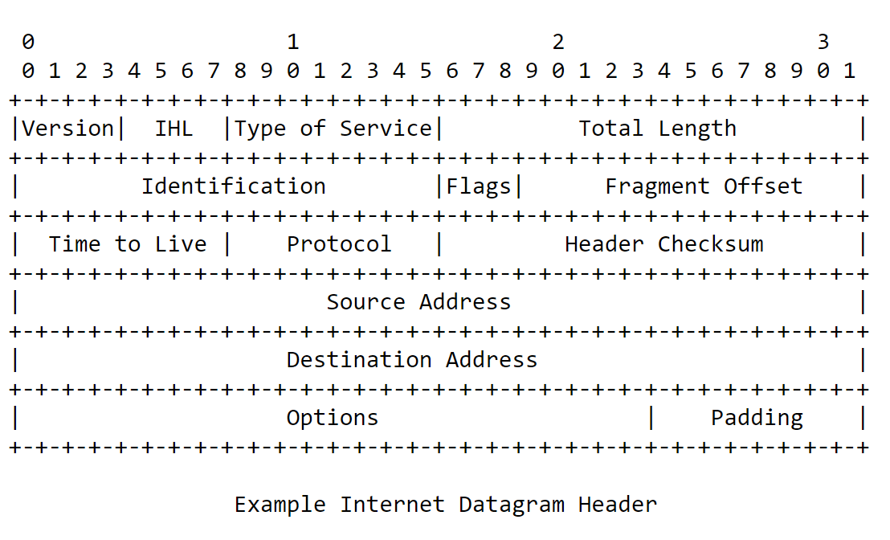

**Figure 1: Example Internet Datagram Header**

**Transmission Control Protocol (RFC: 793)**

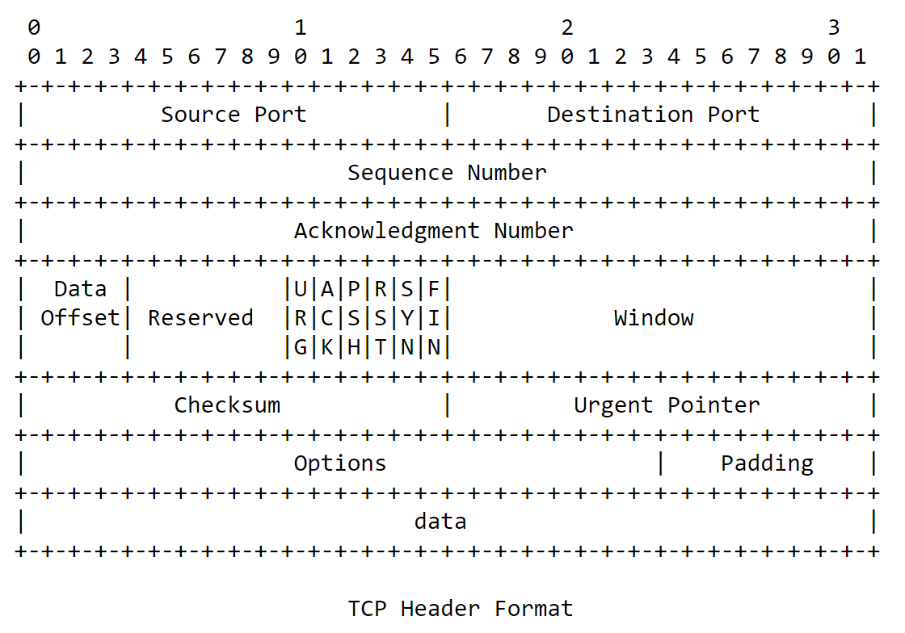

**Figure 2: TCP Header Format**

**User Datagram Prorocol (RFC: 768)**

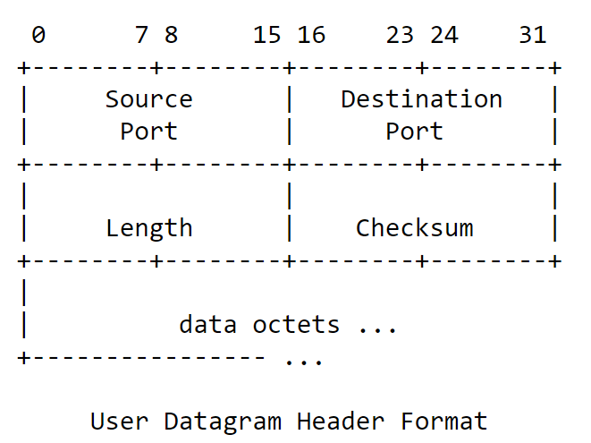

**Figure 3: User Datagram Header Format**

**Hypertext Transfer Protocol Version 2 (HTTP/2) (RFC: 7540)**

[**https://hokofly.github.io/QUIC%E4%BC%A0%E8%BE%93%E6%A0%BC%E5%BC%8F%E8%A7%84%E8%8C%83(%E4%B8%AD%E6%96%87).html**](https://hokofly.github.io/QUIC%E4%BC%A0%E8%BE%93%E6%A0%BC%E5%BC%8F%E8%A7%84%E8%8C%83(%E4%B8%AD%E6%96%87).html)