The first map begins to show you where all of the monasteries in Sicily are located.

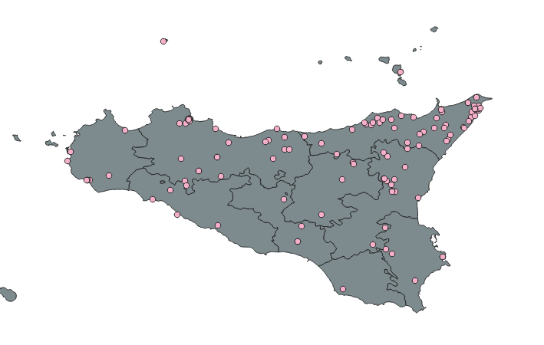

Dedications will be grouped as the following:

* Group 1: Christ
* Group 2: All Saints
* Group 3: The Holy dedications
* Group 4: The Virgin Mary

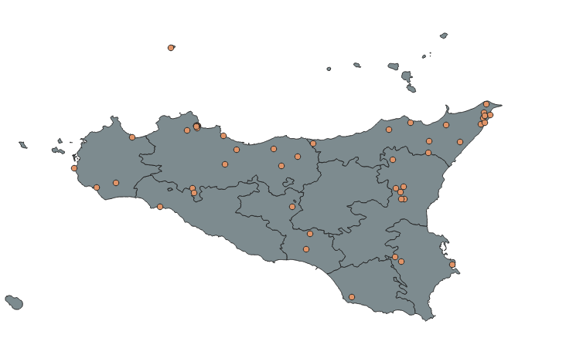

After putting all four groups on the map, now we need to separate to see if there is any geographical clustering across the four dedications.

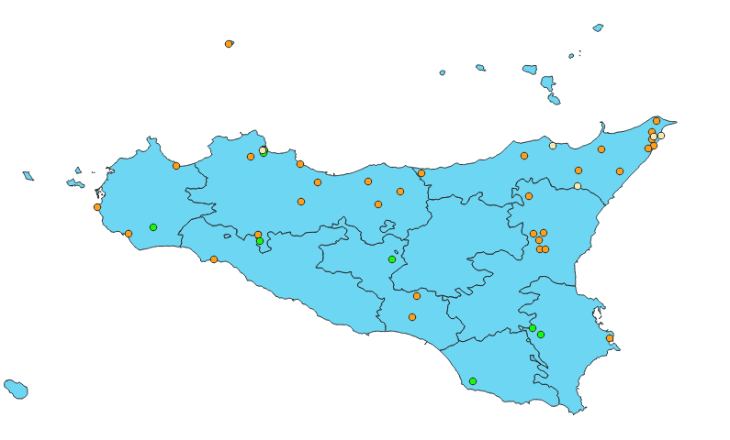

When separating the 4 groups into different points, you mainly see 3 colors. Each color is associated with a different type of dedication.

* Orange= The Virgin Mary
* Green= The Holy Dedication
* Purple= All Saints
* White= Christ

The purple does not show due to the fact that there is only one monastery that is dedicated to all the saints and it is surrounded by other monasteries which makes it a little hidden.

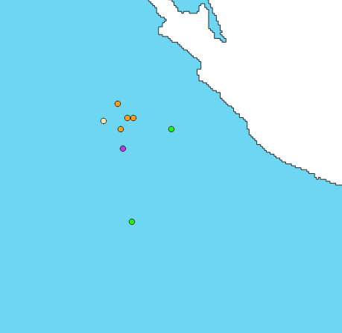

The one monastery dedicated to all the saints is located in the Palermo commune. As you can see, it is surrounded by other monasteries.

An easier way to see how the 4 groups cluster are concentrated across Sicily is by building Chloropleth maps.

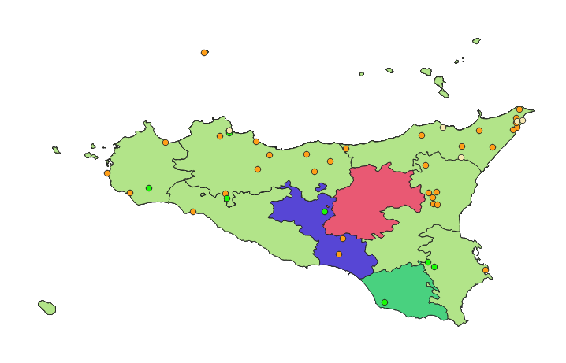

The light olive green means that the highest concentration of monasteries are dedicated to The Virgin Mary. As you can see, that is most of Sicily. The red represents null values and the blue and dark green represent areas where monasteries are dedicated to the holy dedications. Next we can see the distribution of the 4 groups at the commune level.

At the commune level:

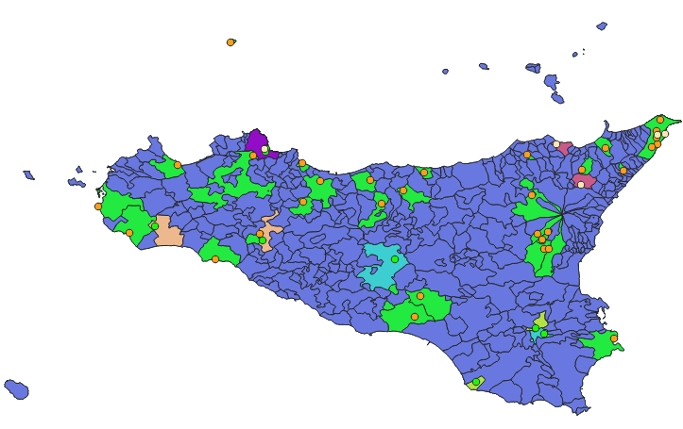

Blue represents null values (no data present). It is better to represent the distribution of the 4 groups by using a chloropleth map at the province level than commune level.