Unfortunately, elevation data is in raster form instead of vector form so geojson is not an allowable format for raster datasets. The elevation data will be uploaded in a different format which leaflet can support.

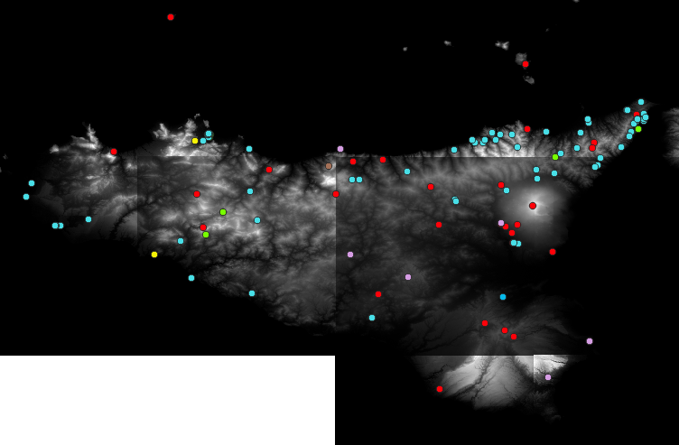

This next map is just the distributions of monasteries based on their order. What’s interesting about this visualization is way a lot of the Basilian order monasteries cluster around the coast lines (with a few exceptions). This will be explored more in future visualizations.

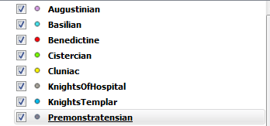

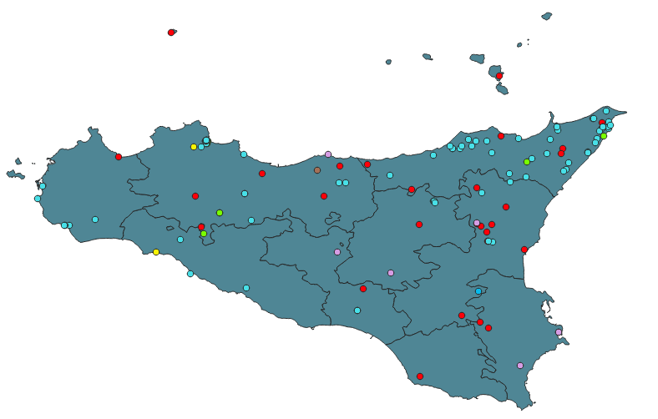

Finally, we have a heat map indicating which areas have the highest amount of monasteries depending on their order.

