MOD3: Project

Dawn Scott

Rasmussen College

Author Note

This paper is being submitted on October 20th, 2019, for Christopher Mattie’s CIS3801C Fundamentals of Mobile Web Application Development.

MOD3: Project

## URL site

Index.html

<http://fmwadvm.centralus.cloudapp.azure.com/MOD3/Project3/Index.html>

Index.php

<http://fmwadvm.centralus.cloudapp.azure.com/MOD3/Project3/Index.php>

ContactUs.php (Contains list of contacts retrieved from mysampledb)

<http://fmwadvm.centralus.cloudapp.azure.com/MOD3/Project3/ContactUs.php>

## URL to Github repository

<https://dawnsgithub1/CIS3801C-FMWAD-DawnScott/MOD3/Project3/Index.php>

Description of website

This website will be used to inform the community of the NFDL Music Programs available within the NFDL School district. This website will also include events and NFDL Music contact information.

Screenshots

Laptop: Index has four links to other php files and 4 external resources.

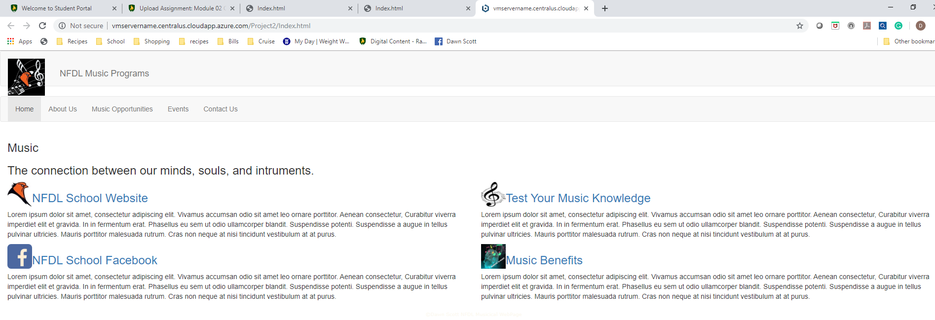

Picture 1: iPad: Contact Us Page with pulled data from mysampledb.

Picture 2: iPhone 6/7/8 Plus with data from mysambledb.

Picture 1 Picture 2

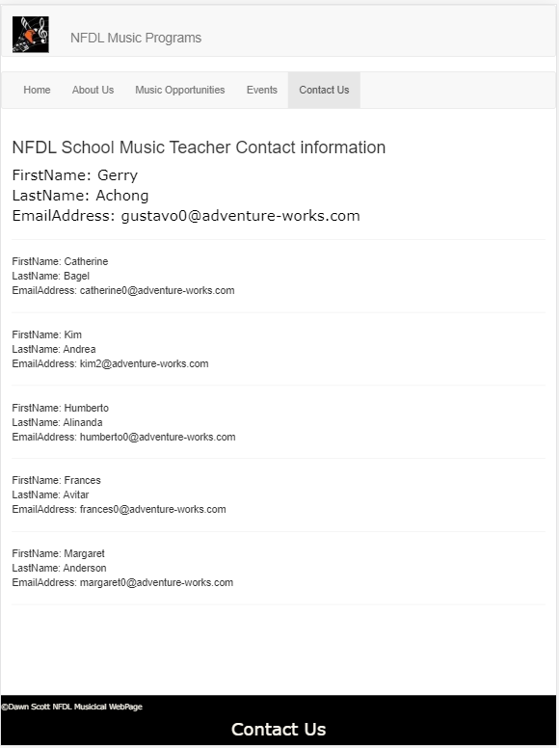 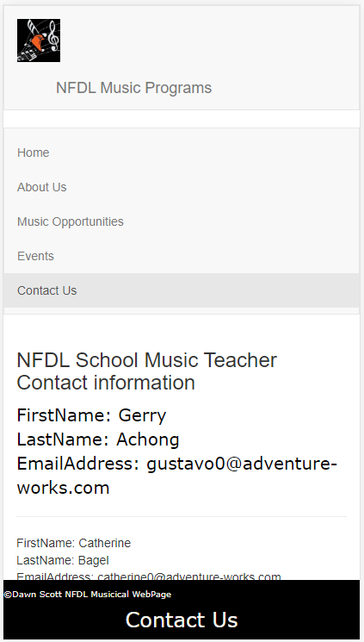:

Reference

Rasmussen College. (n.d.). Module 03: Designing Pages and Linking to a Database. In CIS3801C: Fundamentals of Mobile Web Application Development: Fall 2019 [Lesson]. Retrieved from https://learning.rasmussen.edu/webapps/blackboard/content/listContent.jsp?course_id=_56612_1&content_id=_5002958_1&mode=reset

West, A. W. (2016). Practical Web Design for Absolute Beginners (Chapters 7, 10, 13). Retrieved from https://learning.oreilly.com/library/view/practical-web-design/9781484219935/A418477_1_En_7_Chapter.html