MOD4: Activity Simple Sitemap

Dawn Scott

Rasmussen College

Author Note

This paper is being submitted on October 27th, 2019, for Christopher Mattie’s CIS3801C Fundamentals of Mobile Web Application Development.

MOD4: Activity: Simple Sitemap

**Site map using Microsoft Visio for URL:** http://fmwadvm.centralus.cloudapp.azure.com/MOD3/Project3/Index.html

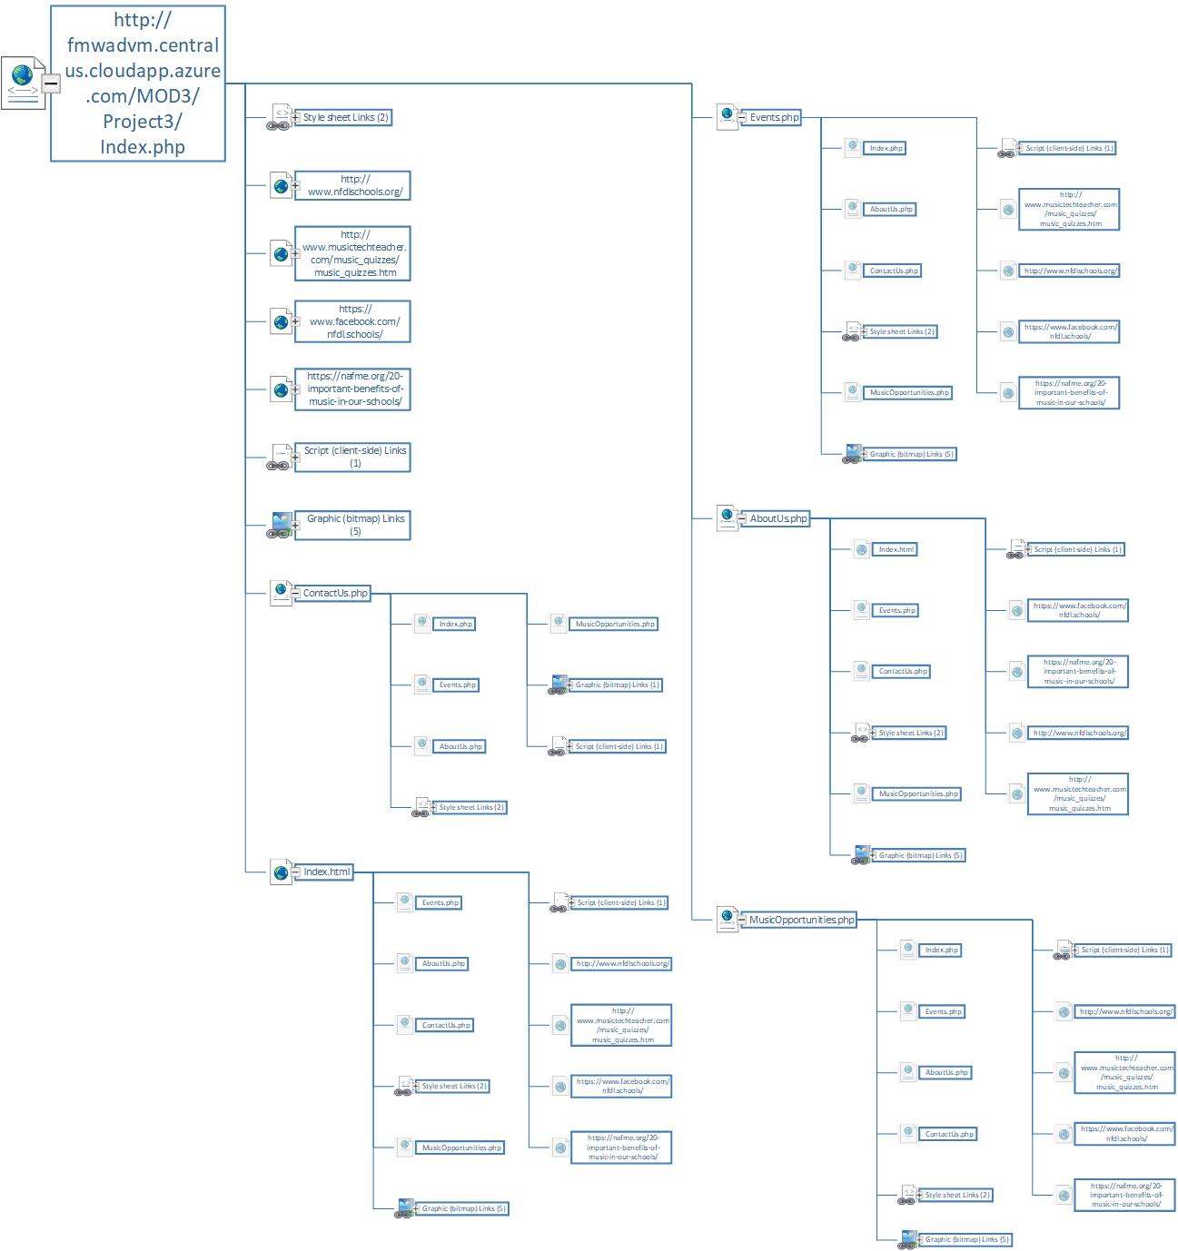

Reference

Rasmussen College. (n.d.). Module 04: Activity – Simple Sitemap. In CIS3801C: Fundamentals of Mobile Web Application Development: Fall 2019 [Lesson]. Retrieved from https://learning.rasmussen.edu/webapps/blackboard/content/listContent.jsp?course_id=_56612_1&content_id=_5002979_1

West, A. W. (2016). Practical Web Design for Absolute Beginners (Chapters 8, 11, 12). Retrieved from <https://learning.oreilly.com/library/view/practical-web-design/9781484219935/A418477_1_En_8_Chapter.html>