MOD4: Project: Adding Navigation

Dawn Scott

Rasmussen College

Author Note

This paper is being submitted on October 28th, 2019, for Christopher Mattie’s CIS3801C Fundamentals of Mobile Web Application Development.

MOD4: Project: Adding Navigation

## URL site

Index.html

<http://fmwadvm.centralus.cloudapp.azure.com/MOD4/Project4/Index.html>

Index.php

<http://fmwadvm.centralus.cloudapp.azure.com/MOD4/Project4/Index.php>

## URL to Github repository

<https://dawnsgithub1/CIS3801C-FMWAD-DawnScott/MOD4/Project4/Index.php>

Screenshots

The Microsoft Word document must also contain screen shots that illustrate 5-6 previews of your page, in portrait and landscape orientation, using Chrome Developer Tools.

iPad - Vertical:

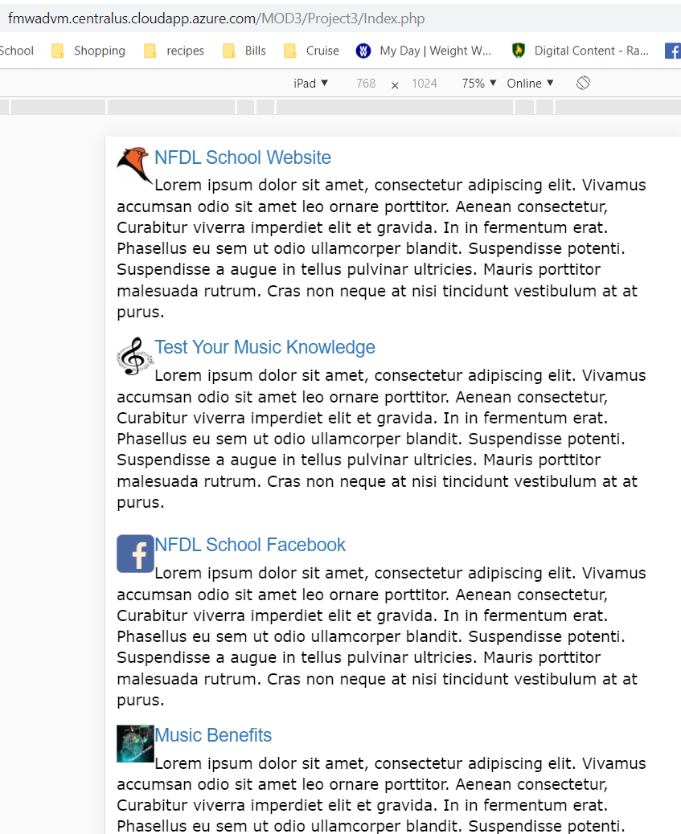

iPad - Horizontal:

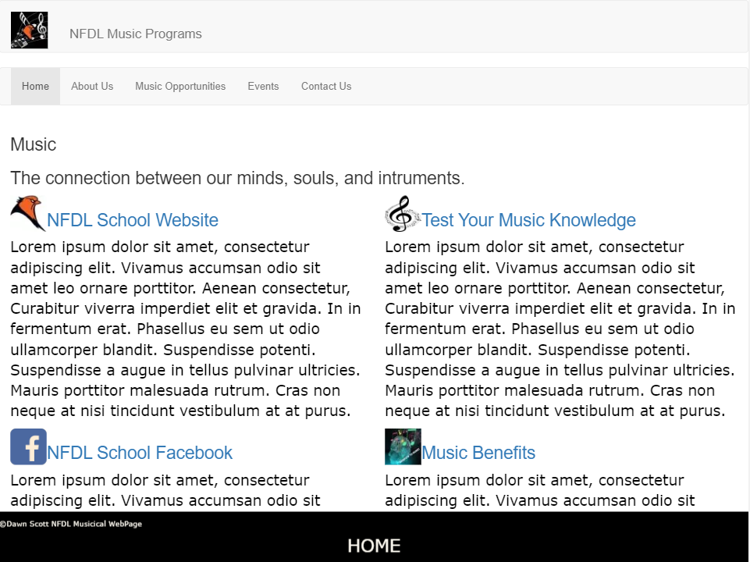

iPhone-6-7-8plus-Horizontal

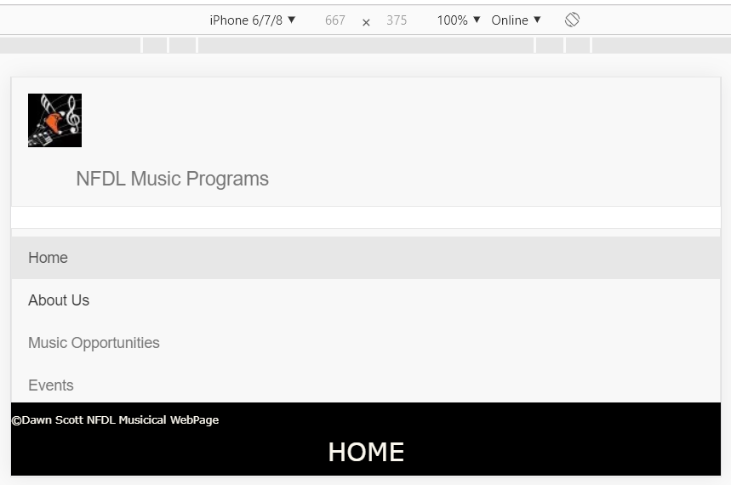

iPhone 6/7/8 Plus Verticle:

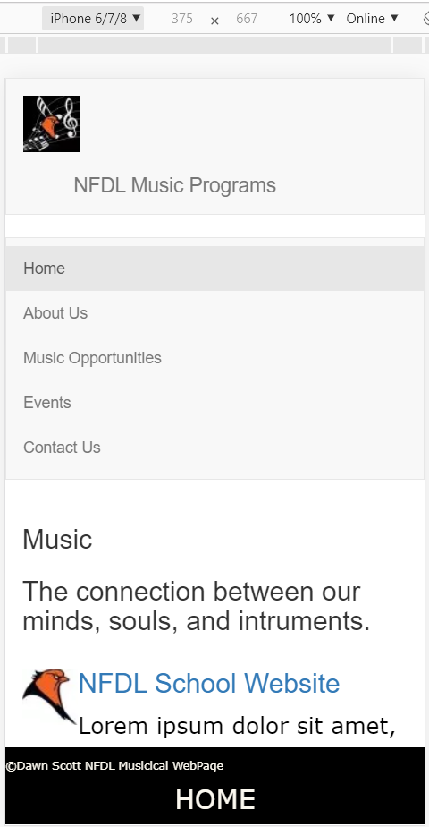

iPhoneX-Horizontal

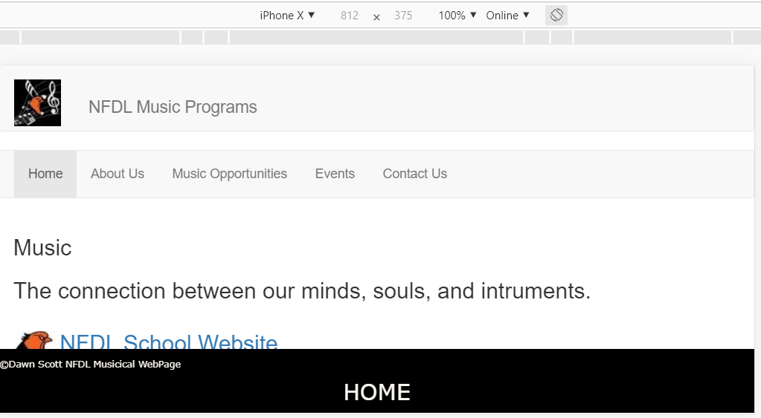

Reference

Rasmussen College. (n.d.). Module 04: Activity – Simple Sitemap. In CIS3801C: Fundamentals of Mobile Web Application Development: Fall 2019 [Lesson]. Retrieved from https://learning.rasmussen.edu/webapps/blackboard/content/listContent.jsp?course_id=_56612_1&content_id=_5002979_1

West, A. W. (2016). Practical Web Design for Absolute Beginners (Chapters 8, 11, 12). Retrieved from <https://learning.oreilly.com/library/view/practical-web-design/9781484219935/A418477_1_En_8_Chapter.html>