### MOD5: [Activity - Testing Screen Display Sizes](https://learning.rasmussen.edu/webapps/assignment/uploadAssignment?content_id=_5003026_1&course_id=_56612_1&group_id=&mode=view)

ng

Dawn Scott

Rasmussen College

Author Note

This paper is being submitted on November 3rd, 2019, for Christopher Mattie’s CIS3801C Fundamentals of Mobile Web Application Development.

MOD5: Activity: Testing Screen Display Sizes

iPad Pro - Vertical:

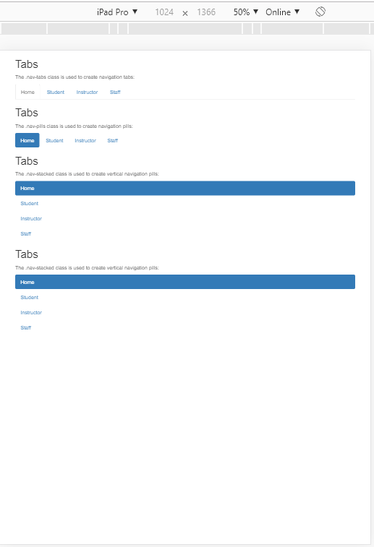

iPad Pro - Horizontal:

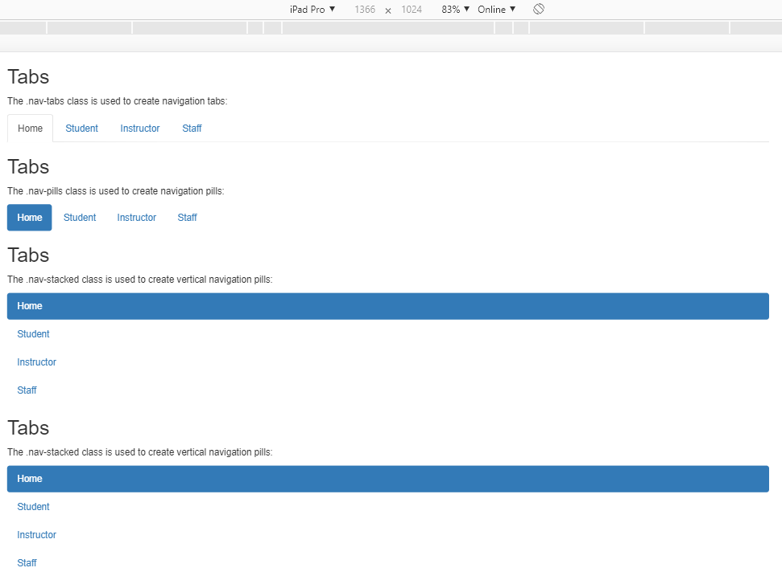

iPhone-6/7/8 - Horizontal

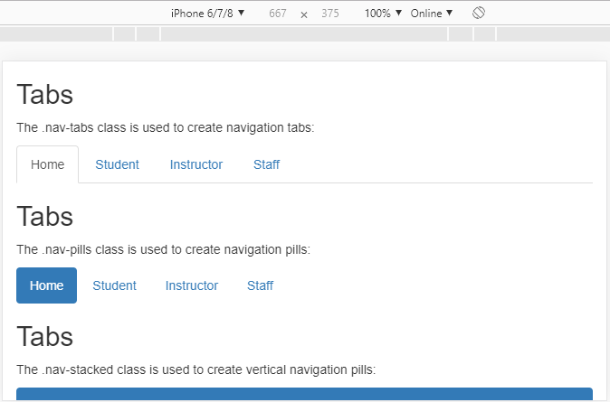

iPhone 6/7/8 Verticle:

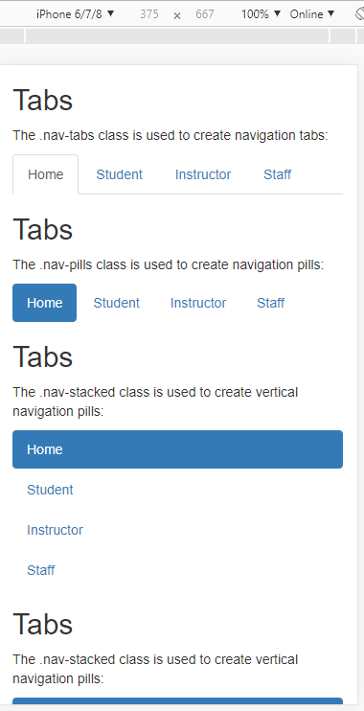

Galaxy S5 - Horizontal

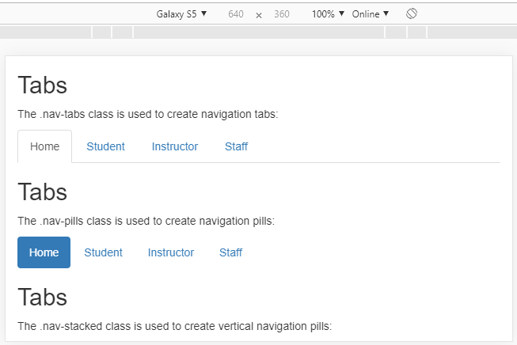

Galaxy S5 – Verticle

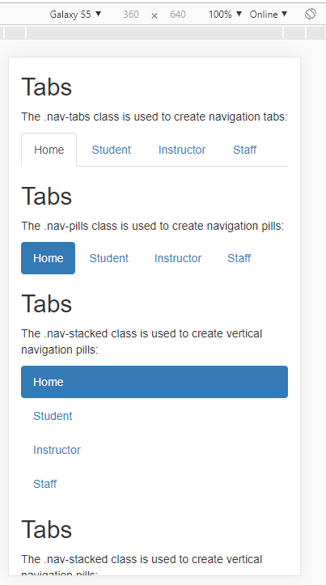

Reference

Rasmussen College. (n.d.). Module 05: Activity – Simple Sitemap. In CIS3801C: Fundamentals of Mobile Web Application Development: Fall 2019 [Lesson]. Retrieved from https://learning.rasmussen.edu/webapps/blackboard/content/listContent.jsp?course_id=_56612_1&content_id=_5002979_1

West, A. W. (2016). Practical Web Design for Absolute Beginners (Chapters 35,36). Retrieved from https://learning.oreilly.com/library/view/practical-web-design/9781484219935/A418477_1_En_36_Chapter.html