MOD1: Wireframe Basic Multi-Page Responsive Website

Dawn Scott

Rasmussen College

Author Note

This paper is being submitted on February 16th, 2020, for Dr. Goodwin’s CIS4655C Advanced Mobile Web Application Development.

MOD1: Wireframe Basic Multi-Page Responsive Website

Screenshots:

* First, you need a host or server to store your web files. We are going to use the Rasmussen SOTD.US hosting site.

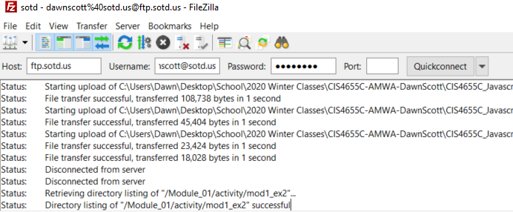

* Next, you will need a text editor to edit HTML, CSS, and JavaScript documents. Throughout the course, we will use a text editor called Atom. 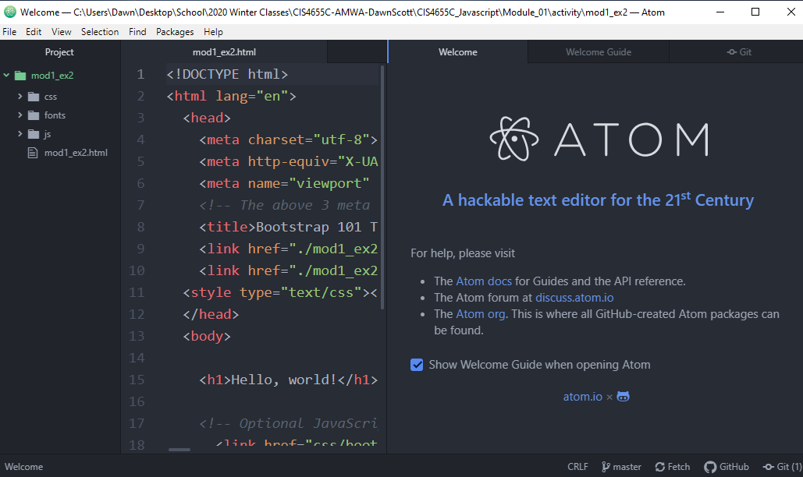
* Next, you will learn how to use a tool called GitHub, which allows developers to maintain copies of projects and source code.

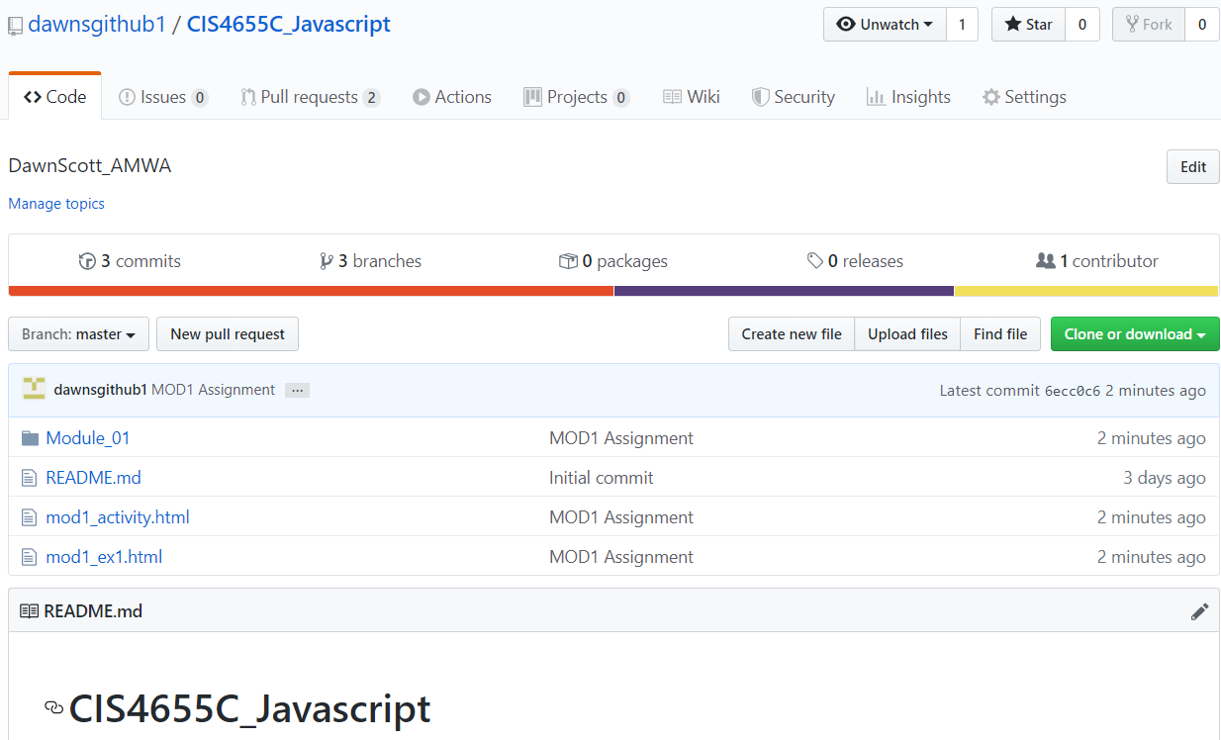

* You will then use a Content Delivery Network (CDN) to install a front-end framework. We will use the Bootstrap CDN for this course.

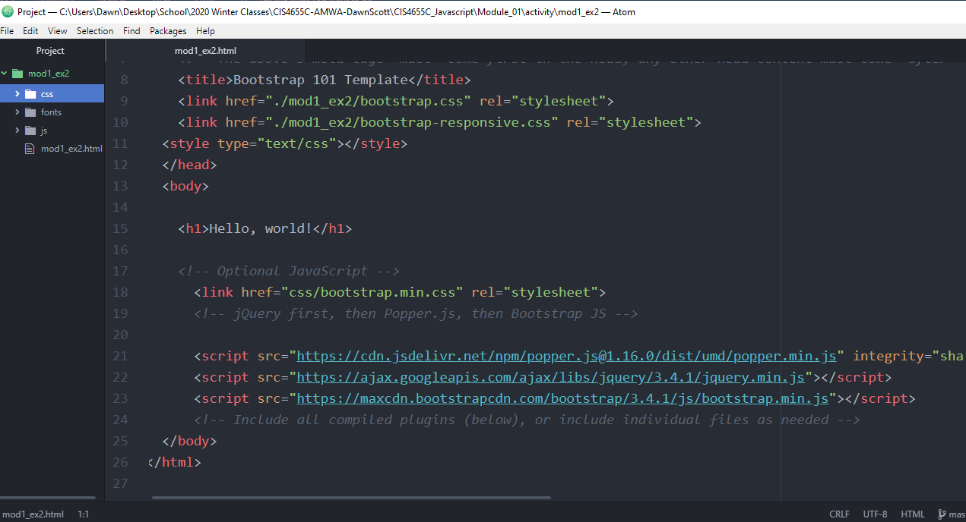

* You will create a single “Hello World” web page using a Bootstrap front-end framework, upload it to your host, and provide the URL to the webpage, as well as copies of your web folder. <http://sotd.us/dawnscott/Module_01/activity/mod1_ex2/mod1_ex2.html>

