MOD1: Wireframe Basic Multi-Page Responsive Website

Dawn Scott

Rasmussen College

Author Note

This paper is being submitted on February 16th, 2020, for Dr. Goodwin’s CIS4655C Advanced Mobile Web Application Development.

MOD1: Wireframe Basic Multi-Page Responsive Website

Create a wireframe based on the home page of the website

[http://sotd.us/dawnscott/Module_01/ project/mod1_proj1/ mod1_proj1.html](http://sotd.us/dawnscott/Module_01/%20project/mod1_proj1/%20mod1_proj1.html)

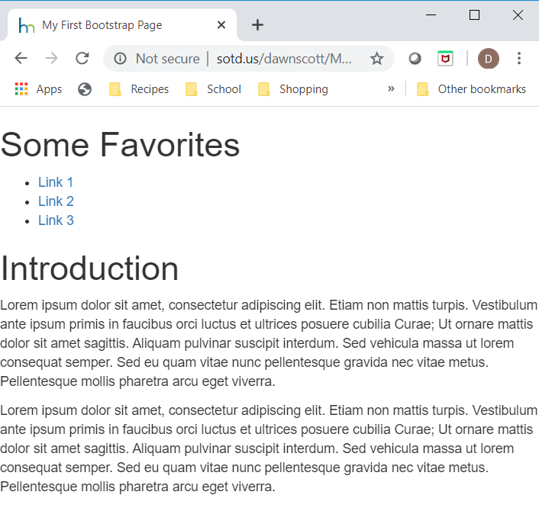

Responsive website with bootstrap, start with this viewport and increase the fluid grid, while adding visuals and media to enhance the users

Add a flexible image logo and search bar

experience. Add a bootstrap scrollspy vertical menu.





Change from a bootstrap dropdown to an inline list of each page link. Bootstrap text and image size change when source gets bigger.



Full view of a CSS Grid Layout with internal and external links



Reference

Rasmussen College. (n.d.). Module 01: Advanced Mobile Web Application Development. In CIS4655C: Fundamentals of Mobile Web Application Development: Winter 2020 [Lesson]. Retrieved from https://learning.rasmussen.edu/webapps/blackboard/content/listContent.jsp?course_id=_63065_1&content_id=_5645025_1

HTML5 and CSS3: Building Responsive Websites. (n.d.). Chapter 1 and 5: HTML5 and CSS3: Building Responsive Websites. Retrieved from https://learning.oreilly.com/library/view/html5-and-css3/9781787124813/pt01.html