MOD2: Basic Template Styling

Dawn Scott

Rasmussen College

Author Note

This paper is being submitted on February 23rd, 2020, for Dr. Goodwin’s CIS4655C Advanced Mobile Web Application Development.

MOD2: Basic Template Styling

<http://sotd.us/dawnscott/Module_02/activity/mod2_assign2/mod2_assign2.html>

A 3-column grid.  
  
The first column displays text that contains one h1 header and formatted text.

The second column contains a form with at least 2 button styles.

The third column contains a responsive image of your choice that resizes as the browser window size changes.

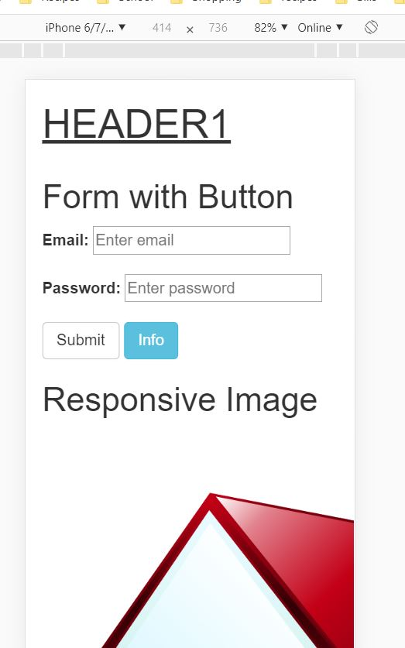

Reference

Rasmussen College. (n.d.). Module 02 Basic Styling. In CIS4655C: Fundamentals of Mobile Web Application Development: Winter 2020 [Lesson]. Retrieved from https://learning.rasmussen.edu/webapps/blackboard/content/listContent.jsp?course_id=_63065_1&content_id=_5645027_1

HTML5 and CSS3: Building Responsive Websites. (n.d.). Module 01, Chapter 1; Module 2, Chapter 3: HTML5 and CSS3: Building Responsive Websites. Retrieved from https://learning.oreilly.com/library/view/html5-and-css3/9781787124813/pt01.html