MOD2: Build basic template based on Wireframe

Dawn Scott

Rasmussen College

Author Note

This paper is being submitted on February 16th, 2020, for Dr. Goodwin’s CIS4655C Advanced Mobile Web Application Development.

MOD2: Build basic template based on Wireframe

Build basic template using the grid system to replicate the layout with features not yet covered.

<http://sotd.us/dawnscott/Module_02/project/mod2_proj2.html>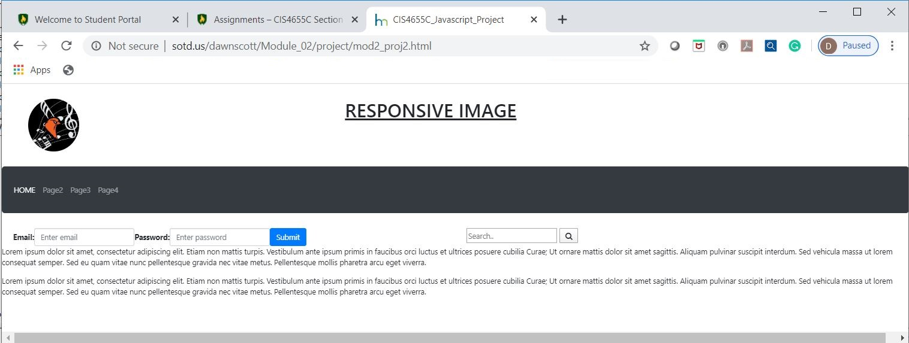

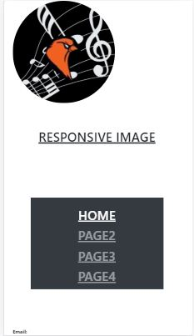 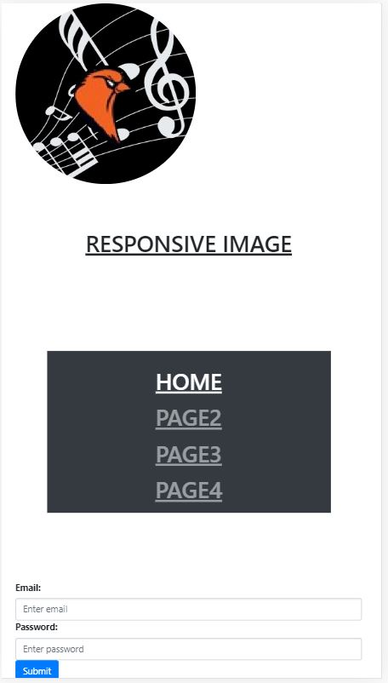

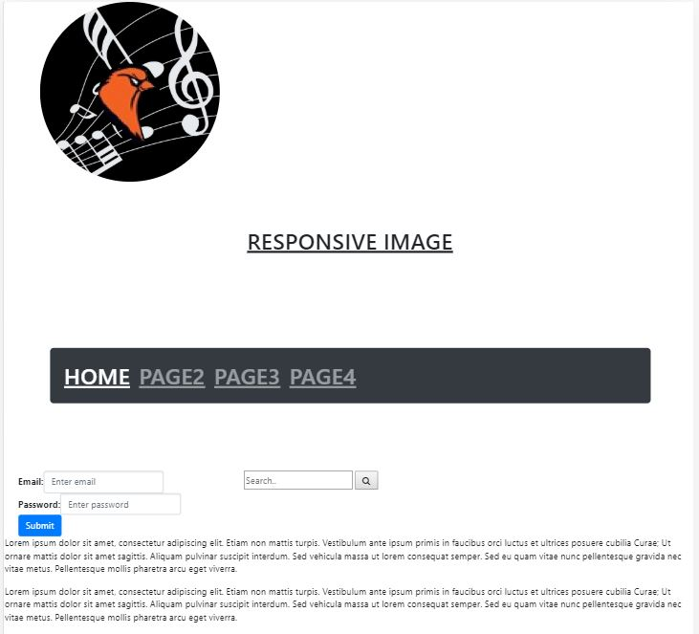

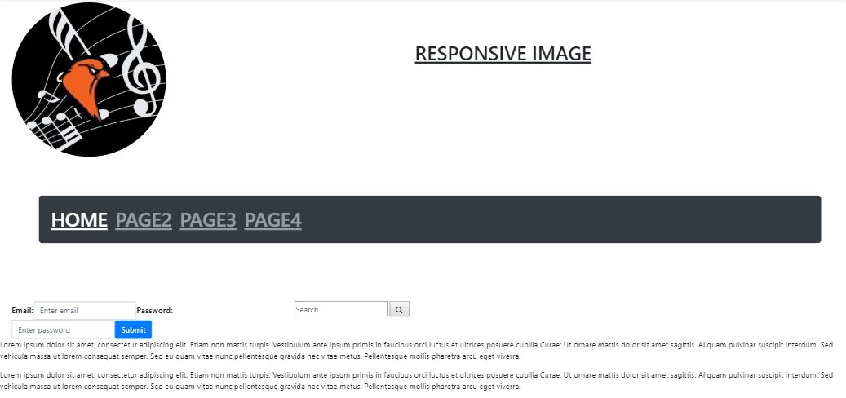

Rasmussen College. (n.d.). Module 02 Basic Styling. In CIS4655C: Fundamentals of Mobile Web Application Development: Winter 2020 [Lesson]. Retrieved from https://learning.rasmussen.edu/webapps/blackboard/content/listContent.jsp?course_id=_63065_1&content_id=_5645027_1

HTML5 and CSS3: Building Responsive Websites. (n.d.). Module 01, Chapter 1; Module 2, Chapter 3: HTML5 and CSS3: Building Responsive Websites. Retrieved from https://learning.oreilly.com/library/view/html5-and-css3/9781787124813/pt01.html