MOD3: Wireframing and Basic Layout

Dawn Scott

Rasmussen College

Author Note

This paper is being submitted on February 29th, 2020, for Dr. Goodwin’s CIS4655C Advanced Mobile Web Application Development.

MOD3: Wireframing and Basic Layout

A Microsoft Word Document containing the URL to your page uploaded to your Rasmussen SOTD site. For example: http://sotd.us/[your account name]/CIS4655/activities/module3.html

<http://sotd.us/dawnscott/Module_3/activity3/mod3_activity3.html>

The Microsoft Word document must also contain screen shots that illustrate 5-6 previews of your page, in portrait and landscape orientation, using Chrome Developer Tools. For example, Galaxy S5, iPhone 6, and iPad Pro.

Galaxy S5 Portrait

iPad Pro - Horizontal

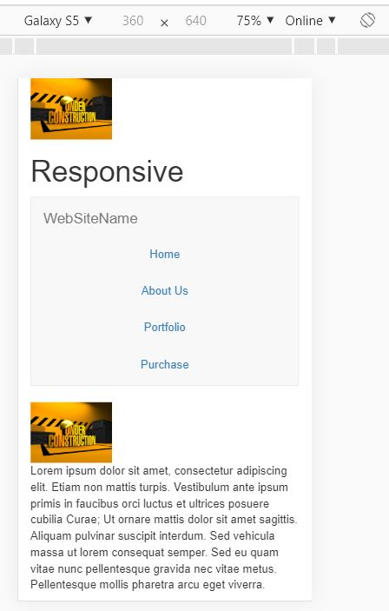

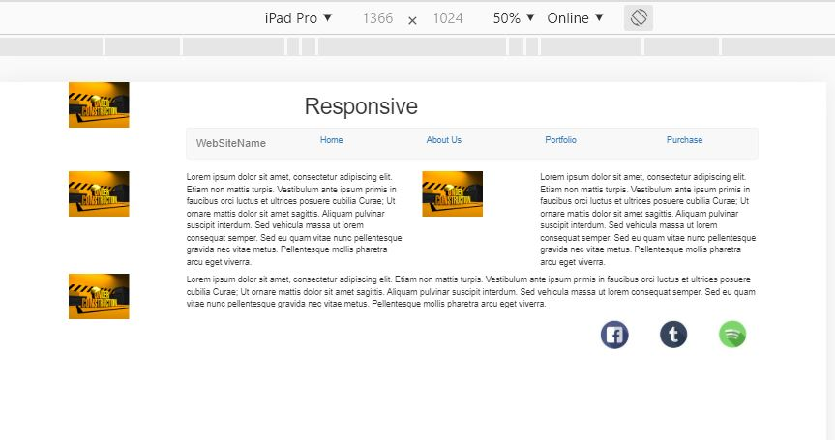

iPad Pro – Vertical

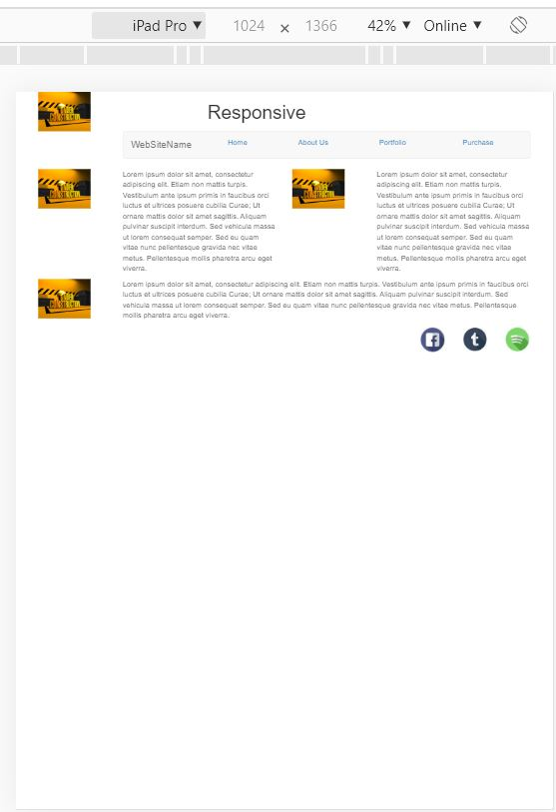

iPhone Plus - Horizontal

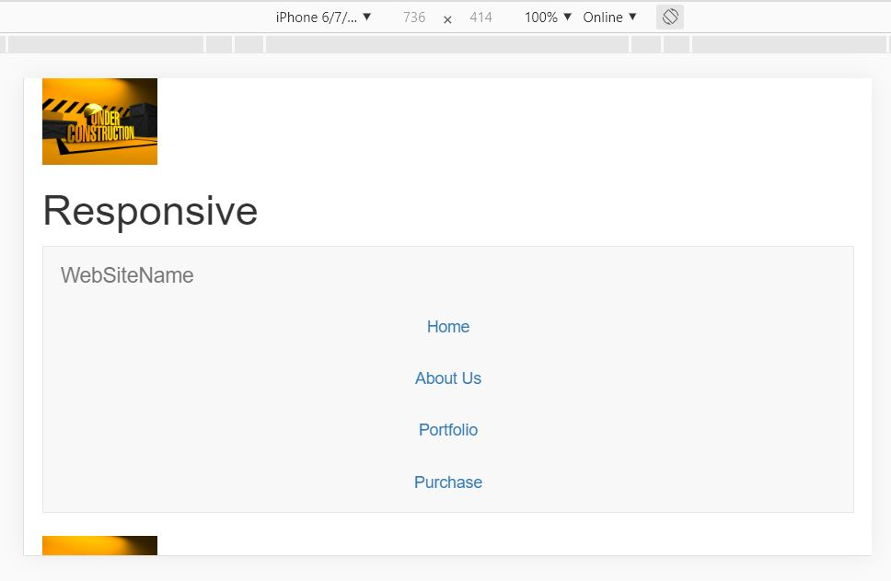

iPhone Plus Vertical

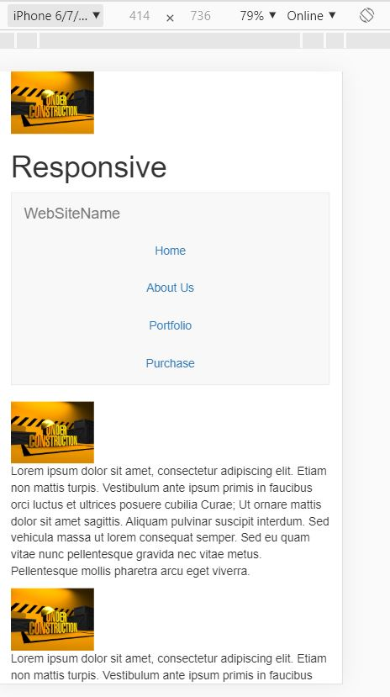

Laptop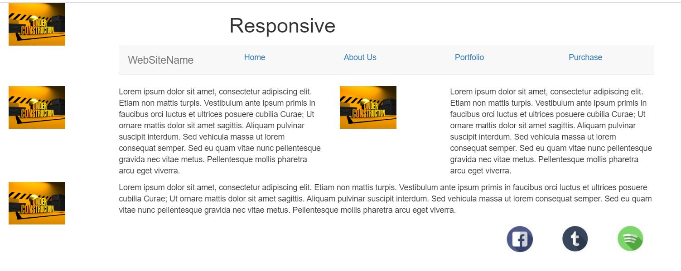

A ZIP file containing your Module 03 Activity assignment (HTML, CSS, images, and any related folders.)

Uploaded to FileZilla and attached to assignment.

Rasmussen College. (n.d.). Module 03 Layouts and Navigation. In CIS4655C: Fundamentals of Mobile Web Application Development: Winter 2020 [Lesson]. Retrieved from https://learning.rasmussen.edu/webapps/blackboard/content/listContent.jsp?course_id=_63065_1&content_id=_5645029_1

HTML5 and CSS3: Building Responsive Websites. (n.d.). Module 01, Chapter 7; Module 2, Chapter 4: HTML5 and CSS3: Building Responsive Websites. Retrieved from https://learning.oreilly.com/library/view/html5-and-css3/9781787124813/pt01.html