Adding Basic Navigation

Dawn Scott

Rasmussen College

Author Note

This paper is being submitted on March 1st, 2020, for Dr. Goodwin’s CIS4655C Advanced Mobile Web Application Development.

# Adding Basic Navigation

A Microsoft Word Document containing the URL to your page uploaded to your Rasmussen SOTD site. For example: http://sotd.us/[your account name]/CIS4655/projects/module3.html

<http://sotd.us/dawnscott/Module_3/project/Index.html>

Screen shots that illustrate 5-6 previews of your page, in portrait and landscape orientation, using Chrome Developer Tools. For example, Galaxy S5, iPhone 6, and iPad Pro.

Galaxy S5 Portrait

iPad Pro - Horizontal

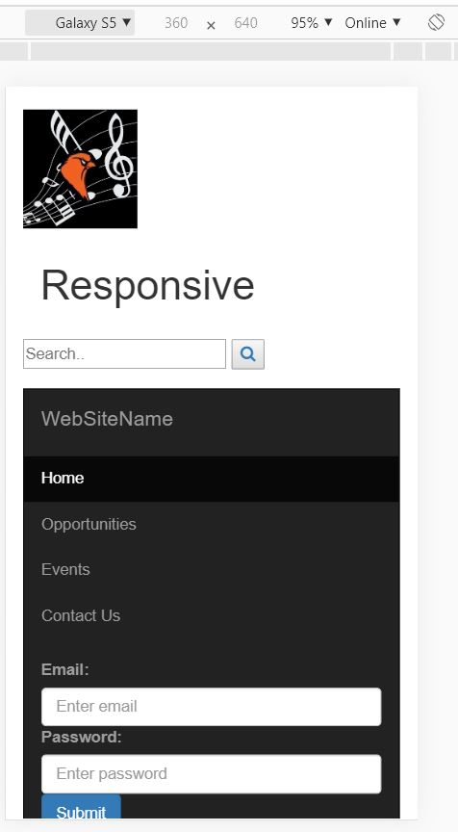

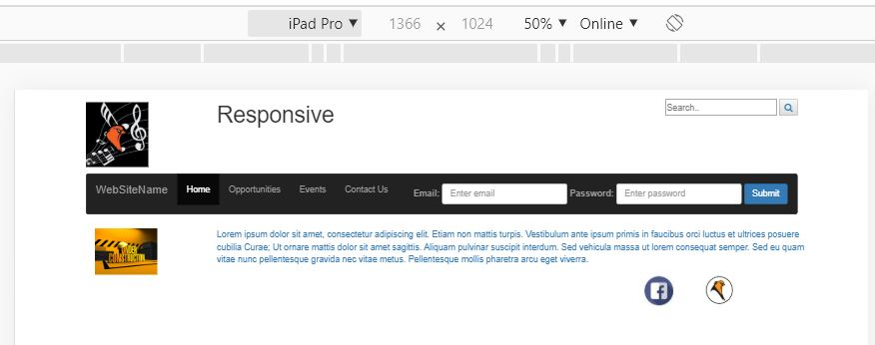

iPad Pro – Vertical

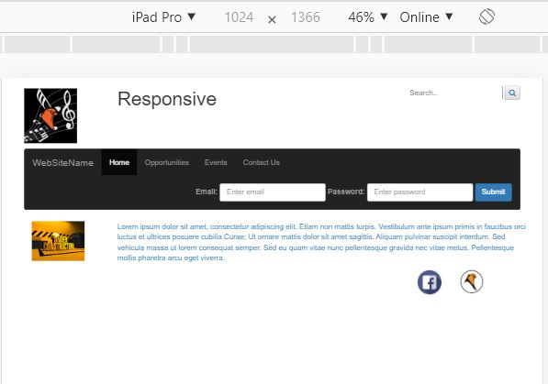

iPhone Plus – Horizontal



iPhone Plus - Verticle

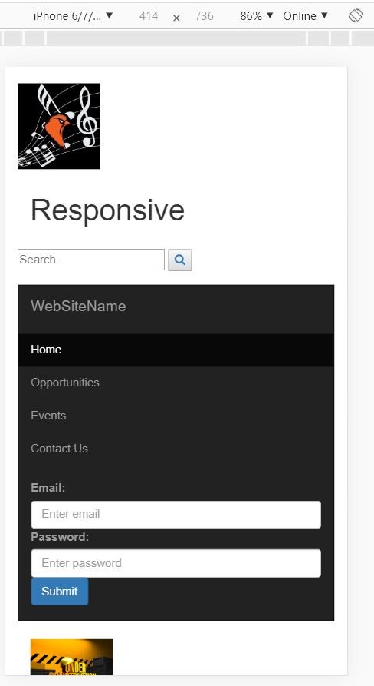

Laptop

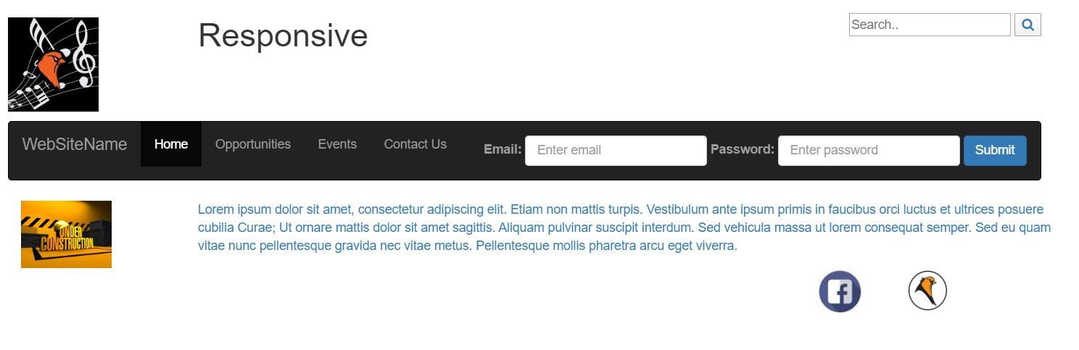

A ZIP file containing your Module 03 Course Project assignment – Attached to Module 3 Project assignment.

Reference

Rasmussen College. (n.d.). Module 03 Layouts and Navigation. In CIS4655C: Fundamentals of Mobile Web Application Development: Winter 2020 [Lesson]. Retrieved from https://learning.rasmussen.edu/webapps/blackboard/content/listContent.jsp?course_id=_63065_1&content_id=_5645029_1

HTML5 and CSS3: Building Responsive Websites. (n.d.). Module 01, Chapter 7; Module 2, Chapter 4: HTML5 and CSS3: Building Responsive Websites. Retrieved from https://learning.oreilly.com/library/view/html5-and-css3/9781787124813/pt01.html