MOD4: Adding style and layout components

Dawn Scott

Rasmussen College

Author Note

This paper is being submitted on March 3rd, 2020, for Dr. Goodwin’s CIS4655C Advanced Mobile Web Application Development.

MOD4: Adding style and layout components

<http://sotd.us/dawnscott/Module_3/project/Index.html>

Style and layout components to the home page or other linked pages:

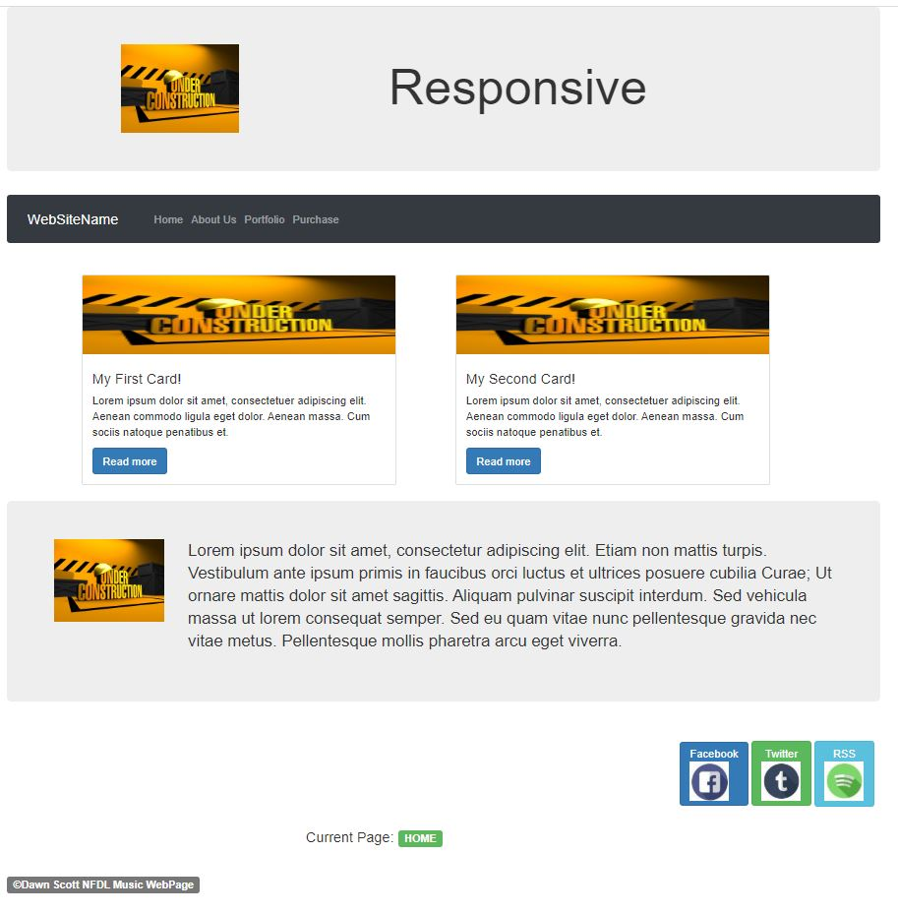

At least 3 buttons that have badges. They can be any size you choose, as well as any style.



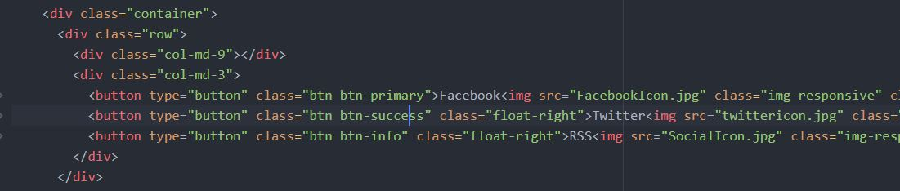

At least 2 labels.



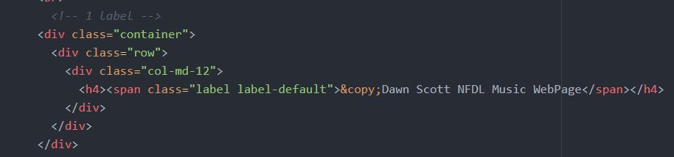

At least 1 jumbotron.



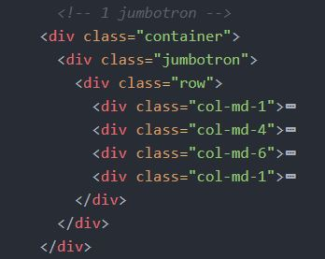

At least 1 card. The button on the card must link to another page of content.



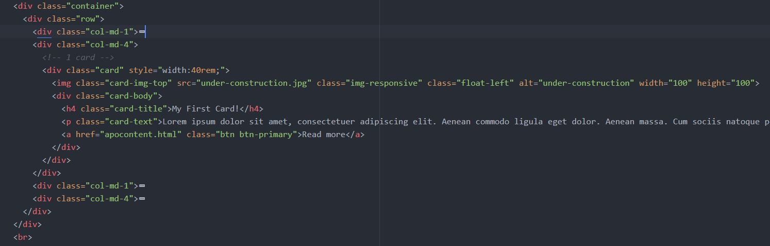

Reference

Rasmussen College. (n.d.). Module 04 Styling. In CIS4655C: Fundamentals of Mobile Web Application Development: Winter 2020 [Lesson]. Retrieved from https://learning.rasmussen.edu/webapps/blackboard/content/listContent.jsp?course_id=_63065_1&content_id=_5645031_1

HTML5 and CSS3: Building Responsive Websites. (n.d.). Module 03, Chapter 6: HTML5 and CSS3: Building Responsive Websites. Retrieved from https://learning.oreilly.com/library/view/html5-and-css3/9781787124813/pt01.html