MOD1: Configure a Development Environment

Dawn Scott

Rasmussen College

Author Note

This paper is being submitted on October 6th, 2019, for Christopher Mattie’s CIS3801C Fundamentals of Mobile Web Application Development.

MOD1: Understanding Core Technologies

URL site: <http://dawnsdns.centralus.cloudapp.azure.com/MOD1/Activity1/Index.html>

Screenshots:

1. Create and configure a Bitnami Lamp Server
   1. Log into Azure:
   2. Deploy a Lamp Virtual Server

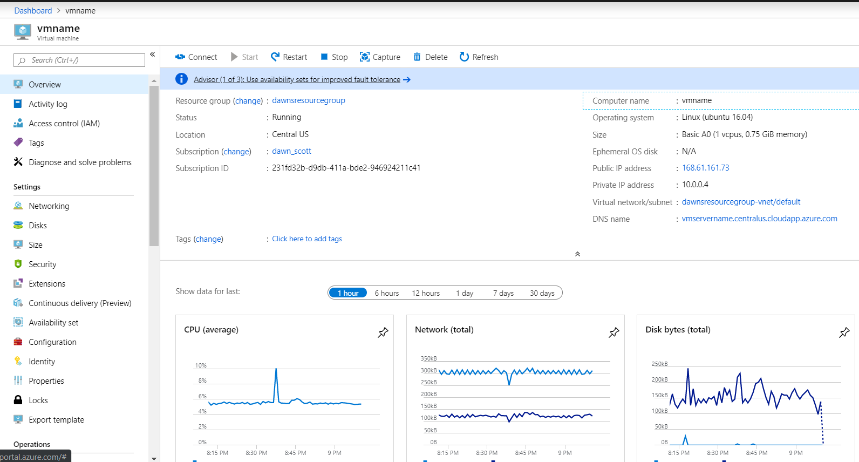

* 1. Create Storage Account

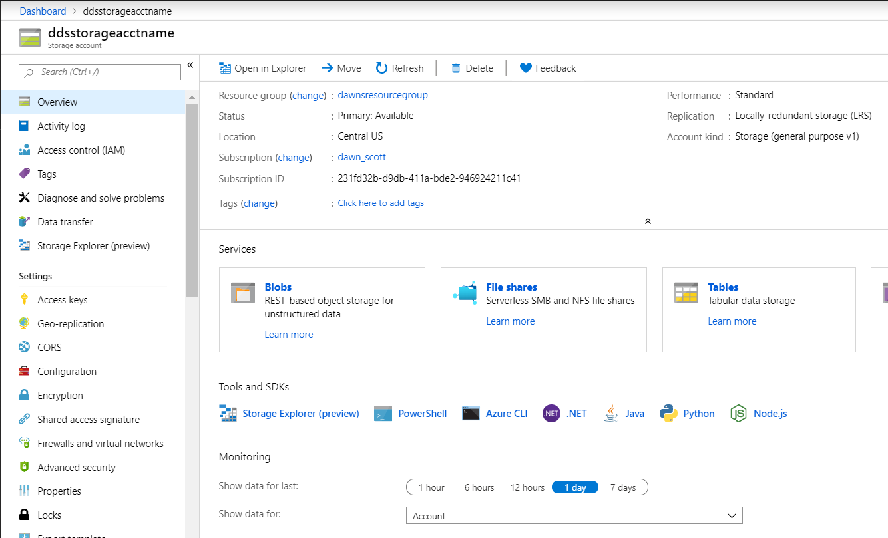

* 1. Connect VM with SSH

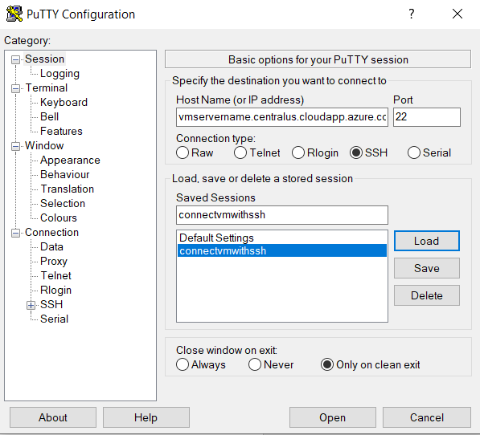

* 1. Log in with lamp server admin user name and password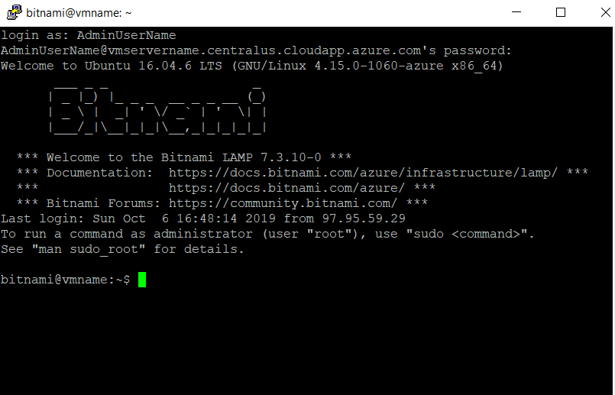

1. Copy a database to a virtual machine
   1. Secure Tunnel

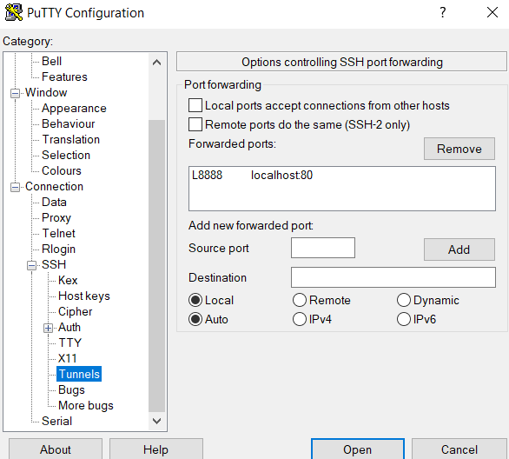

* 1. Log into phpMyAdmin with root and the application password found in the server boot file.
  2. Added JohnDoe to User accounts

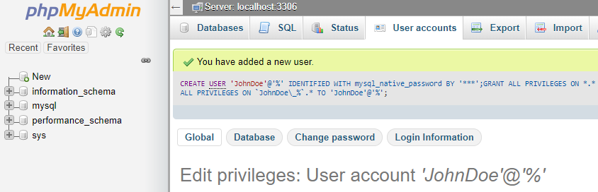

* 1. Login as JohnDoe

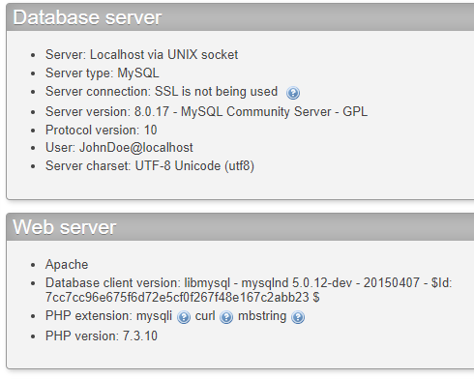

* 1. Restore the AdventureWorks Database
  2. Downloaded AdventureWorks zip file to VM
  3. Unzipped AdventureWorks file
  4. Installed the AdventureWorks database
  5. Connection to the server’s MySQL DBMS utilizing the phpMyAdmin program.

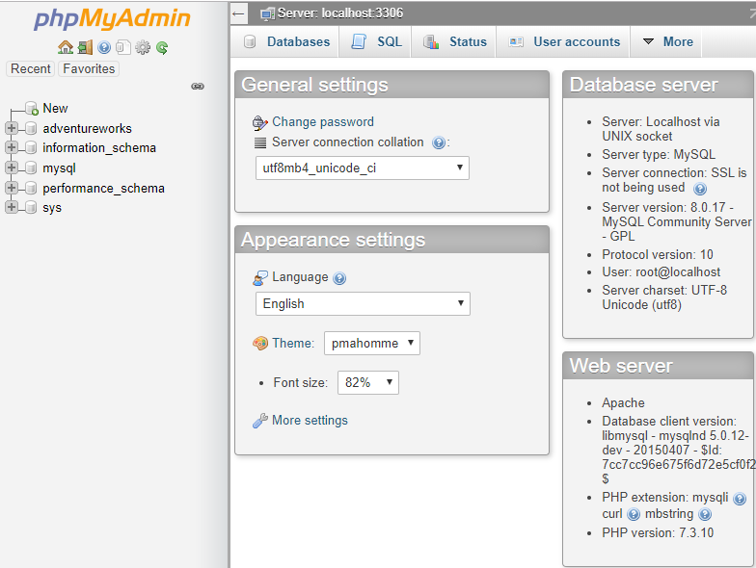

1. Download, install, and setup GitHub
   1. Created new repository in GitHub and first commit
   2. Download the repository to GitHub desktop and first commit

