MOD1: Project: NFDL Music Parents

Dawn Scott

Rasmussen College

Author Note

This paper is being submitted on October 6th, 2019, for Christopher Mattie’s CIS3801C Fundamentals of Mobile Web Application Development.

MOD1: Project: NFDL Music Parents

**My Project** is for Music Parents and students to promote inclusion and a one stop shop for all music opportunities for the Village. I will add useful, informative, and entertaining content to grab the attention of both the music Parents and Students attention. I will include ways kids and parents can get involved, as well as links to websites and scholarship information.

Each Page will include the following:

**Header**: NFDL Music Programs

**Description of site:** Site to show the what music opportunities are in the NFDL Schools

**The Logo:** Top Left of site

**The Navigation bar**: will include three linked pages: About Us, Events, Contacts

**Body of each page:** Information pertaining to each page

**3 x Links**: Left side of page: Link to School site, Facebook site, and Benefits of music.

**The Footer** copyright information on left bottom, link to the Home page bottom right.

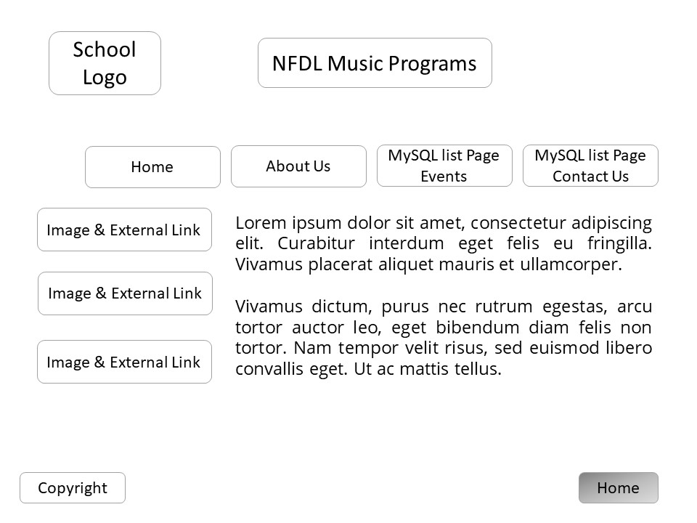

Rasmussen College. (n.d.). Module 01: Understanding Core Technologies. In CIS3801C: Fundamentals of Mobile Web Application Development: Fall 2019 [Lesson]. Retrieved from <https://learning.rasmussen.edu/webapps/blackboard/content/listContent.jsp?course_id=_53974_1&content_id=_4775837_1>

West, A. W. (2016). Practical Web Design for Absolute Beginners (Chapters 1-3). Retrieved from https://learning.oreilly.com/library/view/practical-web-design/9781484219935/A418477_1_En_1_Chapter.html