MOD2: Create a Wireframe of a Home Page

Dawn Scott

Rasmussen College

Author Note

This paper is being submitted on October 10th, 2019, for Christopher Mattie’s CIS3801C Fundamentals of Mobile Web Application Development.

MOD2: Create a Wireframe of a Home Page

# **Index Page:**

This page includes a header with the title of the page, three images which will have links to outside urls, a footer, welcome content, and links to four other webpages.

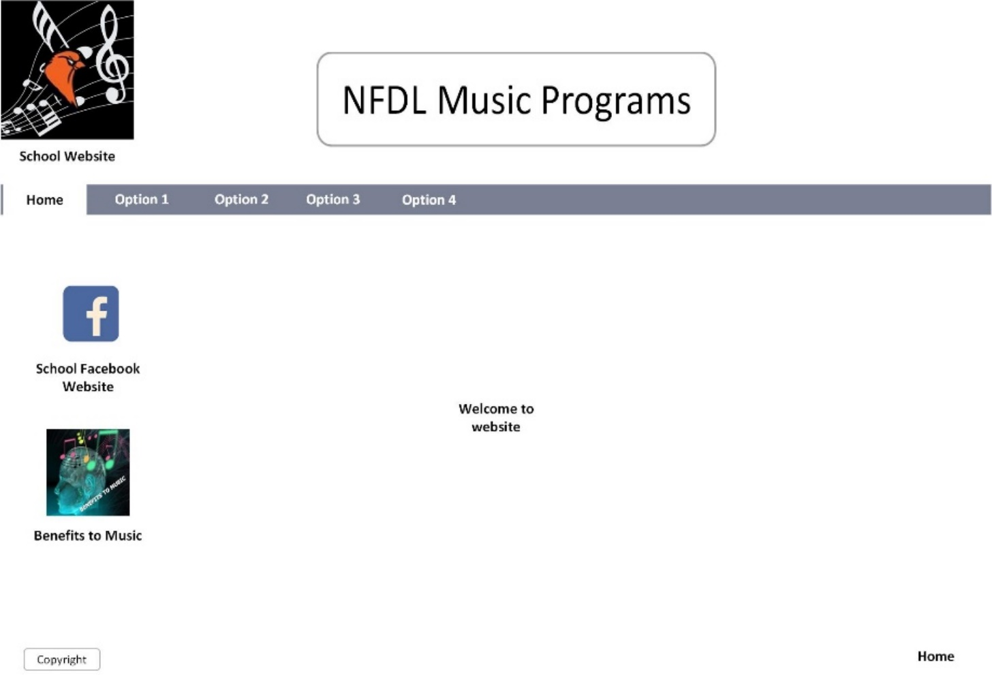

Reference

Rasmussen College. (n.d.). Module 02: Interactive Learning Topics. In CIS3801C: Fundamentals of Mobile Web Application Development: Fall 2019 [Lesson]. Retrieved from https://learning.rasmussen.edu/webapps/blackboard/content/listContent.jsp?course_id=_56612_1&content_id=_5002974_1

West, A. W. (2016). Practical Web Design for Absolute Beginners (Chapters 4-6). Retrieved from https://learning.oreilly.com/library/view/practical-web-design/9781484219935/A418477_1_En_4_Chapter.html