MOD3: Wireframing New Pages

Dawn Scott

Rasmussen College

Author Note

This paper is being submitted on October 20th, 2019, for Christopher Mattie’s CIS3801C Fundamentals of Mobile Web Application Development.

MOD3: Wireframing New Pages

**Home Page** (Index.html)

Upper Right is the logo and NFDL Music Programs is the Webpage Name.

Home, About Us, Music Opportunities, Events, and Contact Us are all links to other html pages. Example of code used to link another the page:

<li><a href="AboutUs.html"target="_blank">About Us</a></li>

NFDL School Website is an external link to the school, NFDL School Facebook is linked to their facebook page, Test Your Music Knowledge is a link to a fun quiz for music lovers, and Music Benefits is a link to benefits of music. Example of code used to link to an external page:

<a href="http://www.nfdlschools.org/" target="_blank"><img src="Oriole.jpg" class="img-responsive pull-left" alt="Oriole" style="width:50px;height:50px;border:2;"> <h3>NFDL School Website</h3></a>

The Footer of the page is a copyright note and name of the current page.

Example of css style used for Footer:

.footer {

position: fixed;

left: 0;

bottom: 0;

width: 100%;

background-color: #000000;

color: white;

}

Example of Footer:

<div class="footer">

<h6 align="left"><font face="verdana" size="1" color=#FBF8EF>&copy;Dawn Scott NFDL Musicical WebPage</h6>

<h6 align="center"><font face="verdana" size="5" color=#FBF8EF>HOME</h6>

</div>

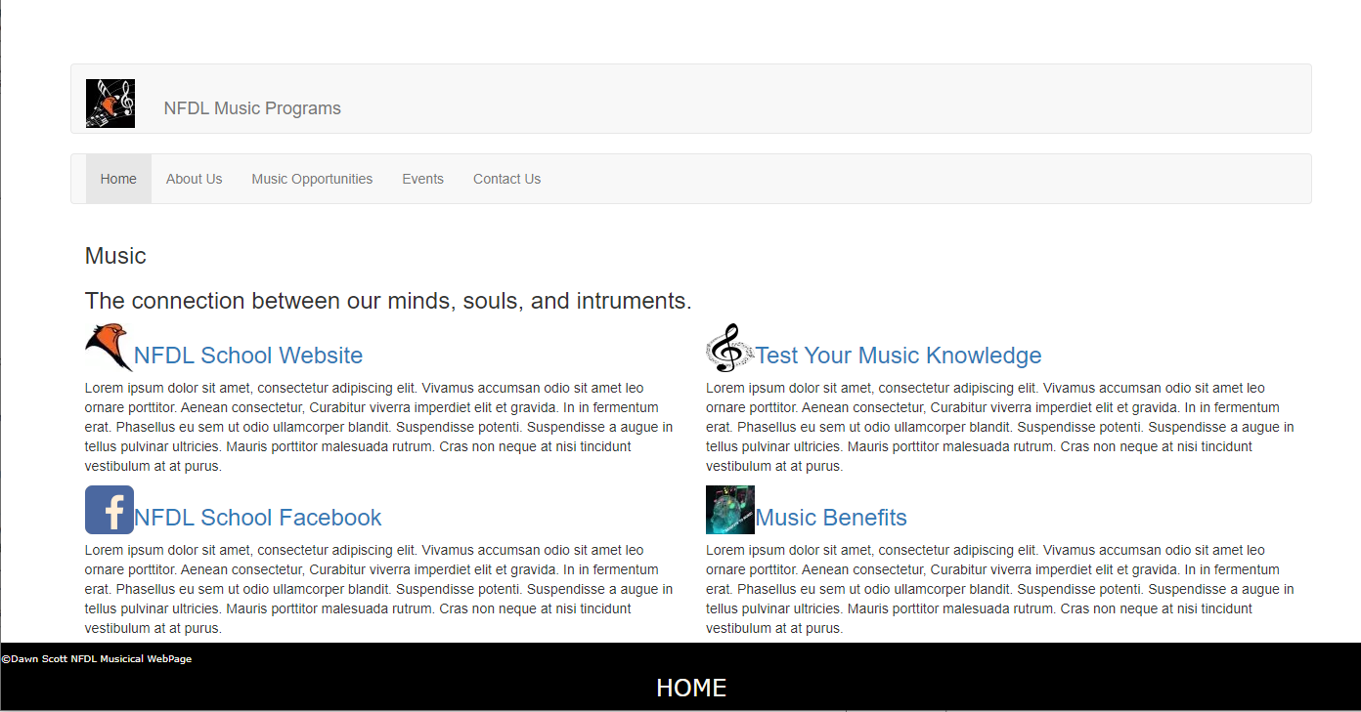

Reference

Rasmussen College. (n.d.). Module 03: Designing Pages and Linking to a Database. In CIS3801C: Fundamentals of Mobile Web Application Development: Fall 2019 [Lesson]. Retrieved from https://learning.rasmussen.edu/webapps/blackboard/content/listContent.jsp?course_id=_56612_1&content_id=_5002958_1&mode=reset

West, A. W. (2016). Practical Web Design for Absolute Beginners (Chapters 7, 10, 13). Retrieved from https://learning.oreilly.com/library/view/practical-web-design/9781484219935/A418477_1_En_7_Chapter.html