MOD2: Project

Dawn Scott

Rasmussen College

Author Note

This paper is being submitted on October 13th, 2019, for Christopher Mattie’s CIS3801C Fundamentals of Mobile Web Application Development.

MOD2: Project

## URL site

<http://vmservername.centralus.cloudapp.azure.com/Project2/Index.html>

## URL to Github repository

<https://github.com/dawnsgithub1/COP1801_Javascript/Index.html>

## Description of website

This website will be used to inform the community of the NFDL Music Programs available within the NFDL School district. This website will also include events and NFDL Music contact information.

The website will depict an HTML doctype and the <head> section will include a viewport meta data tag to make sure rendering and touch zooming is available. The <head> section will also include a bootstrap framework to apply styling to both the site. Within the bootstrap is a grid system to include a feature to adjust the screen size of the website depending on the device being used.

After the <head> section is a <body> section which contains the logo, title of the page, navigation bar, images, and any text added to the website. Within the <body> section are containers which wrap the contents and any grid systems applied.

## Screenshots

Laptop:

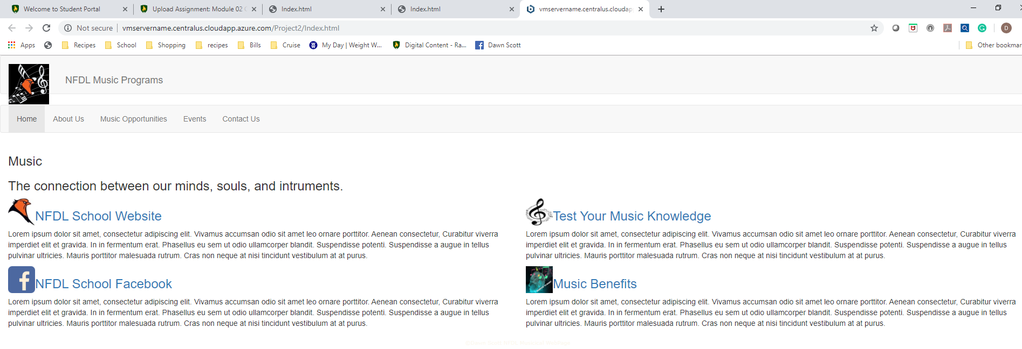

Galaxy S5: iPad:

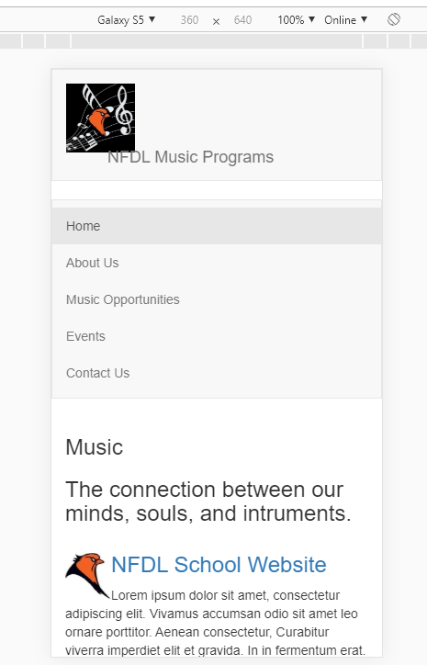 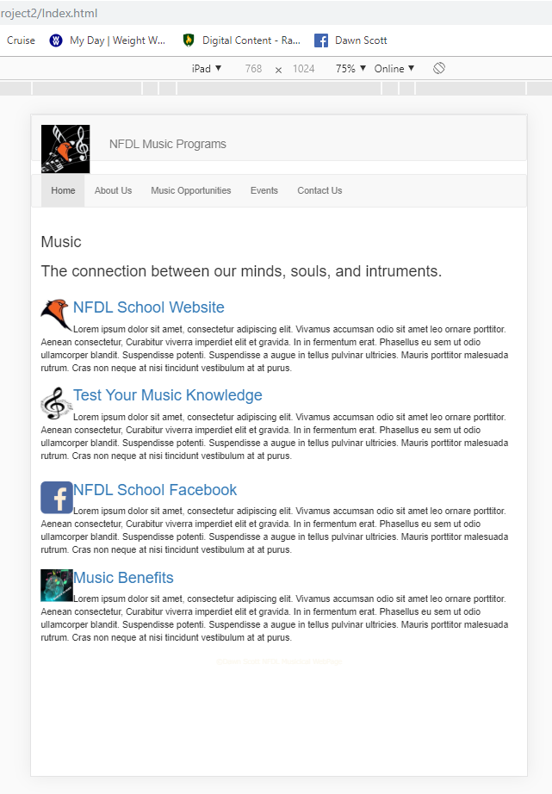

# Reference

Wireframing and Frist Home Page (n.d.). Retrieved from https://learning.rasmussen.edu/courses/1/FAL19T1-ONP-CIS3801C-01/content/_5003003_1/res/index.html

Rasmussen College. (n.d.). Module 02: Interactive Learning Topics. In CIS3801C: Fundamentals of Mobile Web Application Development: Fall 2019 [Lesson]. Retrieved from https://learning.rasmussen.edu/webapps/blackboard/content/listContent.jsp?course_id=_56612_1&content_id=_5002974_1

West, A. W. (2016). Practical Web Design for Absolute Beginners (Chapters 4-6). Retrieved from https://learning.oreilly.com/library/view/practical-web-design/9781484219935/A418477_1_En_4_Chapter.html