DEPARTMENT OF COMPUTER SCIENCE
& ENGINEERING,
SHARDA UNIVERSITY


COURSE NAME

Advanced Java Programming Practical file
(CSP014)

Name: Pratyush Thakur
Semester: IV
Section: CS-H (Group 2)
Faculty: Sushant Jhingran

Q1) Implement collection framework interfaces in java.
Solution:
package com.java.collection_try;
import java.util.*;

//The collection framework provides a set of classes and interfaces for storing and manipulating groups of data as a single unit.
//It has various data structures like lists, sets, and maps, along with algorithms to manipulate them.

public class Set_and_list {
public static void Set() {
Set<String> set = new HashSet<String>();
set.add("America");
set.add("Poland");
set.add("India");
set.add("Sri Lanka");
set.forEach(Desh->System.out.print(Desh + ", "));
}
public static void List() {
List<Integer> list = new ArrayList<>();
list.add(100);
list.add(50);
list.add(40);
list.add(30);
list.forEach(num->System.out.println(num));

}
public static void main(String[] args) {
Set();
List();
}
//Output:
// Sri Lanka, America, Poland, India, 100
// 50
// 40
// 30

Q2) Create program using JDBC connectivity.
Solution:
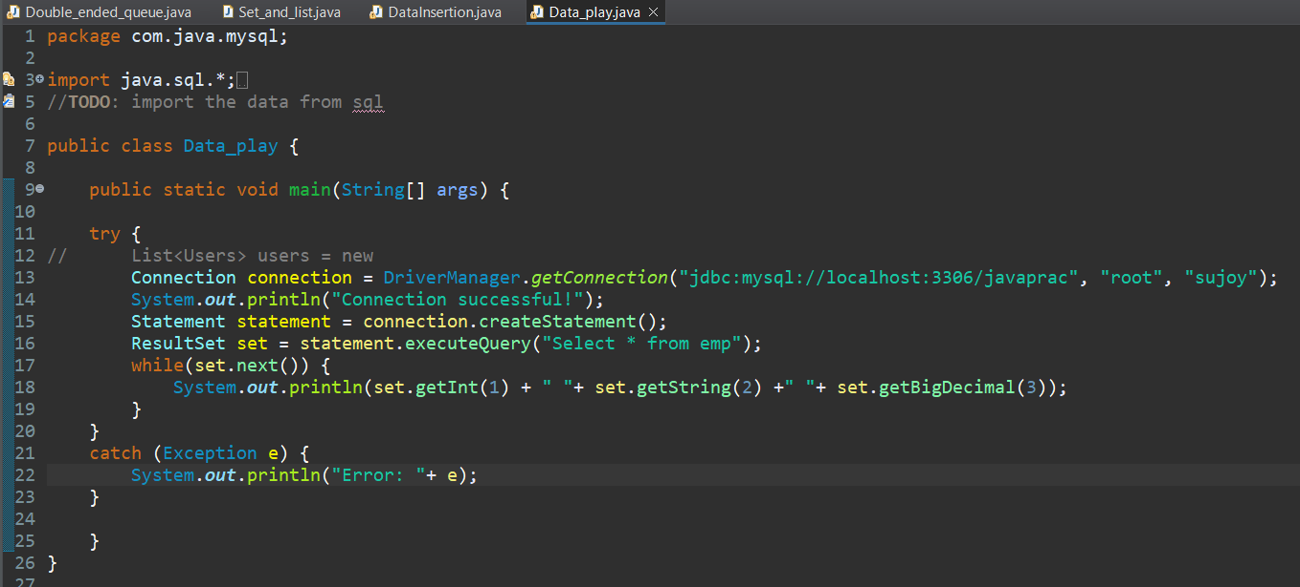
//Output:
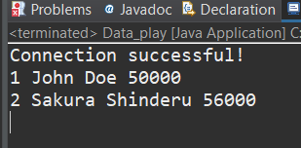
Q3) Develop web based program using servlet and JSP.
Solution:
- Index.html
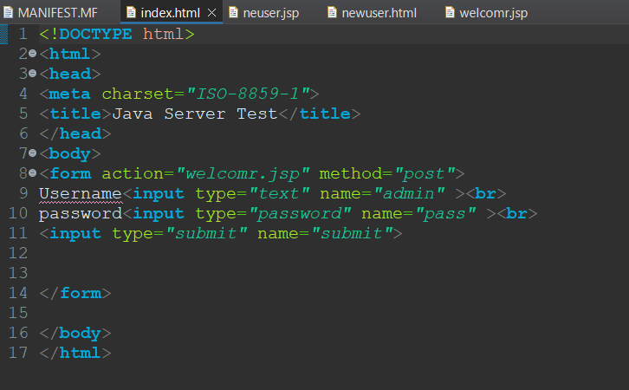
- welcomr.jsp
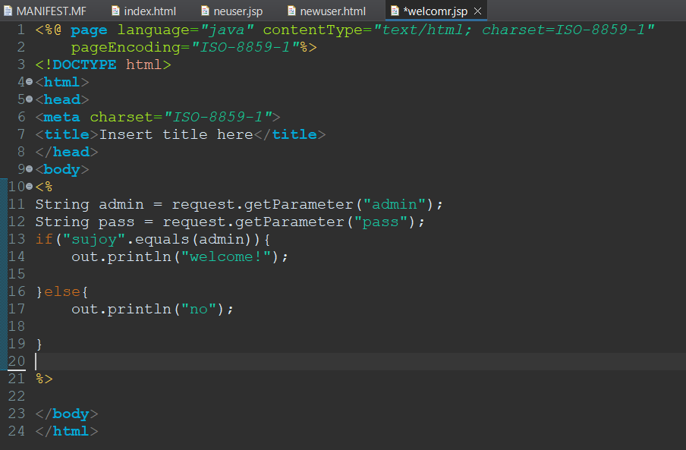
- neuser.jsp
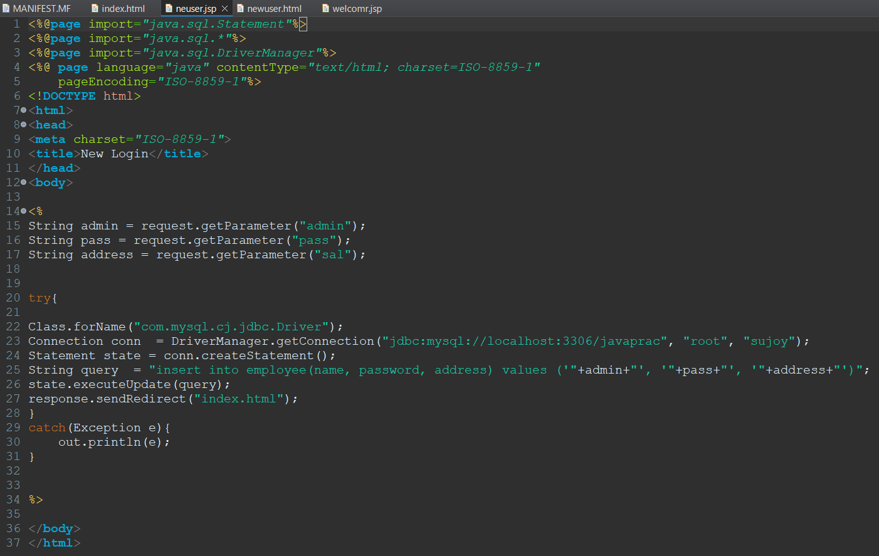

- newuser.html
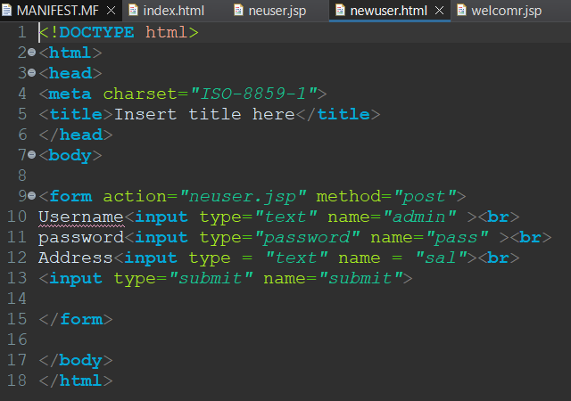
//OUTPUT:
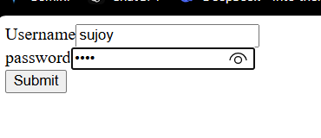
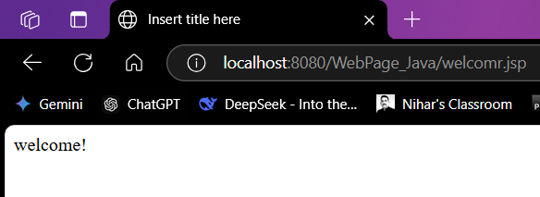
Q4) Implement CRUD operations using JPA and Hibernate.
Solution:
- Emp.java
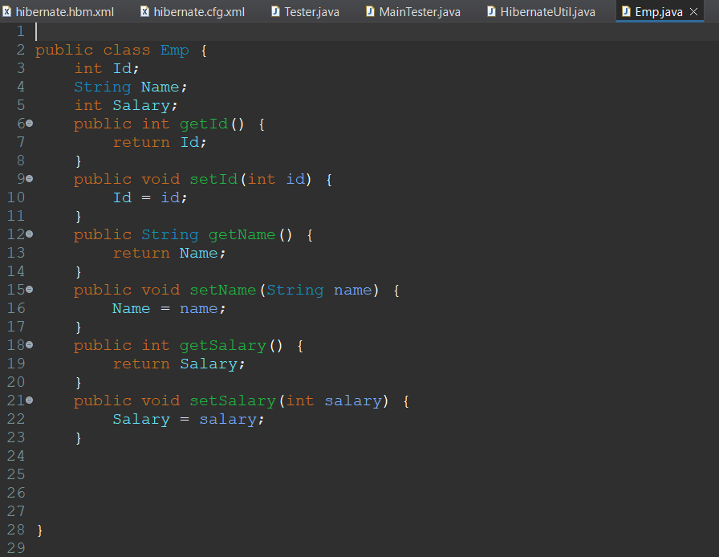

- Hibernate.hbm.xml
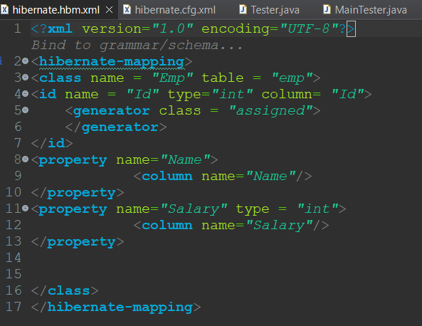

- HibernateUtil.java
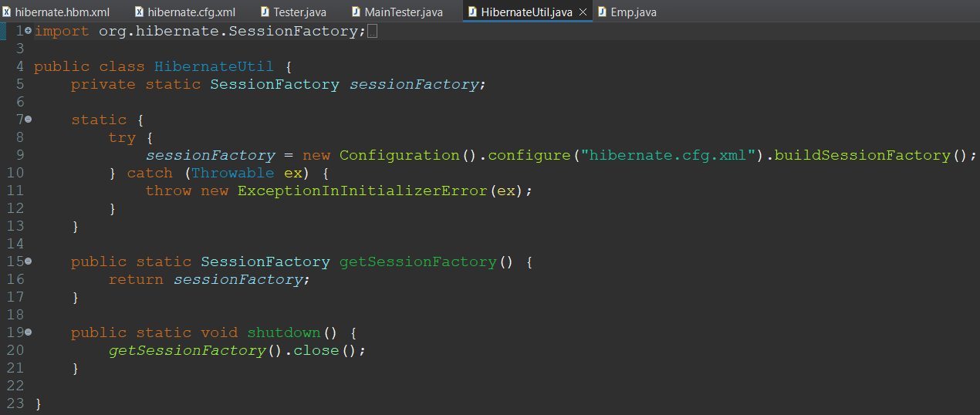
- hibernate.cfg.xml
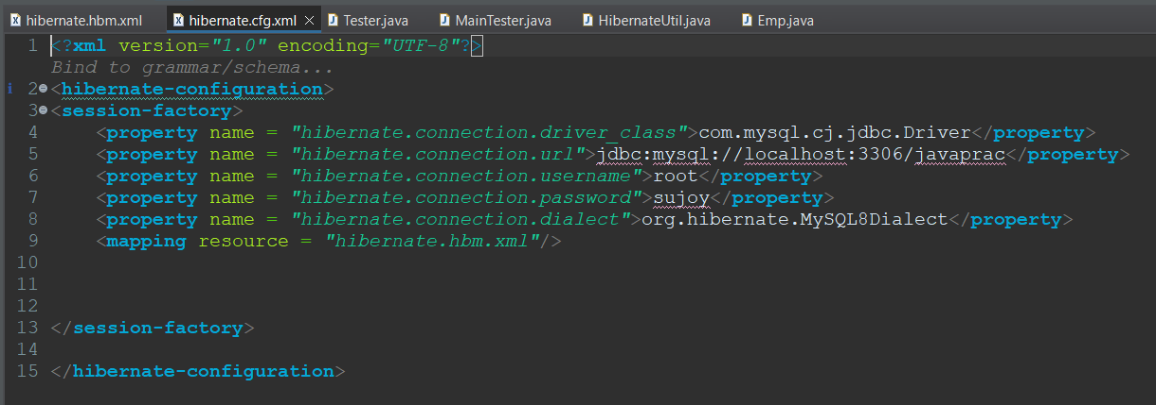
- Tester.java
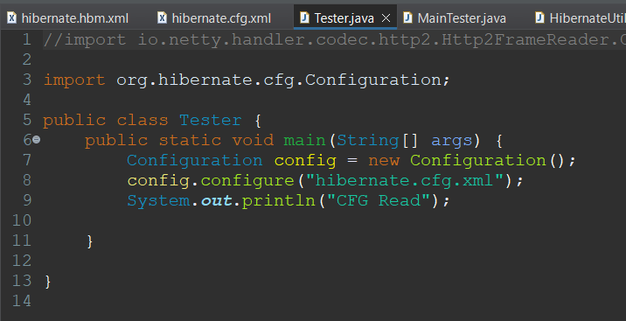
- MainTester.java
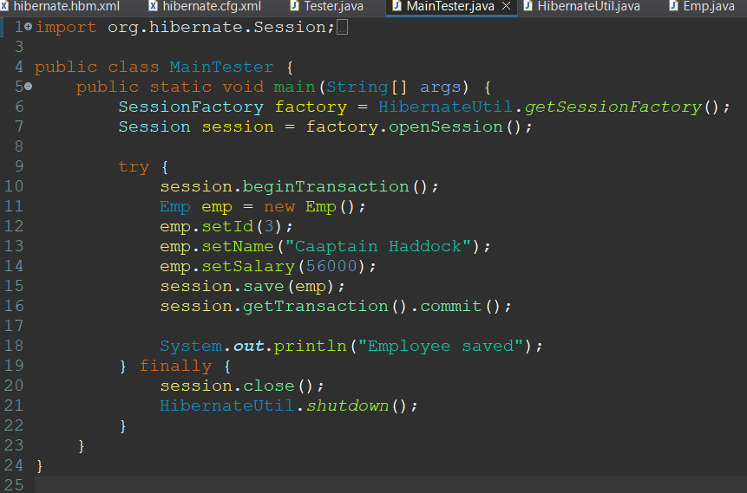
- pom.xml
- <project xmlns="http://maven.apache.org/POM/4.0.0" xmlns:xsi="http://www.w3.org/2001/XMLSchema-instance" xsi:schemaLocation="http://maven.apache.org/POM/4.0.0 https://maven.apache.org/xsd/maven-4.0.0.xsd">
- <modelVersion>4.0.0</modelVersion>
- <groupId>com.hiber</groupId>
- <artifactId>hibernate-practice</artifactId>
- <version>0.0.1-SNAPSHOT</version>
- <dependencies>
- <dependency>
- <groupId>org.hibernate</groupId>
- <artifactId>hibernate-core</artifactId>
- <version>5.6.15.Final</version>
- </dependency>
- <dependency>
- <groupId>mysql</groupId>
- <artifactId>mysql-connector-java</artifactId>
- <version>8.0.24</version>
- <scope>runtime</scope>
- </dependency>
- </dependencies>
- </project>

//OUTPUT:
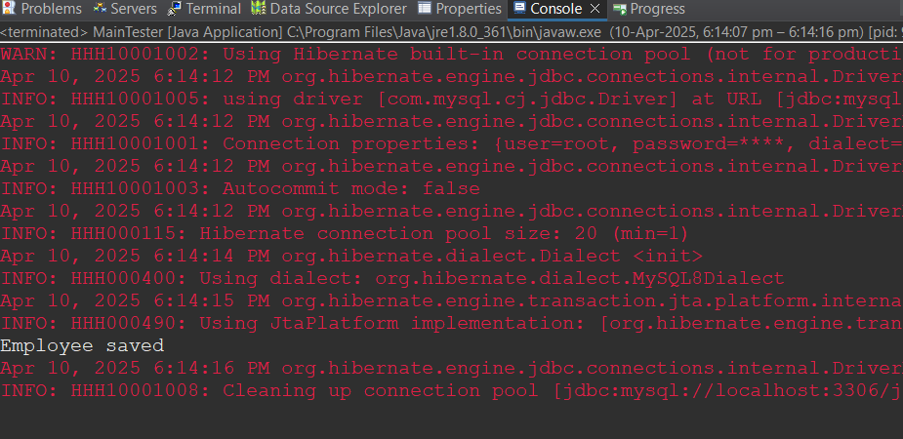
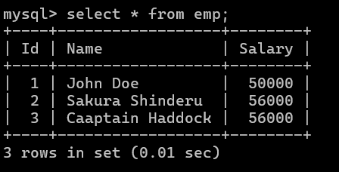

Q5) Implement CRUD operations using SpringBoot.
Solution:
- pom.xml
<?xml version="1.0" encoding="UTF-8"?>
<project xmlns="http://maven.apache.org/POM/4.0.0" xmlns:xsi="http://www.w3.org/2001/XMLSchema-instance"
xsi:schemaLocation="http://maven.apache.org/POM/4.0.0 https://maven.apache.org/xsd/maven-4.0.0.xsd">
<modelVersion>4.0.0</modelVersion>
<parent>
<groupId>org.springframework.boot</groupId>
<artifactId>spring-boot-starter-parent</artifactId>
<version>3.4.4</version>
<relativePath/> <!-- lookup parent from repository -->
</parent>
<groupId>com.assignment</groupId>
<artifactId>sujoy</artifactId>
<version>0.0.1-SNAPSHOT</version>
<name>sujoy</name>
<description>Spring Boot assignment by Sujoy Sengupta</description>
<url/>
<licenses>
<license/>
</licenses>
<developers>
<developer/>
</developers>
<scm>
<connection/>
<developerConnection/>
<tag/>
<url/>
</scm>
<properties>
<java.version>21</java.version>
</properties>
<dependencies>
<dependency>
<groupId>org.springframework.boot</groupId>
<artifactId>spring-boot-starter-data-jpa</artifactId>
</dependency>
<dependency>
<groupId>org.springframework.boot</groupId>
<artifactId>spring-boot-starter-thymeleaf</artifactId>
</dependency>
<dependency>
<groupId>org.springframework.boot</groupId>
<artifactId>spring-boot-starter-web</artifactId>
</dependency>

<dependency>
<groupId>org.springframework.boot</groupId>
<artifactId>spring-boot-devtools</artifactId>
<scope>runtime</scope>
<optional>true</optional>
</dependency>
<dependency>
<groupId>com.mysql</groupId>
<artifactId>mysql-connector-j</artifactId>
<scope>runtime</scope>
</dependency>
<dependency>
<groupId>org.springframework.boot</groupId>
<artifactId>spring-boot-starter-test</artifactId>
<scope>test</scope>
</dependency>
</dependencies>

<build>
<plugins>
<plugin>
<groupId>org.springframework.boot</groupId>
<artifactId>spring-boot-maven-plugin</artifactId>
</plugin>
</plugins>
</build>

</project>

- Songs.java
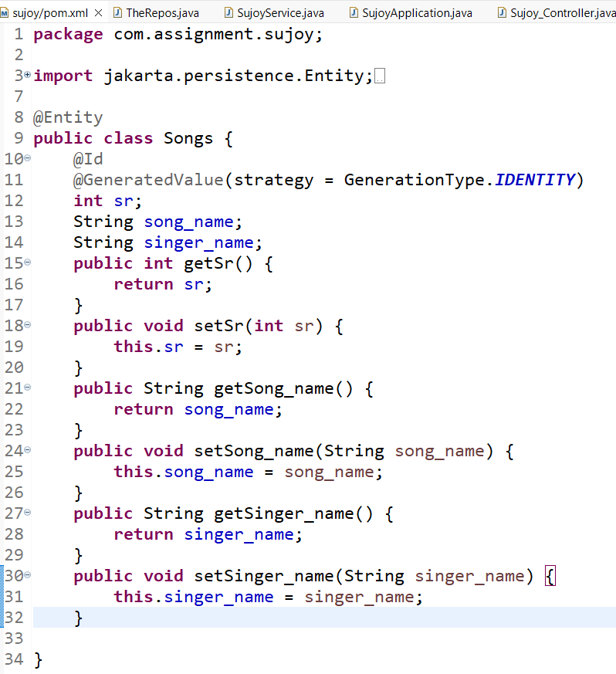
- TheRepos.java
package com.assignment.pratyush;

import org.springframework.data.jpa.repository.JpaRepository;

public interface TheRepos extends JpaRepository<Songs, Integer>{

}

- SujoyService.java
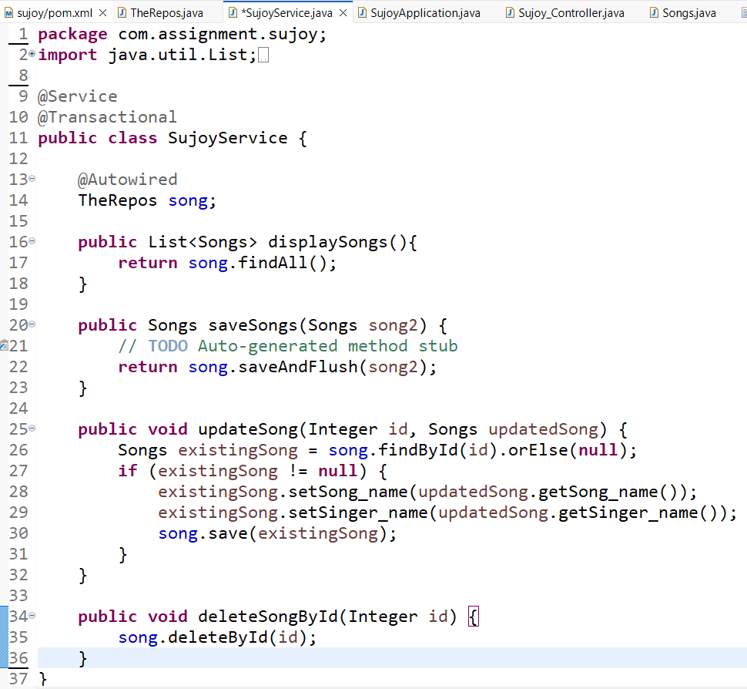
- PratyushApplication.java
package com.assignment.pratyush;
import org.springframework.boot.SpringApplication;
import org.springframework.boot.autoconfigure.SpringBootApplication;
@SpringBootApplication
public class PratyushApplication {
public static void main(String[] args) {
SpringApplication.run(PratyushApplication.class, args);
}
}
- Pratyush_Controller.java
package com.assignment.sujoy;

import java.util.List;

import org.springframework.beans.factory.annotation.Autowired;
import org.springframework.stereotype.Controller;
import org.springframework.ui.Model;
import org.springframework.web.bind.annotation.ModelAttribute;
import org.springframework.web.bind.annotation.PathVariable;
import org.springframework.web.bind.annotation.RequestMapping;
import org.springframework.web.bind.annotation.RequestMethod;

@Controller
public class Pratyush_Controller {

@Autowired
PratyushService service;

@RequestMapping("/show")
public String show(Model pratyushModel) {
List<Songs> list = service.displaySongs();
for(Songs i: list) {
System.out.println(i.getSr()+" "+i.getSong_name()+" "+i.getSinger_name());
}
pratyushModel.addAttribute("data", list);

return "pratyush_index";
}

@RequestMapping(value = "/addSong", method = RequestMethod.POST)
public String addSongs(@ModelAttribute Songs song)
{
service.saveSongs(song);
return "redirect:/show";
}

@RequestMapping(value = "/updateSong/{sr}", method = RequestMethod.POST)
public String updateSong(@PathVariable Integer sr, @ModelAttribute Songs updatedSong) {
service.updateSong(sr, updatedSong);
return "redirect:/show";
}

@RequestMapping(value = "/deleteSong/{sr}", method = RequestMethod.GET)
public String deleteSong(@PathVariable Integer sr) {
service.deleteSongById(sr);
return "redirect:/show";
}
}
- application.properties
spring.application.name=pratyush
server.port = 5567
spring.datasource.url = jdbc:mysql://localhost:3306/javaprac
spring.datasource.username = root
spring.datasource.password = pratyush
spring.datasource.driver-class-name=com.mysql.cj.jdbc.Driver
spring.thymeleaf.prefix=classpath:/templates/
spring.thymeleaf.suffix=.html

//OUTPUT:
