Rental Deserts in France:
Descriptive Statistics and Results

The primary data source for this study is the 2021 French Census (Recensement de la Population), published by INSEE. We use two geographic units of analysis. At the neighborhood level, we use IRIS (Îlots Regroupés pour l'Information Statistique) — sub-municipal statistical units designed to contain approximately 2,000 residents each in urban areas, and the finest geographic level at which census data are consistently disseminated across metropolitan France. In rural communes too small to be subdivided, the entire commune forms a single IRIS. IRIS serve as the French equivalent of US census tracts, and in each IRIS we calculate the share of all primary residences that are renter-occupied. At the city level, we use urban units (Unités Urbaines, UU2020) — clusters of contiguous communes sharing a continuous built-up area of at least 2,000 inhabitants, serving as the French equivalent of metropolitan statistical areas. The UU2020 boundary delineation reflects INSEE's most recent revision of urban unit definitions, updated in 2020; as a geographic classification file it operates on a separate update cycle from the census and is applied here to spatially aggregate the 2021 Census data to the city level.
The IRIS-level housing file (base-ic-logement-2021) provides data on housing tenure, dwelling type, and construction era. A supplementary IRIS-level file provides median disposable household income (DEC_MED21). Both are drawn from the Recensement de la Population 2021 (INSEE, 2021).
- Characteristics of Rental Deserts
We use a national-level cutoff rather than a metropolitan percentile to avoid omitting rural and peri-urban areas where rental housing options can be sparse. Additionally, the cutoff needs to be sufficiently low to suggest that there is a deficit of options for renters, but also needs to be high enough to prevent it from only capturing the most egregious cases. All of the 100 largest urban units in France have a rentership rate above 20% — the lowest being 28.5% — making this a meaningful floor below which rental housing is genuinely scarce rather than simply uncommon. A threshold somewhere between 15 and 20% therefore appears appropriate for the French context. The 20% threshold captures approximately 48% of all IRIS nationally, a notably higher share than the comparable figure for the United States, where the same threshold captures roughly a third of census tracts.
In this paper, we classify rental deserts as IRIS where fewer than 20% of primary residences are renter-occupied. We consider mixed-tenure communities to be those where at least 20% and no more than 80% of the stock is rental, and we classify IRIS with at least 80% rental housing as high-rental neighborhoods. High-rental neighborhoods represent the opposite condition to rental deserts and allow us to show that while rental deserts are relatively common across France — accounting for 48% of all IRIS — the equivalent low share of homeownership options appears far more infrequently (3.3% of all IRIS). Our primary focus is on the comparison between these three neighborhood types.

Table 1. Characteristics of IRIS by Rental Share Category
Characteristic | Rental Deserts  (< 20%) | Mixed-Tenure  (20–80%) | High-Rental  (≥ 80%)
IRIS Coverage
Number of IRIS | 23,312 | 23,668 | 1,612
Share of all IRIS (%) | 48.0 | 48.7 | 3.3
Housing Structure (IRIS averages)
Avg. rental share (%) | 12.8 | 39.0 | 89.7
Avg. total primary residences | 265 | 930 | 967
Share single-family homes (%) | 95.2 | 60.3 | 7.3
Share apartments (%) | 4.4 | 38.8 | 89.9
Share vacant dwellings (%) | 8.3 | 8.6 | 7.6
Geographic Distribution (% of IRIS category)
Central city | 1.7 | 11.2 | 24.1
Suburb | 87.0 | 54.2 | 20.6
Isolated / outside urban unit | 11.3 | 34.6 | 55.3
Notes: IRIS (Îlots Regroupés pour l'Information Statistique) are sub-municipal census units. Rental deserts are IRIS where fewer than 20% of primary residences are renter-occupied. High-rental neighborhoods have at least 80% rental housing. Geographic classification uses binary flags (city/suburb) from INSEE Urban Units 2020 (UU2020). Source: INSEE, Recensement de la Population 2021 (base-ic-logement-2021).

- Spatial Distribution of Rental Housing
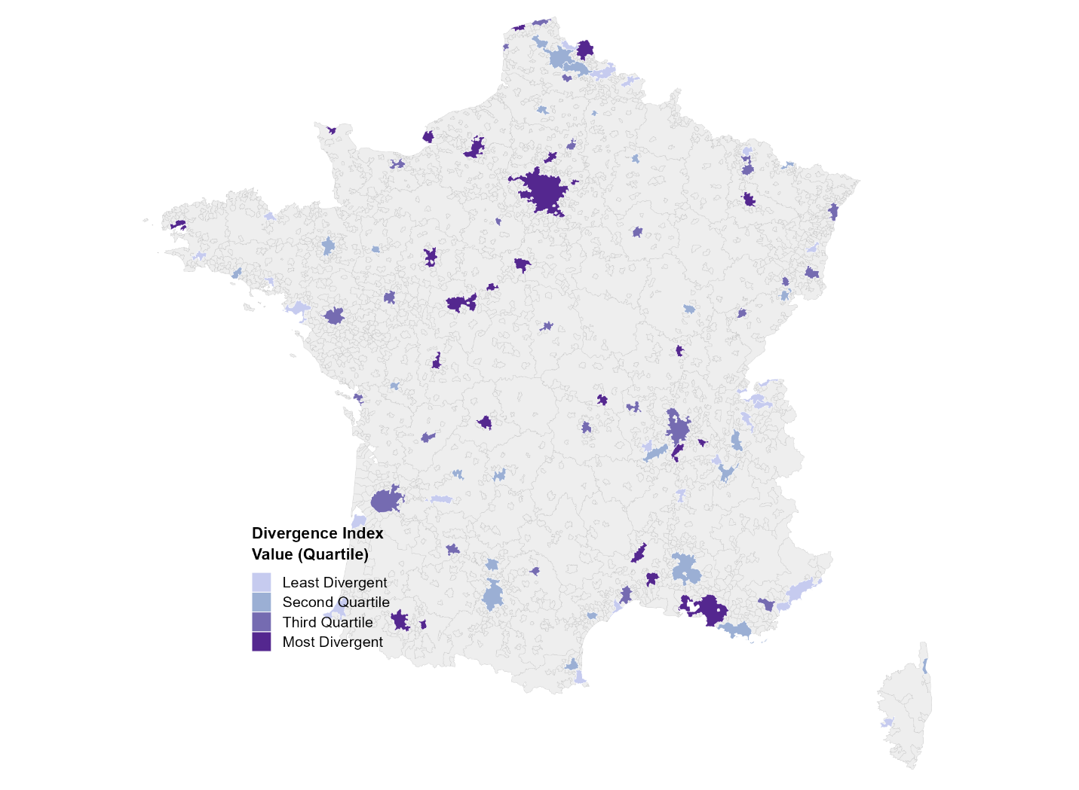
Figure 1. Housing Tenure Divergence Index Across Top 100 Populated Urban Units
The second part of the analysis examines the geography of rental housing and the degree of segregation by housing tenure across urban units in France. Following Airgood-Obrycki et al. (2025), we focus on the 100 most populous urban units (Unités Urbaines, UU2020) — ranging from Paris (10.7 million residents) to Saint-Quentin (61,000) — and identify those where rental deserts make up the largest and smallest share of neighborhoods.
To measure the unevenness of rental housing distribution within each urban unit, we apply the divergence index proposed by Roberto (2024), an approach originally developed as a decomposable measure of segregation and used by Airgood-Obrycki et al. (2025) to measure housing tenure segregation across US metropolitan areas. The index captures the difference between the local and urban-unit-wide composition of housing tenure, comparing the rental and owner-occupied shares at the IRIS level to those of the urban unit as a whole. It produces a value for each urban unit as well as for each individual IRIS, where the IRIS-level value reflects how much that neighborhood's tenure composition deviates from the broader urban context.
The IRIS-level divergence value is calculated as :
DivergenceValue = RentalShare_IRIS × log(RentalShare_IRIS / RentalShare_UU)
+ OwnerShare_IRIS × log(OwnerShare_IRIS / OwnerShare_UU)
The urban-unit-level divergence is then the population-weighted mean of all IRIS-level values within that urban unit, following the household-weighted aggregation used in Airgood-Obrycki et al. (2025). Because this is a relatively new measure, no established thresholds exist for distinguishing high from low divergence (Berkeley Othering & Belonging Institute, n.d.). We therefore adopt the same relational approach as the reference study, dividing the divergence index into quartiles across the 100 urban units to identify those with relatively higher or lower levels of housing tenure segregation.

Table 2. Spatial Distribution of Rental Housing Across the 100 Largest Populated Urban Units
Urban Unit | Population (000s) | Rental Desert Share (%) | Metro Rental Share (%) | Divergence Index
Urban Units with Highest Housing Tenure Divergence (Top 10)
Le Havre | 227 | 19.7 | 52.3 | 15.660
Nîmes | 177 | 9.3 | 52.9 | 13.489
Tours | 355 | 17.2 | 47.1 | 12.750
Limoges | 182 | 15.6 | 49.7 | 12.456
Rouen | 465 | 14.4 | 52.2 | 12.315
Le Mans | 211 | 17.5 | 45.1 | 11.626
Lille (partie française) | 1,038 | 11.2 | 49.4 | 11.233
Brest | 198 | 11.1 | 44.1 | 11.014
Marseille–Aix-en-Provence | 1,586 | 9.0 | 49.2 | 10.934
Paris | 10,698 | 9.0 | 52.4 | 10.826
Urban Units with Lowest Housing Tenure Divergence (Bottom 10)
Saint-Cyprien | 62 | 4.3 | 32.5 | 2.229
Menton-Monaco  (partie française) | 68 | 10.7 | 39.1 | 2.882
La Teste-de-Buch-Arcachon | 68 | 15 | 33.5 | 3.483
Armentières  (partie française) | 78 | 6.9 | 41.3 | 3.807
Fréjus | 99 | 5.9 | 39.1 | 4.156
Annecy | 180 | 6.2 | 42.3 | 4.175
Bayonne  (partie française) | 258 | 8 | 40.2 | 4.546
Maubeuge  (partie française) | 107 | 9.1 | 46.3 | 4.553
Saint-Just-Saint-Rambert | 62 | 31.8 | 28.5 | 4.598
Sète | 93 | 8.6 | 43.3 | 4.87
Notes: Urban units (Unités Urbaines) follow INSEE UU2020 geography. Divergence index is population-weighted mean of IRIS-level divergence values within each UU. Source: INSEE, Recensement de la Population 2021 (base-ic-logement-2021).

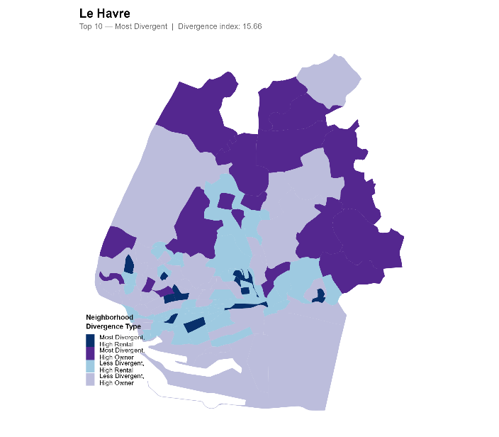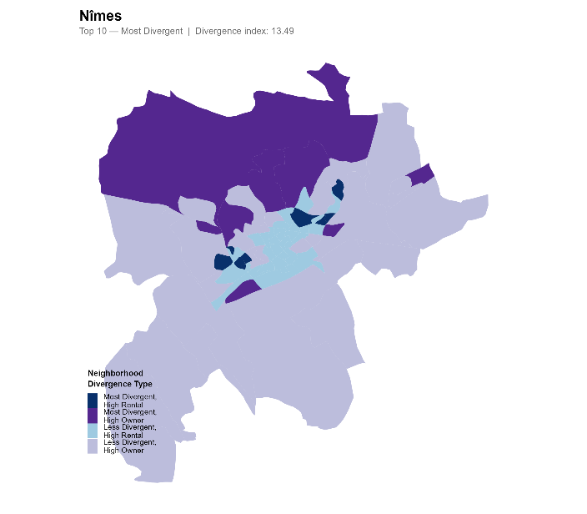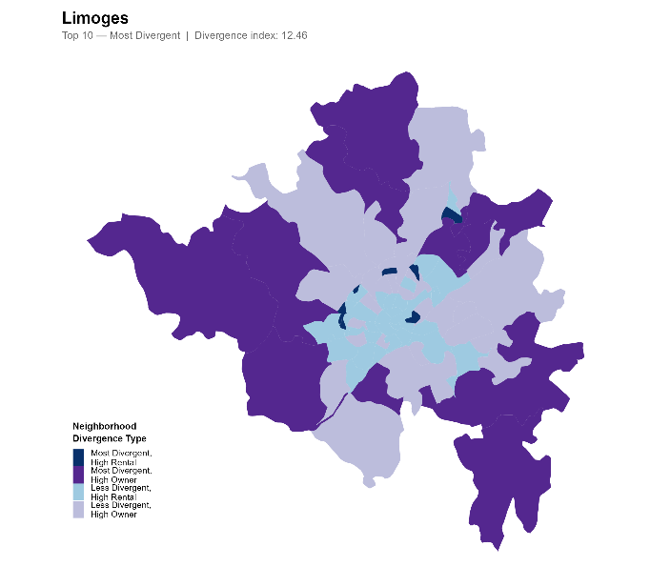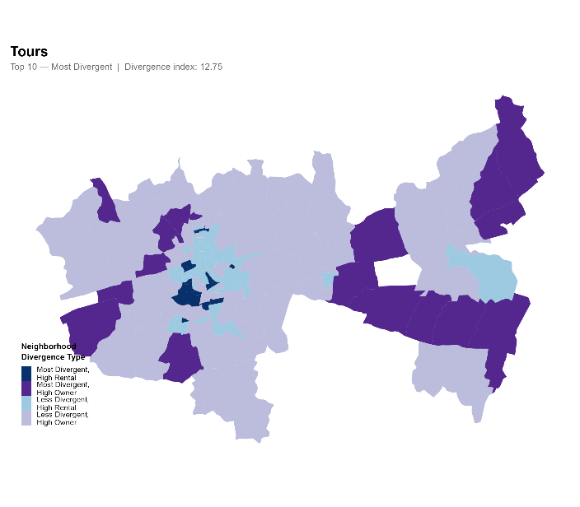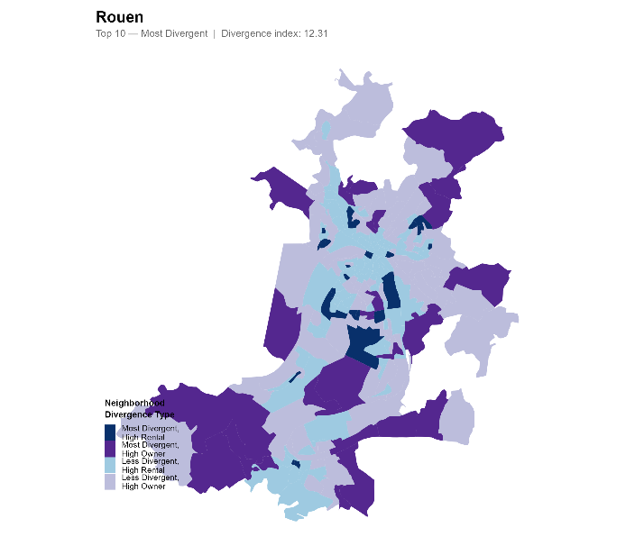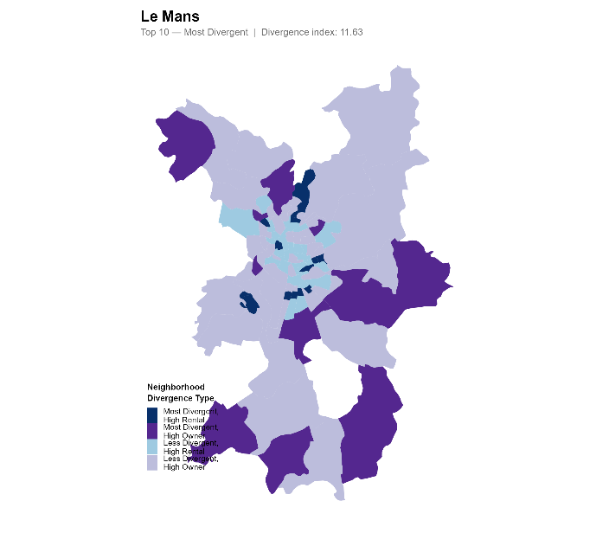
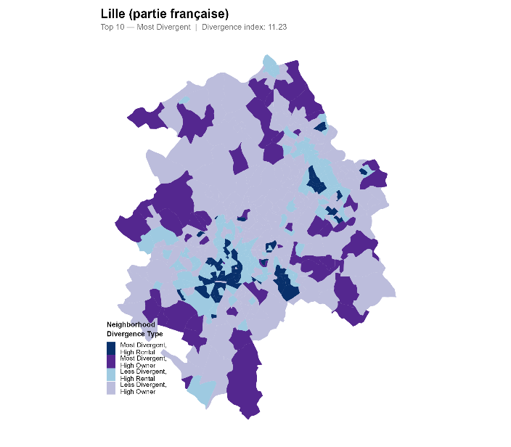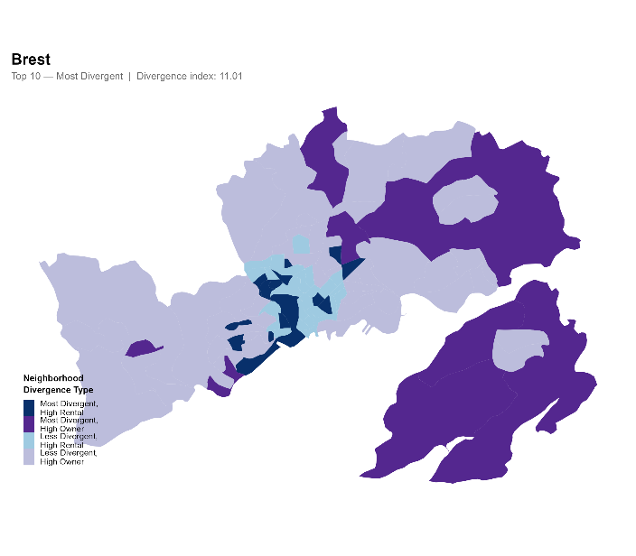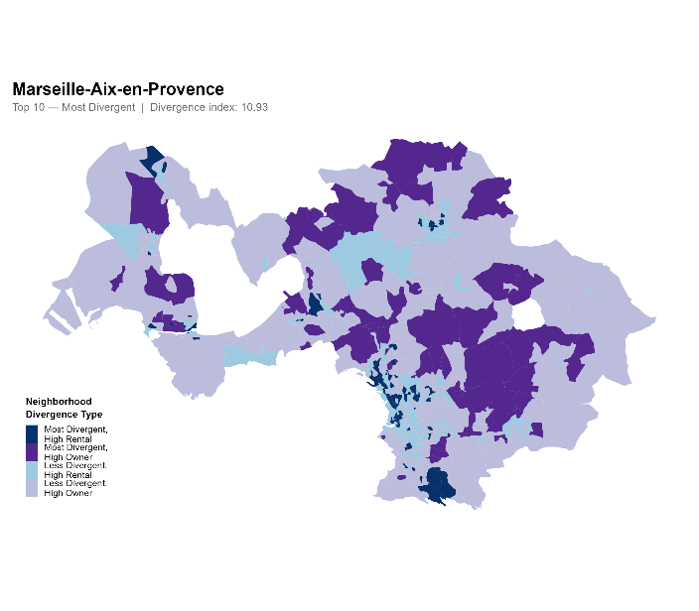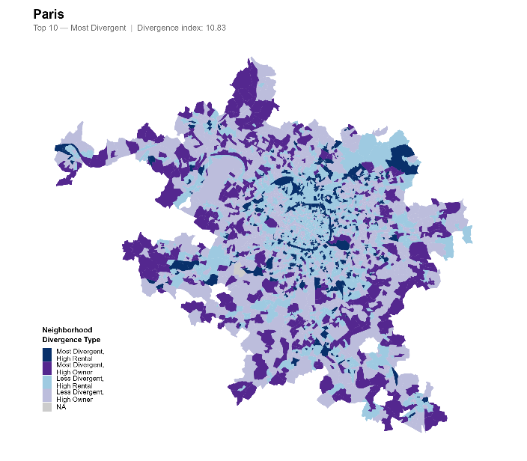
Figure 2. Top 10 Divergent Urban Units
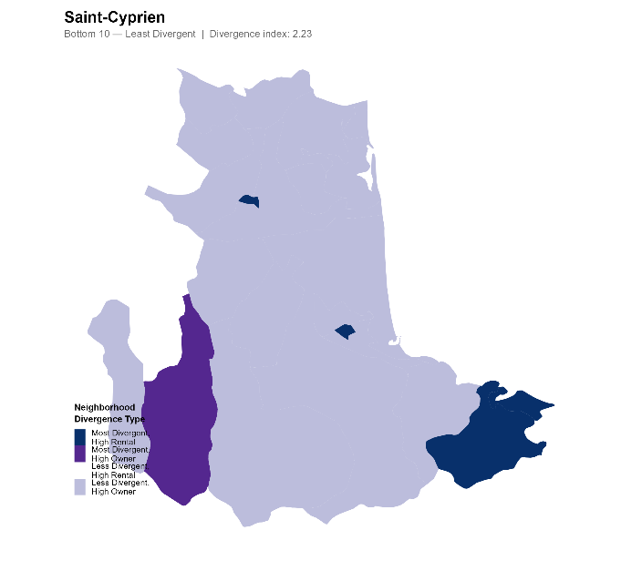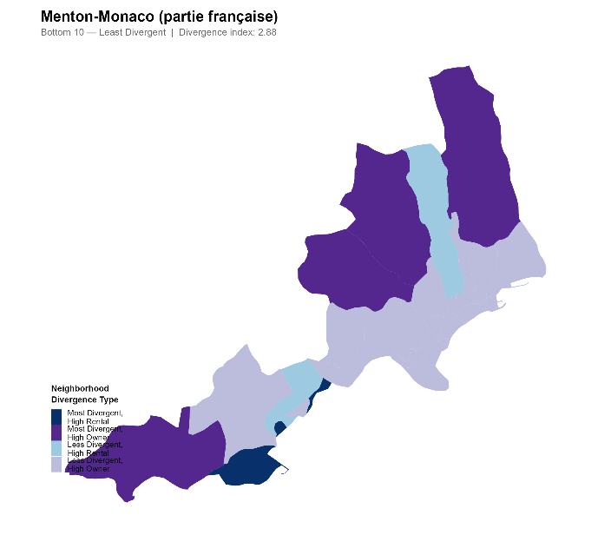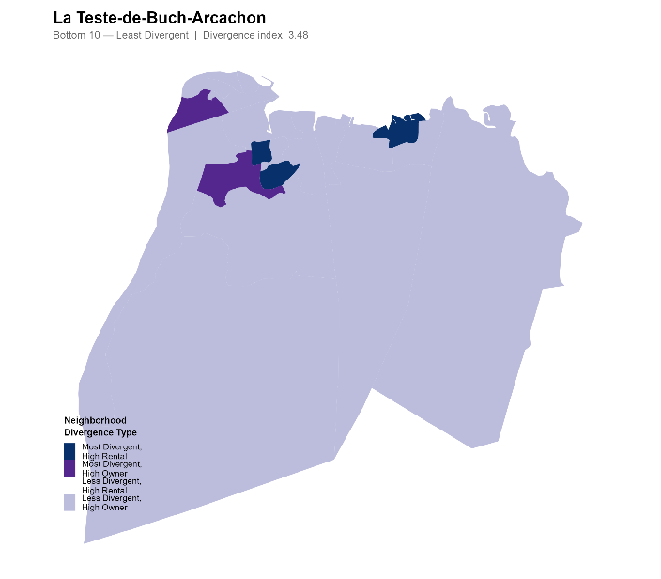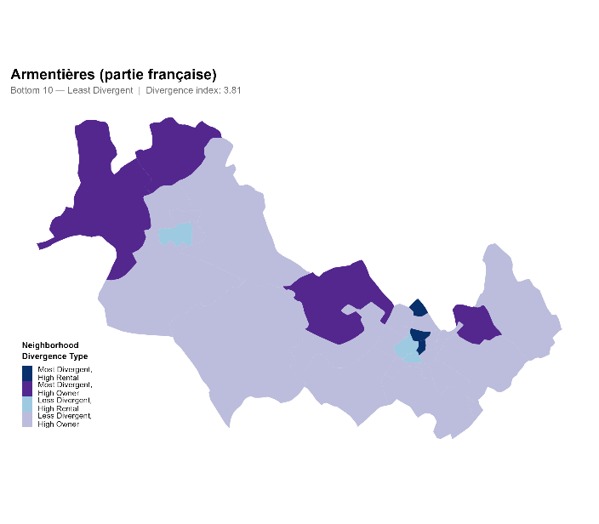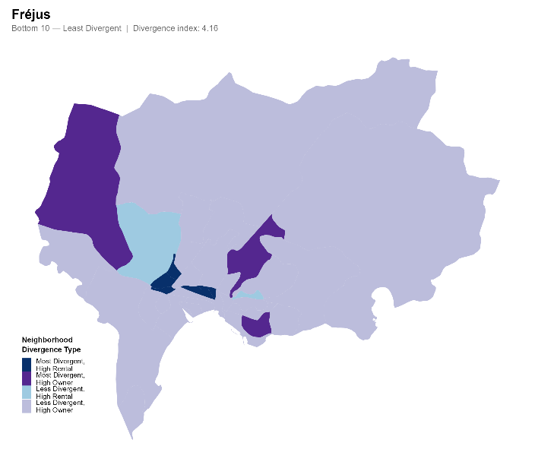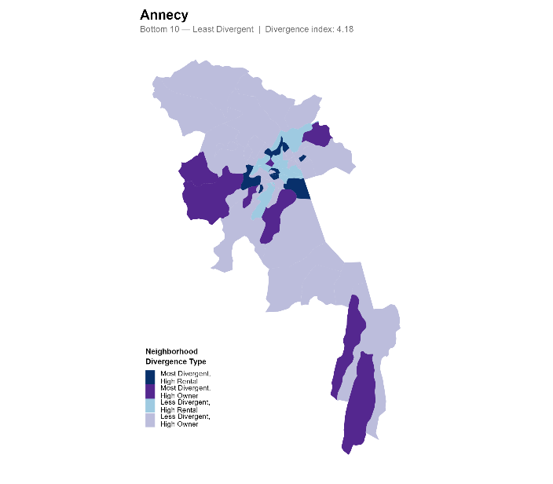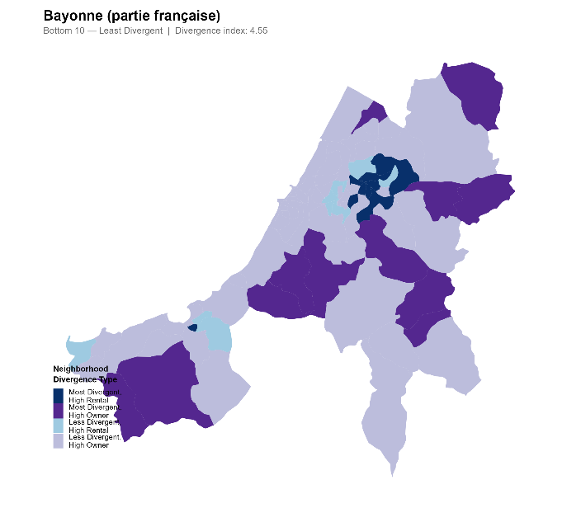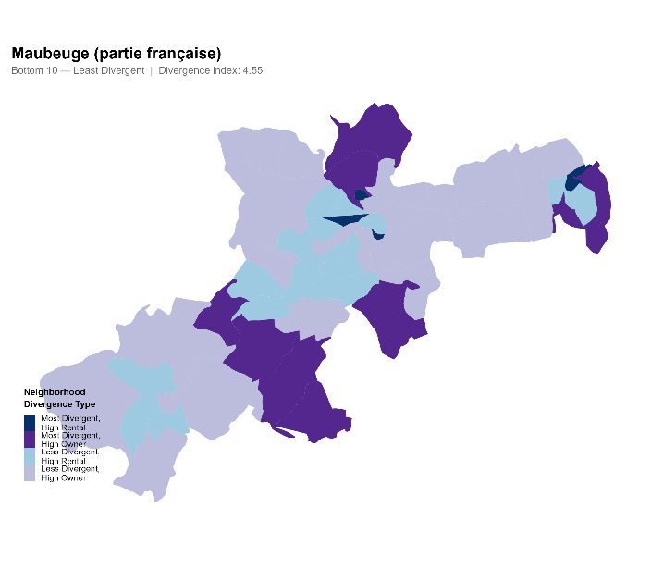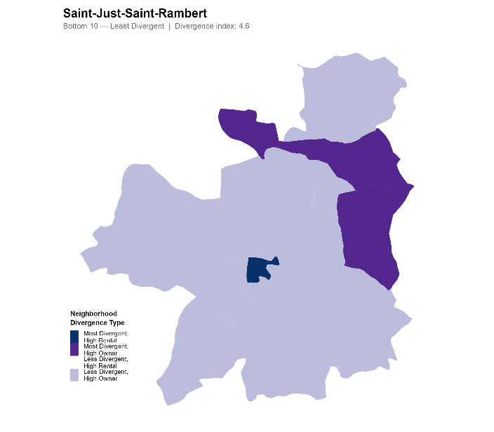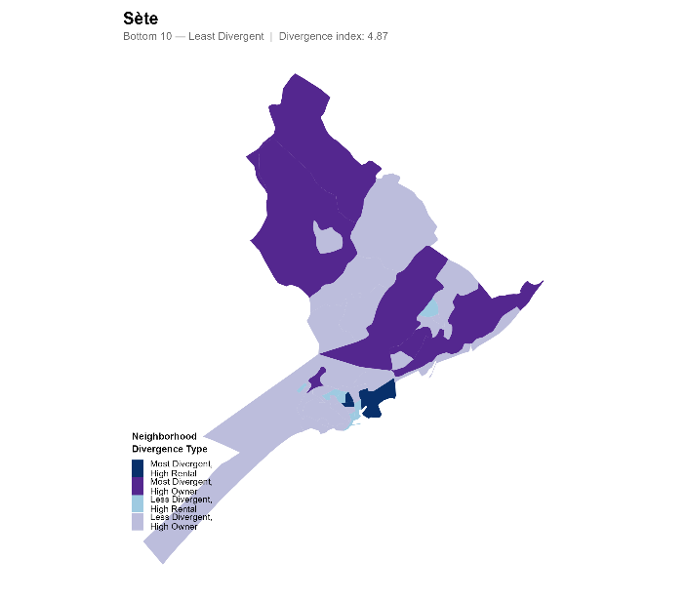
Figure 3. Bottom 10 Divergent Urban Units
- Housing Tenure Divergence, Income Segregation, and Building Age Diversity
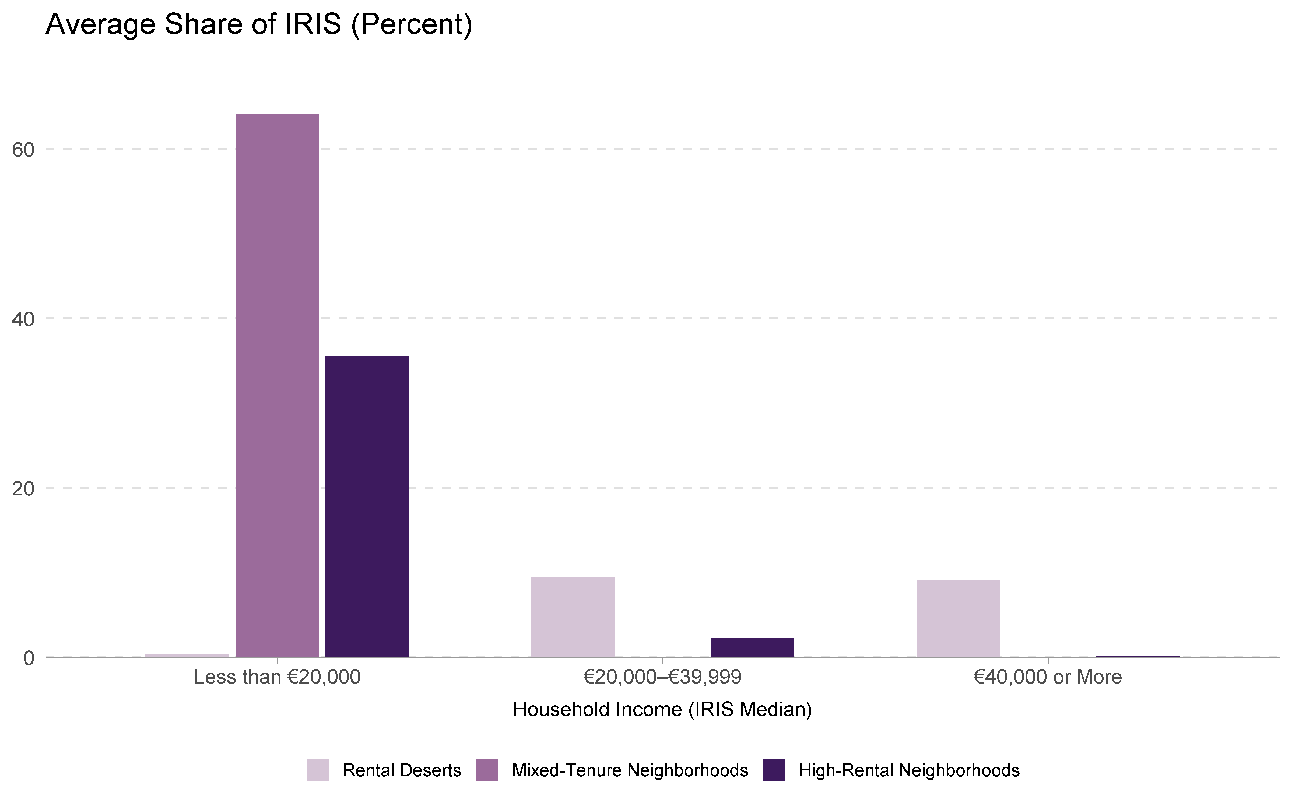
Figure 4. Income and Housing Tenure Shares
We then examine the relationship between the spatial unevenness of rental housing and socioeconomic segregation. We calculate an income divergence index for each of the 100 most populated urban units, comparing the income composition of each urban unit — classified into low-income (less than €20,000 per year), middle-income (€20,000–€39,999), and higher-income (€40,000 or more) IRIS based on median disposable household income (*DEC_MED21*) — to the average income distribution across all 100 urban units. Because France's national statistics do not collect data on race or ethnicity, we supplement this with a building age entropy index as a proxy for neighborhood-level structural diversity. For each IRIS, we compute the Shannon entropy of the housing stock across six construction-era categories available in the census (pre-1919, 1919–1945, 1946–1970, 1971–1990, 1991–2005, and 2006–2018), where higher entropy indicates a more diverse mix of housing vintages; this is then averaged to the urban-unit level. We use simple Pearson correlations to explore the relationship between urban-unit-level housing tenure divergence and both the income divergence index and the building age entropy index.

Table 3. Correlation Between Housing Tenure, Income and Building Age Divergence
Divergence Index Pairing | Pearson r | 95% CI | N | p-value
Tenure divergence × Income divergence | −0.268 | [−0.441, −0.075] | 100 | 0.007
Tenure divergence × Building age entropy | −0.315 | [−0.482, −0.127] | 100 | 0.001
Notes: Pearson correlations across urban units with complete data. Income divergence and building age entropy serve as proxies for socioeconomic and structural diversity in the absence of race/ethnicity data. Source: Author tabulations of INSEE, Recensement de la Population 2021.
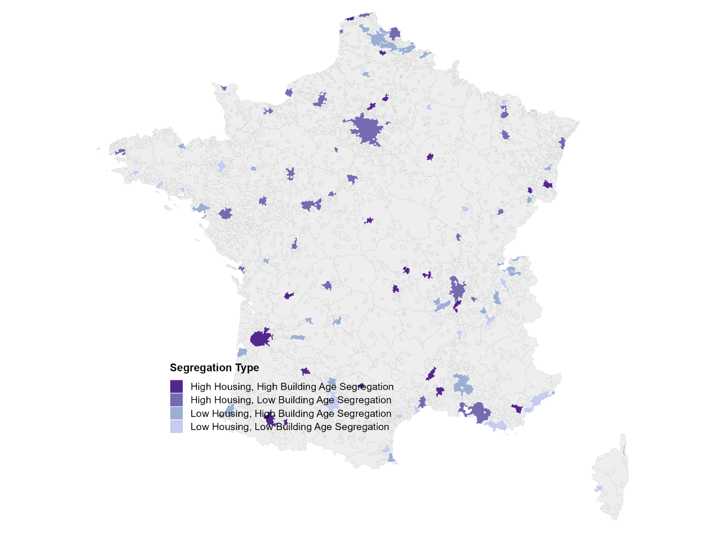
Figure 4. Building Age and Housing Tenure
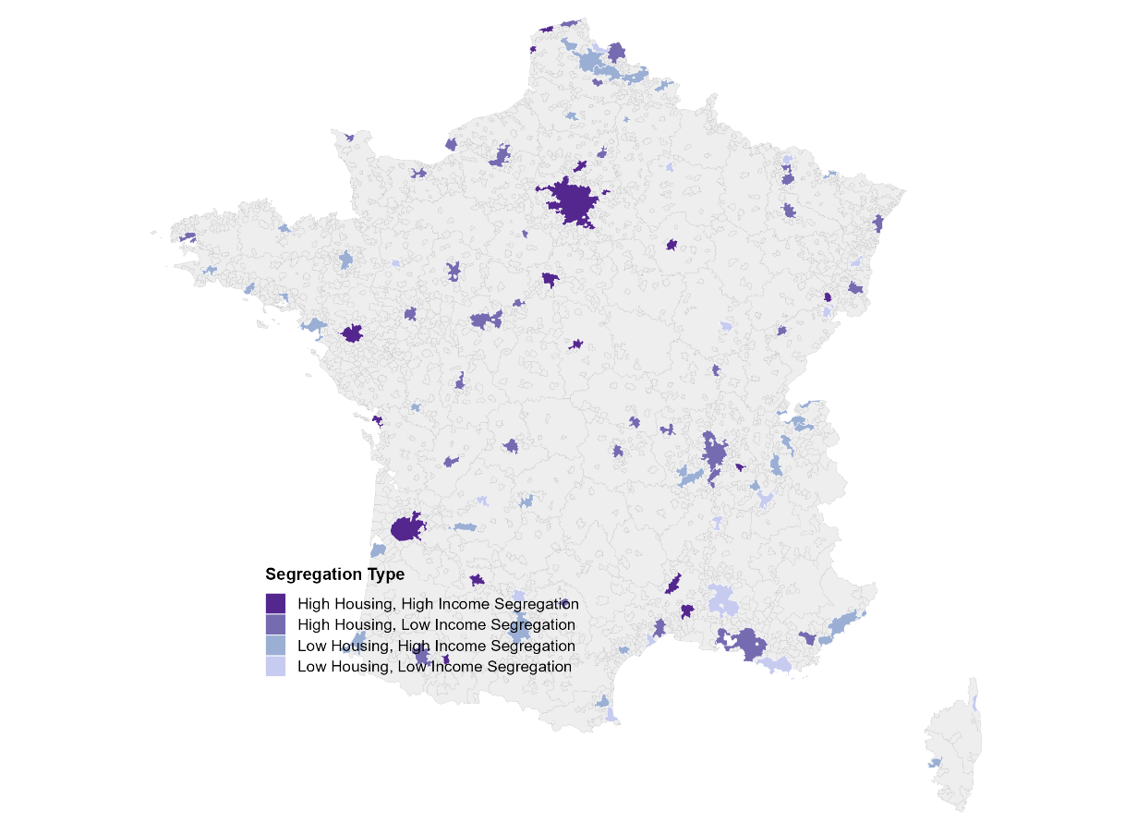
Figure 5. Income and Housing Tenure
- Appendix: Housing Policy and Rental Housing Availability
In In the final part of the analysis, we use indicators of social housing policy to investigate their association with rental geographies. France's primary instrument for expanding affordable rental supply is the Loi Solidarité et Renouvellement Urbain (SRU Law, 2000), which mandates that communes in large urban areas maintain at least 25% social housing in their total housing stock (20% in less urbanized areas). Compliance status and observed social housing rates are drawn from the 2022 bilan SRU published by the Ministère du Logement. We run simple OLS regressions of commune-level rental share against two indicators: whether a commune meets its SRU target (binary compliance) and the actual observed social housing rate (continuous). We examine both in isolation and together to assess how much of the association between compliance status and rental share is explained by the underlying level of social housing stock. While these indicators do not directly dictate rental tenure, their association with the types of housing built makes them a useful policy-relevant predictor of rental availability.

Table 4. Association Between SRU Social Housing Policy and Commune-Level Rental Share
Model | Policy Indicator | β (pp) | 95% CI Low | 95% CI High | p-value
M1: SRU Compliance (binary) — N = 2,066 communes
M1 | SRU-compliant commune (1 = meets 20/25% target) | +14.74 | 13.75 | 15.73 | < 0.001
M2: Actual Social Housing Rate (continuous)
M2 | Actual LLS rate (% social housing in commune) | +0.86 | 0.83 | 0.89 | < 0.001
M3: Both Indicators Together
M3 | SRU-compliant commune | +2.16 | 1.22 | 3.10 | < 0.001
M3 | Actual LLS rate (% social housing) | +0.80 | 0.77 | 0.84 | < 0.001
Notes: Author’s calculations using commune-level housing tenure data from INSEE, Recensement de la Population 2021, and SRU compliance/social housing indicators from the Ministère du Logement, bilan SRU 2022.

OLS regressions of commune-level mean rental share (%) on SRU policy indicators. β coefficients are in percentage points (pp). M1 shows a raw +14.74 pp association between compliance and rental share; controlling for the actual social housing rate (M3) reduces this to +2.16 pp, suggesting the bulk of the compliance effect is mediated by the actual stock level.

