Final Year Design Project System Requirements Specification
E-Masjid System
__________________________________________

Software Design Specification Document

by

Dawood Ahmed | 089264 (2022-KS-158)
Haris Ehsan | 089301 (2022-KS-190)
(Evening)

Project Advisor:
Muhammad Kamran

Faculty of Computing & Information Technology,
University of the Punjab, Lahore, Pakistan.
(2025)

E-Masjid System

Executive Summary

We have made this design document which provide the technical design for our project E-Masjid system. It is a web based platform which help mosque to manage their daily operation digitally. This system is design in a way to solve the basic problems of manual record keeping and lack of transparency by giving features for donation tracking, prayer time management, event organization and online nikah booking service.
We are using modern web technologies including React.js for the user interface, Node.js for the server, and MongoDB for data storage. The design includes secure payment processing with Stripe, proper user authentication, and responsive design for mobile compatibility. This document will help the development team to build the system correctly and efficiently.

Table of Contents
E-Masjid System 2
Executive Summary 2
System Design 5
1. Design Considerations 5
Assumptions 5
Dependencies 6
Limitations 6
Risks 6
2. Requirements Traceability Matrix 6
3. Design Models 7
3.1 Architectural Design 8
Class Diagram 8
Component diagram 9
3.2 Data Design 9
3.2.1 Data Dictionary 11
3.3 User Interface Design 13
3.3.1 Screen Images 15
3.3.2 Screen Objects and Actions 18
3.4 Behavioral Model 19
User Login Sequence Diagram 19
Online Donation Sequence Diagram 20
Prayer Times Update Sequence Diagram 21
State Diagrams: 22
4. Design Decisions 24
5. Summary 26
References 27

List of Tables

Table 1 Requirements Traceability Matrix 6
Table 2 Data Dictionary Table 11

Tables of Figures

Figure 1 High-Level System Architecture 8
Figure 2 Class diagram 9
Figure 3 Component diagram 10
Figure 4 Home page design 16
Figure 5 Login page design 16
Figure 6 Donation Transparency page design 17
Figure 7 Admin Dashboard design 18
Figure 8 Scholar page design 18
Figure 9 Login Sequence Diagram 20
Figure 10 Online Donation Sequence Diagram 21
Figure 11 Nikah Booking Sequence Diagram 22
Figure 12 Admin Update Prayer Times Sequence Diagram 23
Figure 13 User Account State Diagram 24
Figure 14 Nikah Booking Status State Diagram 26
Figure 15 Event State Diagram 26

System Design
Product Perspective
Our E-Masjid System is a complete web based platform that will be accessible through any modern web browser. The system is designed to serve mosque administration for managing operations and community members can use these services.
Dependencies
- Stable internet connection for all users.
- Stripe service availability for payment processing.
- Modern web browsers supporting React.js features.
- MongoDB database server for data storage.
Interaction with Other Systems
- Stripe Payment Gateway: It is used for making online donations securely.
- Email Service: It is used for sending password reset links.
- Internet Connection: It is required for all users to access the system.
Design Constraints
- Performance Requirements: Prayer times page loads within 3 seconds, handles 100+ users during Friday prayers.
- Usability Requirements: Simple interface with large buttons, works on mobile and computer, elderly friendly design.
- Security Requirements: Encrypted passwords, secure payments through Stripe, admin access protection.
- Technical Constraints: MERN stack technology, responsive design, automatic weekly backups.

Design Considerations

Assumptions
Following are the assumptions:
- Mosque administrators have basic computer knowledge.
- Users have internet access and email accounts.
- The mosque has at least one computer for admin use.
- Religious scholars can use basic web applications.
- Community members can use web browsers on phones or computers.

Dependencies
Following are the dependencies:
- Stable internet connection for all users.
- Stripe payment service available at any time.
- Web browsers supporting modern JavaScript.
- MongoDB database running properly.

Limitations
Following are the limitations:
- Cannot work without internet connection.
- No SMS notifications for announcements.
- No mobile app version.
- Payment system requires card payments only.
- Cannot handle offline data entry.

Risks
Following are the risks:
- Payment security issues.
- System downtime during prayer times.
- Elderly users finding the system difficult.
- Data loss from system crashes.

Requirements Traceability Matrix

Table 1 Requirements Traceability Matrix

Requirement ID |  | Requirement Description | Design Specification
FR-1 | The system will allow users to register and login with email and password, with different access levels for admin and community members |  | Component "User Authentication Module"
FR-2 | The system will show donation records, expense details, and financial reports so people can see both income and spending |  | Component "Financial Reporting Module"
FR-3 | The mosque admin will be able to record cash donations with donor name, amount, date, and donation type |  | Component "Donation Management Module"
FR-4 | The admin will be able to add, update, or remove events and announcements such as islamic classes, community programs, and eid prayers. Users can view them on the main page |  | Component "Event & Announcement Manager"
FR-5 | Community members will be able to book nikah registrar for nikah ceremonies by selecting date and providing contact details |  | Component "Nikah Booking Module"
FR-6 | The admin will be able to set and update daily prayer times including special timings for Jummah and Ramadan |  | Component "Prayer Times Manager"
FR-7 | Community members will be able to make donations online through the website by entering amount and personal details and process real payments using Stripe and see payment success message |  | Component "Online Payment Processor"
FR-8 | If users forget their password, they can reset it using their email address |  | Component "Password Recovery Module"
FR-9 | Users can see if their Nikah service request is pending, accepted, or rejected |  | Component "Booking Status Tracker"
FR-10 | Admin can add where mosque money is spend like for repairs, electricity etc |  | Component "Expense Management Module"
FR-11 | Admin can create special accounts for religious scholars who perform Nikah |  | Component "User Account Manager"

Design Models
This section describes the various design models used to represent the E-Masjid System architecture. We use UML diagrams to visualize the system structure, data relationships, and component interactions to ensure clear understanding.

Architectural Design
Our E-Masjid System follows the MVC architecture pattern. This separates the system into three main parts.
- Model: Handles data and business logic.
- View: User interface that users see.
- Controller: Processes user requests and connect Model and View.

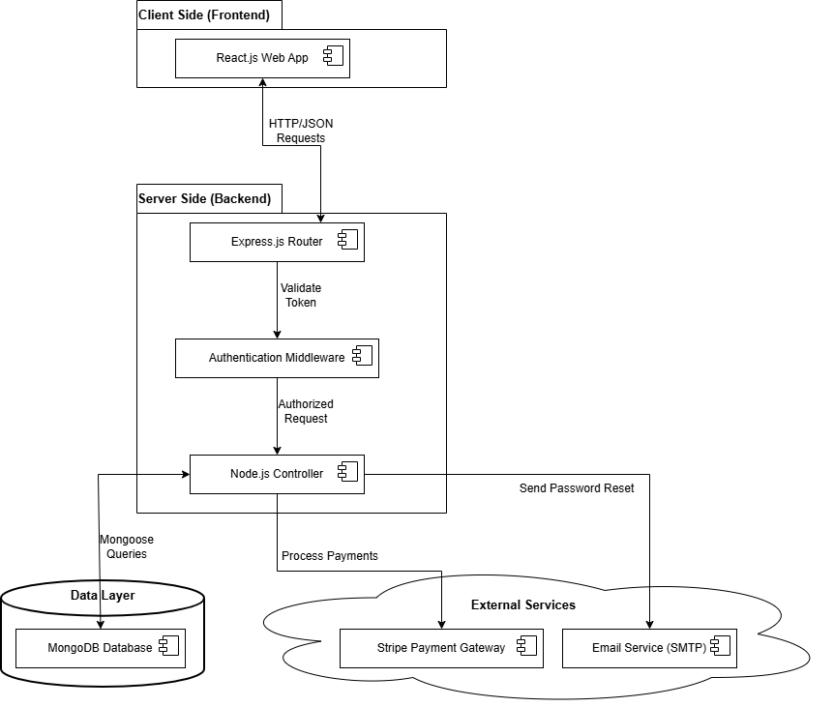
Figure 1 High-Level System Architecture

Class Diagram

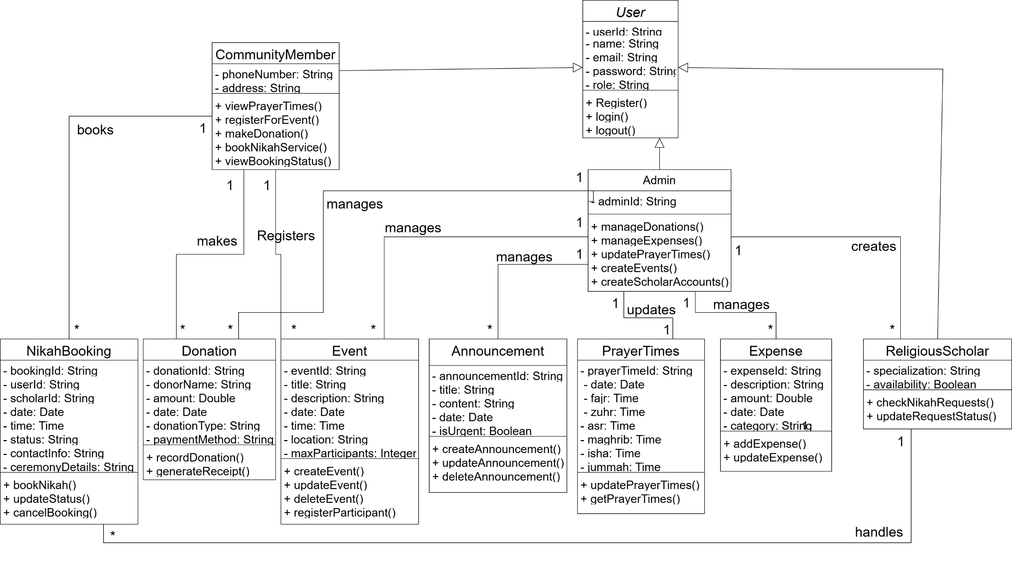
Figure 2 Class diagram

System Architecture Components

Frontend Layer:
- User Interface Components.
- Mobile-responsive design.
- Client side validation.
- Real-time updates.
Backend Layer:
- API routes and controllers.
- Business logic processing.
- Authentication and authorization.
- Payment processing.
Data Layer:
- User data and profiles.
- Donation and expense records.
- Prayer time schedules.
- Event and announcement data.
- Nikah booking requests.
External Services:
- Stripe Payment Gateway.
- Email Service for password resets.

Component diagram

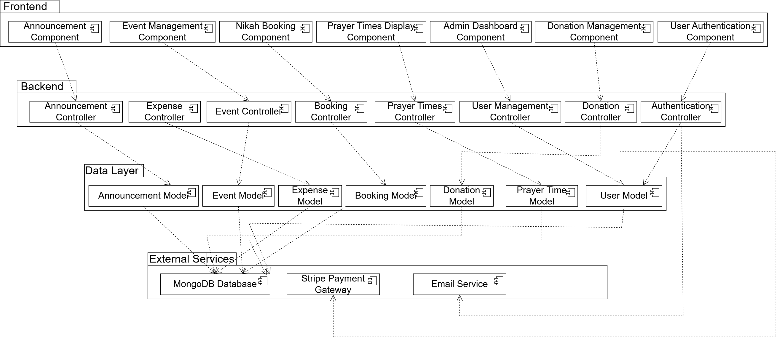
Figure 3 Component diagram

Data Design
The E-Masjid System transform real world mosque operations into structured data using MongoDB collections. Each main entity from the class diagram corresponds to a database collection with specific field to store and manage information efficiently.

Database Collections Structure:

- Users Collection
- Stores all user information including admin, community members, and religious scholars.
- Uses role based access control.
- Fields: userId, name, email, password, role, phone, address, specialization.
- Donations Collection
- Records all donation transactions.
- Links to donor information for transparency.
- Fields: donationId, donorId, amount, date, type , paymentMethod.
- Expenses Collection
- Tracks mosque expenditure for financial transparency.
- Categorized expenses for better reporting.
- Fields: expenseId, description, amount, date, category.
- Events Collection
- Manages mosque events and programs.
- Supports online registration.
- Fields: eventId, title, description, date, time, location, maxParticipants, registeredUsers[ ].
- Announcements Collection
- Stores important mosque announcements.
- Supports urgent flag for important updates.
- Fields: announcementId, title, content, date, isUrgent, publishedBy.
- Prayer Times Collection
- Stores daily prayer schedules.
- Special entries for Jummah and Ramadan.
- Fields: prayerTimeId, date, fajr, zuhr, asr, maghrib, isha, jummah, isSpecial.
- Nikah Bookings Collection
- Manages marriage service requests.
- Tracks booking status.
- Fields: bookingId, userId, scholarId, date, time, status, contactInfo, ceremonyDetails.

Data Relationships:
- One-to-many: One user can make multiple donations.
- One-to-many: One admin can create multiple events.
- Many-to-many: Many users can register for many events.
- One-to-one: Each day has one prayer time schedule.

Data Dictionary
Table 2 Data Dictionary Table
Terminology | Description
Users Collection | Stores all system user accounts
userId | String, Primary key for user identification
Name | String, Full name of the user
Email | String, User email address
Password | String, Encrypted password for security
Role | String, User role (admin/community/scholar)
Phone | String, Contact phone number.
Address | String, User residential address
specialization | String, For scholars area of expertise
Donations Collection | Records all financial donations
donationId | String, Unique donation identifier
donorId | String, Reference to user who donated
Amount | Number, Donation amount in rupees
Date | Date, When donation was made
Type | String, Donation type (Zakat/Sadaqah/Mosque Fund)
paymentMethod | String, Cash or Card payment
Expenses Collection | Tracks mosque spending
expenseId | String, Unique expense identifier
Description | String, What the money was spent on
Amount | Number, Expense amount in rupees
Date | Date, When expense occurred
Category | String, Expense category
Events Collection | Manages mosque events
Eventide | String, Unique event identifier
Title | String, Event name/title
Description | String, Detailed event information
Date | Date, Event date
Time | Time, Event time
Location | String, Where event will be held
maxParticipants | Number, Maximum allowed attendees
registeredUsers | Array, List of user IDs who registered
Announcements Collection | Stores mosque announcements
announcementId | String, Unique announcement identifier
Title | String, Announcement headline
Content | String, Full announcement text
Date | Date, When announcement was posted
isUrgent | Boolean, Marks urgent announcements
publishedBy | String, Admin who posted the announcement
PrayerTimes Collection | Stores prayer schedules
prayerTimeId | String, Unique prayer time identifier
Date | Date, Date for prayer times
Fajr | Time, Fajr prayer time
Zuhr | Time, Zuhr prayer time
Asr | Time, Asr prayer time
Maghrib | Time, Maghrib prayer time
Isha | Time, Isha prayer time
Jummah | Time, Jummah prayer time
NikahBookings Collection | Manages marriage service requests
bookingId | String, Unique booking identifier
userId | String, Reference to user who booked
scholarId | String, Reference to assigned scholar
Date | Date, Requested ceremony date
Time | Time, Requested ceremony time
Status | String, Current status (Pending/Accepted/Rejected)
contactInfo | String, User contact details for ceremony
ceremonyDetails | String, Additional ceremony information

User Interface Design
The E-Masjid System will have a clean, simple, and easy to use interface designed for all
types of users, including elderly people who may not be comfortable with complex technology.

User Experience

- Homepage: Shows current prayer times, recent announcements, and quick access buttons for main features.
- Navigation: Simple menu at the top with clear labels.
- Mobile Friendly: All screens work perfectly on mobile phones and tablets.
- Elderly Friendly: Large buttons, clear text, and simple forms.

How Different Users Will Use the System:

For Community Members:
- Prayer times always visible on top of every page.
- Simple donation form with card payment option.
- One click registration for events.
- Easy booking form with date picker.
- View booking status in their profile.

For Mosque Admin:
- Special admin panel accessible through /admin URL.
- Simple forms to add/update donations, expenses, events, announcements.
- Financial reports showing income and expenses.
- Create and manage religious scholar accounts.

For Religious Scholars:
- View pending requests in simple list format.
- One click buttons to accept or reject bookings.
- See their booked ceremonies in calendar view.

Feedback and Messages:
- Green popup messages for successful actions.
- Red popup messages with simple explanations.
- "Are you sure?" prompts for important actions.
- Spinner animation when system is processing.

Screen Images
We have created basic screen designs to show how the interface will look. These designs follow our guidelines of simplicity and ease of use.
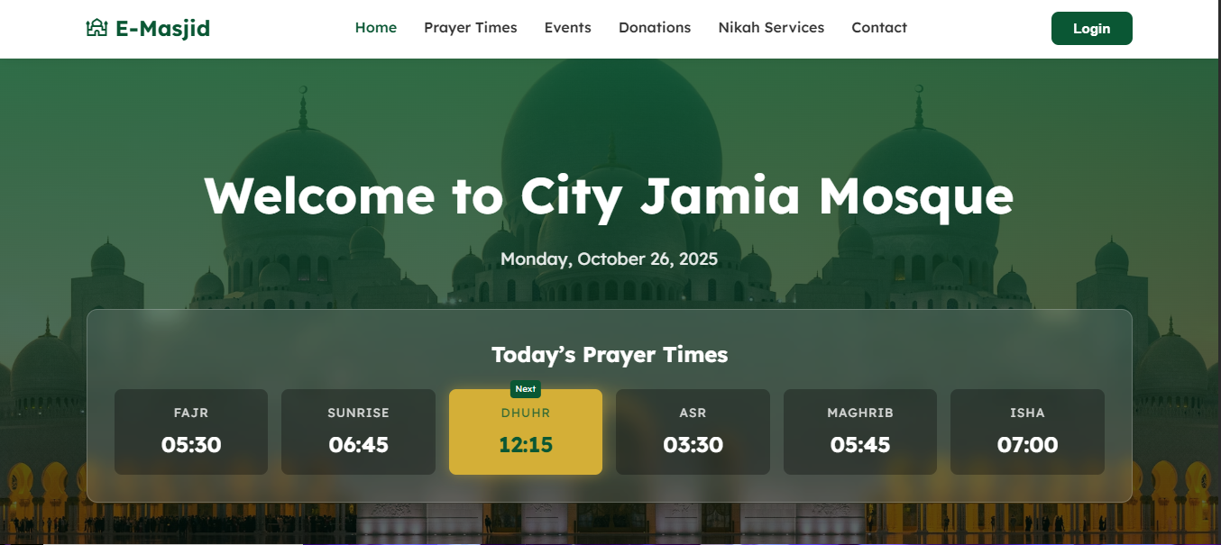
Figure 4 Home page design

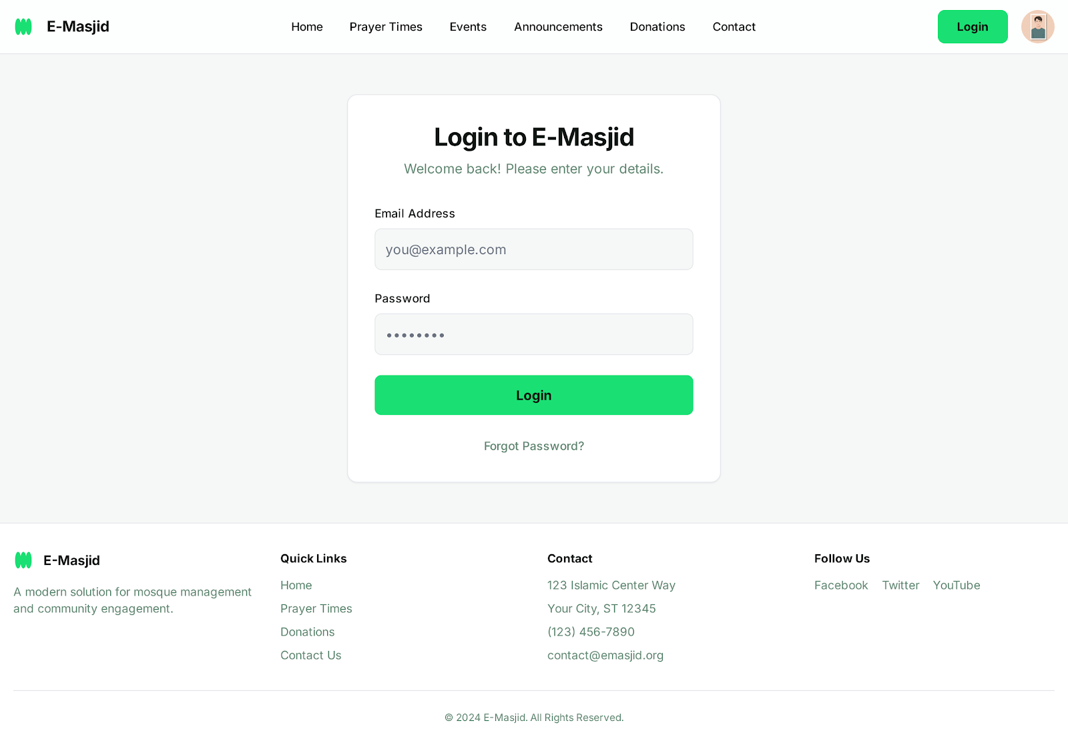
Figure 5 Login page design
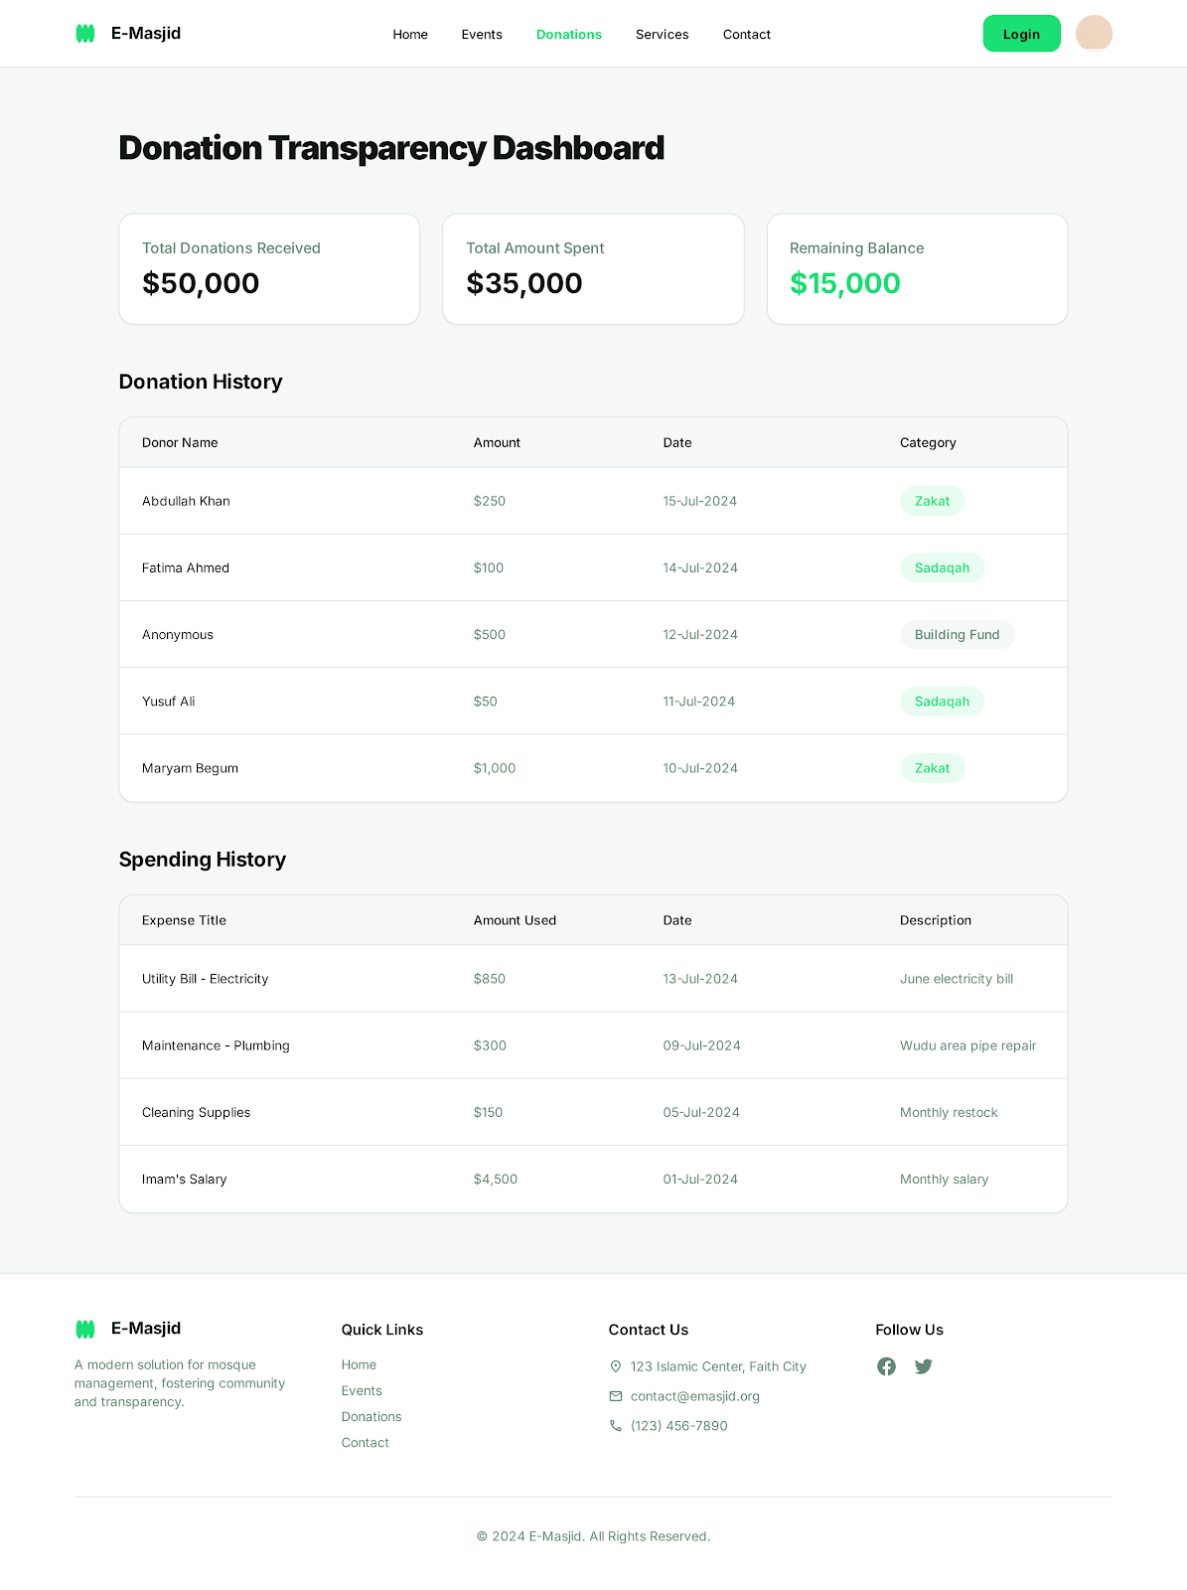
Figure 6 Donation Transparency page design
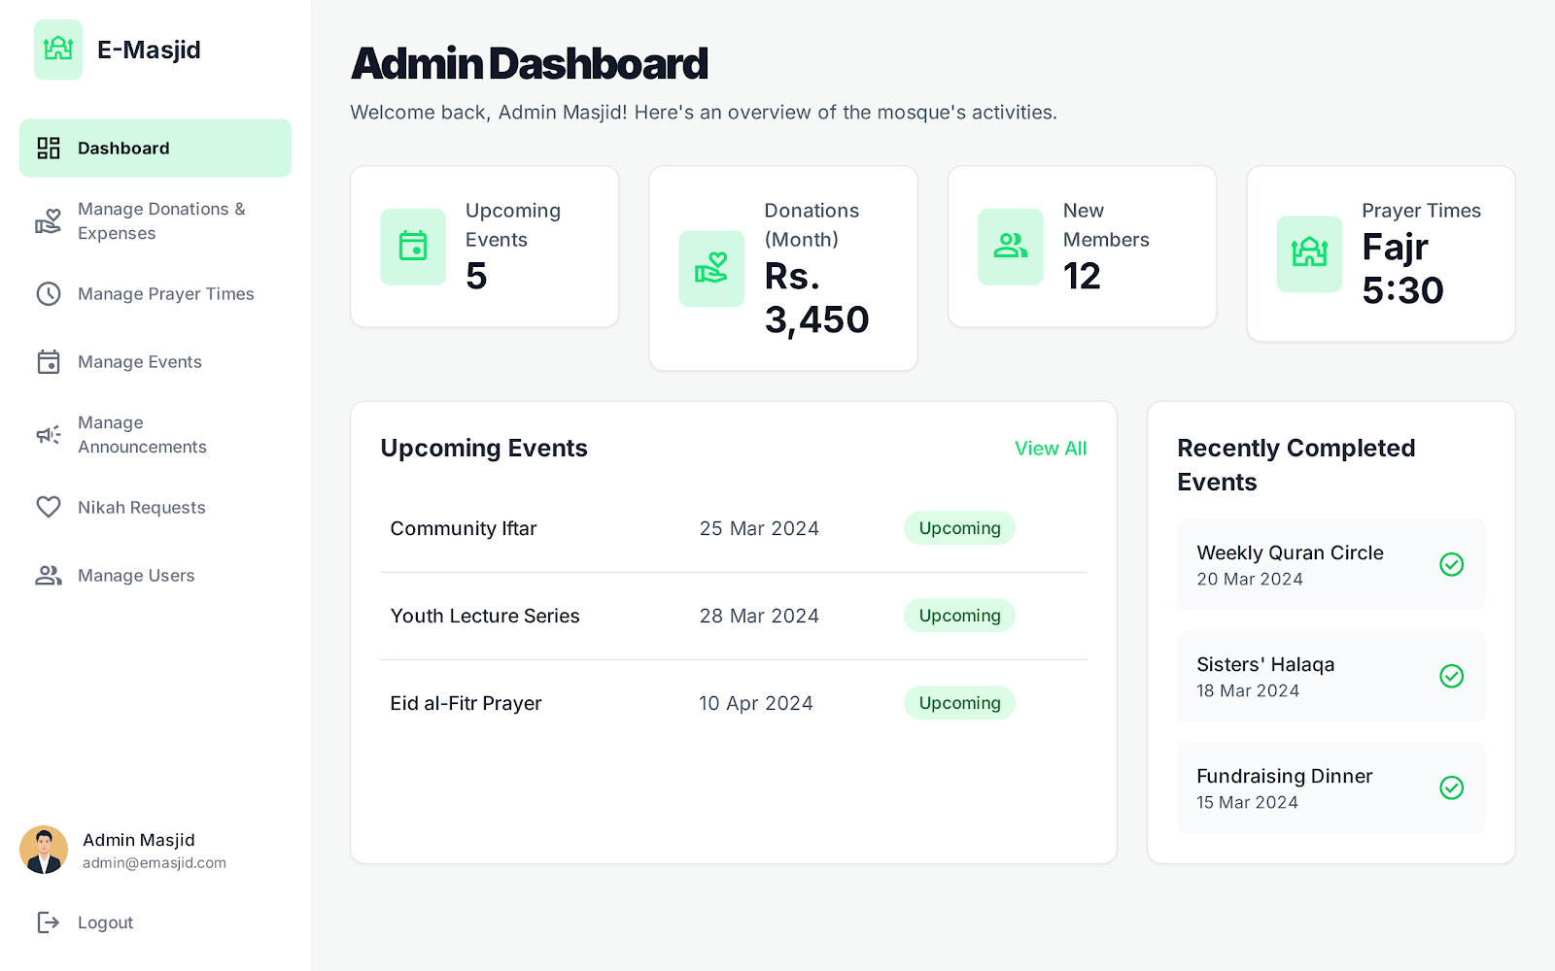
Figure 7 Admin Dashboard design

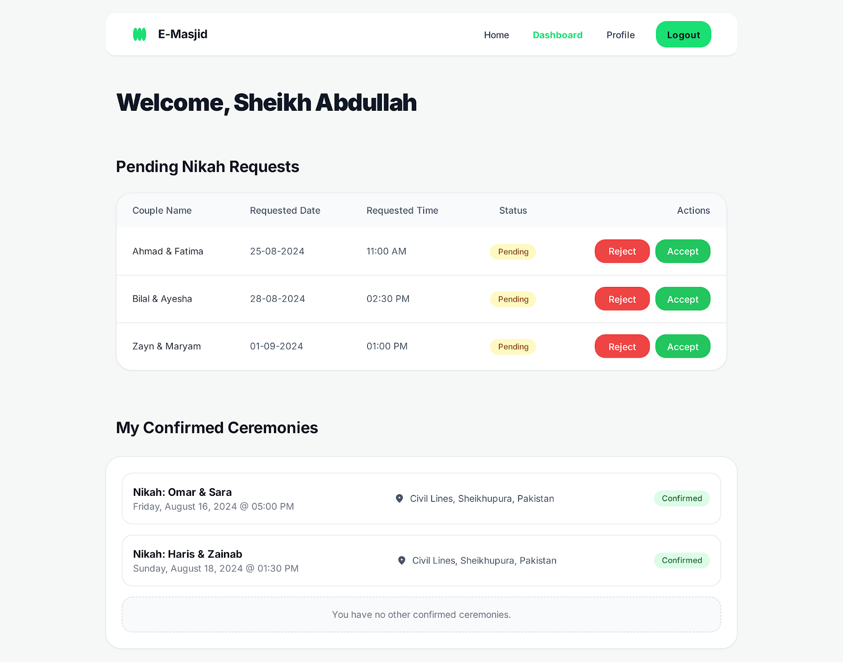
Figure 8 Scholar page design

Screen Objects and Actions

Use Case 1: Making an Online Donation

Screen Objects:
- Donation Amount Field: Text box to enter donation amount.
- Donation Type Dropdown: Select Zakat, Sadaqah, or Mosque Fund.
- Card Details Form: Fields for card number, expiry, CVC.
- Donate Now Button: Green button to submit donation.
- Cancel Button: Red button to cancel the process.
Actions:
- User enters amount: System validates it's a positive number.
- User selects donation type: System shows description of that type.
- User enters card details: System validates card format.
- User clicks Donate Now: System processes payment via Stripe.
- Payment successful: Shows green "Donation Successful" message on the dashboard.
- Payment failed: Shows red "Payment Failed" message with retry option.

Use Case 2: Admin Creating an Event

Screen Objects:
- Event Title Field: Text box for event name.
- Date and Time Pickers: Calendar and time selectors.
- Description Box: Large text area for event details.
- Location Field: Text box for event location.
- Max Participants Field: Number field for attendance limit.
- Publish Button: Blue button to publish event.
- Save Draft Button: Gray button to save for later.
Actions:
- Admin enters event details: System validates all required fields.
- Admin sets date/time: System checks date is not in past.
- Admin sets max participants: System validates positive number.
- Admin clicks Publish: System creates event and shows on website.
- Event published: Shows green "Event Published Successfully".
- Validation error: Shows red message next to incorrect field.

Behavioral Model
Behavioral models show how the system components interact and how states change during different processes.

User Login Sequence Diagram

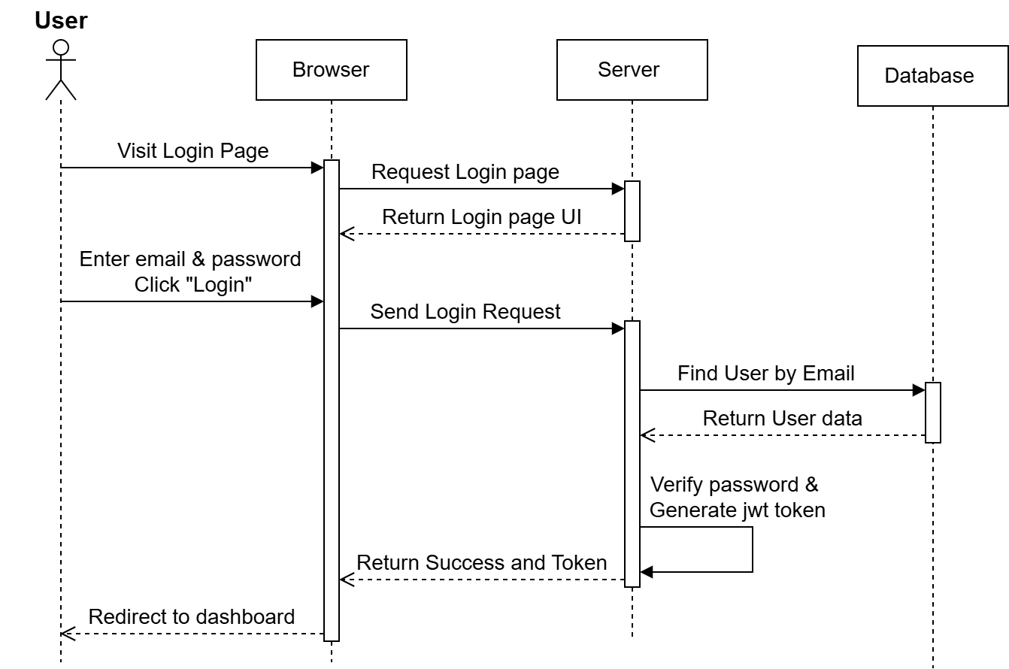
Figure 9 Login Sequence Diagram
This diagram shows the steps that happen when a user logs into the E-Masjid system. It explains how the system checks the user's details to ensure security.
Key Steps:
- User enters email and password, clicks "Login".
- Browser sends details to server.
- Server checks database for the email.
- Database finds user and sends info back.
- Server checks if password is correct.
- If correct, server creates security token.
- Token sent to browser, user taken to dashboard.
- If wrong, error message shown to use.

Online Donation Sequence Diagram

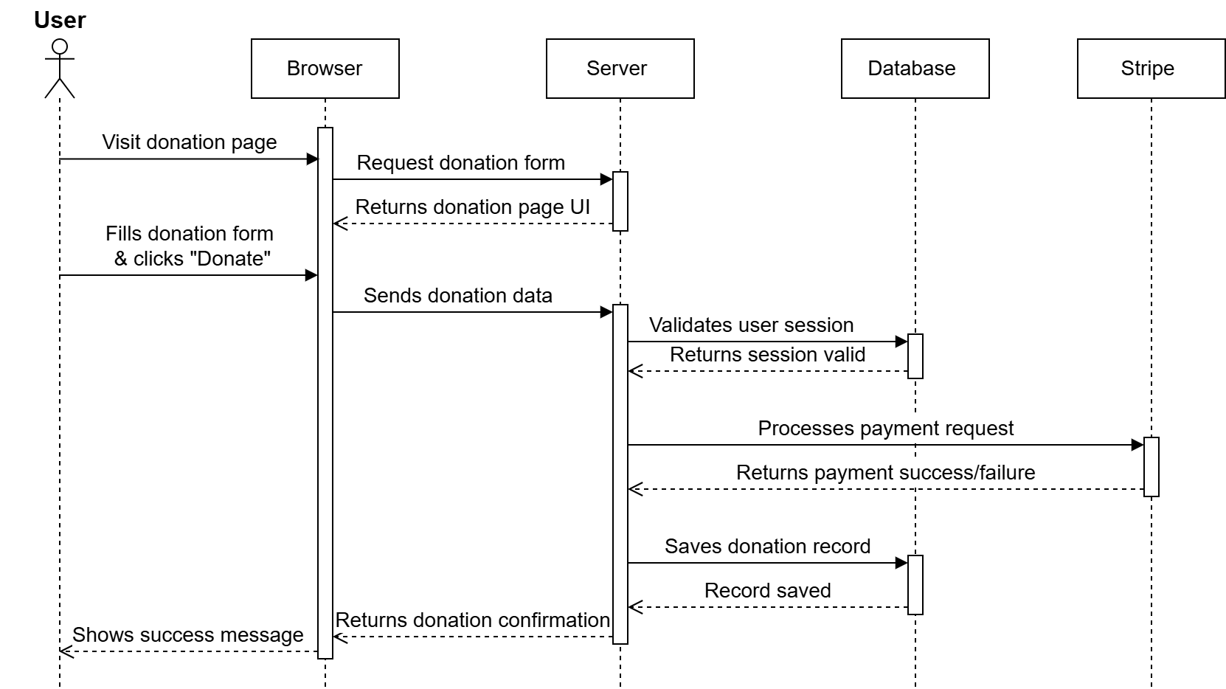
Figure 10 Online Donation Sequence Diagram
This diagram shows the complete flow when a community member makes an online donation. The process involves the user interface, backend server, database, and Stripe payment gateway working together to process the payment and record the transaction.
Key Steps:
- User submits donation form.
- Backend validates and processes payment via Stripe.
- Payment result recorded in database and confirmation displayed to user.
Nikah Booking Sequence Diagram
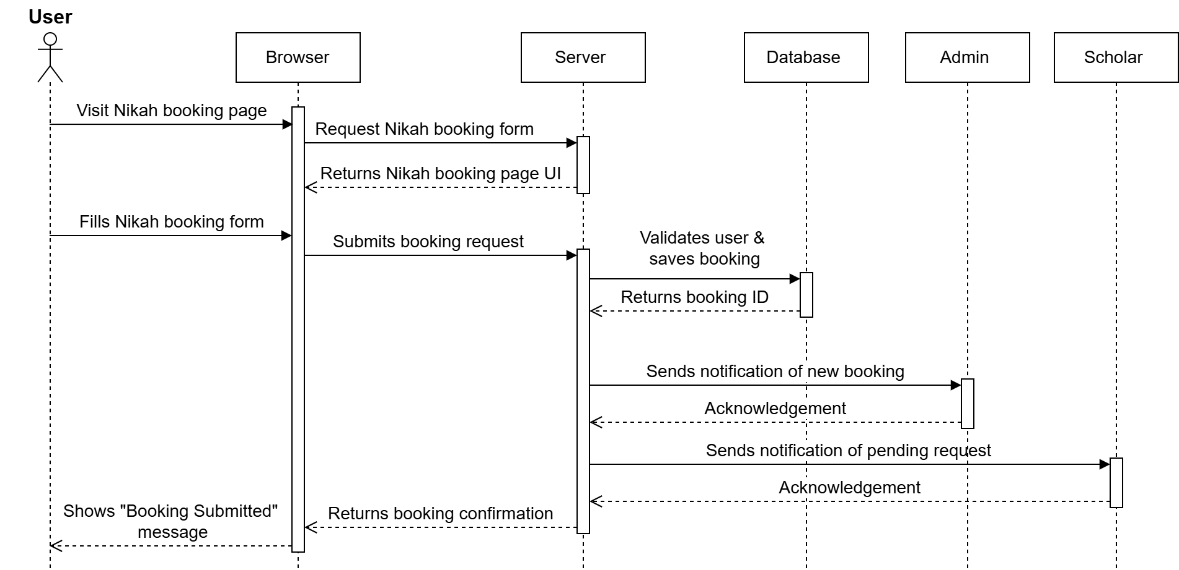
Figure 11 Nikah Booking Sequence Diagram
This diagram display all the steps of the process when a user books Nikah services. The booking request goes through validation, storage, and notification to both admin and religious scholar.
Key Steps:
- User submits booking request.
- System validates and stores the request.
- Notifications sent to admin and scholar.
- User receives booking confirmation.
- Scholar can later update booking status.

Prayer Times Update Sequence Diagram
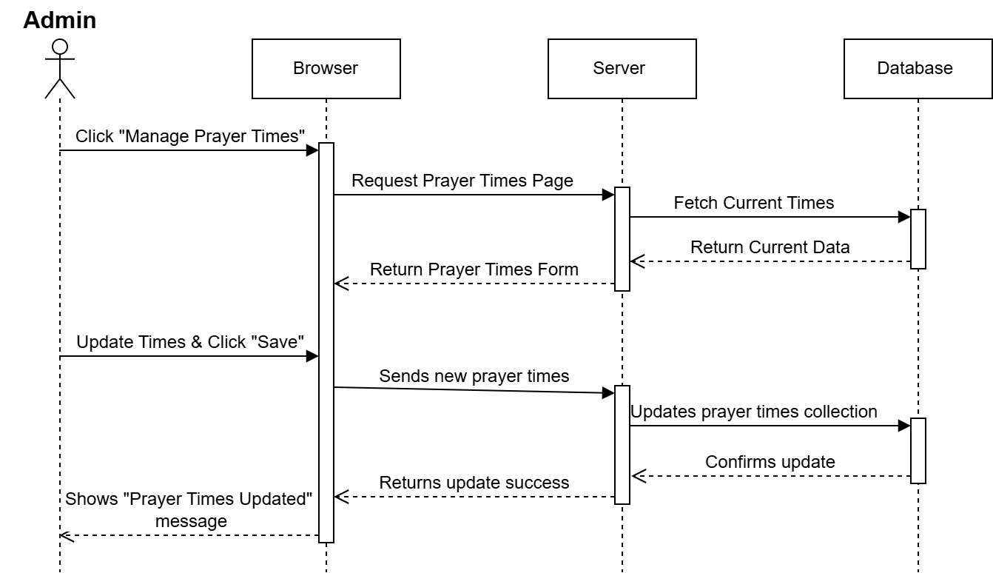
Figure 12 Admin Update Prayer Times Sequence Diagram
This diagram shows how mosque admin updates prayer times.
Key Steps:
- Admin updates times.
- Changes saved to database.
- Admin receives confirmation.

State Diagrams:

The following state diagrams display the dynamic behavior of key system entities.
They show how entities transition between states in response to user actions and
system events, ensuring proper workflow implementation.
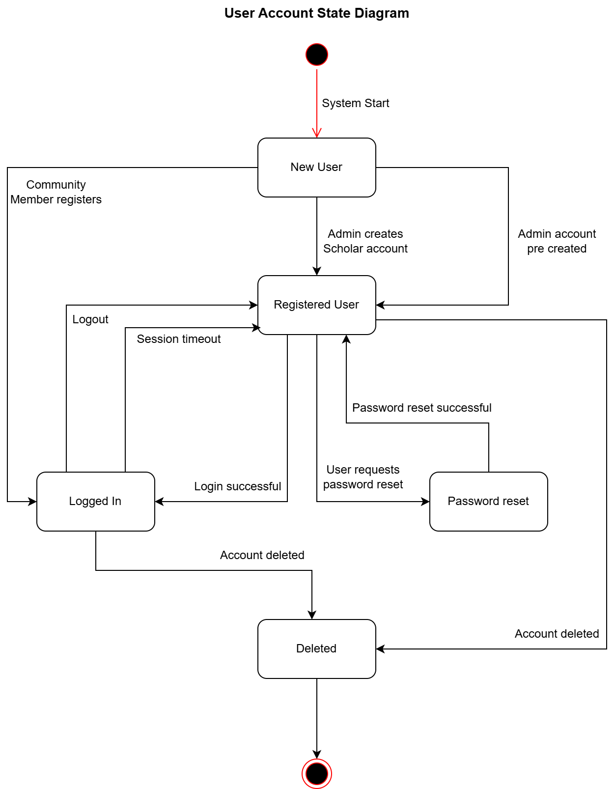
Figure 13 User Account State Diagram
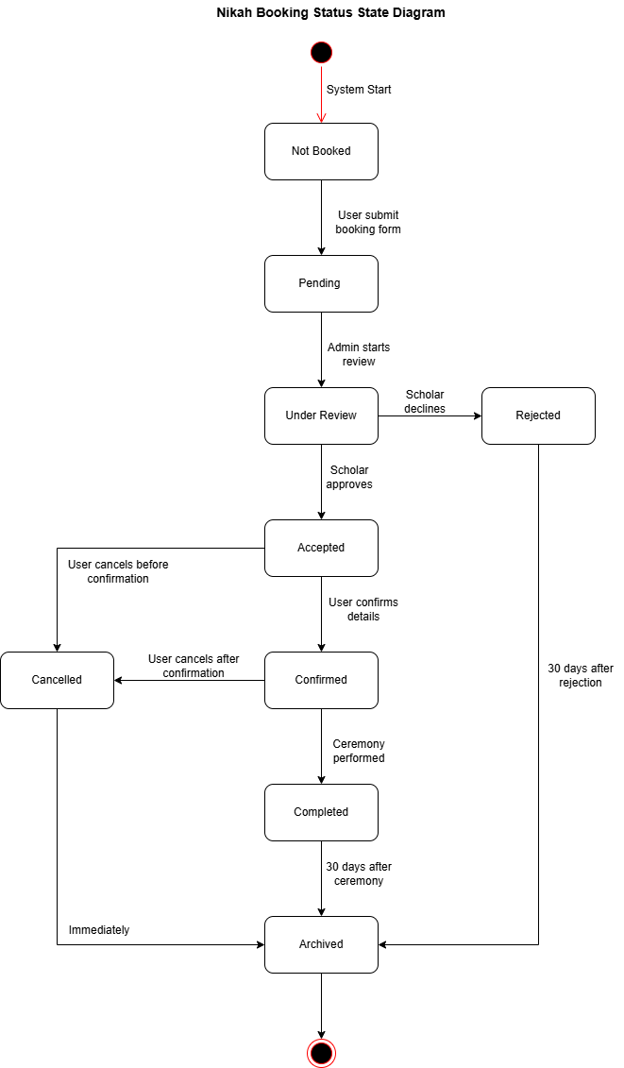
Figure 14 Nikah Booking Status State Diagram

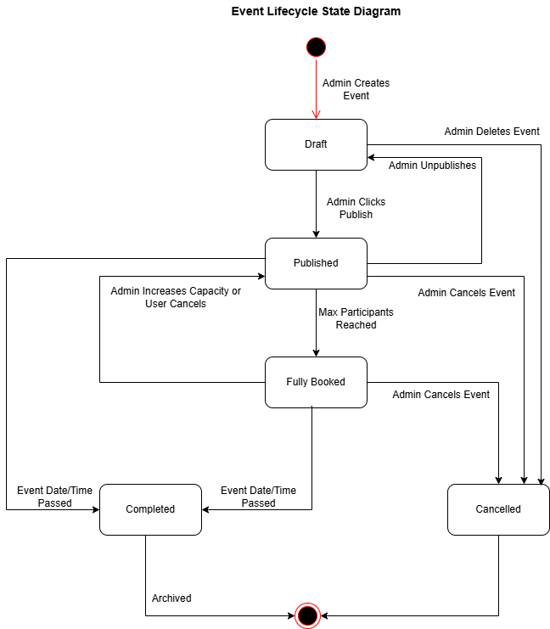
Figure 15 Event State Diagram

Design Decisions
This section explains the main design choices we made for the E-Masjid System and why we chose them.
Architecture Pattern Selection
We decided to use the MVC pattern for our system. This means we separate our code into three main parts which is model, view and controller. This makes our code cleaner and easier to fix if something goes wrong.
Technology Stack MERN
We are using the MERN stack for our project. We chose this because all parts use JavaScript, which makes development faster. React helps us create reusable components, and Node.js can handle many users at once.
Database System
We picked MongoDB instead of traditional SQL databases because it works naturally with JavaScript and Node.js. It can handle lots of data when many people use the system and it is free to use for our project size. We tried MySQL first but found MongoDB easier for our type of data.
Pay Gateway Integration
We chose Stripe for online donations because it is very secure and handles card details safely and many other projects use it successfully. Stripe has good documentation that helped us learn and it is reliable and processes payments quickly.
Deployment Strategy
We plan to deploy the system on cloud services because it is more reliable than our own computers and can handle more users during busy times. It automatically backs up data and it is affordable for a mosque budget.

Summary
This Software Design Specification show the complete technical plan for our E-Masjid System. We have explained the MVC architecture, MERN technology, database design, and user interfaces. The design describes all functional requirements and provides clear guidance for development. Following this document we will ensure to build a reliable system that meets the mosque's needs.

References
1. Project Documents
  - E-Masjid System Requirements Specification (SRS), Version 1.2.

2. Technical Documentation & Guides

  - React.js Official Documentation. Available: https://react.dev/
  - Node.js Documentation. Available: https://nodejs.org/en/docs/
  - Express.js Routing Guide. Available: https://expressjs.com/guide/routing.html
  - MongoDB Manual & Drivers. Available: https://www.mongodb.com/docs/manual/
  - Mongoose Documentation. Available: https://mongoosejs.com/docs/
  - Stripe API Reference. Available: https://stripe.com/docs/api

3. Design & Modeling Resources

  - Draw.io User Manual for UML Diagrams.

