 | Assignment No. 1  Semester: Spring 2023  CS301 – Data Structures | Total Marks: 20  Due Date: 17th May, 2023

Instructions
Please read the following instructions carefully before submitting the assignment solution:
It should be clear that your assignment will not get any credit/marks if:
- Assignment is submitted after due date.
- Submitted assignment does not open or file is corrupt.
- Assignment is copied (From internet/students).

Recommended Tools
- Dev C++

Assignment Submission Instructions
You have to submit only “.cpp” file.
Assignment submitted in any other (zip,.doc, .pdf, image, etc.) format will not be accepted and will be scaled with zero marks. No excuse will be accepted on submitting solution file in any other format.
For any query related to assignment, please contact cs301@vu.edu.pk.

Problem Statement:
You are required to make a program using C++ language to implement singly linked list. You need to create a linked list with NUMERIC digits of your VU id, after that distinguish them into two separate linked list according to odd/even, and then at the end merge these two lists into a single linked list.

Step By Step Procedure:
- Create a linked list.
- Fill the linked list while taking input on console, in such a way that user enters the NUMERIC digits of their VU ID, one by one. For example, if we consider BC123456789, then BC would be ignored and you only have to insert 1 2 3 4 5 6 7 8 9 one by one, in the linked list. (as shown in the screenshot below).
- After filling your linked list, now you need to create two other linked list one for odd numbers and the other for even numbers.
- Now, filter out the digits one by one, and put them in their respective linked list. For example, if your VU ID is BC123456789, then 1,3,5,7,9 would be inserted in the odd linked list while 2,4,6,8 would be inserted in even linked list.
- After creating two separate linked list, merge them into a single one in such a way that odd one should be inserted first and then the even linked list.
- As an output, your code should display, odd digits of your vu id, even digits of your vu id and then the merged list at the end (as shown in the screenshot below)

Important Instructions:
You need to fulfill the following requirements while solving the assignment task.
- Use only user defined classes for Node and List, the use of struct is not allowed.
- The structure of Node and List classes should be similar to the structure given below. If you will create extra data members then your marks will be deducted.
- You need to use your actual VU ID, otherwise marks would be deducted.
- Screenshot is attached for your reference.

Classes Structure:

Node
-object:int
-nextNode:Node

+set()
+get()
+setNext()
+getNext()

Structure of classes need to be created for required program.
Non Member Functions
main()
friend traverse():void
friend addNodes():List
friend mergeLists():List

List
-headNode:Node
-currentNode:Node
-lastCurrentNode:Node

+List()
+get()
+add()
+next()

Graphical Representation on the basis of (VU ID: BC123456789):

Initial Linked List

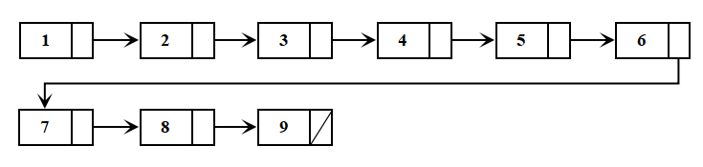

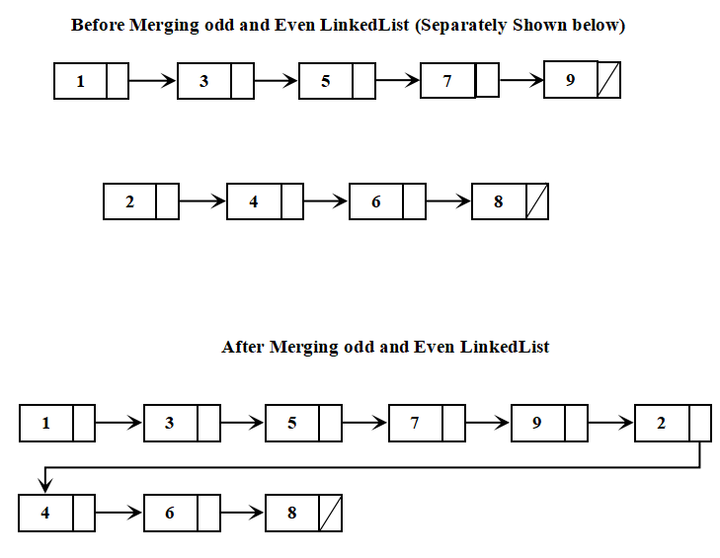
Sample Output:

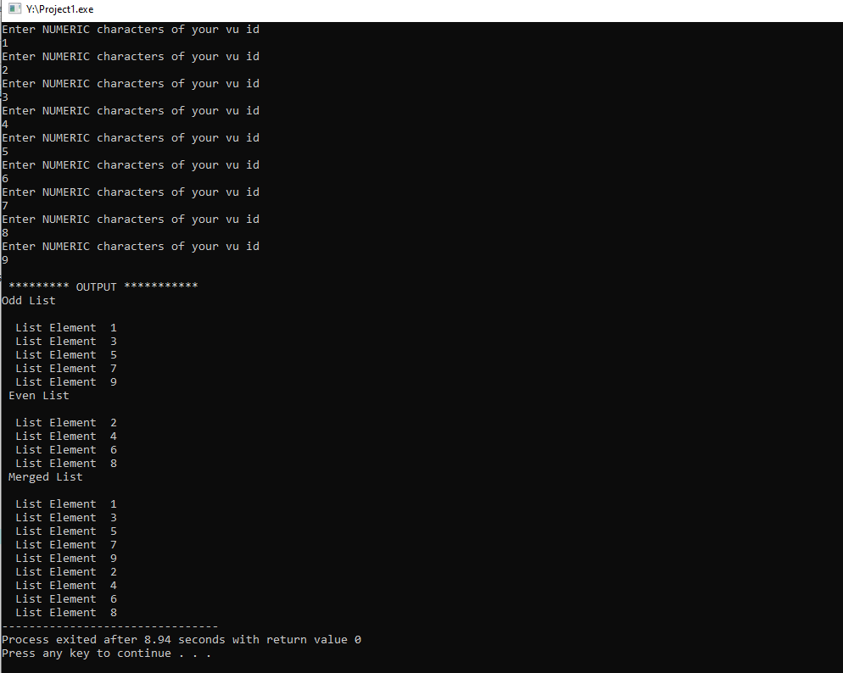

Lectures Covered: Lecture # 1 - 10
Due Date:

