**Name: Dawood Tanvir**

**Roll Number: 21i1665**

**QNO4**

* In qno4 we were asked to find the ranges of black pixels in the image.
* Using Run length coding which is used to compress images using code
* For apple image



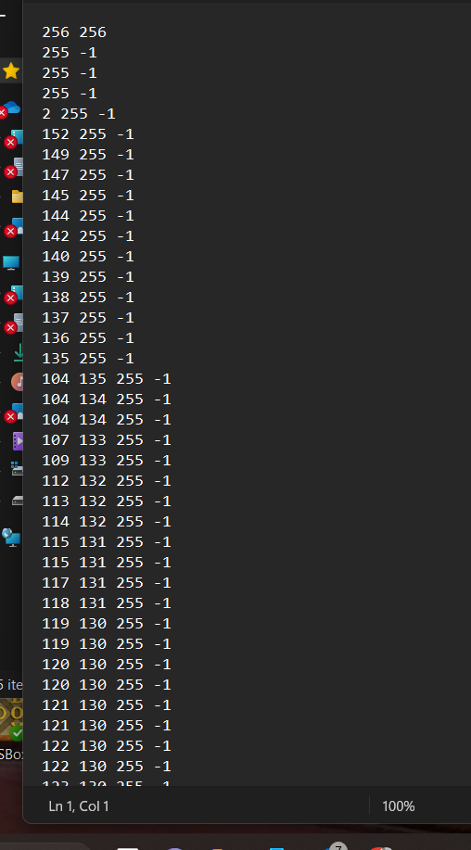

* We were asked to convert the image to negative as well

Time complexity of linked list: O(1)->insertion

Space complexity of linked list = O(1)



**QNO6**

* In qno6 we were supposed to make a image recognizer which again uses black pixels in the image
* In first step I am passing a file name in read function which reads the files and convert it in array.
* Horizontal and vertical projections are extracted.
* The images were used that were provided by the constructor
* Use of hash table made with linked list
* Time complexity hash table-> O(1) but it changes if collisions occur it will convert to O(log(n))

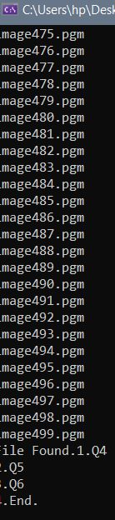

**Challenges**

* One of the biggest challenge was to decide the size of the hash table but as the code goes in the flow it worked out at the end.
* As many new concepts were added in the assignment aka project it was a little hard to apply them at first.
* Qno6 was a little trickier and took time with lots of errors

EOF