Task 1
#include <iostream>
#include <fstream>
#include <string>
using namespace std;

enum type {Current=1, Saving};

class bank
{
char name[25];
char account[25];
const type accountType;
double balance;
char bankName[25];
char branch[25];
char city[25];
static int currentCount;
static int savingCount;

public:
bank() :
name("N/A"),
account("N/A"),
accountType(Current),
balance(0),
bankName("N/A"),
branch("N/A"),
city("N/A")
{
currentCount++;
};
bank(char inName[], char inAccount[], type inType, double inBalance,char inBank[], char inBranch[], char inCity[])
: accountType(inType)
{
strcpy_s(name, inName);
strcpy_s(account, inAccount);
strcpy_s(branch,inBranch);
strcpy_s(bankName,inBank);
strcpy_s(city,inCity);
balance = inBalance;
if (accountType == 1)
currentCount++;
else
savingCount++;
};

static void getAccCounts(int& s, int& c, int& t)
{
s = savingCount;
c = currentCount;
t = s + c;
}

void deposit(double amount)
{
if (amount >= 0)
balance += amount;
cout << amount << " deposited to " << account<< endl;
}

void Withdraw(double amount)
{
if (amount >= balance)
balance -= amount;
cout << amount << " withdrawn from " << account<< endl;
}

void display()
{
cout << "\nHolder Name: " << name << endl;
cout << "Account Number: " << account << endl;
cout << "Account Type: " << accountType << endl;
cout << "Bank Name: " << bankName << endl;
cout << "Branch: " << branch << endl;
cout << "City: " << city << endl;
cout << "Current Balance: " << balance << endl;
}
void write(string filename)
{
ofstream file(filename, ios::app);

file << name << endl;
file << account << endl;
file << accountType << endl;
file << bankName << endl;
file << branch << endl;
file << city << endl;
file << balance << endl;
file << endl;
}

~bank()
{
if (accountType == 1)
currentCount--;
else
savingCount--;
cout << "Account '" << account << "' Deleted!" << endl;
}

};

int bank::currentCount = 0;
int bank::savingCount = 0;

bank* createAccount();
void printInfo(bank* ptrs[], const int& total, const int& c, const int& s);
void deleteAccount(bank* ptrs[], const int& total);
void writeInfo(bank* ptrs[], int& total, int& savings, int& Current);
void readInfo(bank* ptrs[], int& total, int& savings, int& current);

int main()
{
bank* ptrs[100];
int savingAcc = 0;
int currentAcc = 0;
int totalAcc = 0;

readInfo(ptrs, totalAcc, savingAcc, currentAcc);

int choice;
do
{
cout << "1 - Create a New Account\n";
cout << "2 - Print Info of All Accounts\n";
cout << "3 - Delete Account\n";
cout << "0 - Exit\n";
cout << "Select: ";
cin >> choice;

switch (choice)
{
case 1:
ptrs[totalAcc] = createAccount();
bank::getAccCounts(savingAcc, currentAcc, totalAcc);
break;
case 2:
printInfo(ptrs, totalAcc, currentAcc, savingAcc);
break;
case 3:
deleteAccount(ptrs,totalAcc);
bank::getAccCounts(savingAcc, currentAcc, totalAcc);
break;
case 0:
cout << "Exiting..." << endl;
break;
default:
cout << "Invalid Choice!\n";
}
cout << endl;
} while (choice);

writeInfo(ptrs, totalAcc, savingAcc, currentAcc);
}

bank* createAccount()
{
char name[25];
char account[25];
int accountType;
double balance;
char bankName[25];
char branch[25];
char city[25];

cin.ignore();
cout << "\nEnter Account Info\n";
cout << "Holder Name: ";
cin.getline(name, 25);
cout << "Account Number: ";
cin.getline(account, 25);
cout << "Bank Name: ";
cin.getline(bankName, 25);
cout << "Branch Name: ";
cin.getline(branch, 25);
cout << "City Name: ";
cin.getline(city, 25);
cout << "Account Type (1: current , 2: Savings): ";
cin >> accountType;
cout << "Balance: ";
cin >> balance;

bank* obj = new bank(name, account, (accountType == 1 ? Current : Saving), balance, bankName, branch, city);
return obj;
}

void printInfo(bank* ptrs[],const int& total, const int& c, const int& s)
{
for (int i = 0; i < total; i++)
ptrs[i]->display();

cout << "\nTotal Accounts Actice: " << total<<endl;
cout << "Savings Accounts: " << s << endl;
cout << "Current Accounts: " << c << endl;
}

void deleteAccount(bank* ptrs[], const int& total)
{
int index;
cout << "Pick from 0 - " << total - 1 << endl;
cout << "Enter index of account to delete: ";
cin >> index;
if (index < 0 || index >= total)
{
cout << "Invalid Index!\n";
return;
}

bank* temp[100];
for (int i = index + 1; i < total; i++)
temp[i] = ptrs[i];
delete ptrs[index];
ptrs[index] = nullptr;
for (int i = index; i < total && i < 99; i++)
ptrs[i] = temp[i + 1];
}

void writeInfo(bank* ptrs[], int& total, int& savings, int& current)
{
ofstream handler ("accounts.txt");
if (!handler)
return;
handler << total << endl;
handler << current << endl;
handler << savings << endl;

for (int i = 0; i < total; i++)
ptrs[i]->write("accounts.txt");

cout << "|Data Stored Successfully|\n";
}

void readInfo(bank* ptrs[], int& total, int& savings, int& current)
{
char name[25];
char account[25];
int accountType;
double balance;
char bankName[25];
char branch[25];
char city[25];
string line;

ifstream file("accounts.txt");
if (!file)
{
cout << "Error Readin File!!\n";
return;
}

getline(file,line);
total = stoi(line);
getline(file, line);
current = stoi(line);
getline(file, line);
savings = stoi(line);

for (int i = 0; i < total; i++)
{
file.getline(name, 25);
file.getline(account, 25);
getline(file, line);
accountType = stoi(line);
file.getline(bankName, 25);
file.getline(branch, 25);
file.getline(city, 25);
getline(file, line);
balance = stod(line);
getline(file, line);
ptrs[i] = new bank(name, account, (accountType == 1 ? Current : Saving), balance, bankName, branch, city);
}

cout << "| Data Loaded Correctly |\n" << endl;
}

Output
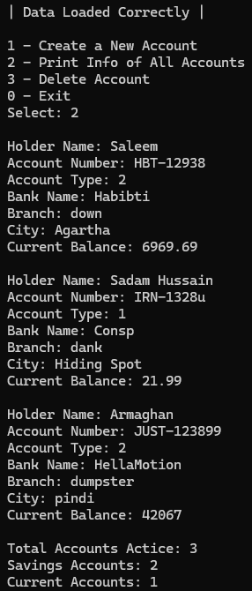
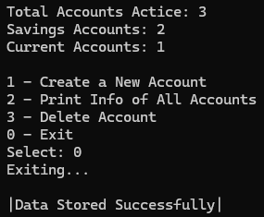
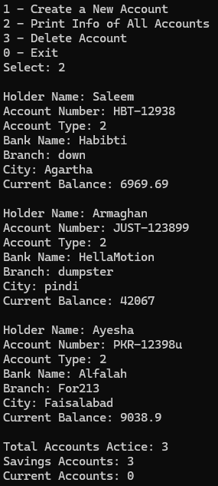
2.
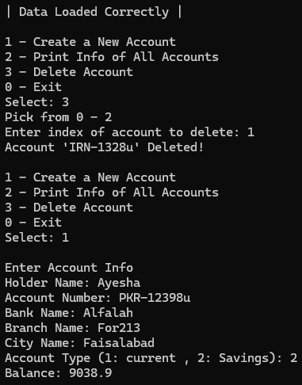

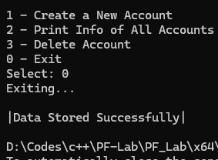

Task 2
#include <iostream>
#include <fstream>
#include <string>
using namespace std;

class HotDogStand
{
private:
int ID;
int sold;
static int totalSold;
public:
HotDogStand()
{
ID = 0;
sold = 0;
}
HotDogStand(int inID, int inSold)
{
ID = inID;
sold = inSold;
totalSold += sold;
}
void sellHotDog()
{
sold++;
totalSold++;
}
int getSold()
{
return sold;
}
static int getTotalSold()
{
return totalSold;
}

};

int HotDogStand::totalSold = 0;

int main()
{
HotDogStand a, b(123, 9), c(21, 21);

cout << "HotDogs sold by Stand a: " << a.getSold() << endl;
cout << "HotDogs sold by Stand b: " << b.getSold() << endl;
cout << "HotDogs sold by Stand c: " << c.getSold() << endl;
cout << "\nSelling Dogs at Stand a...\n";
a.sellHotDog();
a.sellHotDog();
a.sellHotDog();
a.sellHotDog();
a.sellHotDog();
a.sellHotDog();
cout << "HotDogs sold by Stand a: " << a.getSold() << endl;
cout << "\nTotal HotDogs Sold: " << HotDogStand::getTotalSold() << endl;
}

Output
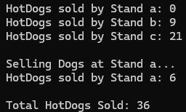

Task 4
#include <iostream>
#include <fstream>
#include <string>
using namespace std;

class toolbooth
{
private:
int NumberOfCars;
double moneyCollected;
public:
toolbooth()
{
NumberOfCars = 0;
moneyCollected = 0;
}
void payingCar()
{
NumberOfCars++;
moneyCollected += 50;
}
void const noPayCar()
{
NumberOfCars++;
}
void const display()
{
cout << "\nTotal Number of Passed Cars: " << NumberOfCars << endl;
cout << "Total amount of Money Collected: " << moneyCollected << endl;
cout << endl;
}
};

int main()
{
toolbooth booth;
int choice;
do
{
cout << "1- Pass Paying Car\n";
cout << "2- Pass Non-Paying Car\n";
cout << "3- Print Info\n";
cout << "0- Exit\n";
cout << "Choose: ";
cin >> choice;

switch (choice)
{
case 1:
booth.payingCar();
cout << "Paying Car Passed!\n";
break;
case 2:
booth.noPayCar();
cout << "Paying Car Passed!\n";
break;
case 3:
booth.display();
break;
case 0:
cout << "Exiting...\n";
break;
default:
cout << "Invalid Choice!\n";
}

} while (choice);
}

Output
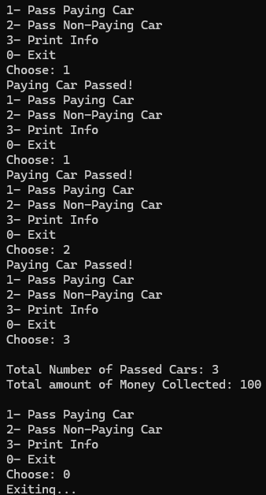
Task 5
#include <iostream>
#include <fstream>
#include <string>
using namespace std;

class Time
{
private:
int hours; Output
int minutes;
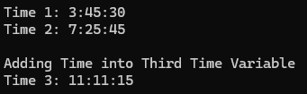
int seconds;
public:
Time()
{
hours = 0;
minutes = 0;
seconds = 0;
}
Time(int h, int m, int s)
{
hours = h % 12;
minutes = m % 60;
seconds = s % 60;
}
void display() const
{
cout << hours << ":" << minutes << ":" << seconds << endl;
}
void add(const Time& a, const Time& b)
{
seconds = (a.seconds + b.seconds) % 60;
minutes = ((a.minutes + b.minutes) + (a.seconds + b.seconds) / 60) % 60;
int carryHours = ((a.minutes + b.minutes) + (a.seconds + b.seconds) / 60) / 60;
hours = (a.hours + b.hours + carryHours) % 12;
}
};

int main()
{
Time a, b(3,45,30), c(7,25,45);
cout << "Time 1: " ;
b.display();
cout << "Time 2: ";
c.display();
cout << "\nAdding Time into Third Time Variable\n";
a.add(b, c);
cout << "Time 3: ";
a.display();
}

