
OBJECT ORIENTED PROGRAMMING
ASSIGNMENT 3


ABEEHA FATIMA 25F-0021

QUESTION1:
#include <iostream>
#include <fstream>
#include <cstring>
using namespace std;
enum AccType { Current, Saving };
class Account
{
private:
char DPName[100];
char AccNum[100];
AccType AccountType;
double balance;
char Bname[100];
char BCode[100];
char city[100];
static unsigned int currentCount;
static unsigned int savingCount;

public:
Account() {
strcpy_s(DPName, sizeof(DPName), "");
strcpy_s(AccNum, sizeof(AccNum), "");
AccountType = Saving;
balance = 0.0;
strcpy_s(Bname, sizeof(Bname), "");
strcpy_s(BCode, sizeof(BCode), "");
strcpy_s(city, sizeof(city), "");
}
Account(const char* dpName, const char* accNum, AccType type, double bal,
const char* bname, const char* code, const char* cityName)
{
strcpy_s(DPName, sizeof(DPName), dpName);
strcpy_s(AccNum, sizeof(AccNum), accNum);
AccountType = type;
balance = bal;
strcpy_s(Bname, sizeof(Bname), bname);
strcpy_s(BCode, sizeof(BCode), code);
strcpy_s(city, sizeof(city), cityName);

if (type == Current)
currentCount++;
else
savingCount++;
}
void Deposit(double amount)
{
balance += amount;
}
bool Withdraw(double amount)
{
if (balance >= amount)
{
balance -= amount;
return true;
}
return false;
}

void Display()
{
cout << endl;
cout << "-------ACCOUNT DETAILS-------" << endl;
cout << "Name : " << DPName << endl;
cout << "Account Number : " << AccNum << endl;
cout << "Account Type : " << (AccountType == Current ? "Current" : "Saving") << endl;
cout << "Bank Name : " << Bname << endl;
cout << "Branch Code : " << BCode << endl;
cout << "City : " << city << endl;
cout << "Balance : " << balance << endl;
}

const char* getAccNum() { return AccNum; }

AccType getType() { return AccountType; }

static void decCount(AccType type)
{
if (type == Current) currentCount--;
else savingCount--;
}

static void getAccCounts()
{
cout << endl;
cout << "---------ACCOUNT COUNTS---------" << endl;
cout << "Current Accounts : " << currentCount << endl;
cout << "Saving Accounts : " << savingCount << endl;
}

void SaveToFile(ofstream& ofs)
{
ofs << DPName << endl;
ofs << AccNum << endl;
ofs << AccountType << endl;
ofs << balance << endl;
ofs << Bname << endl;
ofs << BCode << endl;
ofs << city << endl;
}

bool LoadFromFile(ifstream& ifs)
{
if (!ifs.getline(DPName, 100)) return false;
if (!ifs.getline(AccNum, 100)) return false;

int type;
if (!(ifs >> type)) return false;
AccountType = static_cast<AccType>(type);

if (!(ifs >> balance)) return false;
ifs.ignore(1000, '\n');

if (!ifs.getline(Bname, 100)) return false;
if (!ifs.getline(BCode, 100)) return false;
if (!ifs.getline(city, 100)) return false;

if (AccountType == Current) currentCount++;
else savingCount++;

return true;
}
};
unsigned int Account::currentCount = 0;
unsigned int Account::savingCount = 0;
int main()
{

Account* accounts[100] = { nullptr };
int index = 0;
ifstream infile("accounts.txt");
if (infile.is_open())
{
while (index < 100)
{
Account* temp = new Account();
if (!temp->LoadFromFile(infile))
{
delete temp;
break;
}
accounts[index++] = temp;
}
infile.close();
}

int choice;
do
{
cout << endl;
cout << "------BANK MANAGEMENT SYSTEM------" << endl;
cout << "1. Create New Account" << endl;
cout << "2. Display All Accounts" << endl;
cout << "3. Deposit Amount" << endl;
cout << "4. Withdraw Amount" << endl;
cout << "5. Delete Account" << endl;
cout << "6. Show Account Counts" << endl;
cout << "7. Exit" << endl;
cout << "Enter your choice: ";
cin >> choice;

switch (choice)
{
case 1:
{
if (index >= 100)
{
cout << "Cannot create more accounts.\n";
break;
}

char name[100], accNum[100], bname[100], bcode[100], city[100];
int type;
double bal;

cin.ignore(1000, '\n');
cout << "Enter Depositor Name: "; cin.getline(name, 100);
cout << "Enter Account Number: "; cin.getline(accNum, 100);
cout << "Enter Account Type (0=Current,1=Saving): "; cin >> type;
cout << "Enter Balance: "; cin >> bal;
cin.ignore(1000, '\n');
cout << "Enter Bank Name: "; cin.getline(bname, 100);
cout << "Enter Branch Code: "; cin.getline(bcode, 100);
cout << "Enter City: "; cin.getline(city, 100);

accounts[index++] = new Account(name, accNum, static_cast<AccType>(type), bal, bname, bcode, city);
cout << "Account created successfully" << endl;
break;
}

case 2:
if (index == 0)
{
cout << "No accounts available" << endl;
}
else
{
for (int i = 0; i < index; i++)
{
cout << endl;
cout << "Account #" << i + 1;
accounts[i]->Display();
}
}
break;

case 3:
{
char accnum[100];
double amount;
cin.ignore(1000, '\n');
cout << "Enter Account Number: "; cin.getline(accnum, 100);
cout << "Enter Amount to Deposit: "; cin >> amount;

bool found = false;
for (int i = 0; i < index; i++)
{
if (strcmp(accounts[i]->getAccNum(), accnum) == 0)
{
accounts[i]->Deposit(amount);
cout << "Amount deposited successfully.\n";
found = true;
break;
}
}
if (!found) cout << "Account not found.\n";
break;
}

case 4:
{
char accnum[100];
double amount;
cin.ignore(1000, '\n');
cout << "Enter Account Number: "; cin.getline(accnum, 100);
cout << "Enter Amount to Withdraw: "; cin >> amount;

bool found = false;
for (int i = 0; i < index; i++)
{
if (strcmp(accounts[i]->getAccNum(), accnum) == 0)
{
if (accounts[i]->Withdraw(amount))
cout << "Amount withdrawn successfully.\n";
else
cout << "Transaction failed: Insufficient balance.\n";
found = true;
break;
}
}
if (!found) cout << "Account not found.\n";
break;
}

case 5:
{
char accnum[100];
cin.ignore(1000, '\n');
cout << "Enter Account Number to Delete: "; cin.getline(accnum, 100);

bool found = false;
for (int i = 0; i < index; i++)
{
if (strcmp(accounts[i]->getAccNum(), accnum) == 0)
{
Account::decCount(accounts[i]->getType());
delete accounts[i];

for (int j = i; j < index - 1; j++)
accounts[j] = accounts[j + 1];

accounts[index - 1] = nullptr;
index--;
cout << "Account deleted successfully.\n";
found = true;
break;
}
}
if (!found) cout << "Account not found.\n";
break;
}

case 6:
Account::getAccCounts();
break;

case 7:
{
ofstream ofs("accounts.txt");
for (int i = 0; i < index; i++)
accounts[i]->SaveToFile(ofs);
ofs.close();
cout << "Data saved. Exiting program" << endl;
break;
}
}

} while (choice != 7);

for (int i = 0; i < index; i++)
delete accounts[i];

return 0;
}
OUTPUT:
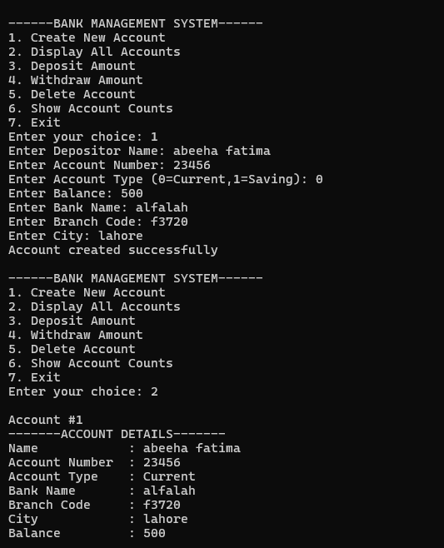
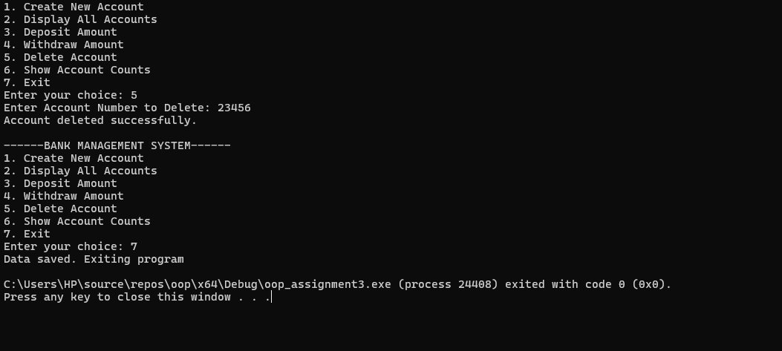
QUESTION2:
#include <iostream>
using namespace std;
class HotDogStand
{
private:
int ID;
int sold;
static int totalSold;
public:
HotDogStand(int hs, int h)
{
this->ID = hs;
this->sold = h;
totalSold += h;
}
void justSold()
{
this->sold++;
totalSold++;
}
int getHotDogsSold()
{
return this->sold;
}
static int getTotalHotDogsSold()
{
return totalSold;
}
int getHotDogStandID()
{
return this->ID;
}
};
int HotDogStand::totalSold = 0;
int main()
{
HotDogStand stand1(1, 7);
HotDogStand stand2(2, 3);
HotDogStand stand3(3, 8);
stand1.justSold();
stand1.justSold();
stand2.justSold();
stand3.justSold();
stand3.justSold();
stand3.justSold();
cout << "Stand " << stand1.getHotDogStandID() << " sold: " << stand1.getHotDogsSold() << endl;
cout << "Stand " << stand2.getHotDogStandID() << " sold: " << stand2.getHotDogsSold() << endl;
cout << "Stand " << stand3.getHotDogStandID() << " sold: " << stand3.getHotDogsSold() << endl;
cout << "Total number of hot dogs sold are : " << HotDogStand::getTotalHotDogsSold() << endl;
system("pause");
return 0;
}
OUTPUT:
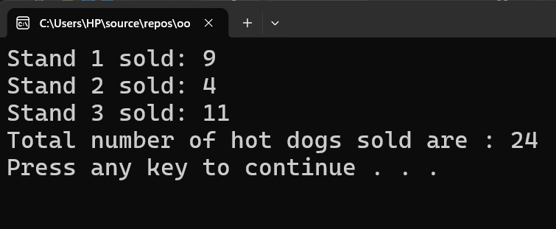
QUESTION3:
#include <iostream>
#include <fstream>
#include <string>
using namespace std;
struct Students
{
string name;
string CNIC;
string gender;
float CGPA;
};
class Section
{
private:
Students arr[40];
string Section_name;
string Class_teacher;
int studentCount;
public:
Section()
{
studentCount = 0;
Section_name = "N/A";
Class_teacher = "N/A";
}
void editSection()
{
cin.ignore();
cout << "Enter Section Name: ";
getline(cin, Section_name);
cout << "Enter Class Teacher Name: ";
getline(cin, Class_teacher);
}

void addStudent() {
if (studentCount >= 40) {
cout << "Section Full!" << endl;
return;
}
cin.ignore();
cout << endl;
cout << "Enter Name: ";
getline(cin, arr[studentCount].name);
cout << "Enter CNIC: ";
getline(cin, arr[studentCount].CNIC);
cout << "Enter Gender: ";
getline(cin, arr[studentCount].gender);
cout << "Enter CGPA: ";
cin >> arr[studentCount].CGPA;
studentCount++;
}

void updateStudent() {
string searchName;
cin.ignore();
cout << "Enter student name to update: ";
getline(cin, searchName);
for (int i = 0; i < studentCount; i++) {
if (arr[i].name == searchName) {
cout << "Enter New CGPA: ";
cin >> arr[i].CGPA;
cout << "Updated Successfully!" << endl;
return;
}
}
cout << "Student not found" << endl;
}

void printList()
{
cout << endl;
cout << "--------SECTION DETAILS-------" << endl;
cout << "Section: " << Section_name << endl;
cout << "Teacher: " << Class_teacher << endl;
for (int i = 0; i < studentCount; i++)
{
cout << "-----STUDENT DETAILS-------" << endl;
cout << "Student " << i + 1 << endl;
cout << "Name: " << arr[i].name << endl;
cout << "CNIC: " << arr[i].CNIC << endl;
cout << "Gender: " << arr[i].gender << endl;
cout << "CGPA: " << arr[i].CGPA << endl;
cout << endl;
}
cout << endl;
}
void writeString(ofstream& out, const string& str) {
size_t len = str.size();
out.write(reinterpret_cast<const char*>(&len), sizeof(len));
out.write(str.c_str(), len);
}
void readString(ifstream& in, string& str)
{
size_t len;
in.read(reinterpret_cast<char*>(&len), sizeof(len));
char* buffer = new char[len + 1];
in.read(buffer, len);
buffer[len] = '\0';
str = buffer;
delete[] buffer;
}
void save(ofstream& outFile)
{
outFile.write(reinterpret_cast<char*>(&studentCount), sizeof(studentCount));
writeString(outFile, Section_name);
writeString(outFile, Class_teacher);
for (int i = 0; i < studentCount; i++)
{
writeString(outFile, arr[i].name);
writeString(outFile, arr[i].CNIC);
writeString(outFile, arr[i].gender);
outFile.write(reinterpret_cast<char*>(&arr[i].CGPA), sizeof(arr[i].CGPA));
}
}
void load(ifstream& inFile)
{
inFile.read(reinterpret_cast<char*>(&studentCount), sizeof(studentCount));
readString(inFile, Section_name);
readString(inFile, Class_teacher);
for (int i = 0; i < studentCount; i++)
{
readString(inFile, arr[i].name);
readString(inFile, arr[i].CNIC);
readString(inFile, arr[i].gender);
inFile.read(reinterpret_cast<char*>(&arr[i].CGPA), sizeof(arr[i].CGPA));
}
}
};
int main() {
Section* ptr;
int num;
ifstream inFile("sections.dat", ios::binary);
if (inFile) {
inFile.read(reinterpret_cast<char*>(&num), sizeof(num));
ptr = new Section[num];
for (int i = 0; i < num; i++)
ptr[i].load(inFile);
inFile.close();
cout << "Loaded " << num << " sections from file." << endl;
}
else
{
cout << "Enter the sections: ";
cin >> num;
ptr = new Section[num];
}
int choice, Index;
do
{
cout << "----- MENU -----";
cout << endl;
cout << "1. Edit Section"<<endl;
cout << "2. Add Student"<<endl;
cout << "3. Update Student"<<endl;
cout << "4. Print Students"<<endl;
cout << "5. Print All Sections"<<endl;
cout << "6. Exit"<<endl;
cout << "Enter choice: ";
cin >> choice;
if (choice >= 1 && choice <= 5)
{
cout << "Enter section index (0 to " << num - 1 << "): ";
cin >> Index;
while (Index < 0 || Index >= num)
{
cout << "The index is invalid, Enter again: ";
cin >> Index;
}
}
switch (choice)
{
case 1:
ptr[Index].editSection();
break;
case 2:
ptr[Index].addStudent();
break;
case 3:
ptr[Index].updateStudent();
break;
case 4:
ptr[Index].printList();
break;
case 5:
for (int i = 0; i < num; i++)
{
cout << "\nSection Index: " << i << endl;
ptr[i].printList();
}
break;
case 6: cout << "Exiting..." << endl; break;
default: cout << "Invalid choice!" << endl;
}
} while (choice != 6);
ofstream outFile("sections.dat", ios::binary);
outFile.write(reinterpret_cast<char*>(&num), sizeof(num));
for (int i = 0; i < num; i++)
{
ptr[i].save(outFile);
}
outFile.close();
delete[] ptr;
system("pause");
return 0;
}
OUTPUT:
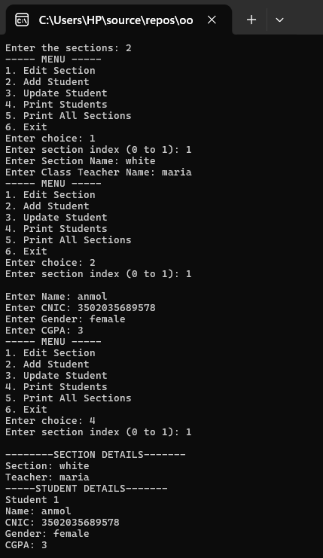
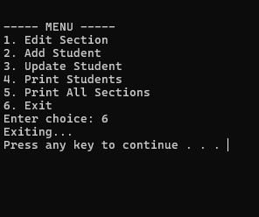
QUESTION4:
#include <iostream>
using namespace std;
class TollBooth
{
private:
unsigned int totalCars;
double totalCash;
public:
TollBooth()
{
totalCars = 0;
totalCash = 0;
}
void payingCar()
{
totalCars++;
totalCash += 50;
}
void noPayCar()
{
totalCars++;
}
void display() const
{
cout << "Total cars: " << totalCars << endl;
cout << "Total cash: " << totalCash << endl;
}
};
int main()
{
TollBooth t;
char choice;
do
{
cout << "1 Paying car" << endl;
cout << "2 Non.Paying car" << endl;
cout << "3 Display totals" << endl;
cout << "4 Exit" << endl;
cout << "Enter choice: ";
cin >> choice;
if (choice == '1')
{
t.payingCar();
}
else if (choice == '2')
{
t.noPayCar();
}
else if (choice == '3')
{
t.display();
}
else if (choice == '4')
{
t.display();
}
}
while (choice != '4');
system("pause");
return 0;
}
OUTPUT:
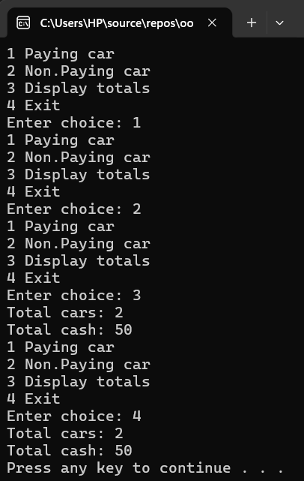
QUESTION5:
#include <iostream>
using namespace std;
class Time
{
private:
int hours;
int minutes;
int seconds;
public:
Time()
{
hours = 0;
minutes = 0;
seconds = 0;
}
Time(int h, int m, int s)
{
this->hours = h;
this->minutes = m;
this->seconds = s;
}
void display() const
{
cout << (hours < 10 ? "0" : "") << hours << ":" << (minutes < 10 ? "0" : "") << minutes << ":" << (seconds < 10 ? "0" : "") << seconds << endl;

}
void addtime(const Time& t1, const Time& t2)
{
seconds = t1.seconds + t2.seconds;
minutes = t1.minutes + t2.minutes + seconds / 60;
seconds = seconds % 60;
hours = t1.hours + t2.hours + minutes / 60;
minutes = minutes % 60;
}
};
int main()
{
const Time t1(11, 59, 59);
const Time t2(7, 40, 20);
Time t3;
t3.addtime(t1, t2);
t3.display();
system("pause");
return 0;
}
OUTPUT:
