Question no 1;

#include<iostream>
#include<string>
#include<fstream>
using namespace std;

class bankaccount {

private:

string Name;
double balance;
float branchcode;
string city;

public:
string accountno;
enum AccountType { CURRENT, SAVING };
AccountType type;
static unsigned int count;

bankaccount()
{
balance = 0;
count++;
Name = " ";
city = " ";
}

void create()
{
cin.ignore(1000, '\n');

cout << "Enter the account no: " << endl;
getline(cin, accountno);

cout << "Enter the NAME: " << endl;
getline(cin, Name);

cout << "Enter the branch code: " << endl;
cin >> branchcode;

cin.ignore(1000, '\n');

cout << "Enter city name: " << endl;
getline(cin, city);

int t;
cout << " enter 1 for current account and 2 for saving account " << endl;
cin >> t;

if (t == 1)
type = CURRENT;
else
type = SAVING;

saveToFile();
}

void saveToFile()
{
ofstream file("accounts.txt", ios::app);
file << accountno << endl;
file << Name << endl;
file << balance << endl;
file << branchcode << endl;
file << city << endl;
file << type << endl;
file.close();
}

void deposit()
{
int amount;
cout << " Enter the amount " << endl;
cin >> amount;
balance = balance + amount;
cout << " successfully deposit your money." << endl;
saveAll();
}

void withdrwal()
{
int amount;
cout << " enter amount " << endl;
cin >> amount;

if (amount > balance)
{
cout << "Your balance is not sufficient." << endl;
}
else
{
balance = balance - amount;
cout << "Money withdrawn successfully." << endl;
cout << "Remaining Balance: " << balance << endl;
saveAll();
}
}

void saveAll()
{
ofstream file("accounts.txt");
file << accountno << endl;
file << Name << endl;
file << balance << endl;
file << branchcode << endl;
file << city << endl;
file << type << endl;

}
string reT()
{
return accountno;
}
~bankaccount()
{
count--;
}

void show()
{
cout << "=-------------------------------------------=" << endl;
cout << " name :" << Name << endl;
cout << " Bank account :" << accountno << endl;
cout << "current Balance :" << balance << endl;
cout << " Branch code :" << branchcode << endl;
cout << " branch city name :" << city << endl;
if (type == 0)
{
cout << " Account type : current Account ." << endl;
}
else
{
cout << " Account tyoe : saving Account." << endl;
}

cout << "=---------------------------------------------=" << endl;
}
};

unsigned int bankaccount::count = 0;

int main()
{
bankaccount* b[100];
int n;
int size = 0;

do
{
cout << "=-----------------------------------=" << endl;
cout << " Enter 1 for create account. " << endl;
cout << " Enter 2 for Add money. " << endl;
cout << " Enter 3 for withdrawal money. " << endl;
cout << " Enter 4 for delete account." << endl;
cout << " Enter 5 for display account " << endl;
cout << " Enter 0 for Exit." << endl;
cout << "=-----------------------------------=" << endl;
cout << " Enter your choice ." << endl;
cin >> n;

switch (n)
{
case 1:
{
if (size < 100)
{
b[size] = new bankaccount();
b[size]->create();
size++;
}
break;
}
case 2:
{
bool f = true;
string n;
cout << " Enter the account number " << endl;
cin >> n;
for (int i = 0; i < size; i++)
{
if (n == b[i]->reT())
{
f = true;
b[i]->deposit();

break;
}
}
if (!f)
{
cout << " Account not found " << endl;
}
break;
}
case 3:
{

bool f = true;
string n;
cout << " Enter the account number " << endl;
cin >> n;
for (int i = 0; i < size; i++)
{
if (n == b[i]->reT())
{
f = true;
b[i]->withdrwal();
cout << " succesfuuly update ." << endl;
break;
}
}
if (!f) {
cout << " Account not found " << endl;
}
break;
}
case 4:
{
int idx;
cout << " enter the account id you want to remove " << endl;
cin >> idx;

if (idx < size)
{
delete b[idx];
for (int i = idx; i < size - 1; i++)
b[i] = b[i + 1];
size--;
}
break;
}
case 5:
{
for (int i = 0; i < size; i++)
b[i]->show();
break;
}
default:
cout << " invalid choice." << endl;
}

} while (n != 0);

cout << " TOTAL BANK ACCOUNT ARE MAKE " << bankaccount::count << endl;

}
Output;
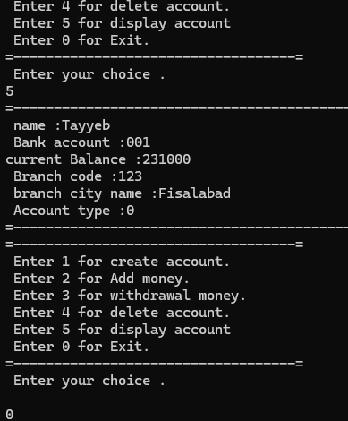
Question no 2
#include<iostream>
#include<string>
using namespace std;
class Time {
private:
int hours;
int min;
int sec;
public:
Time()
{
hours = 0;
min = 0;
sec = 0;
}
Time(int h, int m, int s)
{
hours = h;
min = m;
sec = s;
}
void add(Time t1,Time t2)
{
sec = t1.sec + t2.sec;

min = t1.min + t2.min;
hours = t1.hours + t2.hours;
if (sec >= 60)
{
min =min+ sec / 60;
sec =sec % 60;
}

if (min >= 60)
{
hours = hours+min / 60;
min = min% 60;
}

}

void show()
{
cout << " Time " << endl;
cout << hours << ":" << min << ":" << sec << endl;
}

};

int main()
{

Time t1(2, 34, 43);
Time t2(12, 23, 45);

Time t3;
t3.add(t1,t2);
t3.show();

}
Output;
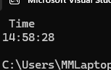
Question no 4;
#include<iostream>
#include<string>
using namespace std;
class toolboth
{
static unsigned int totalcar;
static double totalamount;

public:

toolboth()
{
totalamount = 0;
totalcar = 0;

}
void payingcar()
{
totalcar++;
totalamount = totalamount + 50;
}
void nopaycar()
{
totalcar++;
}

void display() const
{
cout <<"Total car :" << totalcar << endl;
cout << "Total amount :" << totalamount << endl;
}
};
double toolboth::totalamount = 0;
unsigned int toolboth::totalcar = 0;
int main()
{
toolboth b;
int choice;

do
{
cout << " enter the 1 for paying car:" << endl;
cout << " enter the 2 for no paying car:" << endl;
cout << " enter the 3 for check detail :" << endl;
cout << " enter the 0 for Exist :" << endl;

cout << " enter your choices :" << endl;
cin >> choice;
switch (choice)
{
case 1:
{
b.payingcar();
break;

}
case 2:
{
b.nopaycar();
break;
}
case 3:
{
b.display();
break;

}

default:
{
cout << " Invalide choice " << endl;
}

}

} while (choice != 0);

}
Output;
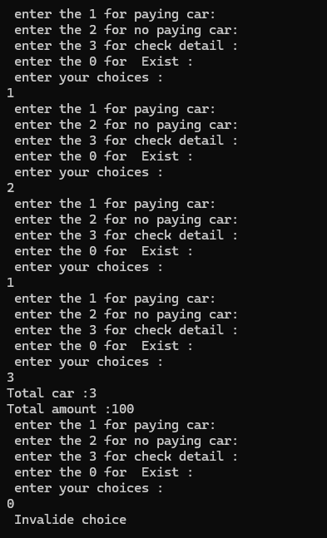
Question no 2;
#include<iostream>
#include<string>
using namespace std;
class dogname {
private:
int id;
int sold;
public:
static int totaldog;
dogname()
{
id = 0;
sold=0;
}
dogname(int id, int sold)
{
this->id = id;
this->sold = sold;
totaldog += sold;

}
void justsold()
{
sold++;
totaldog++;
}
int getsold()
{
return sold;
}
static int total()
{
return totaldog;
}
};

int dogname::totaldog = 0;
int main()
{
dogname d1(1, 6);
dogname d2(2, 4);
dogname d3(3,8);
d1.justsold();
d2.justsold();
d2.justsold();
d3.justsold();

cout << " sold dog day 1 :" << d1.getsold() << endl;
cout << " sold dog day 2 :" << d2.getsold() << endl;
cout << " sold dog day 3 :" << d3.getsold()<<endl;

cout << " TOtal dog sale all days :" << dogname::total() << endl;

}
Output;
