Object Oriented Programming
Name: Ali Sher
Roll no: 25F-0050
Section: 2B-BSAI
Question 1:
#include<iostream>
#include<string>
#include<fstream>
using namespace std;
enum Type { current, savings };
class BankAccount {
private:
char nameofdepositor[20];
char accountnumber[20];
Type type;
double balanceamount;
static char bankname[20];
char branchcode[20];
char city[20];
public:
static unsigned int currentcount;
static unsigned int savingscount;
BankAccount()
{
strcpy(nameofdepositor, "unknown");
strcpy(accountnumber, "unknown");
type = current;
balanceamount = 0.0;
strcpy(branchcode, "unknown");
strcpy(city, "unknown");
}
BankAccount(char name[], char accno[], Type t, double balance, char bcode[], char c[])
{
strcpy(nameofdepositor, name);
strcpy(accountnumber, accno);
type = t;
balanceamount = balance;
strcpy(branchcode, bcode);
strcpy(city, c);
}
static void setAccCounts(char bname[])
{
strcpy(bankname, bname);
}
static char* getbankname()
{
return bankname;
}
void deposit(int depo)
{
balanceamount = balanceamount + depo;
}
char* getnameofsepositor()
{
return nameofdepositor;
}
void setnameofdepositor(char n[])
{
strcpy(nameofdepositor, n);
}
char* getaccountnumber()
{
return accountnumber;
}
void setaccountnumber(char acc[])
{
strcpy(accountnumber, acc);
}
Type getaccountytpe()
{
return type;
}
void setaccounttype(Type ty)
{
type = ty;
}
double getbalanceamount()
{
return balanceamount;
}
void setbalanceamount(double b)
{
balanceamount = b;
}
void setbranchcode(char bc[])
{
strcpy(branchcode, bc);
}
char* getbranchcode()
{
return branchcode;
}
void setcity(char ci[])
{
strcpy(city, ci);
}
char* getcity()
{
return city;
}
void withdraw(int w)
{
cout << "Checking the balance...." << endl;
cout << "Balance: " << balanceamount << endl;
if (balanceamount - w > 0)
balanceamount = balanceamount - w;
else
cout << "Insufficient balance: amount withdrawn is greater than balance" << endl;
cout << endl;
}
void display()
{
cout << "Bank Account Details: " << endl;
cout << "Name of depositor: " << nameofdepositor << endl;
cout << "Bank name: " << bankname << endl;
cout << "City: " << city << endl;
cout << "Account balance: " << balanceamount << endl;
cout << endl;
}
};
char BankAccount::bankname[20] = "HBL";
unsigned int BankAccount::currentcount = 0;
unsigned int BankAccount::savingscount = 0;
int main()
{
BankAccount* b[100];
int x;
int i = 0;
int arr[100];
int a = 1;
do
{
cout << "Menu: " << endl;
cout << "Enter 1 to create an account " << endl;
cout << "Enter 2 to deposit an amount " << endl;
cout << "Enter 3 to withdraw an amount " << endl;
cout << "Enter 4 to display account information" << endl;
cout << "Enter 5 to save the information in a file" << endl;
cout << "Enter 6 to delete an account " << endl;
cout << "Enter 7 to continue or exit" << endl;
cout << "Enter a number (1-8): ";
cin >> x;
cin.ignore();
cout << endl;
switch (x)
{
case 1:
{
b[i] = new BankAccount;
char na[20];
char acc[20];
Type ty;
int y;
double bal;
char bcode[20];
char ci[20];
cout << "Enter name of depositor: ";
cin.getline(na, 20);
b[i]->setnameofdepositor(na);
cout << "Enter account number: ";
cin.getline(acc, 20);
b[i]->setaccountnumber(acc);
cout << "Enter account type (current = 0 or savings = 1): ";
cin >> y;
ty = (Type)y;
b[i]->setaccounttype(ty);
cout << "Enter balance amount: ";
cin >> bal;
b[i]->setbalanceamount(bal);
cout << "Enter branchcode: ";
cin.ignore();
cin.getline(bcode, 20);
b[i]->setbranchcode(bcode);
cout << "Enter city: ";
cin.getline(ci, 20);
b[i]->setcity(ci);
i++;
break;
}
case 2:
{
int depo, n;
cout << "Enter the account number you want to deposit the amount in (1-100): ";
cin >> n;
cout << "Enter the deposit amount: ";
cin >> depo;
b[n - 1]->deposit(depo);
break;
}
case 3:
{
int w, n;
cout << "Enter the account number you want to withdraw amount from (1-100): ";
cin >> n;
cout << "Enter the withdraw amount: ";
cin >> w;
b[n - 1]->withdraw(w);
break;
}
case 4:
{
int n;
cout << "Enter the account number you want to display information of: ";
cin >> n;
b[n - 1]->display();
break;
}
case 5:
{
fstream file;
file.open("accounts.txt", ios::out);
if (!file)
cout << "accounts.txt not opened" << endl << endl;
else
{
for (int k = 0; k < i; k++)
{
file << b[k]->getnameofsepositor() << endl;
file << b[k]->getaccountnumber() << endl;
file << b[k]->getaccountytpe() << endl;
file << b[k]->getbalanceamount() << endl;
file << b[k]->getbranchcode() << endl;
file << b[k]->getcity() << endl;
}
}
file.close();
break;
}
case 6:
{
int n;
cout << "Enter account number you want to delete: ";
cin >> n;
if (n - 1 == i - 1)
{
delete b[n - 1];
i--;
}
else
{
for (; n < i; n++)
{
b[n - 1] = b[n];
}
delete b[i - 1];
i--;
}
break;
}
case 7:
{
cout << "Enter 1 if you want to continue 0 to exit: ";
cin >> a;
cout << "Exiting... " << endl << endl;
fstream file;
file.open("accounts.txt", ios::out);
if (!file)
cout << "accounts.txt not opened" << endl << endl;
else
{
for (int k = 0; k < i; k++)
{
file << b[k]->getnameofsepositor() << endl;
file << b[k]->getaccountnumber() << endl;
file << b[k]->getaccountytpe() << endl;
file << b[k]->getbalanceamount() << endl;
file << b[k]->getbranchcode() << endl;
file << b[k]->getcity() << endl;
}
}
file.close();
break;
}
}
}while (a);
}
Output:
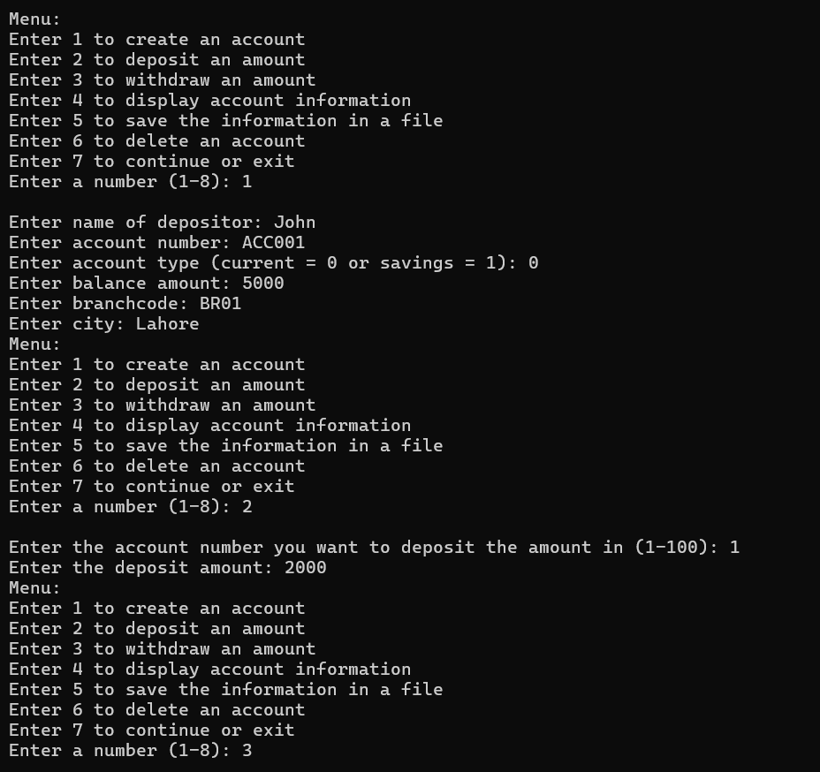
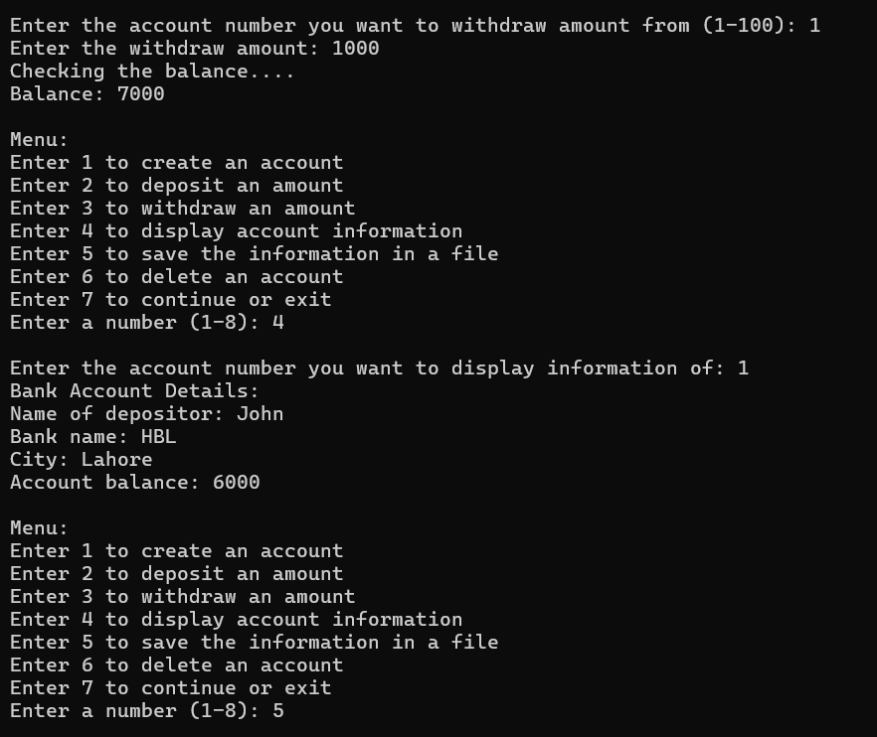
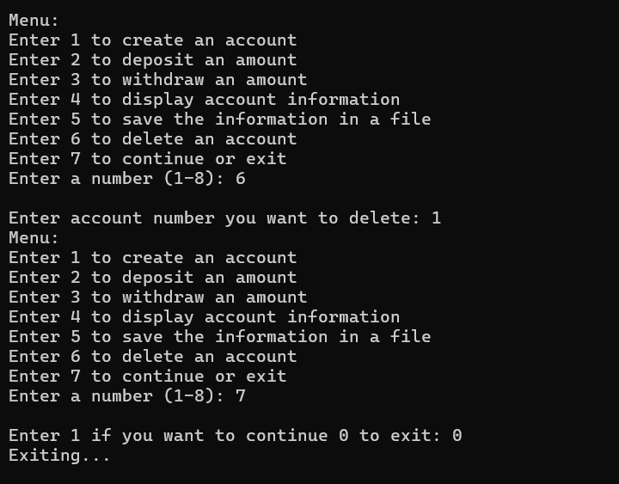
Question 2:
#include<iostream>
using namespace std;
class HotDogStand {
private:
int id;
int nohd;
static int total;
public:
HotDogStand()
{
id = 0;
nohd = 0;
}
void setdata(int i, int n)
{
id = i;
nohd = n;
total = total + nohd;
}
void justsold()
{
nohd++;
total++;
}
static int gettotalhotdogs()
{
return total;
}
void display()
{
cout << "Hot Dog ID: " << id << endl;
cout << "Number of hot dogs sold in one day: " << nohd << endl;
}
};
int HotDogStand::total = 0;
int main()
{
HotDogStand obj[3];
for (int j = 0; j < 3; j++)
{
int i, n;
cout << "Enter ID for hot dog " << j + 1 << ": ";
cin >> i;
cout << "Enter number of hot dogs sold in one day for hot dog " << j + 1 << ": ";
cin >> n;
obj[j].setdata(i, n);
obj[j].justsold();
}
for (int k = 0; k < 3; k++)
{
obj[k].display();
}
cout << "Total number of hot dogs sold: " << HotDogStand::gettotalhotdogs() << endl;
}
Output:
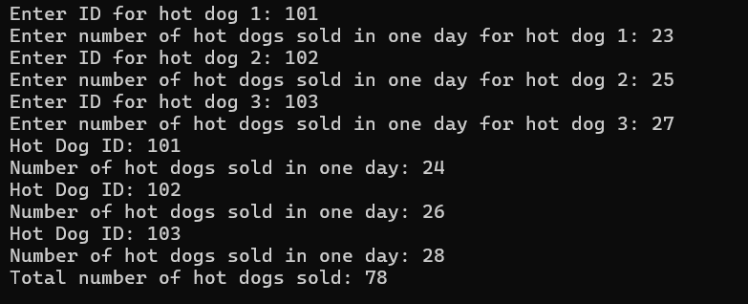
Question 4:
#include<iostream>
using namespace std;
class tollbooth {
private:
unsigned int totalnumberofcars;
double totalamountofmoney;
public:
tollbooth()
{
totalamountofmoney = 0;
totalnumberofcars = 0;
}
void payingcar()
{
totalnumberofcars++;
totalamountofmoney = totalamountofmoney + 50;
}
void nopaycar()
{
totalnumberofcars++;
totalamountofmoney = totalamountofmoney + 0;
}
void display()
{
cout << "Total number of cars: " << totalnumberofcars << endl;
cout << "Total amount of money: " << totalamountofmoney << endl;
}
};
int main()
{
tollbooth t;
int choice;
do
{
cout << "Enter 1 to count a paying car" << endl;
cout << "Enter 2 to count a nonpaying car" << endl;
cout << "Enter 3 to print the total cash and total cars" << endl;
cout << "Enter 0 to exit" << endl;
cout << "Enter a number (0-3)" << endl;
cin >> choice;
switch (choice)
{
case 1:
t.payingcar();
break;
case 2:
t.nopaycar();
break;
case 3:
t.display();
break;
}
} while (choice);
}
Output:
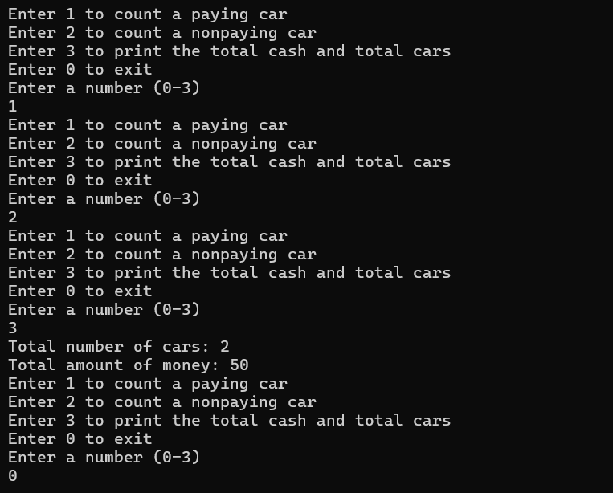
Question 5:
#include<iostream>
using namespace std;
class Time {
private:
int hours;
int minutes;
int seconds;
public:
Time()
{
hours = 0;
minutes = 0;
seconds = 0;
}
Time(int h, int m, int s)
{
hours = h;
minutes = m;
seconds = s;
}
void add(Time t1,Time t2)
{
hours = t1.hours + t2.hours;
minutes = t1.minutes + t1.minutes;
seconds = t1.seconds + t1.seconds;
}
void display() const
{
cout << hours << ":" << minutes << ":" << seconds;
}
};
int main()
{
Time t3;
Time t1(12, 34, 56);
Time t2(6, 23, 34);
t3.add(t1, t2);
t3.display();
}
Output:

