OOP ASSIGNMENT 3
TASK 1:
Code:
#include<iostream>
#include<cstring>
#include<fstream>
using namespace std;
enum AccType { Current, Saving };
class Account
{
private:
char DPName[100];
char AccNum[100];
AccType AccountType;
double balance;
char Bname[100];
char Bcode[100];
char city[100];
static unsigned int CurrCount;
static unsigned int SavCount;
public:
Account()
{
DPName[0] = '\0';
AccNum[0] = '\0';
Bname[0] = '\0';
Bcode[0] = '\0';
city[0] = '\0';
balance = 0;
}
Account(const char* name, const char* accNum, AccType type,
double bal, const char* bankName, const char* bankCode,
const char* cityName, bool incrementCounter = true)
{
strcpy_s(DPName, name);
strcpy_s(AccNum, accNum);
AccountType = type;
balance = bal;
strcpy_s(Bname, bankName);
strcpy_s(Bcode, bankCode);
strcpy_s(city, cityName);
if (incrementCounter)
{
if (type == Current)
{
CurrCount++;
}
else
{
SavCount++;
}
}
}
const char* get_Bank()
{
return Bname;
}
const char* get_Code()
{
return Bcode;
}
const char* get_City()
{
return city;
}
void set_Balance(double b)
{
balance = b;
}
void deposit(double amount)
{
if (amount > 0)
{
balance += amount;
}
}
void withdraw(double amount)
{
if (amount <= balance)
{
balance -= amount;
}
else
{
cout << "Insufficient Balance"<<endl;
}
}
const char* get_AccNum()
{
return AccNum;
}
const char* get_Name()
{
return DPName;
}
double get_Balance()
{
return balance;
}
AccType get_Type()
{
return AccountType;
}
void display()
{
cout << endl;
cout << "-----ACCOUNT DETAILS-----"<<endl;
cout << "Name: " << DPName << endl;
cout << "Account Number: " << AccNum << endl;
cout << "Type: " << (AccountType == Current ? "Current" : "Saving") << endl;
cout << "Balance: " << balance << endl;
cout << "Bank: " << Bname << endl;
cout << "City: " << city << endl;
cout << "---------------------------" << endl;
}
static void getAccCounts()
{
cout << "Current Accounts: " << CurrCount << endl;
cout << "Saving Accounts: " << SavCount << endl;
}
};
unsigned int Account::CurrCount = 0;
unsigned int Account::SavCount = 0;
int main()
{
Account* arr[100];
int count = 0;
ifstream inFile("accounts.txt");
char name[100], accNum[100], bank[100], code[100], city[100];
int type;
double bal;
while (inFile.getline(name, 100, ','))
{
if (strlen(name) == 0) continue;
if (!inFile.getline(accNum, 100, ',')) break;
if (!(inFile >> type)) break;
inFile.ignore();
if (!(inFile >> bal)) break;
inFile.ignore();
if (!inFile.getline(bank, 100, ',')) break;
if (!inFile.getline(code, 100, ',')) break;
if (!inFile.getline(city, 100)) break;

arr[count] = new Account(name, accNum,
(type == 0 ? Current : Saving), bal, bank, code, city, true);
count++;
}
inFile.close();
int choice;
do
{
cout << endl;
cout << "1. Create Account"<<endl;
cout << "2. Display All" << endl;
cout << "3. Delete" << endl;
cout << "4. Deposit "<< endl;
cout << "5. Withdraw" << endl;
cout << "6. Show Counts "<< endl;
cout << "7. Exit" << endl;
cout << "Enter choice: ";
cin >> choice;
if (choice > 7 || choice < 1)
{
cout << "Wrong Choice(1-7).Enter Again: ";
cin >> choice;
}
cin.ignore();
if (choice == 1)
{
char name[100], accNum[100], bank[100], code[100], city[100];
int type;
double bal;
cout << "Enter Name: ";
cin.getline(name, 100);
cout << "Enter Account Number: ";
cin.getline(accNum, 100);
cout << "Enter Type (0 Current, 1 Saving): ";
cin >> type;
if (type != 0 && type != 1)
{
cout << "Invalid Type. Enter 0 or 1:";
cin >> type;
}
cout << "Enter Balance: ";
cin >> bal;
cin.ignore();
cout << "Enter Bank Name: ";
cin.getline(bank, 100);
cout << "Enter Bank Code: ";
cin.getline(code, 100);
cout << "Enter City: ";
cin.getline(city, 100);
arr[count] = new Account(name, accNum,
(type == 0 ? Current : Saving), bal, bank, code, city);
count++;
}
else if (choice == 2)
{
if (count == 0)
{
cout << "No Account Stored" << endl;
}
else
{
for (int i = 0; i < count; i++)
{
arr[i]->display();
}
}
}
else if (choice == 3)
{
char delAcc[100];
if (count == 0)
{
cout << "No Account Stored" << endl;
}
else
{
cout << "Enter Account number to delete: ";
cin.getline(delAcc, 100);
for (int i = 0; i < count; i++)
{
if (strcmp(arr[i]->get_AccNum(), delAcc) == 0)
{
delete arr[i];
for (int j = i; j < count - 1; j++)
{
arr[j] = arr[j + 1];
}
count--;
cout << "Account Deleted" << endl;
break;
}
}
}
}
else if (choice == 4)
{
char acc[100];
double amt;
if (count == 0)
{
cout << "No Account Stored" << endl;
}
else
{
cout << "Enter Account Number: ";
cin.getline(acc, 100);
cout << "Enter Amount: ";
cin >> amt;
cin.ignore();
for (int i = 0; i < count; i++)
{
if (strcmp(arr[i]->get_AccNum(), acc) == 0)
{
arr[i]->deposit(amt);
}
}
}
}
else if (choice == 5)
{
char acc[100];
double amt;
if (count == 0)
{
cout << "No Account Stored" << endl;
}
else
{
cout << "Enter Account Number: ";
cin.getline(acc, 100);
cout << "Enter Amount: ";
cin >> amt;
cin.ignore();
for (int i = 0; i < count; i++)
{
if (strcmp(arr[i]->get_AccNum(), acc) == 0)
{
arr[i]->withdraw(amt);
}
}
}
}
else if (choice == 6)
{
Account::getAccCounts();
}
} while (choice != 7);
ofstream outFile("accounts.txt");
for (int i = 0; i < count; i++)
{
outFile << arr[i]->get_Name() << ","
<< arr[i]->get_AccNum() << ","
<< (arr[i]->get_Type() == Current ? 0 : 1) << ","
<< arr[i]->get_Balance() << ","
<< arr[i]->get_Bank() << ","
<< arr[i]->get_Code() << ","
<< arr[i]->get_City() << endl;
}
outFile.close();
for (int i = 0; i < count; i++)
{
delete arr[i];
}
return 0;
}
OUTPUT:
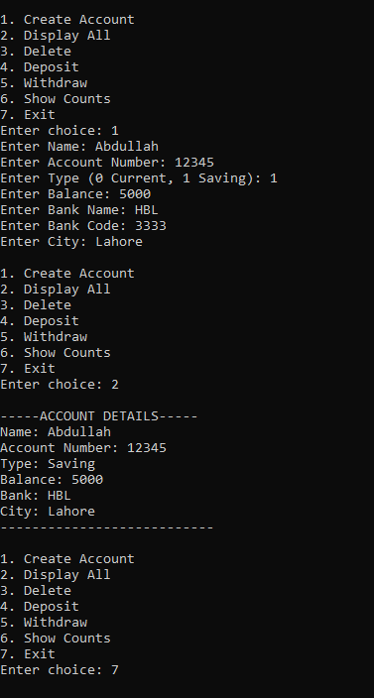
TASK 2:
CODE:
#include<iostream>
#include<string>
using namespace std;
class HotDogStand
{
private:
int hsID;
int hCount;
static int totalHdogs;
public:
HotDogStand(int id, int hcount)
{
hsID = id;
hCount = hcount;
totalHdogs += hcount;
}
int get_hsID()
{
return hsID;
}
void justSold()
{
hCount++;
totalHdogs++;
}
int get_hsCount()
{
return hCount;
}
static int get_totalHdogs()
{
return totalHdogs;
}
};
int HotDogStand::totalHdogs = 0;
int main()
{
HotDogStand s1(1, 0);
HotDogStand s2(2, 0);
HotDogStand s3(3, 0);
s1.justSold();
s1.justSold();
s2.justSold();
s3.justSold();
s3.justSold();
s3.justSold();
cout << "Stand 1 sold: " << s1.get_hsCount() << endl;
cout << "Stand 2 sold: " << s2.get_hsCount() << endl;
cout << "Stand 3 sold: " << s3.get_hsCount() << endl;
cout << "Total hotdogs sold: " << HotDogStand::get_totalHdogs() << endl;
}

OUTPUT:
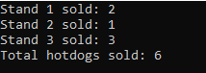
TASK 3:
CODE:
#include<iostream>
#include<string>
#include<fstream>
using namespace std;
struct Students
{
string name;
string CNIC;
string gender;
float CGPA;
};
class section
{
private:
Students arr[40];
string Section_name;
string Class_teacher;
int studentCount;
public:
section()
{
studentCount = 0;
Section_name = "N/A";
Class_teacher = "N/A";
}
void editSection()
{
cin.ignore();
cout << "Enter Section Name: ";
getline(cin, Section_name);
cout << "Enter Class Teacher Name: ";
getline(cin, Class_teacher);
}
void addStudent()
{
if (studentCount >= 40)
{
cout << "Section Full" << endl;
return;
}
cin.ignore();
cout << "Enter Name: ";
getline(cin, arr[studentCount].name);
cout << "Enter CNIC: ";
getline(cin, arr[studentCount].CNIC);
cout << "Enter Gender: ";
getline(cin, arr[studentCount].gender);
cout << "Enter CGPA: ";
cin >> arr[studentCount].CGPA;
studentCount++;
}
void updateStudent()
{
string searchName;
cin.ignore();
cout << "Enter student name to update: ";
getline(cin, searchName);
for (int i = 0; i < studentCount; i++)
{
if (arr[i].name == searchName)
{
cout << "Enter New CGPA: ";
cin >> arr[i].CGPA;
cout << "Updated Successfully!" << endl;
return;
}
}
cout << "Student not found" << endl;
}
void printList()
{
cout << endl;
cout << "--------SECTION DETAILS-------" << endl;
cout << "Section: " << Section_name << endl;
cout << "Teacher: " << Class_teacher << endl;
for (int i = 0; i < studentCount; i++)
{
cout << "-----STUDENT DETAILS-------" << endl;
cout << "Student " << i + 1 << endl;
cout << "Name: " << arr[i].name << endl;
cout << "CNIC: " << arr[i].CNIC << endl;
cout << "Gender: " << arr[i].gender << endl;
cout << "CGPA: " << arr[i].CGPA << endl;
cout << "-----------------------------" << endl;
}
cout << "--------------------------------" << endl;
}
void writeString(ofstream& out, const string& str)
{
size_t len = str.size();
out.write((char*)&len, sizeof(len));
out.write(str.c_str(), len);
}
void readString(ifstream& in, string& str)
{
size_t len;
in.read((char*)&len, sizeof(len));
char* buffer = new char[len + 1];
in.read(buffer, len);
buffer[len] = '\0';
str = buffer;
delete[] buffer;
}
void save(ofstream& outFile)
{
outFile.write((char*)&studentCount, sizeof(studentCount));
writeString(outFile, Section_name);
writeString(outFile, Class_teacher);
for (int i = 0; i < studentCount; i++)
{
writeString(outFile, arr[i].name);
writeString(outFile, arr[i].CNIC);
writeString(outFile, arr[i].gender);
outFile.write((char*)&arr[i].CGPA, sizeof(arr[i].CGPA));
}
}

void load(ifstream& inFile)
{
inFile.read((char*)&studentCount, sizeof(studentCount));
readString(inFile, Section_name);
readString(inFile, Class_teacher);
for (int i = 0; i < studentCount; i++)
{
readString(inFile, arr[i].name);
readString(inFile, arr[i].CNIC);
readString(inFile, arr[i].gender);
inFile.read((char*)&arr[i].CGPA, sizeof(arr[i].CGPA));
}
}
};
int main()
{
section* ptr;
int num;
ifstream inFile("sections.dat", ios::binary);
if (inFile)
{
inFile.read((char*)&num, sizeof(num));
ptr = new section[num];
for (int i = 0; i < num; i++)
{
ptr[i].load(inFile);
}
inFile.close();
cout << "Loaded " << num << " sections from file." << endl;
}
else
{
cout << "Enter Number of sections you want to create: ";
cin >> num;
ptr = new section[num];
}
int choice, Index;
do
{
cout << endl;
cout << "1. Edit Section" << endl;
cout << "2. Add Student" << endl;
cout << "3. Update Student" << endl;
cout << "4. Print Students" << endl;
cout << "5. Print All Sections" << endl;
cout << "6. Exit" << endl;
cout << "Enter choice: ";
cin >> choice;
if (choice >= 1 && choice <= 5)
{
cout << "Enter section index (0 to " << num - 1 << "): ";
cin >> Index;
if (Index > num - 1 || Index < 0)
{
cout << "Invalid Index. Enter again: ";
cin >> Index;
}
}
switch (choice)
{
case 1:
ptr[Index].editSection();
break;
case 2:
ptr[Index].addStudent();
break;
case 3:
ptr[Index].updateStudent();
break;
case 4:
ptr[Index].printList();
break;
case 5:
for (int i = 0; i < num; i++)
{
cout << "Section Index: " << i << endl;
ptr[i].printList();
}
break;
case 6:
cout << "Exit" << endl;
break;
default:
cout << "Invalid choice!" << endl;
}
} while (choice != 6);
ofstream outFile("sections.dat", ios::binary);
outFile.write((char*)&num, sizeof(num));
for (int i = 0; i < num; i++)
{
ptr[i].save(outFile);
}
outFile.close();
delete[] ptr;
}
OUTPUT:
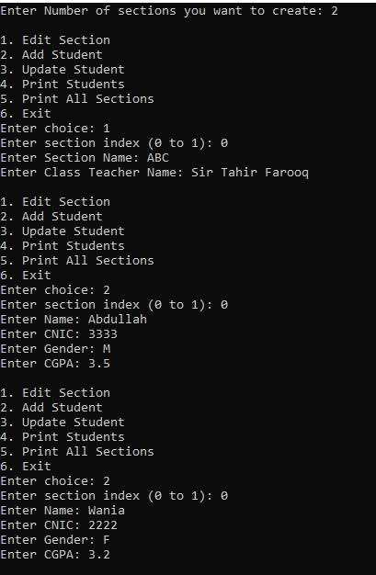
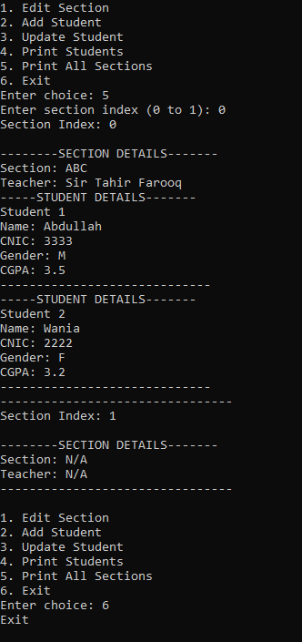
TASK 4:
CODE:
#include<iostream>
#include<string>
using namespace std;
class tollbooth
{
private:
unsigned int CarCount;
double PayCars;
public:
tollbooth()
{
CarCount = 0;
PayCars = 0;
}
void payingCar()
{
PayCars += 50;
CarCount++;
}
void noPayCar()
{
CarCount++;
}
void display() const
{
cout << endl;
cout << "------TOLLBOOTH DETAILS-------" << endl;
cout << "Total Number Of Cars: " << CarCount << endl;
cout << "Total Cash Collected: " << PayCars << endl;
cout << "-------------------------------" << endl;
}
};
int main()
{
tollbooth t;
int choice;

do
{
cout << endl;
cout << "1. Paying Car" << endl;
cout << "2. Non-Paying Car" << endl;
cout << "3. Display" << endl;
cout << "4. Exit" << endl;
cout << "Enter your choice: ";
cin >> choice;

switch (choice)
{
case 1:
t.payingCar();
break;

case 2:
t.noPayCar();
break;

case 3:
t.display();
break;

case 4:
cout << "Exiting program..." << endl;
break;

default:
cout << "Invalid choice!" << endl;
}

} while (choice != 4);
}
OUTPUT:
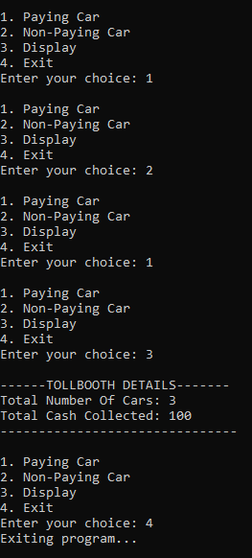
TASK 5:
CODE:
#include<iostream>
#include<string>
using namespace std;
class Time
{
private:
int hours;
int min;
int sec;
public:
Time()
{
hours = 0;
min = 0;
sec = 0;
}
Time(int h, int m, int s)
{
hours = h;
min = m;
sec = s;
}
void display() const
{
cout << endl;
cout << "-----------TIME---------" << endl;
cout << hours << ":"
<< (min < 10 ? "0" : "") << min << ":"
<< (sec < 10 ? "0" : "") << sec << endl;
cout << "------------------------" << endl;
}
void add(const Time& t1, const Time& t2)
{
sec = t1.sec + t2.sec;
min = t1.min + t2.min + sec / 60;
sec = sec % 60;
hours = t1.hours + t2.hours + min / 60;
min = min % 60;
}
};
int main()
{
const Time t1(2, 45, 50);
const Time t2(3, 20, 30);
Time t3;
t3.add(t1, t2);
t3.display();
}
OUTPUT:


