ASSIGNMENT 3

CODE 1:
#include<iostream>
#include<cstring>
#include<fstream>
using namespace std;
enum AccType { CURRENT, SAVING };
class BankAcc
{
private:
char name[100];
char accNo[100];
AccType type;
double balance;
char bank[100];
char code[100];
char city[100];
static unsigned int currCount;
static unsigned int savCount;
public:
BankAcc()
{
name[0] = '\0';
accNo[0] = '\0';
bank[0] = '\0';
code[0] = '\0';
city[0] = '\0';
balance = 0;
}
BankAcc(const char* n, const char* a, AccType t,
double b, const char* bk, const char* c, const char* ct, bool inc = true)
{
strcpy_s(name, n);
strcpy_s(accNo, a);
type = t;
balance = b;
strcpy_s(bank, bk);
strcpy_s(code, c);
strcpy_s(city, ct);
if (inc)
{
if (t == CURRENT)
{
currCount++;
}
else
{
savCount++;
}
}
}
const char* getName()
{
return name;
}
const char* getAccNo()
{
return accNo;
}
const char* getBank()
{
return bank;
}
const char* getCode()
{
return code;
}
const char* getCity()
{
return city;
}
double getBal()
{
return balance;
}
AccType getType()
{
return type;
}
void setBal(double b)
{
balance = b;
}
void deposit(double amt)
{
if (amt > 0)
balance += amt;
}
void withdraw(double amt)
{
if (amt <= balance)
balance -= amt;
else
cout << "Low balance\n";
}
void show()
{
cout << "\nName: " << name << endl;
cout << "Bank: " << bank << endl;
cout << "City: " << city << endl;
cout << "Balance: " << balance << endl;
}
static void getAccCounts()
{
cout << "Current = " << currCount << endl;
cout << "Saving = " << savCount << endl;
}
};
unsigned int BankAcc::currCount = 0;
unsigned int BankAcc::savCount = 0;
int main()
{
BankAcc* list[100];
int total = 0;
ifstream fin("accounts.txt");
char name[100], acc[100], bank[100], code[100], city[100];
int t;
double bal;
while (fin.getline(name, 100, ','))
{
if (strlen(name) == 0) continue;
fin.getline(acc, 100, ',');
fin >> t;
fin.ignore();
fin >> bal;
fin.ignore();
fin.getline(bank, 100, ',');
fin.getline(code, 100, ',');
fin.getline(city, 100);
list[total++] = new BankAcc(name, acc,
(t == 0 ? CURRENT : SAVING), bal, bank, code, city, true);
}
fin.close();
int ch;
do
{
cout << "\n1. New Account\n";
cout << "2. Show All\n";
cout << "3. Delete\n";
cout << "4. Deposit\n";
cout << "5. Withdraw\n";
cout << "6. Counts\n";
cout << "7. Exit\n";
cout << "Enter: ";
cin >> ch;
cin.ignore();
if (ch == 1)
{
cout << "Enter name: ";
cin.getline(name, 100);
cout << "Enter acc no: ";
cin.getline(acc, 100);
cout << "Enter type (0 current, 1 saving): ";
cin >> t;
cout << "Enter balance: ";
cin >> bal;
cin.ignore();
cout << "Enter bank: ";
cin.getline(bank, 100);
cout << "Enter code: ";
cin.getline(code, 100);
cout << "Enter city: ";
cin.getline(city, 100);
list[total++] = new BankAcc(name, acc,
(t == 0 ? CURRENT : SAVING), bal, bank, code, city);
}
else if (ch == 2)
{
if (total == 0)
{
cout << "No data\n";
}
else
{
for (int i = 0; i < total; i++)
{
list[i]->show();
}
}
}
else if (ch == 3)
{
char del[100];
cout << "Enter acc no: ";
cin.getline(del, 100);
for (int i = 0; i < total; i++)
{
if (strcmp(list[i]->getAccNo(), del) == 0)
{
delete list[i];

for (int j = i; j < total - 1; j++)
{
list[j] = list[j + 1];
}
total--;
cout << "Deleted\n";
break;
}
}
}
else if (ch == 4)
{
char a[100];
double amt;
cout << "Enter acc no: ";
cin.getline(a, 100);
cout << "Enter amount: ";
cin >> amt;
cin.ignore();
for (int i = 0; i < total; i++)
{
if (strcmp(list[i]->getAccNo(), a) == 0)
{
list[i]->deposit(amt);
}
}
}
else if (ch == 5)
{
char a[100];
double amt;
cout << "Enter acc no: ";
cin.getline(a, 100);
cout << "Enter amount: ";
cin >> amt;
cin.ignore();

for (int i = 0; i < total; i++)
if (strcmp(list[i]->getAccNo(), a) == 0)
list[i]->withdraw(amt);
}
else if (ch == 6)
{
BankAcc::getAccCounts();
}

} while (ch != 7);
ofstream fout("accounts.txt");
for (int i = 0; i < total; i++)
{
fout << list[i]->getName() << ","
<< list[i]->getAccNo() << ","
<< (list[i]->getType() == CURRENT ? 0 : 1) << ","
<< list[i]->getBal() << ","
<< list[i]->getBank() << ","
<< list[i]->getCode() << ","
<< list[i]->getCity() << endl;
}
fout.close();
for (int i = 0; i < total; i++)
{
delete list[i];
}
return 0;
}
OUTPUT:
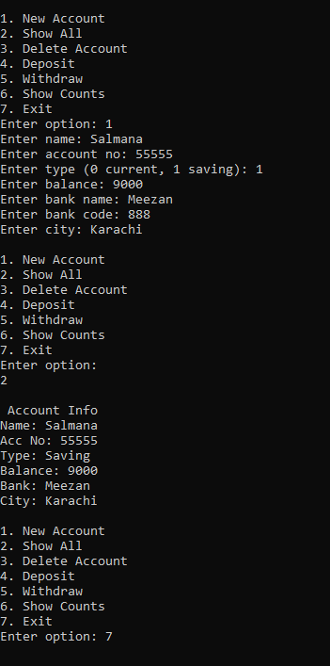
CODE 2:
#include<iostream>
#include<string>
using namespace std;
class Stall
{
private:
int id;
int sold;
static int totalSold;
public:
Stall(int i, int s)
{
id = i;
sold = s;
totalSold += s;
}
int getID()
{
return id;
}
void sell()
{
sold++;
totalSold++;
}
int getSold()
{
return sold;
}
static int getTotal()
{
return totalSold;
}
};
int Stall::totalSold = 0;
int main()
{
Stall s1(101, 2);
Stall s2(102, 1);
Stall s3(103, 3);
s1.sell();
s1.sell();
s2.sell();
s3.sell();
s3.sell();
s3.sell();
cout << "Stall 1 sold = " << s1.getSold() << endl;
cout << "Stall 2 sold = " << s2.getSold() << endl;
cout << "Stall 3 sold = " << s3.getSold() << endl;
cout << "Total sold = " << Stall::getTotal() << endl;
return 0;
}
OUTPUT:
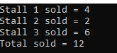
CODE 3:
#include<iostream>
#include<string>
#include<fstream>
using namespace std;
struct Student
{
string name;
string cnic;
string gender;
float cgpa;
};
class Section
{
private:
Student list[40];
string secName;
string teacher;
int count;
public:
Section()
{
count = 0;
secName = "N/A";
teacher = "N/A";
}
void editSection()
{
cin.ignore();
cout << "Enter section name: ";
getline(cin, secName);
cout << "Enter teacher: ";
getline(cin, teacher);
}
void addStudent()
{
if (count >= 40)
{
cout << "Section full\n";
return;
}
cin.ignore();
cout << "Enter name: ";
getline(cin, list[count].name);
cout << "Enter CNIC: ";
getline(cin, list[count].cnic);
cout << "Enter gender: ";
getline(cin, list[count].gender);
cout << "Enter CGPA: ";
cin >> list[count].cgpa;
count++;
}
void updateStudent()
{
string name;
cin.ignore();
cout << "Enter name to update: ";
getline(cin, name);
for (int i = 0; i < count; i++)
{
if (list[i].name == name)
{
cout << "Enter new CGPA: ";
cin >> list[i].cgpa;

cout << "Updated\n";
return;
}
}
cout << "Not found\n";
}
void printList()
{
cout << "\nSection: " << secName << endl;
cout << "Teacher: " << teacher << endl;
for (int i = 0; i < count; i++)
{
cout << "\nStudent " << i + 1 << endl;
cout << "Name: " << list[i].name << endl;
cout << "CNIC: " << list[i].cnic << endl;
cout << "Gender: " << list[i].gender << endl;
cout << "CGPA: " << list[i].cgpa << endl;
}
cout << "------------------\n";
}
void writeStr(ofstream& out, const string& s)
{
size_t len = s.size();
out.write((char*)&len, sizeof(len));
out.write(s.c_str(), len);
}
void readStr(ifstream& in, string& s)
{
size_t len;
in.read((char*)&len, sizeof(len));
char* temp = new char[len + 1];
in.read(temp, len);
temp[len] = '\0';
s = temp;
delete[] temp;
}
void save(ofstream& fout)
{
fout.write((char*)&count, sizeof(count));
writeStr(fout, secName);
writeStr(fout, teacher);
for (int i = 0; i < count; i++)
{
writeStr(fout, list[i].name);
writeStr(fout, list[i].cnic);
writeStr(fout, list[i].gender);
fout.write((char*)&list[i].cgpa, sizeof(list[i].cgpa));
}
}
void load(ifstream& fin)
{
fin.read((char*)&count, sizeof(count));
readStr(fin, secName);
readStr(fin, teacher);
for (int i = 0; i < count; i++)
{
readStr(fin, list[i].name);
readStr(fin, list[i].cnic);
readStr(fin, list[i].gender);
fin.read((char*)&list[i].cgpa, sizeof(list[i].cgpa));
}
}
};
int main()
{
Section* sec;
int n;
ifstream fin("sections.dat", ios::binary);
if (fin)
{
fin.read((char*)&n, sizeof(n));
sec = new Section[n];
for (int i = 0; i < n; i++)
{
sec[i].load(fin);
}
fin.close();
cout << "Data loaded: " << n << " sections\n";
}
else
{
cout << "Enter number of sections: ";
cin >> n;
sec = new Section[n];
}
int choice, idx;
do
{
cout << "\n1. Edit Section\n";
cout << "2. Add Student\n";
cout << "3. Update Student\n";
cout << "4. Print Students\n";
cout << "5. Print All Sections\n";
cout << "6. Exit\n";
cout << "Enter option: ";
cin >> choice;
if (choice >= 1 && choice <= 4)
{
cout << "Enter index (0 to " << n - 1 << "): ";
cin >> idx;
if (idx < 0 || idx >= n)
{
cout << "Invalid index\n";
continue;
}
}
switch (choice)
{
case 1:
sec[idx].editSection();
break;
case 2:
sec[idx].addStudent();
break;
case 3:
sec[idx].updateStudent();
break;
case 4:
sec[idx].printList();
break;
case 5:
for (int i = 0; i < n; i++)
{
cout << "\nSection index: " << i << endl;
sec[i].printList();
}
break;
case 6:
cout << "Exit\n";
break;
default:
cout << "Wrong option\n";
}
} while (choice != 6);
ofstream fout("sections.dat", ios::binary);
fout.write((char*)&n, sizeof(n));
for (int i = 0; i < n; i++)
{
sec[i].save(fout);
}
fout.close();
delete[] sec;
return 0;
}
OUTPUT:
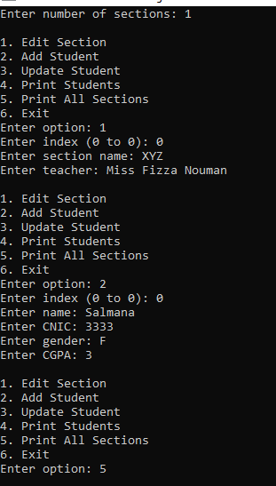
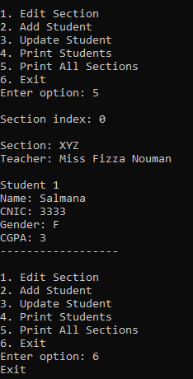
CODE 4:
#include<iostream>
#include<string>
using namespace std;
class TollBooth
{
private:
unsigned int totalCars;
double totalCash;
public:
TollBooth()
{
totalCars = 0;
totalCash = 0;
}
void payingCar()
{
totalCars++;
totalCash += 50;
}
void noPayCar()
{
totalCars++;
}
void display() const
{
cout << "\nTotal cars = " << totalCars << endl;
cout << "Total cash = " << totalCash << endl;
}
};
int main()
{
TollBooth t;
int ch;
do
{
cout << "\n1. Paying Car\n";
cout << "2. Non-Paying Car\n";
cout << "3. Show Data\n";
cout << "4. Exit\n";
cout << "Enter option: ";
cin >> ch;
switch (ch)
{
case 1:
t.payingCar();
break;
case 2:
t.noPayCar();
break;
case 3:
t.display();
break;
case 4:
cout << "Program ended\n";
break;
default:
cout << "Wrong option\n";
}
} while (ch != 4);
return 0;
}
OUTPUT:
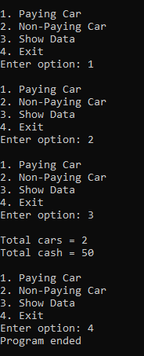
CODE 5:
#include<iostream>
#include<string>
using namespace std;
class Time
{
private:
int hr;
int min;
int sec;
public:
Time()
{
hr = 0;
min = 0;
sec = 0;
}
Time(int h, int m, int s)
{
hr = h;
min = m;
sec = s;
}
void show() const
{
cout << "\nTime = "
<< hr << ":"
<< (min < 10 ? "0" : "") << min << ":"
<< (sec < 10 ? "0" : "") << sec << endl;
}
void add(const Time& t1, const Time& t2)
{
sec = t1.sec + t2.sec;
min = t1.min + t2.min + sec / 60;
sec = sec % 60;
hr = t1.hr + t2.hr + min / 60;
min = min % 60;
}
};
int main()
{
const Time t1(6, 50, 30);
const Time t2(4, 10, 50);
Time result;
result.add(t1, t2);
result.show();
return 0;
}
OUTPUT:
