Object Oriented programming:
Assignment 3:
Task 1:
#include<iostream>
#include<fstream>
#include<cstring>
using namespace std;

class Account
{
public:
enum AccountType { CURRENT=0, SAVING=1 };

private:
char naam[50];
char accNo[20];
const AccountType type;
double balance;
static char bankName[50];
char branch[20];
char city[20];
static unsigned int currentCount;
static unsigned int savingCount;

public:
Account() : type(SAVING)
{
strcpy_s(naam, "N/A");
strcpy_s(accNo, "0");
strcpy_s(branch, "N/A");
strcpy_s(city, "N/A");
balance = 0;
savingCount++;
}
Account(char n[], char a[], AccountType t,double b, char br[], char c[]) : type(t)
{
strcpy_s(naam, n);
strcpy_s(accNo, a);
strcpy_s(branch, br);
strcpy_s(city, c);
balance = b;
if (t == CURRENT)
currentCount++;
else
savingCount++;
}
static char* getBankName()
{
return bankName;
}
static void setBankName(char b[])
{
strcpy_s(bankName, b);
}
void deposit(double amt)
{
if (amt > 0)
balance += amt;
else
cout << "Invalid amount!" << endl;
}
void withdraw(double amt)
{
if (amt > 0 && amt <= balance)
balance -= amt;
else
cout << "Insufficient balance!" << endl;
}
~Account()
{
if (type == CURRENT)
currentCount--;
else
savingCount--;
}
static void showCounts()
{
cout << "Current Accounts: " << currentCount << endl;
cout << "Saving Accounts: " << savingCount << endl;
cout << "Total: " << currentCount + savingCount << endl;
}
void display()
{
cout << "\nName: " << naam << endl;
cout << "Bank: " << bankName << endl;
cout << "City: " << city << endl;
cout << "Balance: " << balance << endl;
cout << "Acc No: " << accNo << endl;
cout << "Type: " << (type == CURRENT ? "Current" : "Saving") << endl;
}
char* getAccNo()
{
return accNo;
}
void save(ofstream& out)
{
out << naam << "\n";
out << accNo << "\n";
out << type << "\n";
out << balance << "\n";
out << branch << "\n";
out << city << "\n";
}
};
char Account::bankName[50] = "MyBank";
unsigned int Account::currentCount = 0;
unsigned int Account::savingCount = 0;
int main()
{
Account* arr[100];
for (int i = 0; i < 100; i++)
arr[i] = nullptr; //to avoid garbage
int count = 0;
ifstream in("accounts.txt");
if (in)
{
char name[50], acc[20], branch[20], city[20];
int type;
double bal;
while (count < 100 && in >> name >> acc >> type >> bal >> branch >> city)
{
arr[count] = new Account(name, acc,(Account::AccountType)type,bal, branch, city);
count++;
}
in.close();
cout << count << " accounts loaded." << endl;
}
int choice;
do
{
cout << "\n1. Create" << endl;
cout << "2. Display" << endl;
cout << "3. Deposit" << endl;
cout << "4. Withdraw" << endl;
cout << "5. Delete" << endl;
cout << "6. Show Counts" << endl;
cout << "0. Exit" << endl;
cout << "Choice: ";
cin >> choice;
if (choice == 1)
{
if (count >= 100)
{
cout << "Maximum accounts reached!" << endl;
continue;
}
char name[50], acc[20], branch[20], city[20];
int t;
double bal;
cout << "Name: "; cin >> name;
cout << "Acc No: "; cin >> acc;
cout << "Type (0=Current, 1=Saving): "; cin >> t;
cout << "Balance: "; cin >> bal;
cout << "Branch: "; cin >> branch;
cout << "City: "; cin >> city;
arr[count++] = new Account(name, acc,(Account::AccountType)t, bal, branch, city);
cout << "Account created!" << endl;
}
else if (choice == 2)
{
if (count == 0)
{
cout << "No accounts!" << endl;
continue;
}
for (int i = 0; i < count; i++)
arr[i]->display();
Account::showCounts();
}
else if (choice == 3)
{
char acc[20]; double amt;
cout << "Acc No: "; cin >> acc;
bool found = false;
for (int i = 0; i < count; i++)
{
if (strcmp(arr[i]->getAccNo(), acc) == 0)
{
cout << "Amount: "; cin >> amt;
arr[i]->deposit(amt);
found = true;
break;
}
}
if (!found) cout << "Account not found!" << endl;
}
else if (choice == 4)
{
char acc[20]; double amt;
cout << "Acc No: "; cin >> acc;
bool found = false;
for (int i = 0; i < count; i++)
{
if (strcmp(arr[i]->getAccNo(), acc) == 0)
{
cout << "Amount: "; cin >> amt;
arr[i]->withdraw(amt);
found = true;
break;
}
}
if (!found) cout << "Account not found!" << endl;
}
else if (choice == 5)
{
char acc[20];
cout << "Acc No: "; cin >> acc;
bool found = false;
for (int i = 0; i < count; i++)
{
if (strcmp(arr[i]->getAccNo(), acc) == 0)
{
delete arr[i];
for (int j = i; j < count - 1; j++)
arr[j] = arr[j + 1];
arr[count - 1] = nullptr;
count--;
found = true;
cout << "Account deleted!" << endl;
break;
}
}
if (!found) cout << "Account not found!" << endl;
}
else if (choice == 6)
{
Account::showCounts();
}

} while (choice != 0);
ofstream out("accounts.txt");
for (int i = 0; i < count; i++)
arr[i]->save(out);
out.close();
cout << "Accounts saved!" << endl;
for (int i = 0; i < count; i++)
{
delete arr[i];
arr[i] = nullptr;
}

return 0;
}
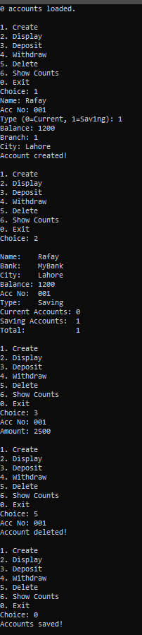

Task 2:
#include<iostream>
using namespace std;

class HotDogStand
{
private:
int id;
int hotdogsSold;

static int totalSold;

public:
HotDogStand(int i, int sold)
{
id = i;
hotdogsSold = sold;
totalSold += sold;
cout << "Stand " << id << " created!" << endl;
}

~HotDogStand()
{
cout << "Stand " << id << " closed." << endl;
}

void justSold()
{
hotdogsSold++;
totalSold++;
cout << "Stand " << id << " sold a hotdog! "<< "Stand total: " << hotdogsSold << endl;
}

int getSold()
{
return hotdogsSold;
}

int getID()
{
return id;
}

void display()
{
cout << "Stand ID: " << id << endl;
cout << "Stand Sold: " << hotdogsSold << endl;
}

static int getTotalSold()
{
return totalSold;
}
};

int HotDogStand::totalSold = 0;

int main()
{
cout << " Opening Stands " << endl;
HotDogStand* s1 = new HotDogStand(1, 0);
HotDogStand* s2 = new HotDogStand(2, 0);
HotDogStand* s3 = new HotDogStand(3, 0);

cout << endl << " Stand 1 Selling " << endl;
s1->justSold();
s1->justSold();
s1->justSold();

cout << endl << " Stand 2 Selling " << endl;
s2->justSold();
s2->justSold();
cout << endl << " Stand 3 Selling " << endl;
s3->justSold();
s3->justSold();
s3->justSold();
s3->justSold();
cout << endl << " End of Day Summary " << endl;
s1->display();
cout << endl;
s2->display();
cout << endl;
s3->display();
cout << endl;
cout << "Total Hotdogs Sold (All Stands): "<< HotDogStand::getTotalSold() << endl;
cout << endl << "Closing Stands " << endl;
delete s1;
delete s2;
delete s3;

return 0;
}
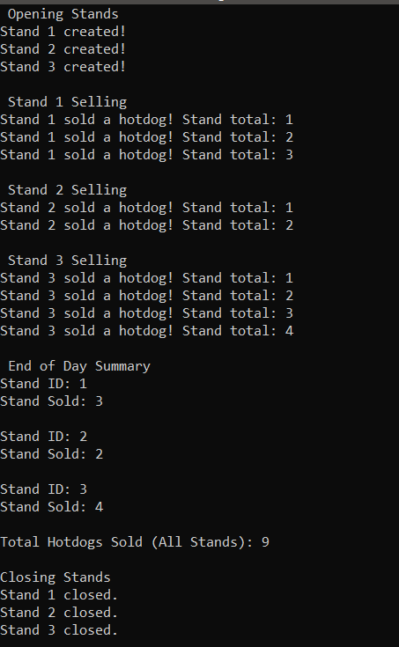
Task 4:
#include<iostream>
using namespace std;

class tollbooth
{
private:
unsigned int totalCars;
double totalCash;

public:
tollbooth()
{
totalCars = 0;
totalCash = 0;
}
void payingCar()
{
totalCars++;
totalCash += 50;
cout << "Paying car passed. Cash added: 50" << endl;
}
void noPayCar()
{
totalCars++;
cout << "Non-paying car passed. No cash added." << endl;
}
void display() const
{
cout << "Total Cars: " << totalCars << endl;
cout << "Total Cash: " << totalCash << " rupees" << endl;
}
unsigned int getCars() const
{
return totalCars;
}
double getCash() const
{
return totalCash;
}
};

int main()
{
tollbooth* tb = new tollbooth();

char choice;
cout << " TOLL BOOTH SYSTEM " << endl;
cout << "p = Paying car" << endl;
cout << "n = Non-paying car" << endl;
cout << "d = Display totals" << endl;
cout << "q = Quit" << endl;

do
{
cout << "\nEnter choice: ";
cin >> choice;

if (choice == 'p' || choice == 'P')
{
tb->payingCar();
}
else if (choice == 'n' || choice == 'N')
{
tb->noPayCar();
}
else if (choice == 'd' || choice == 'D')
{
cout << endl;
tb->display();
}
else if (choice != 'q' && choice != 'Q')
{
cout << "Invalid choice!" << endl;
}

} while (choice != 'q' && choice != 'Q');

cout << endl << "Final Report " << endl;
tb->display();

delete tb;
tb = nullptr;

return 0;
}
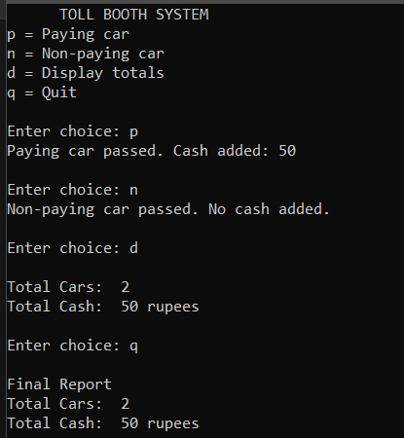

Task 5:
#include<iostream>
#include<iomanip>
using namespace std;

class time2
{
private:
int hours;
int minutes;
int seconds;

public:
time2()
{
hours = 0;
minutes = 0;
seconds = 0;
}

time2(int h, int m, int s)
{
hours = h;
minutes = m;
seconds = s;
}

void display() const
{
cout << setw(2) << setfill('0') << hours << ":"<< setw(2) << setfill('0') << minutes << ":" << setw(2) << setfill('0') << seconds << endl;
}

void add(const time2& t1, const time2& t2)
{
seconds = t1.seconds + t2.seconds;
minutes = t1.minutes + t2.minutes + seconds / 60;
hours = t1.hours + t2.hours + minutes / 60;

seconds %= 60;
minutes %= 60;
hours %= 24;
}
};

int main()
{
const time2 t1(10, 29, 25);
const time2 t2(1, 45, 50);

time2 t3;

cout << "Time 1: ";
t1.display();

cout << "Time 2: ";
t2.display();

t3.add(t1, t2);

cout << "Result: ";
t3.display();

return 0;
}
