Assignment no 3
Question no 1:
Output:

Question no 2:
#include<iostream>
using namespace std;
class hotdog
{
int id;
int sold;
static int total;
static int t;
public:
hotdog()
{
id = 0;
sold = 0;

}
hotdog(int i,int s)
{
id = i;
sold = s;
total += s;
}
void justsold()
{
static int i = 1;
cout << "\nFor stand " << i++<<" done ";
sold++;
total ++;
}
void display()
{
cout << "\n Stand having ID: " << id << " SOLD: " << sold;
t++;
if (t == 4 || t == 8)
{
cout << " \n Total sold : " << total;
}
}
};
int hotdog:: total=0;
int hotdog::t = 0;
int main()
{
hotdog h1(2, 7), h2(4, 67),h3(7,90),h4,h5;
h1.display();
h2.display();
h3.display();
h4.display();
cout << "\n Calling justsold function for every stand ";
h1.justsold();
h2.justsold();
h3.justsold();
h4.justsold();
cout << "\n After become ";
h1.display();
h2.display();
h3.display();
h4.display();
return 0;
}
Output:
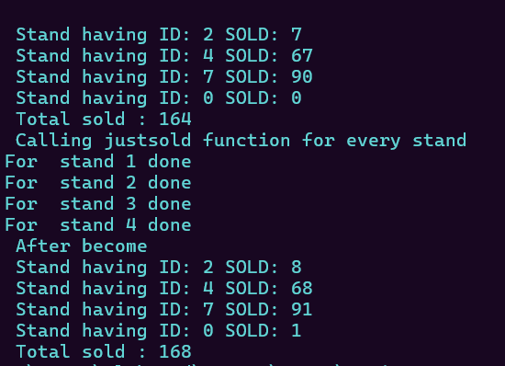

Question no 3:
Output:

Question no 4:
#include<iostream>
using namespace std;
class tollboth
{
unsigned int car;
double money;
public:
tollboth()
{
car = 0;
money = 0.0;
}
void payingcar()
{
car++;
money += 50;
cout << " done\n ";
}
void nopaycar()
{
car++;
cout << " ___done___\n";
}
void display()
{
cout << " Total number of car gone through booth: " << car;
cout << "\n Total amount : " << money;

}
};
int main()
{
tollboth t1;
bool flag=true;
int n;
while (flag)
{
cout << "Press 1 to pay the tollbooth.\nPress 2 for not paying the tollbooth.\nPress 3 for display. \nPress 4 to exit.\n";
cin >> n;
switch (n)
{
case 1:
t1.payingcar();
break;
case 2:
t1.nopaycar();
break;
case 3:
t1.display();
break;
case 4:
flag = false;
break;
default:
cout << " Invalid input ";
}
}
return 0;
}
Output:
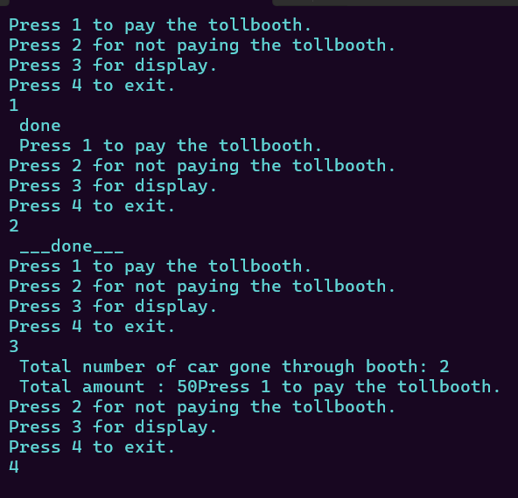

Question no 5:
#include<iostream>
using namespace std;
class Time
{
int hours;
int min;
int sec;

public:
Time()
{
hours = 0;
min = 0;
sec = 0;
}
Time(int h, int m, int s)
{
hours = h;
min = m;
sec = s;
}
void add(const Time& t1, const Time& t2)
{
sec = t1.sec + t2.sec;
min = t1.min + t2.min;
hours = t1.hours + t2.hours;

if (sec >= 60)
{
min += sec / 60;
sec = sec % 60;
}

if (min >= 60)
{
hours += min / 60;
min = min % 60;
}
}
void display()
{
cout << endl << hours << ":" << min << ":" << sec;
}
};
int main()
{
const Time t1(5, 16, 27);
const Time t2(5, 46, 17);
Time t3;
t3.add(t1, t2);
cout << "After adding time becomes: ";
t3.display();
return 0;
}
Output:
